String
1.In Java, string is basically an object that represents sequence of char values
2.String objects are called immutable.
3.The Java Virtual Machine(JVM) creates a memory location especially for Strings called String Constant Pool. That’s why String can be initialized without ‘new’ keyword.
4.String class falls under java.lang.String hierarchy. But there is no need to import this class. Java platform provides them automatically.
5.Java String is created by using double quotes.

There are two ways to create String object:
1.By literal string (like object)
String s="welcome";
Each time you create a literal string , the JVM checks the "string constant pool" first. If the string already exists in the pool no new memory will be generated but it will share the memory for duplicates value of string. If the string doesn't exist in the pool, a new string instance is created and placed in the pool. For example:
String s1="Welcome";
String s2="Welcome";//It doesn't create a new instance

jvm will find the string value "Welcome" in the pool, it will not create a new object because value of both (s1,s2) are same so it will share the memory for both variable .
Why Java uses the concept of String literal?
To make Java more memory efficient (because no new objects are created if it exists already in the string constant pool).
2.By non - literal string (using new keyword like an object)
String s=new String("Welcome");//creates two objects and one reference variable
here JVM will create a new string object in heap memory. The variable s will refer to the object in a heap (non-pool).
Immutable String in Java
A String is an unavoidable type of variable while writing any application program. String are used to store various attributes like username, password, etc. In Java, String objects are immutable. Immutable simply means unmodifiable or unchangeable.
Once String object is created its data or state can't be changed but a new String object is created.
understand the concept of immutability by the example given below
class Testimmutablestring{
public static void main(String args[]){
String s="Sachin";
s.concat(" Tendulkar");//concat() method appends the string at the end
System.out.println(s);//will print Sachin because strings are immutable objects
}
} o/t = sachin
Now it can be understood by the diagram given below. Here Sachin is not changed but a new object is created with Sachin Tendulkar. That is why String is known as immutable.
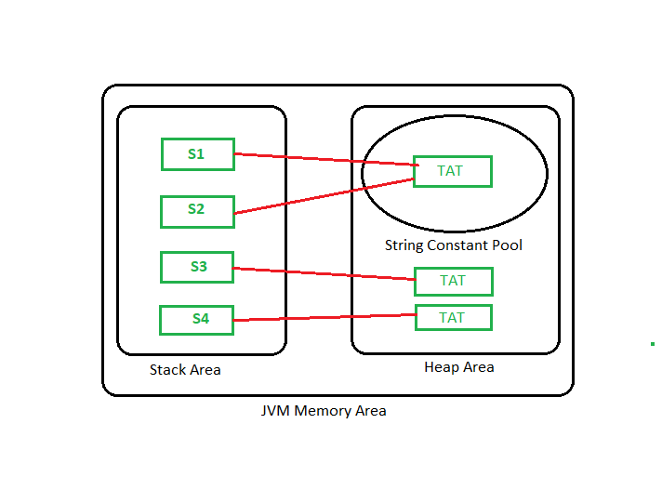
two objects are created but s reference variable still refers to "Sachin" not to "Sachin Tendulkar".
example
class Testimmutablestring1{
public static void main(String args[]){
String s="Sachin";
s=s.concat(" Tendulkar");
System.out.println(s);
}
}
pupose of immutable string
The immutability of String helps to minimize the usage in the heap memory.
When we try to declare a new String object, the JVM checks whether the value already exists in the String pool or not. If it exists, the same value is assigned to the new object.
This feature allows Java to use the heap space efficiently.
Why String class is Final in Java?
The reason behind the String class being final is because no one can override the methods of the String class.
There are three ways to compare String in Java:
By Using equals() Method
example
class Teststringcomparison1{
public static void main(String args[]){
String s1="Sachin";
String s2="Sachin";
String s3=new String("Sachin");
String s4="Saurav";
System.out.println(s1.equals(s2));//true
System.out.println(s1.equals(s3));//true
System.out.println(s1.equals(s4));//false
}
}
In the above code, two strings are compared using equals() method of String class. And the result is printed as boolean values, true or false.
example 2
class Teststringcomparison2{
public static void main(String args[]){
String s1="Sachin";
String s2="SACHIN";

System.out.println(s1.equals(s2));//false
System.out.println(s1.equalsIgnoreCase(s2));//true
}
}
In the above program, the methods of String class are used. The equals() method returns true if String objects are matching and both strings are of same case. equalsIgnoreCase() returns true regardless of cases of strings.
By Using == Operator
The == operator compares references not values.
class Teststringcomparison3{
public static void main(String args[]){
String s1="Sachin";
String s2="Sachin";
String s3=new String("Sachin");
System.out.println(s1==s2);//true (because both refer to same instance)
System.out.println(s1==s3);//false(because s3 refers to instance created in nonpool)
}
}
By compareTo() Method
The String class compareTo() method compares values lexicographically and returns an integer value that describes if first string is less than, equal to or greater than second string.
Suppose s1 and s2 are two String objects. If:
s1 == s2 : The method returns 0.
s1 > s2 : The method returns a positive value.
s1 < s2 : The method returns a negative value.
class Teststringcomparison4{
public static void main(String args[]){
String s1="Sachin";
String s2="Sachin";
String s3="Ratan";
System.out.println(s1.compareTo(s2));//0
System.out.println(s1.compareTo(s3));//1(because s1>s3)
System.out.println(s3.compareTo(s1));//-1(because s3 < s1 )
}
}
=======================================================================
public class StringProgramms {

public static void main(String[] args) {

/*//literal String
String str = "java";
String str1= "java";

System.out.println(System.identityHashCode(str));
System.out.println(System.identityHashCode(str1));*/

//Non-literal String
/*
String str = new String("java");
String str1= new String("java");

System.out.println(System.identityHashCode(str));
System.out.println(System.identityHashCode(str1));*/

//ImMutable String
System.out.println("Immutable String");
String str = new String("java");
String str1= new String("Python");

System.out.println(System.identityHashCode(str));
System.out.println(System.identityHashCode(str1));
String concat = str.concat("Python");
System.out.println(concat);

System.out.println(System.identityHashCode(concat));

//To changer from Immutable into Mutable String
//String Builder
/* System.out.println("Mutable String");
StringBuilder builder = new StringBuilder("java");
StringBuilder builder1 = new StringBuilder("Python");
StringBuilder append = builder.append(builder1);
System.out.println(append);
System.out.println("String Java:"+System.identityHashCode(builder));
System.out.println("String Python:"+System.identityHashCode(builder1));
System.out.println("String both:"+System.identityHashCode(append));*/

//String Buffer
System.out.println("Mutable String");
StringBuffer buffer = new StringBuffer("java");
StringBuffer buffer1 = new StringBuffer("Python");
StringBuffer append = buffer.append(buffer1);
System.out.println(append);
System.out.println("String Java:"+System.identityHashCode(buffer));
System.out.println("String Python:"+System.identityHashCode(buffer1));
System.out.println("String both:"+System.identityHashCode(append));

}

}

