ASSIGNMENT 4

Ganesh Kale

2021-04-24

# Markdown Basics

## Favorite Foods

1. Egg Omlette
2. Grilled Salmon
3. Chicken Fajitas

## Images

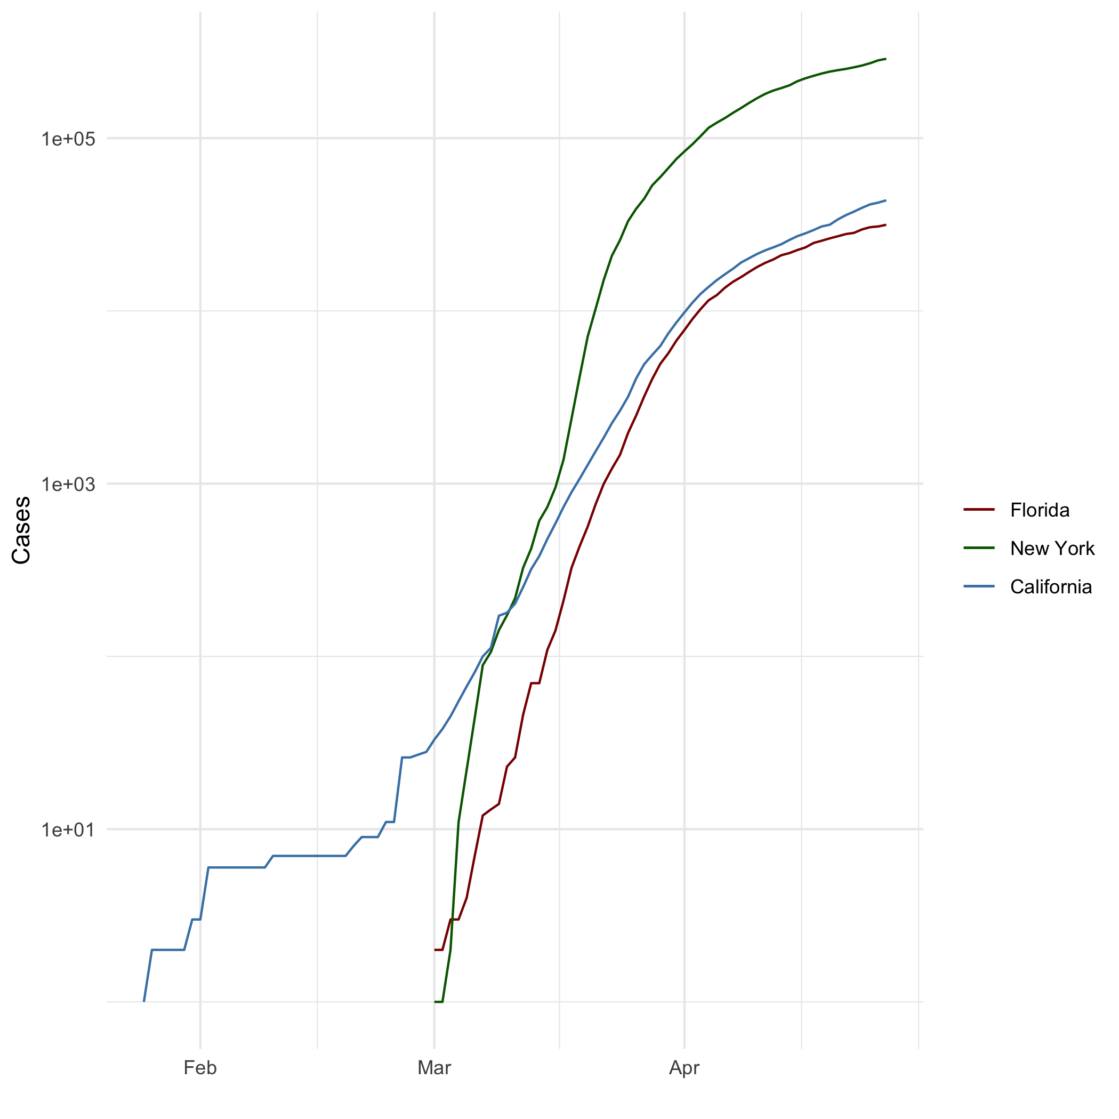

All Cases (Log Plot)

## Add a Quote

Someone Said:

A finite mindset fears surprises, an infinite mindset sees opportunity in uncertain.

## Add an Equation

$$\sum_{i=1}^{n}{{\left(X_{i}−Y_{i}\right)}^{2}}$$

## Add a Footnote

This is footnote[1]

## Add Citations

* R for Everyone (Lander 2014)
* Discovering Statistics Using R (Field, Miles, and Field 2012)

# Inline Code

## NY Times COVID-19 Data

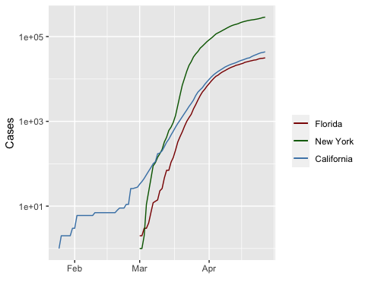

## R4DS Height vs Earnings

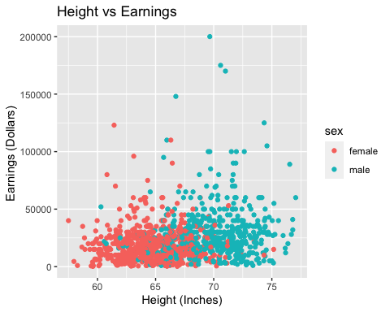 # Tables

## Knitr Table with Kable

One Ring to Rule Them All

|  |  |  |  |  |
| --- | --- | --- | --- | --- |
| name | race | in_fellowship | ring_bearer | age |
| Aragon | Men | TRUE | FALSE | 88 |
| Bilbo | Hobbit | FALSE | TRUE | 129 |
| Frodo | Hobbit | TRUE | TRUE | 51 |
| Galadriel | Elf | FALSE | FALSE | 7000 |
| Sam | Hobbit | TRUE | TRUE | 36 |
| Gandalf | Maia | TRUE | TRUE | 2019 |
| Legolas | Elf | TRUE | FALSE | 2931 |
| Sauron | Maia | FALSE | TRUE | 7052 |
| Gollum | Hobbit | FALSE | TRUE | 589 |

## Pandoc Table

##   
##   
## | Name | Race | fellowship | bearer | Age |  
## |:------:|:------:|:----------:|:------:|:----:|  
## | Aragon | Men | Yes | No | 88 |  
## | Bilbo | Hobbit | No | Yes | 129 |  
## | Frodo | Hobbit | Yes | Yes | 51 |  
## | Sam | Hobbit | Yes | Yes | 36 |  
## | Sauron | Maia | No | Yes | 7052 |

# References

Field, A., J. Miles, and Z. Field. 2012. *Discovering Statistics Using r*. SAGE Publications. <https://books.google.com/books?id=wd2K2zC3swIC>.

Lander, J. P. 2014. *R for Everyone: Advanced Analytics and Graphics*. Addison-Wesley Data and Analytics Series. Addison-Wesley. <https://books.google.com/books?id=3eBVAgAAQBAJ>.

1. R for Everyone.