QI Project

Team A

Document for 2018 summer IoT Project

# Table of Contents

## 1. Introduction of Team A

1.1 Team Member List

1.2 Workspace

## 2. Reference Model

## 3. System Architecture

## 4. ER Model

## 5. Procedure

## 5.1 User Management

## 5.2 Sensor Management

## 5.3 Data Management

## 5.4 Data Monitoring

## 6. Flowchart

## 6.1 User Management

## 6.2 Sensor Management

## 6.3 Data Management

## 6.4 Data Monitoring

## 

# 1. Introduction of Team A

## 1.1 Team Member List

| Name | Affiliation | Part |
| --- | --- | --- |
| Joowon Byun | Pusan University | Web / Team Leader |
| Umji Choi (Wendy) | Keimyung University | Web |
| Doyoung Ha (James) | Keimyung University | App |
| Janghyeon Song (Jack) | Chosun University | App |
| Junho Suk (Juno) | Keimyung University | Sensor |

## 

## 1.2 Workspace

* Server and Web Side : <https://github.com/Joowon0/BuildingRun_server>
* App Side : <https://github.com/Joowon0/BuildingRun>

# 2. Reference Model

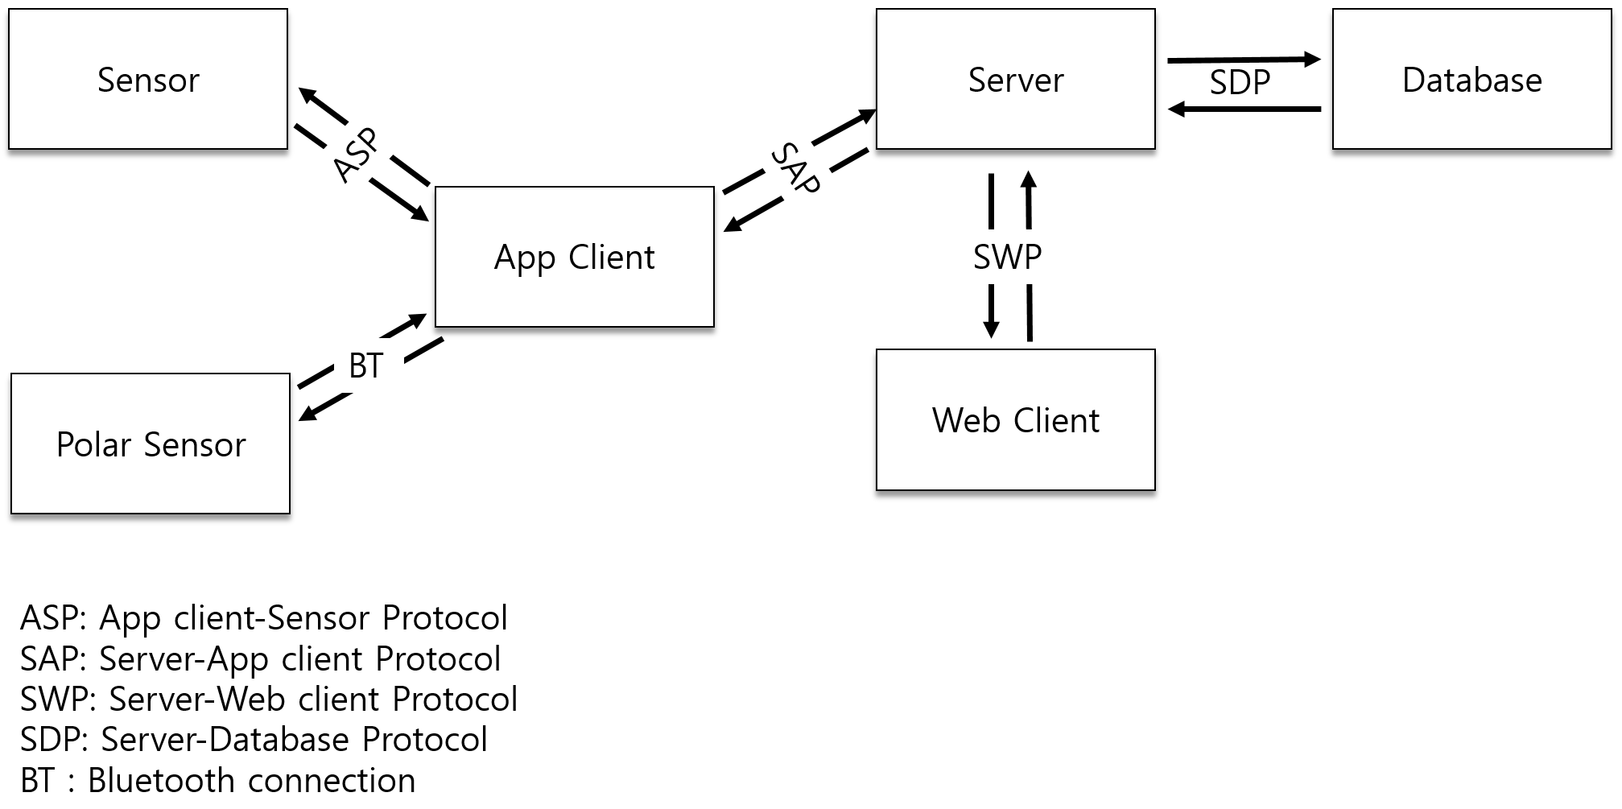

# 3. System Architecture

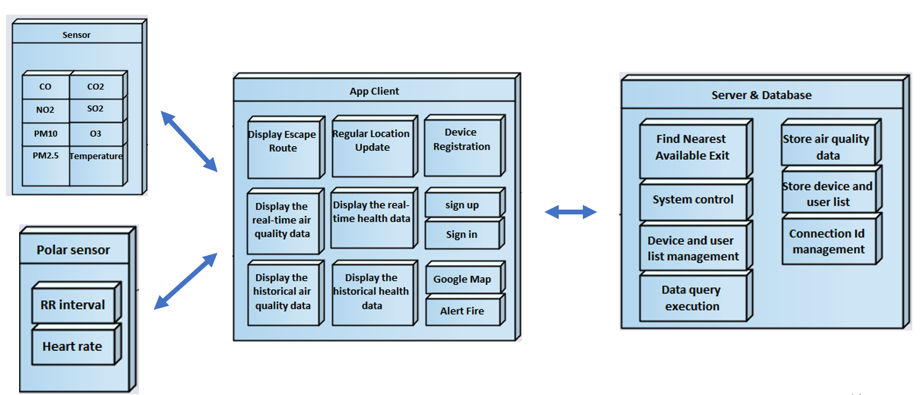

# 4. ER Model

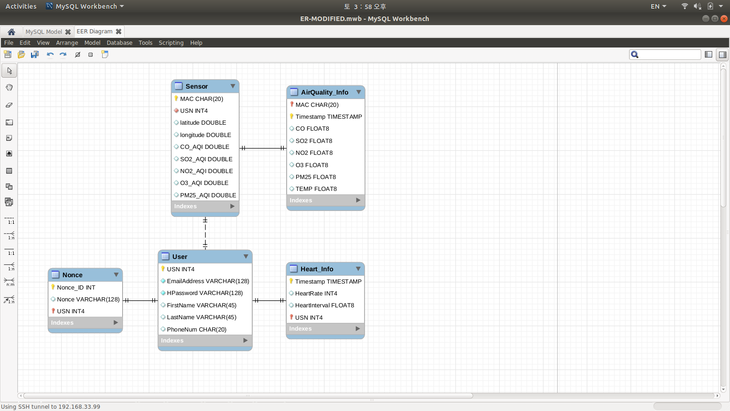

5. Procedure

5.1 User Management

1) Sign-up

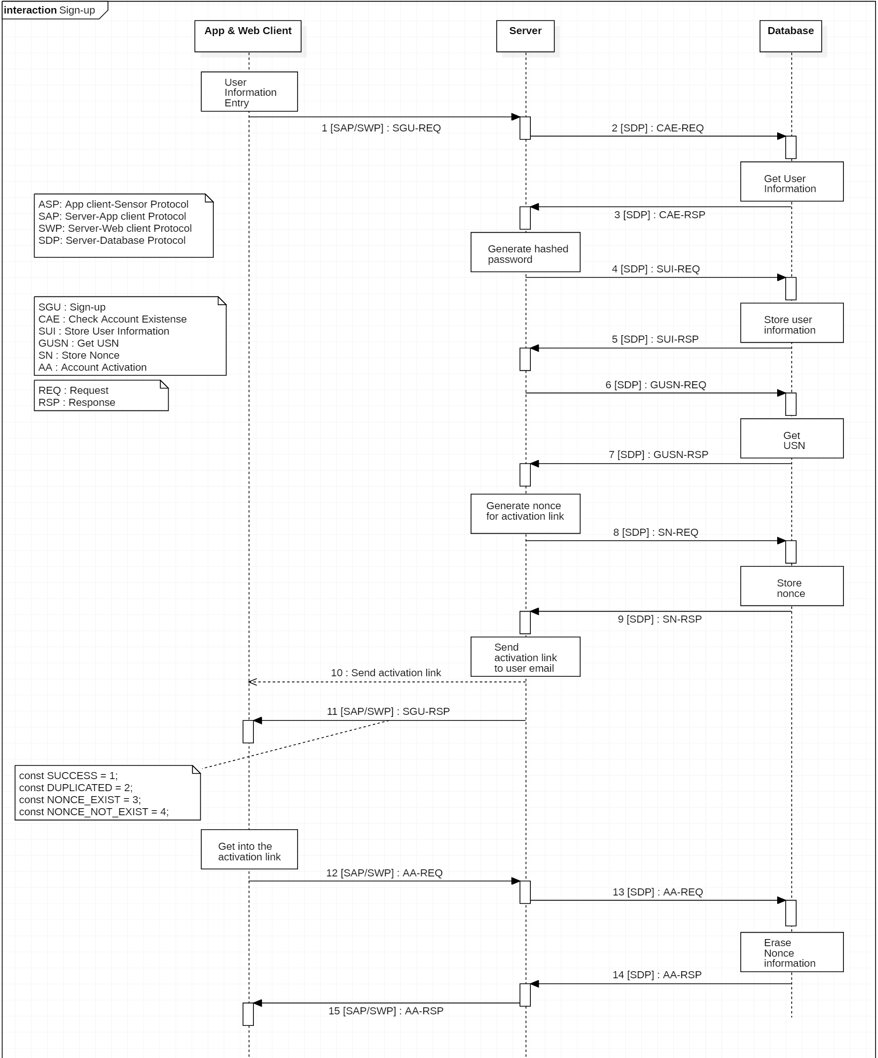

2) Sign-in

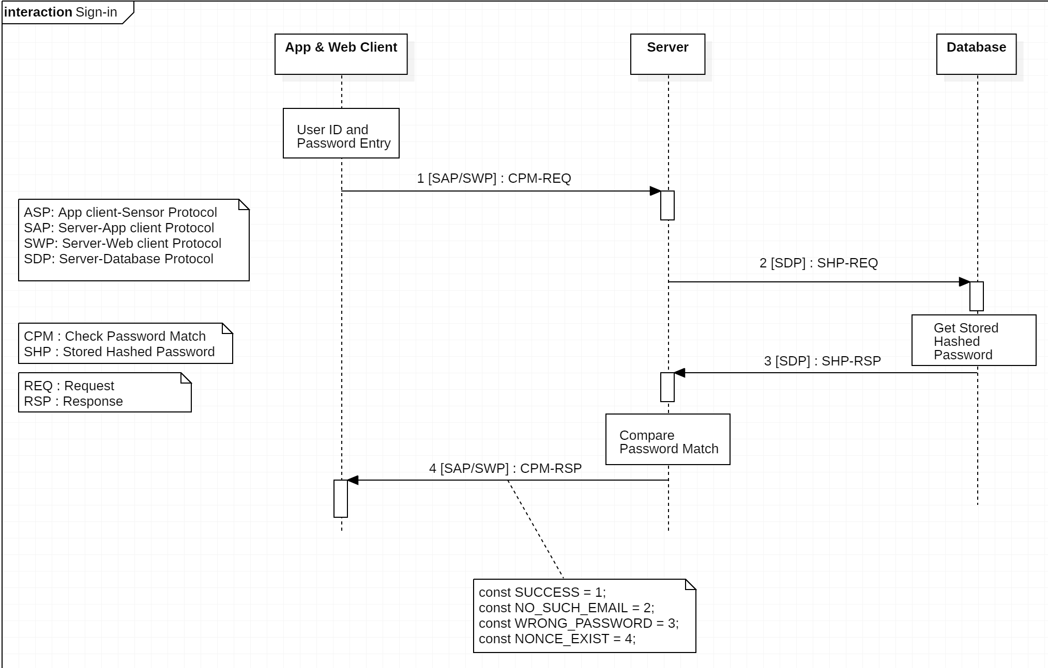

3) Sign-out

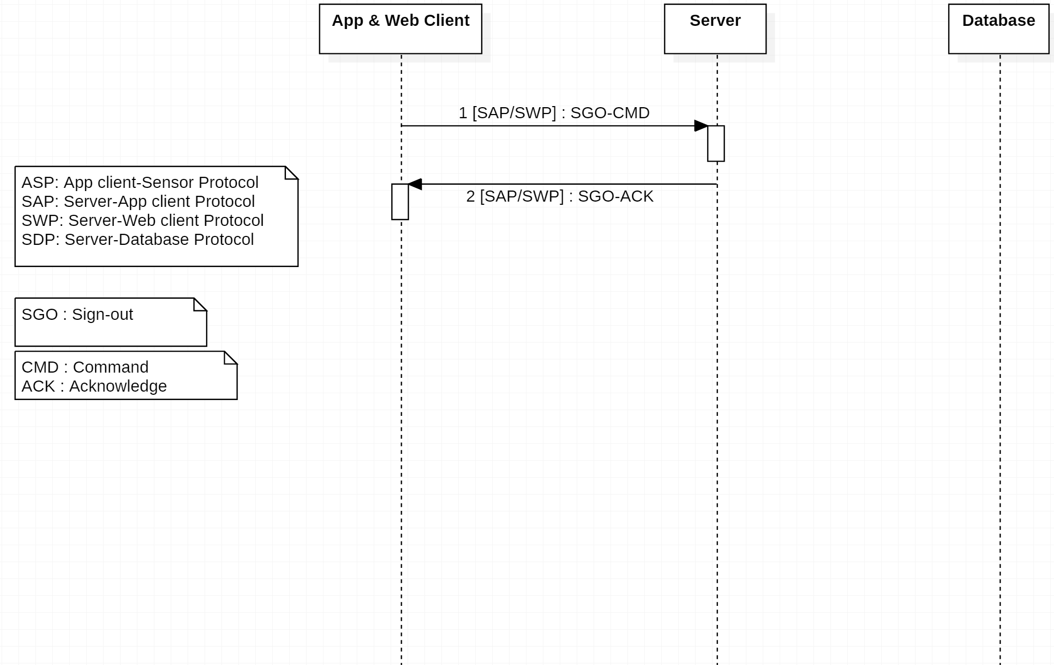

4) User password change

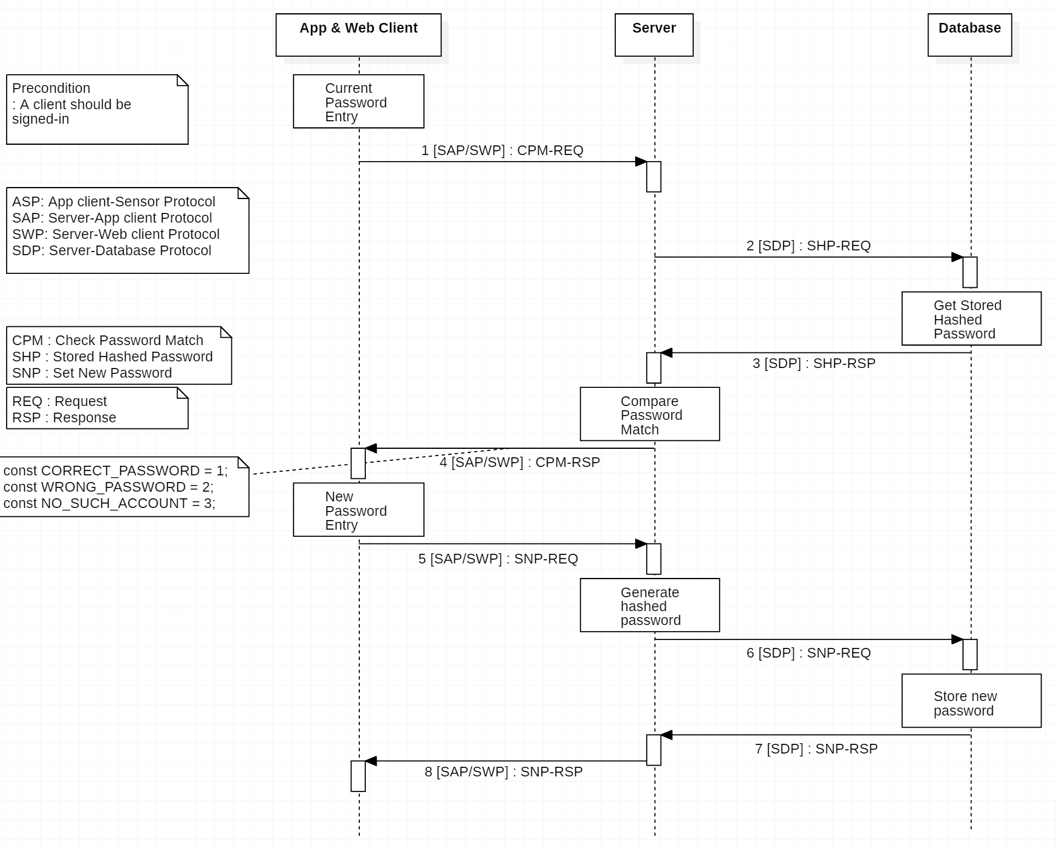

5) Forgotten password update

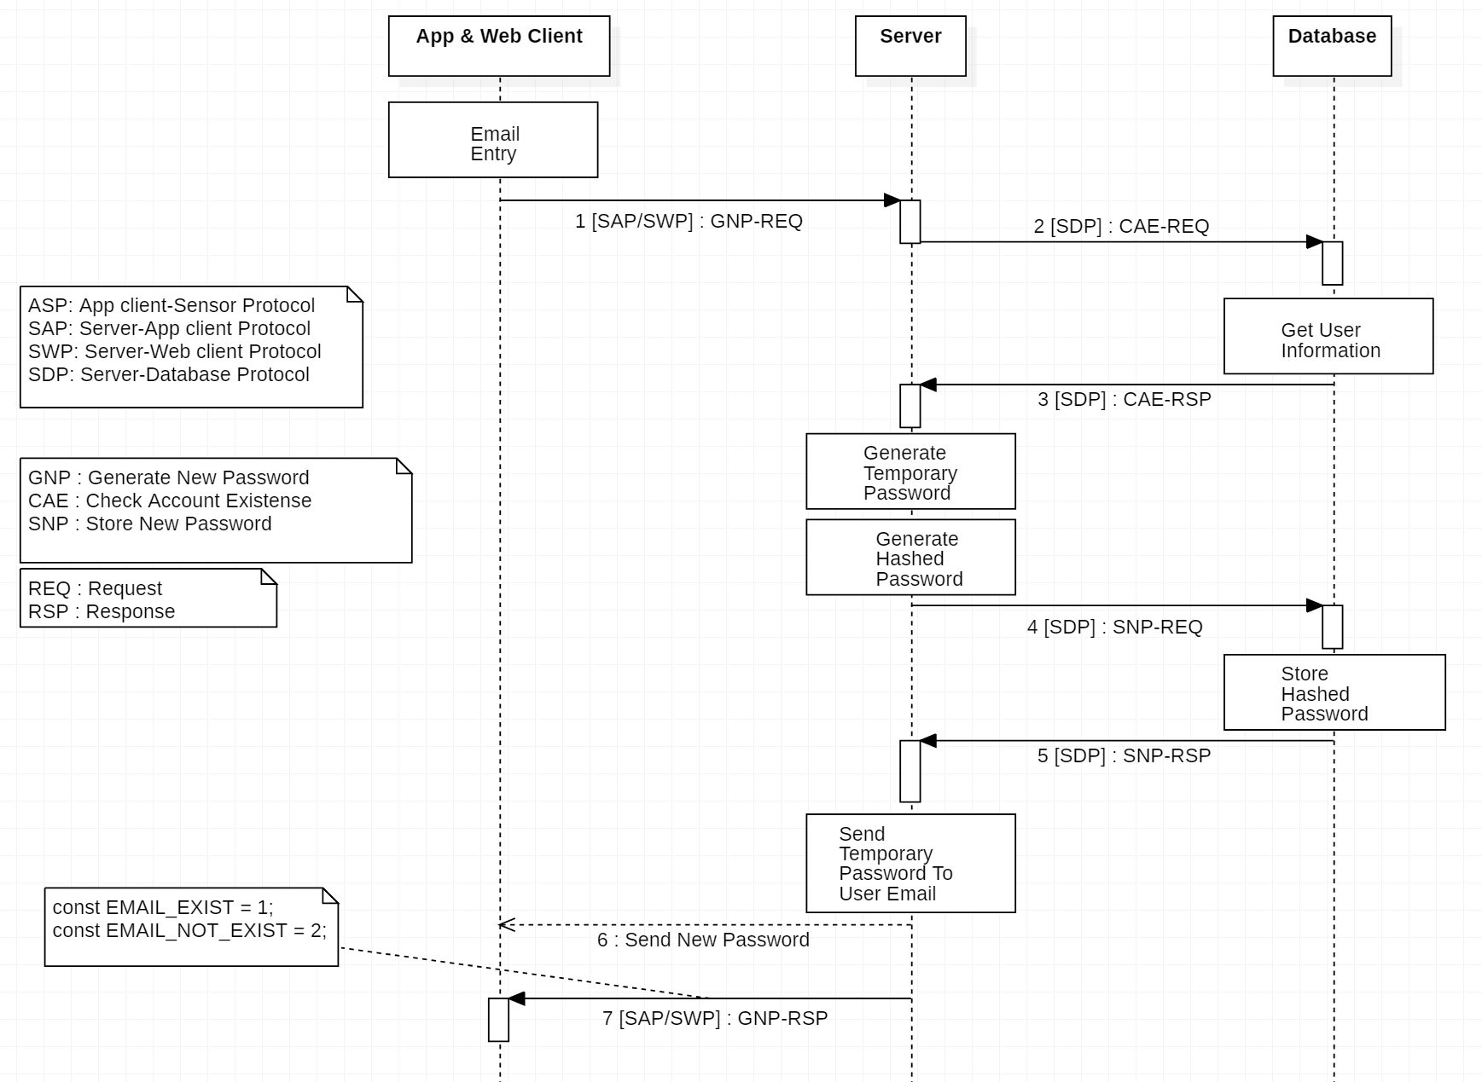

6) ID cancellation

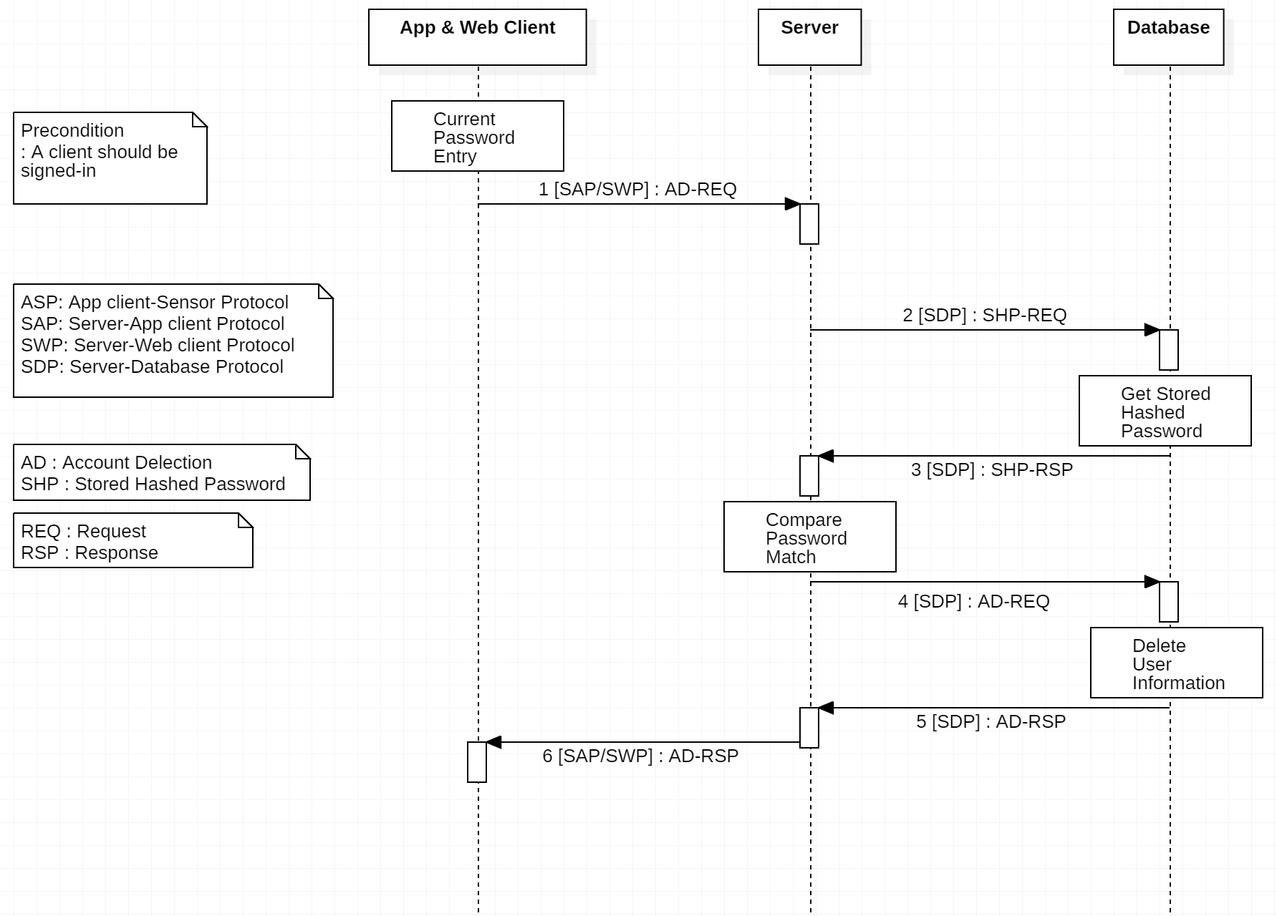

5.2 Sensor Management

1) Sensor registration and association

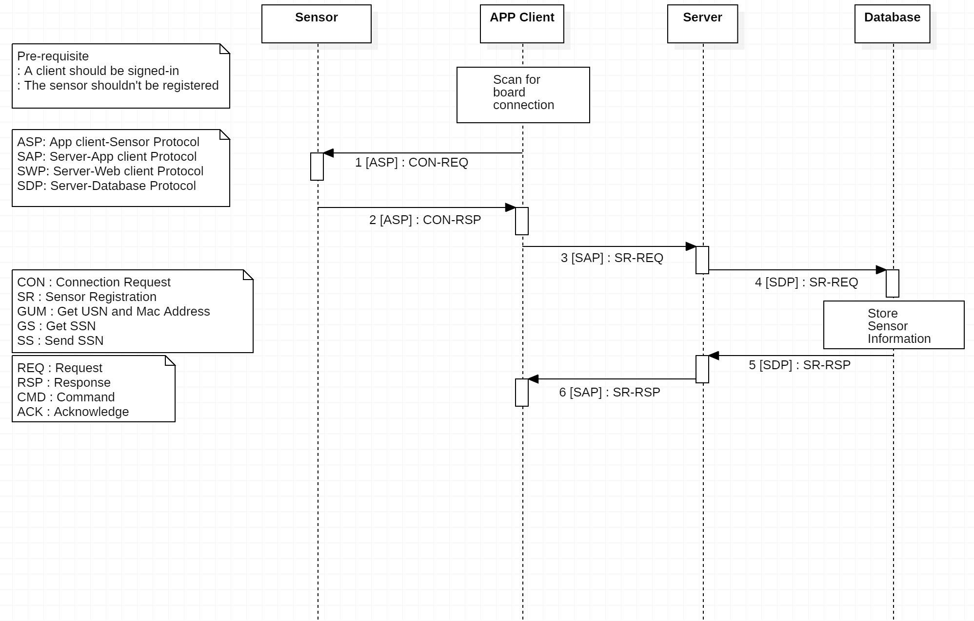

2) Sensor deregistration and disassociation

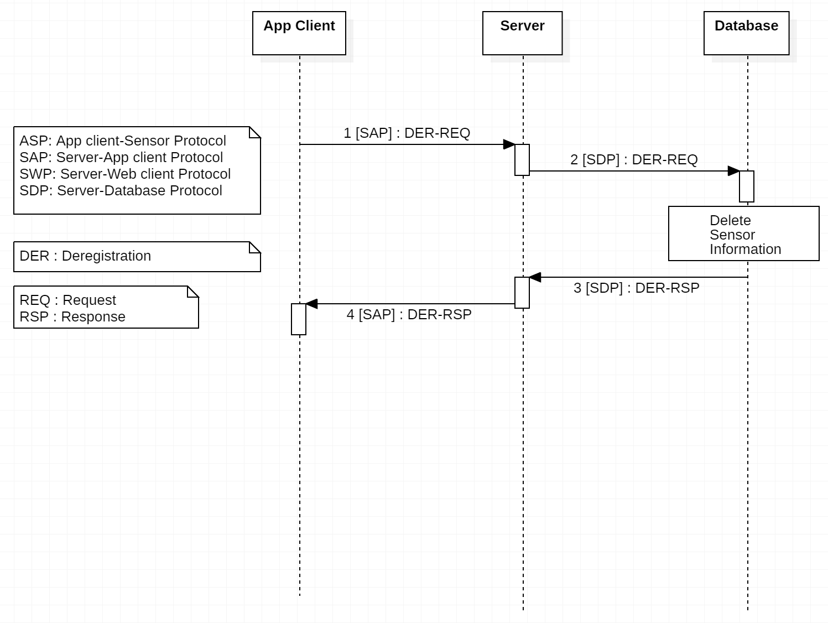

3) Sensor list view

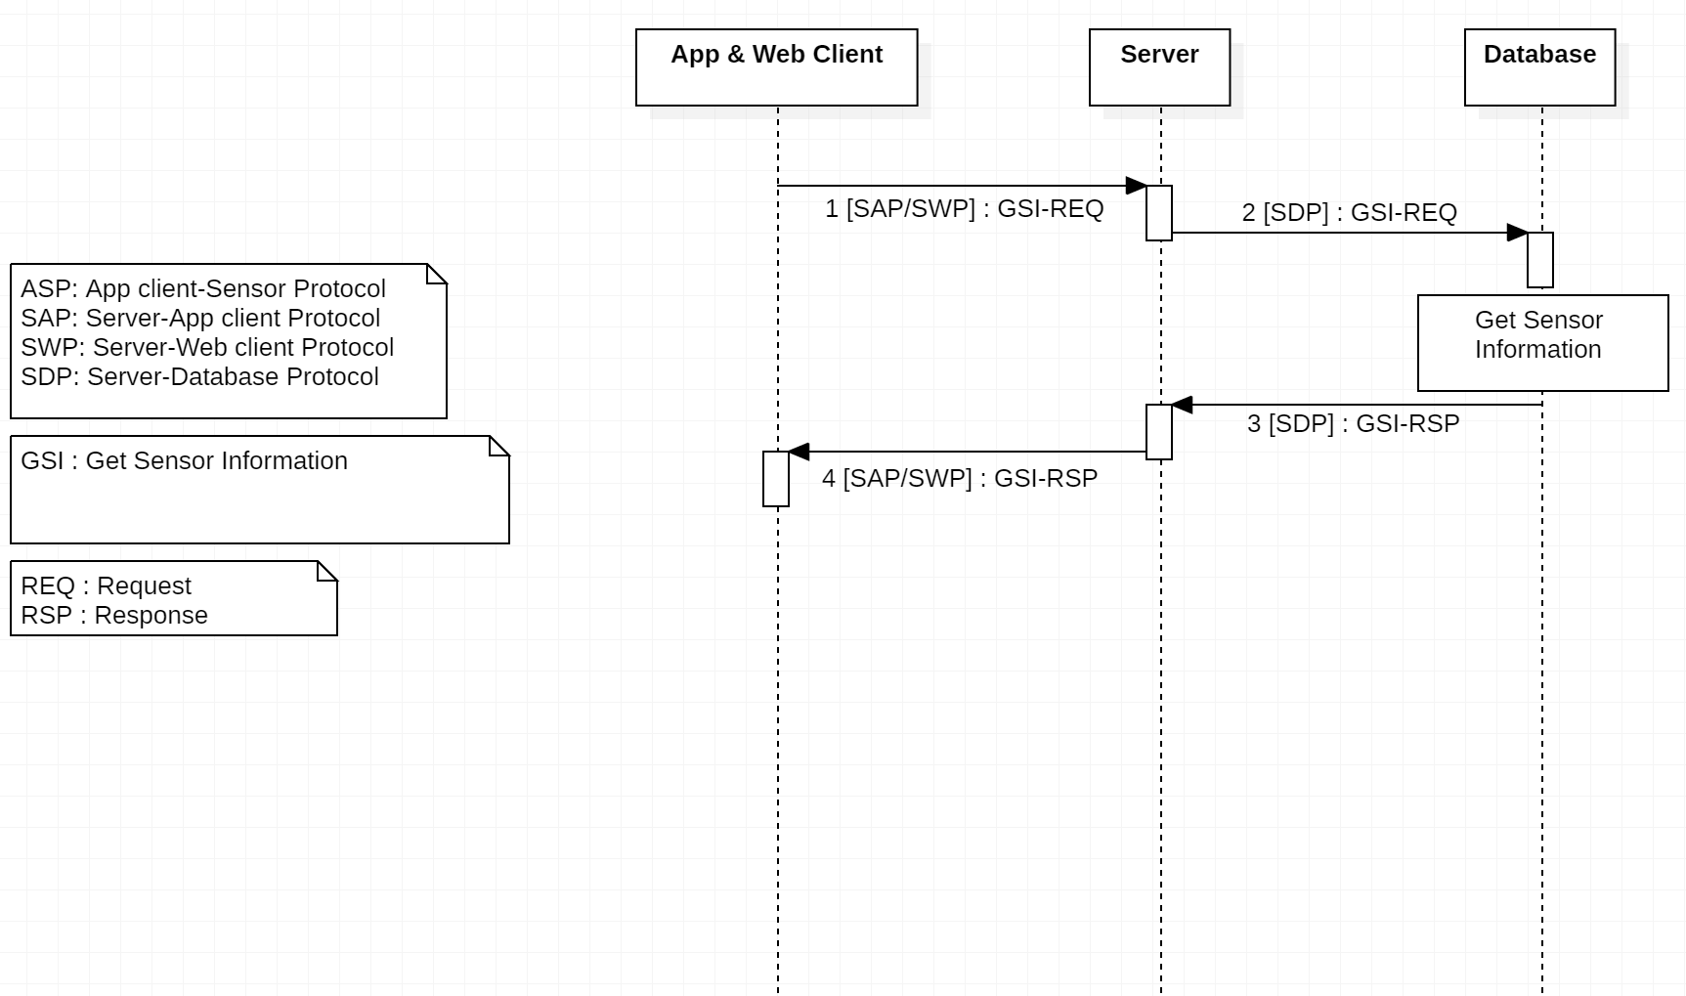

5.3 Data Management

1) Real-time air quality data transfer

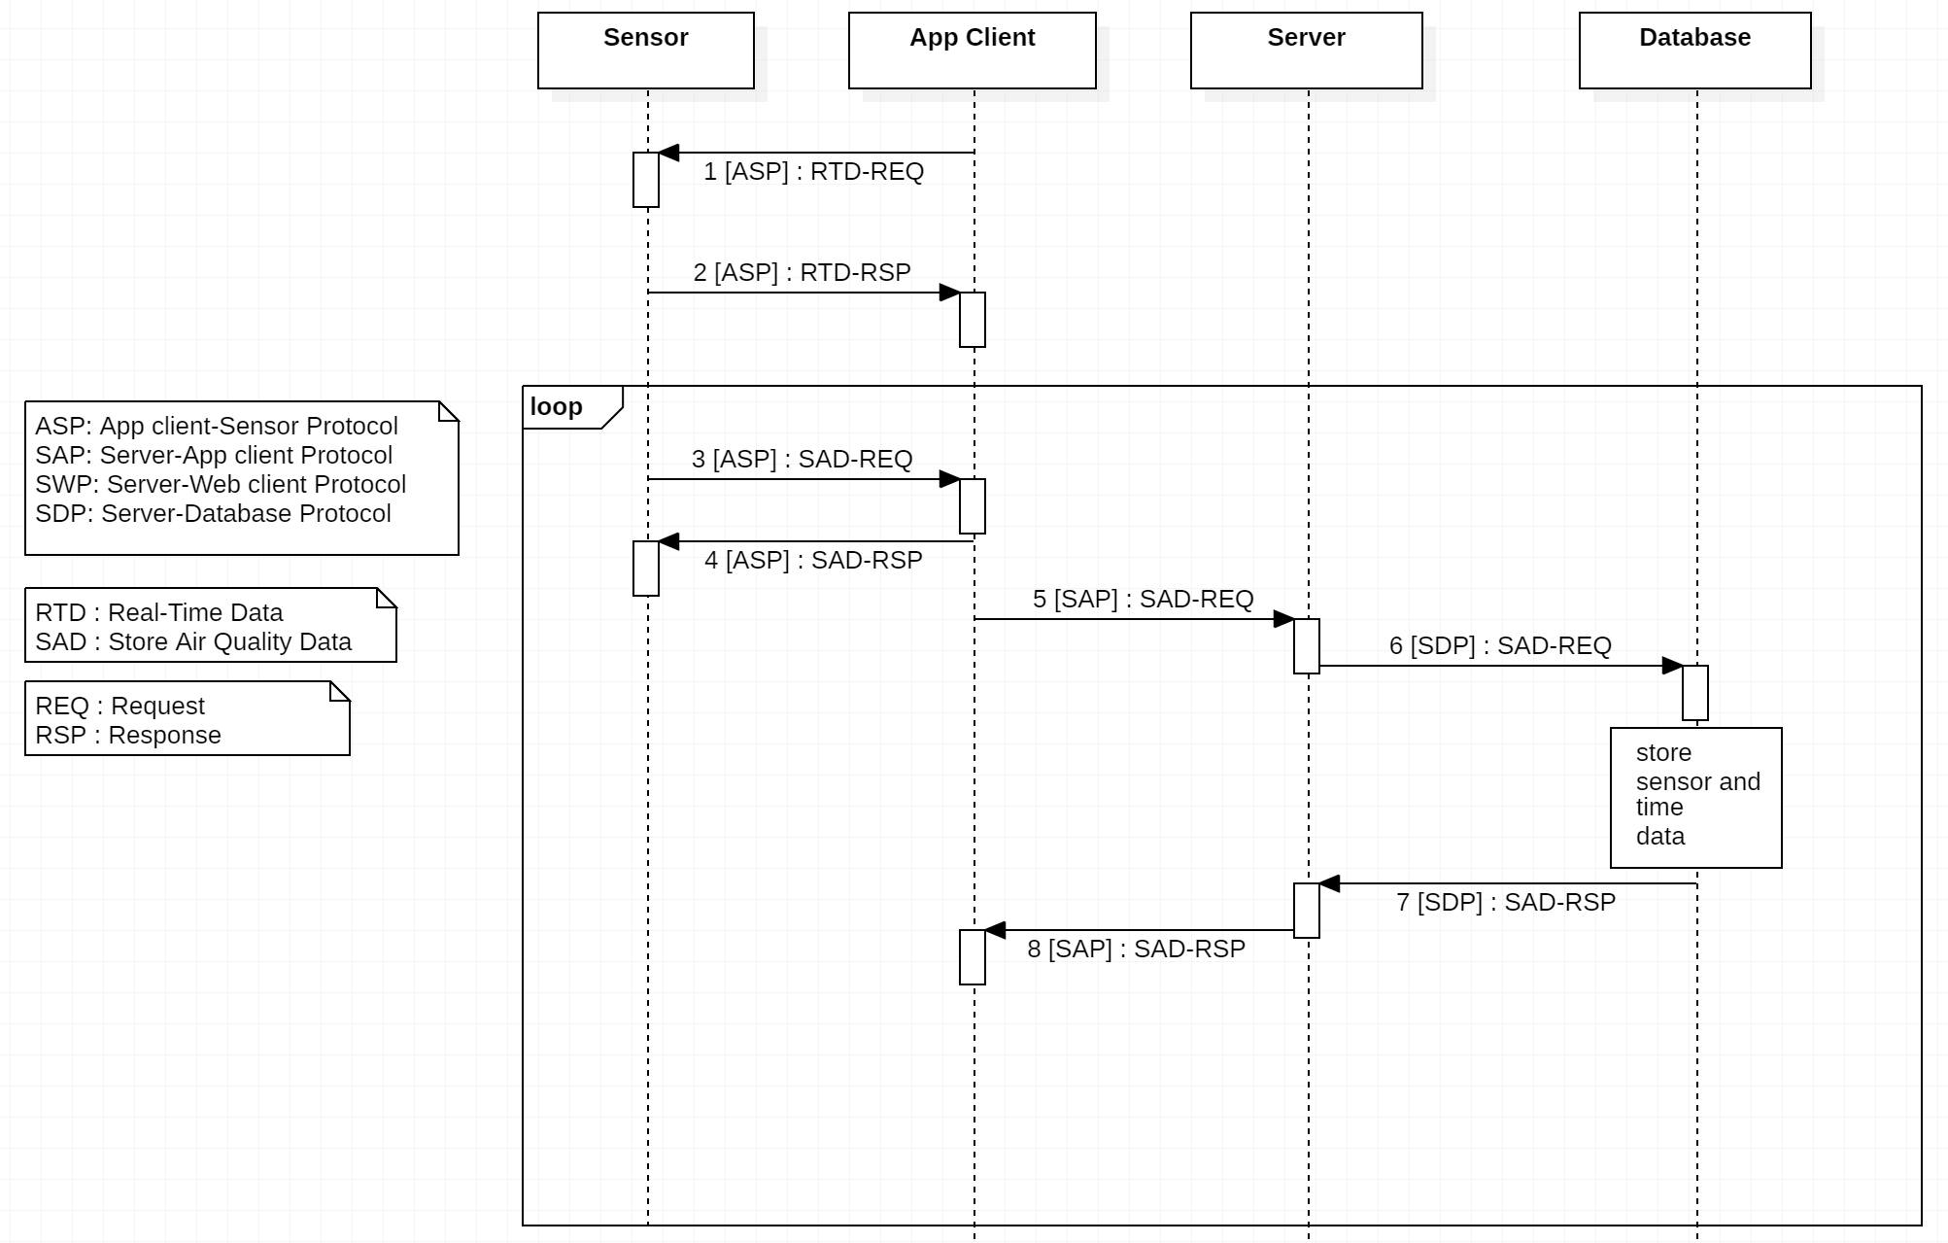

2) Real-time heart-related data transfer

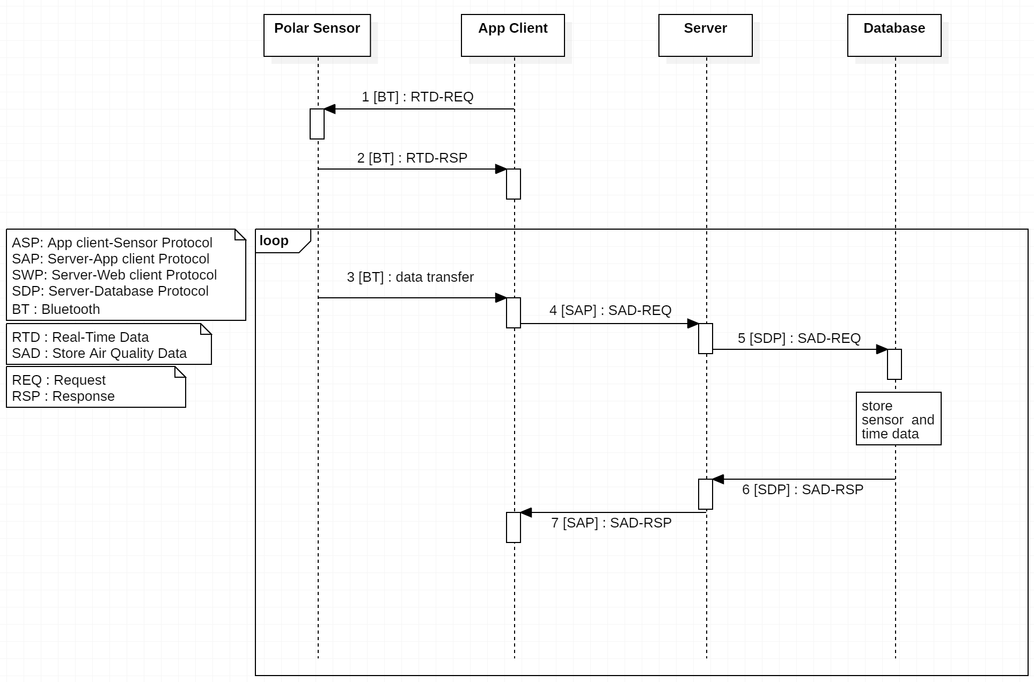

5.4 Data Monitoring

1) Real-time air quality and heart-related data view

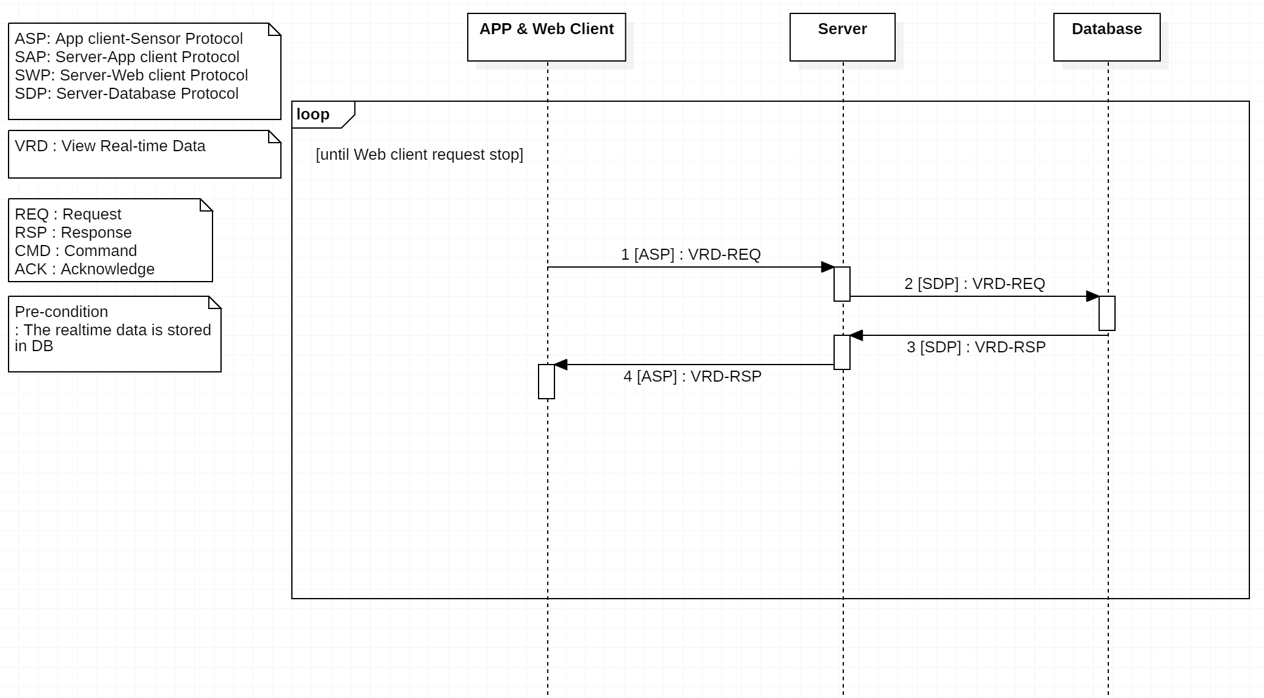

2) Historical air quality data view

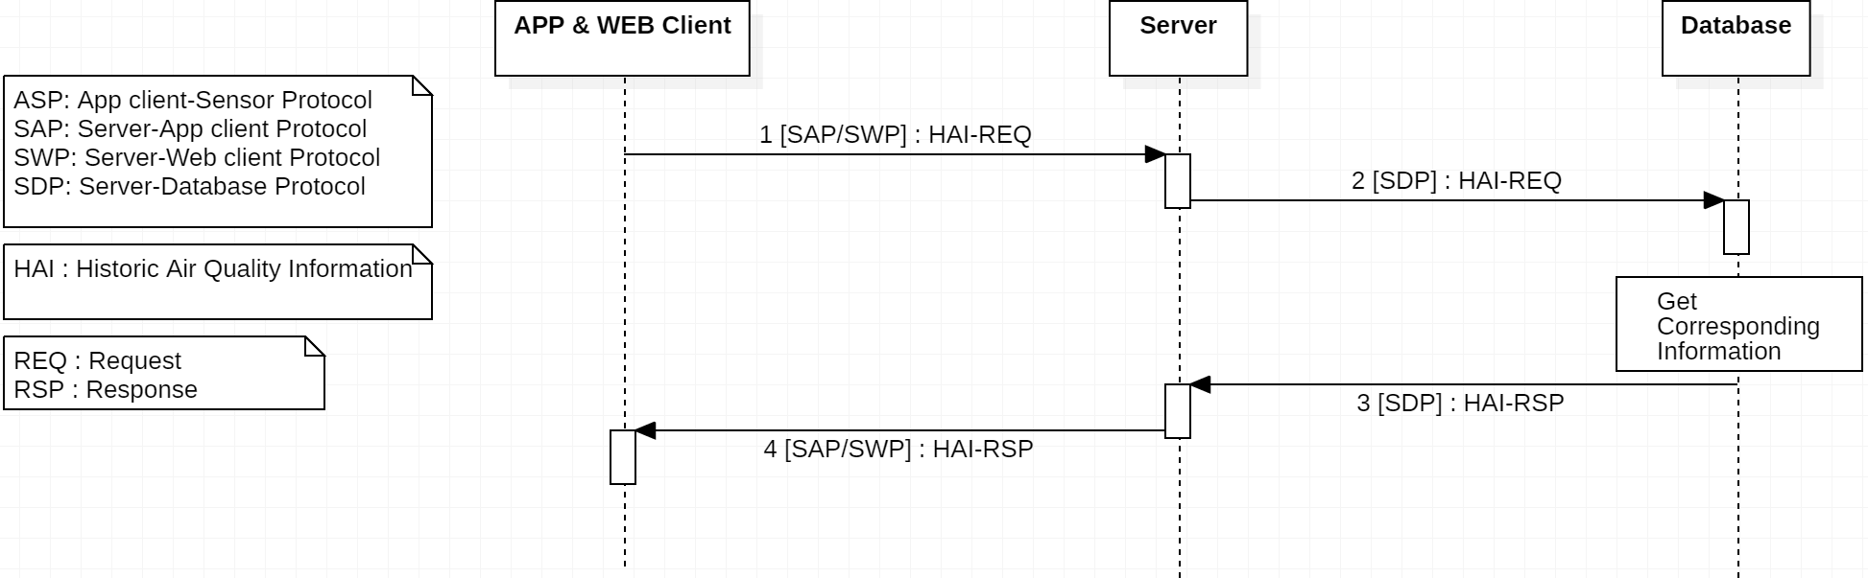

3) Historical heart-related data view

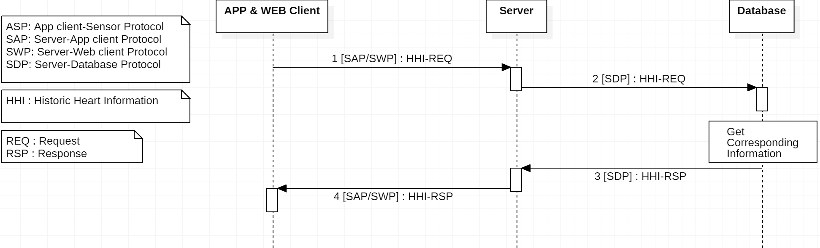

# 

# 6. Flowchart

5.1 User Management

1) Sign-up

-App & Web

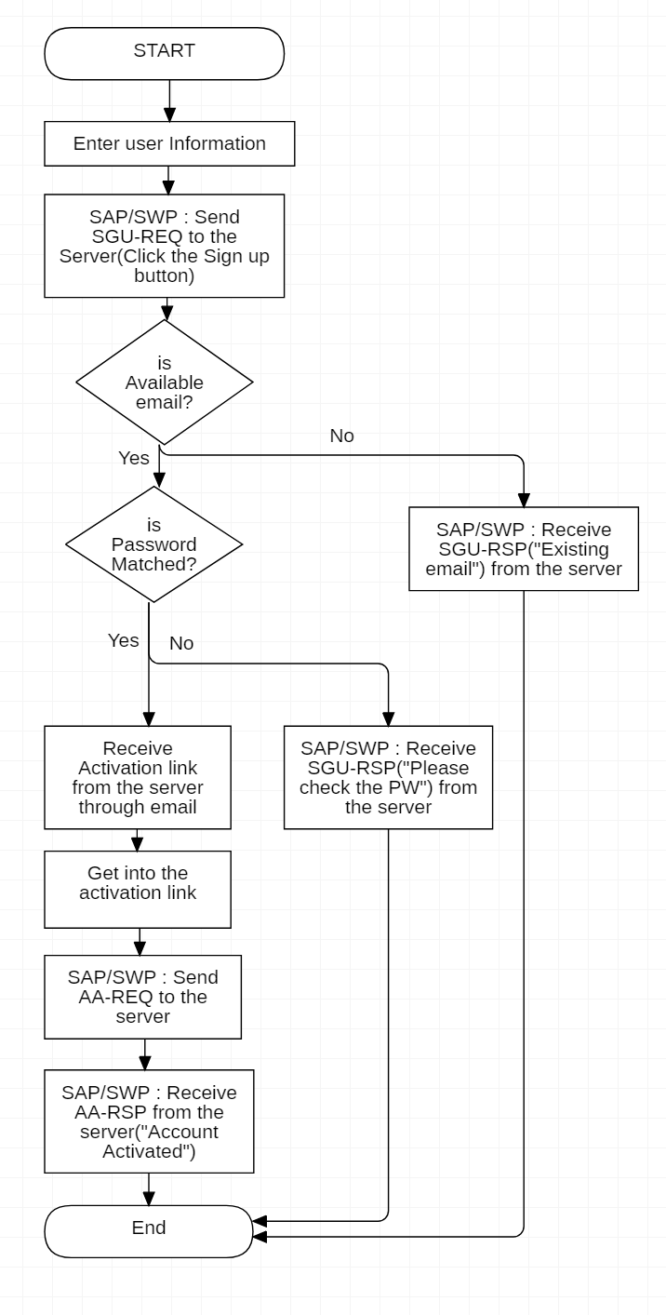

-Server

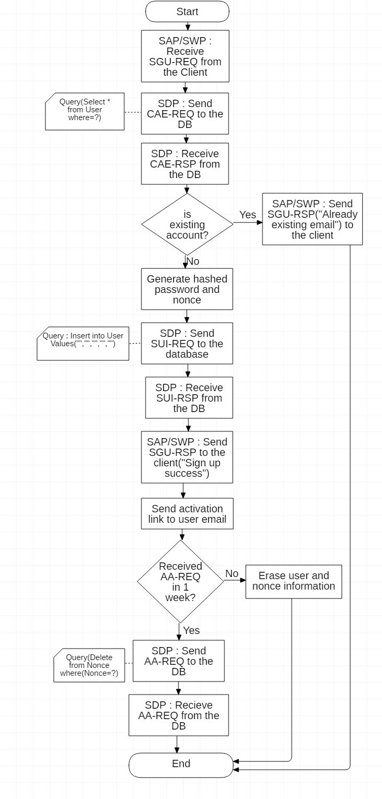

2) Sign-in

-App & Web

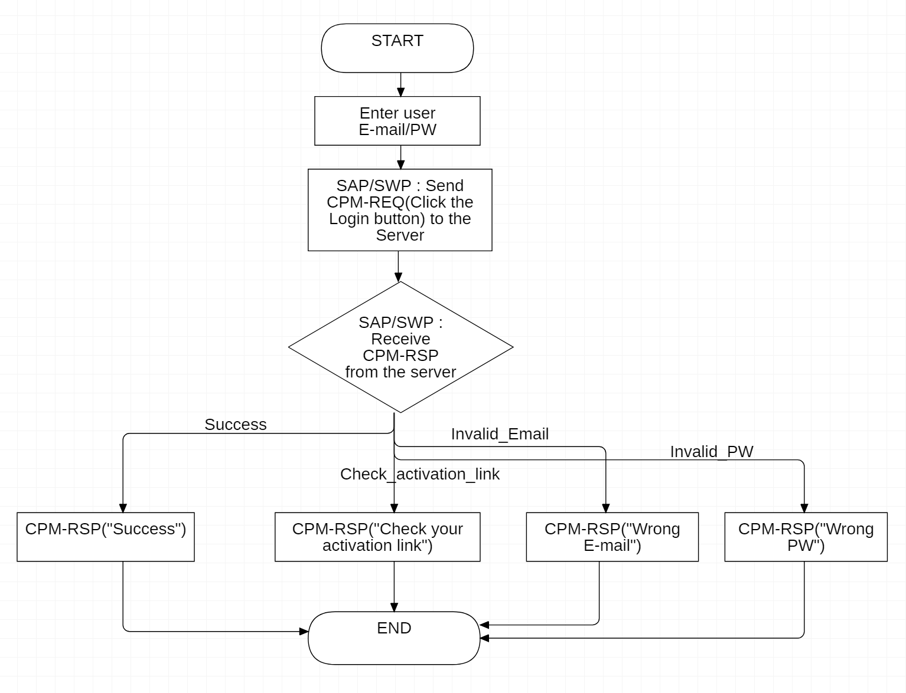

-Server

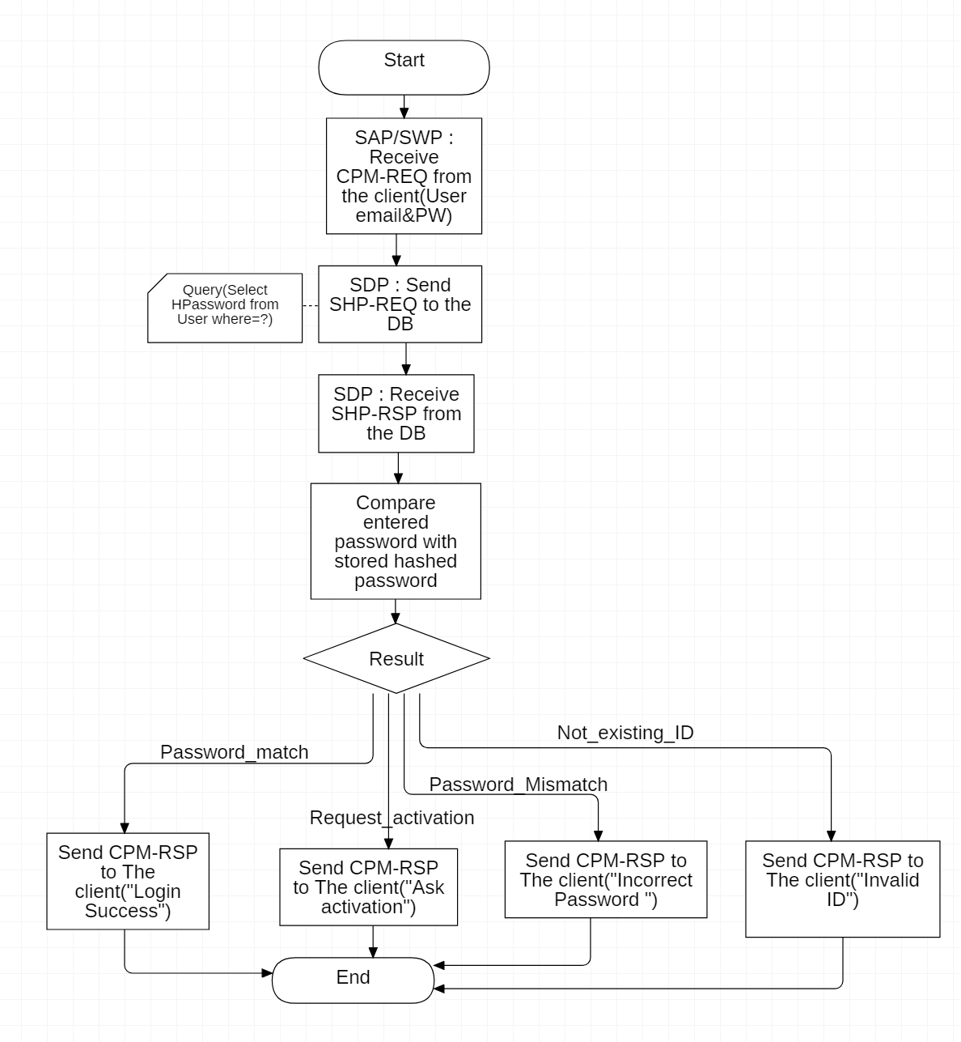

3) Sign-out

-App & Web

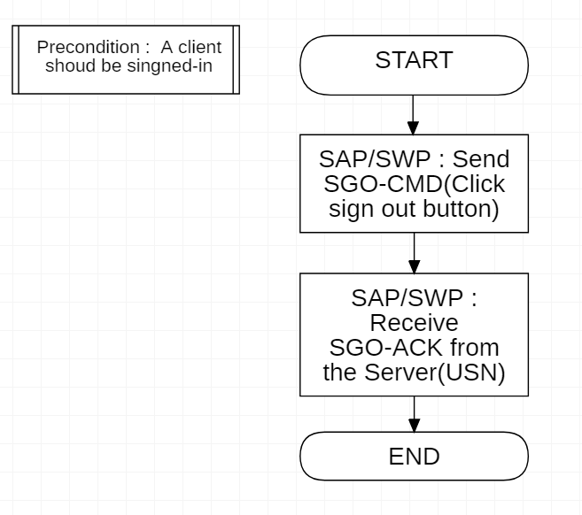

-Server

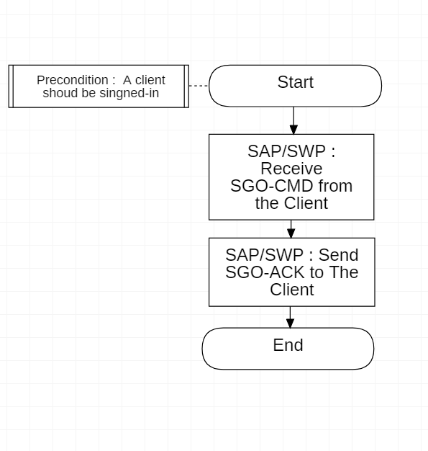

4) User password change

-App & Web

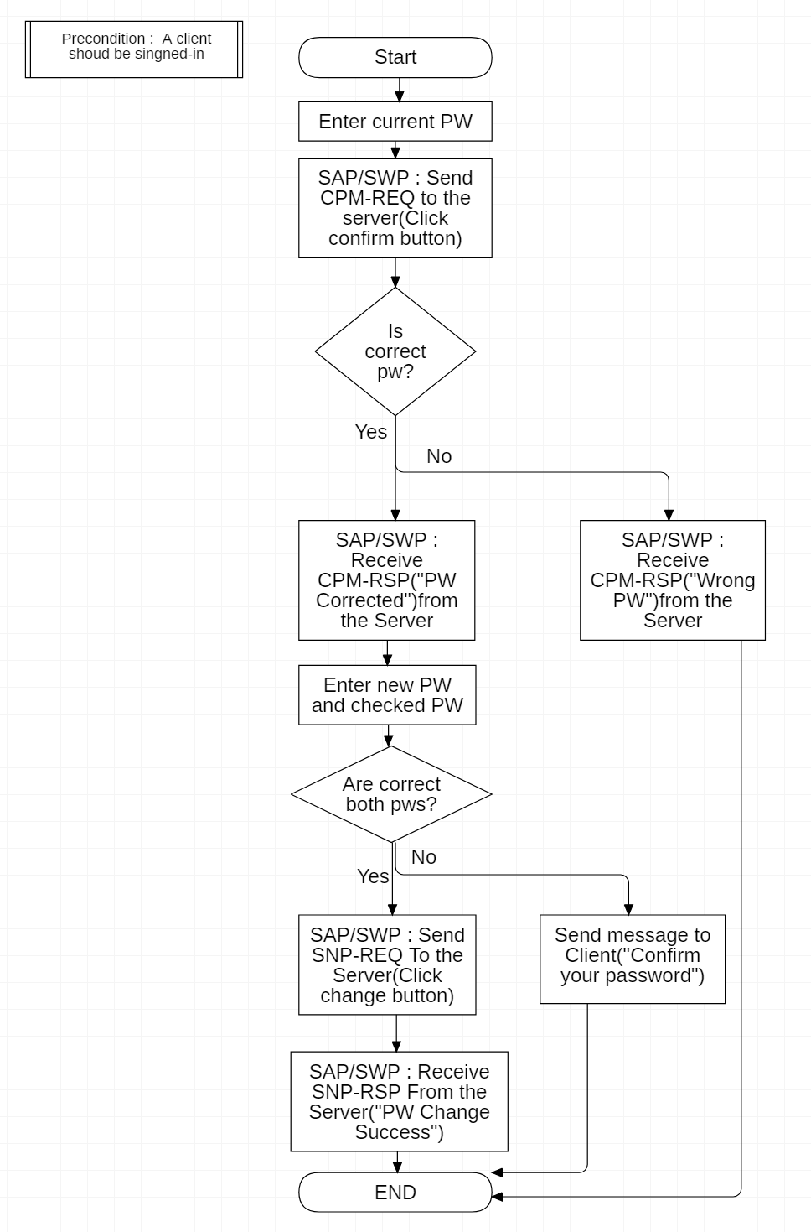

-Server

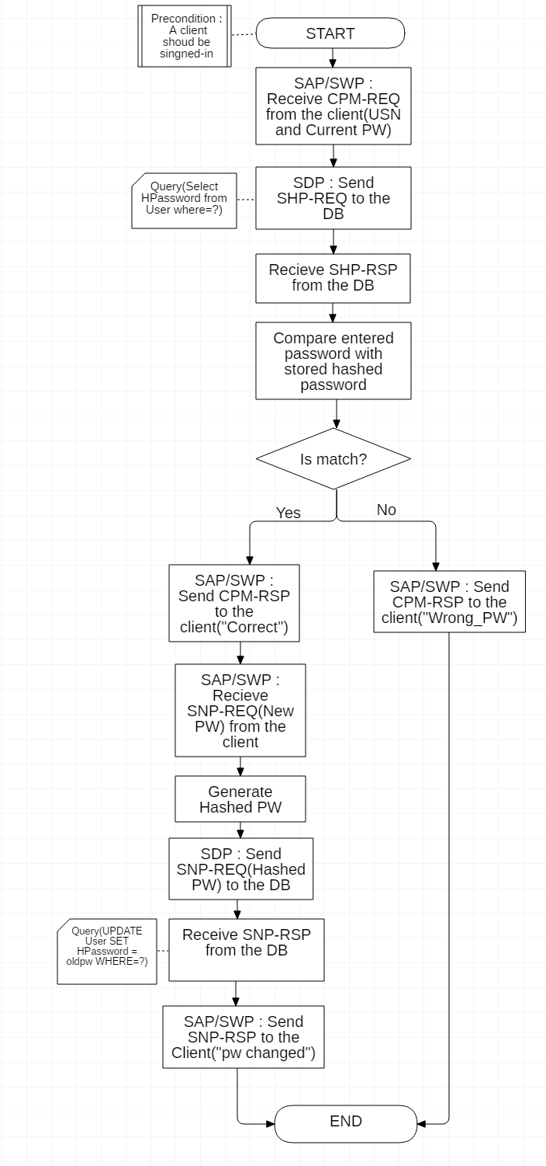

5) Forgotten password update

-App & Web

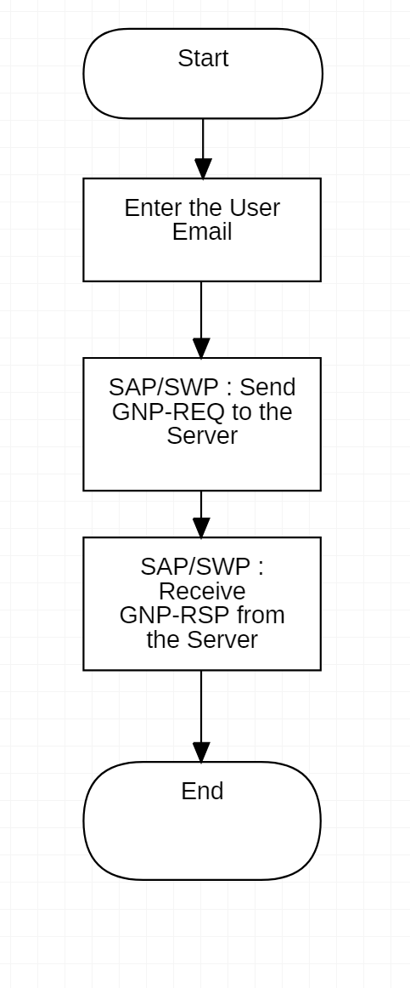

-Server

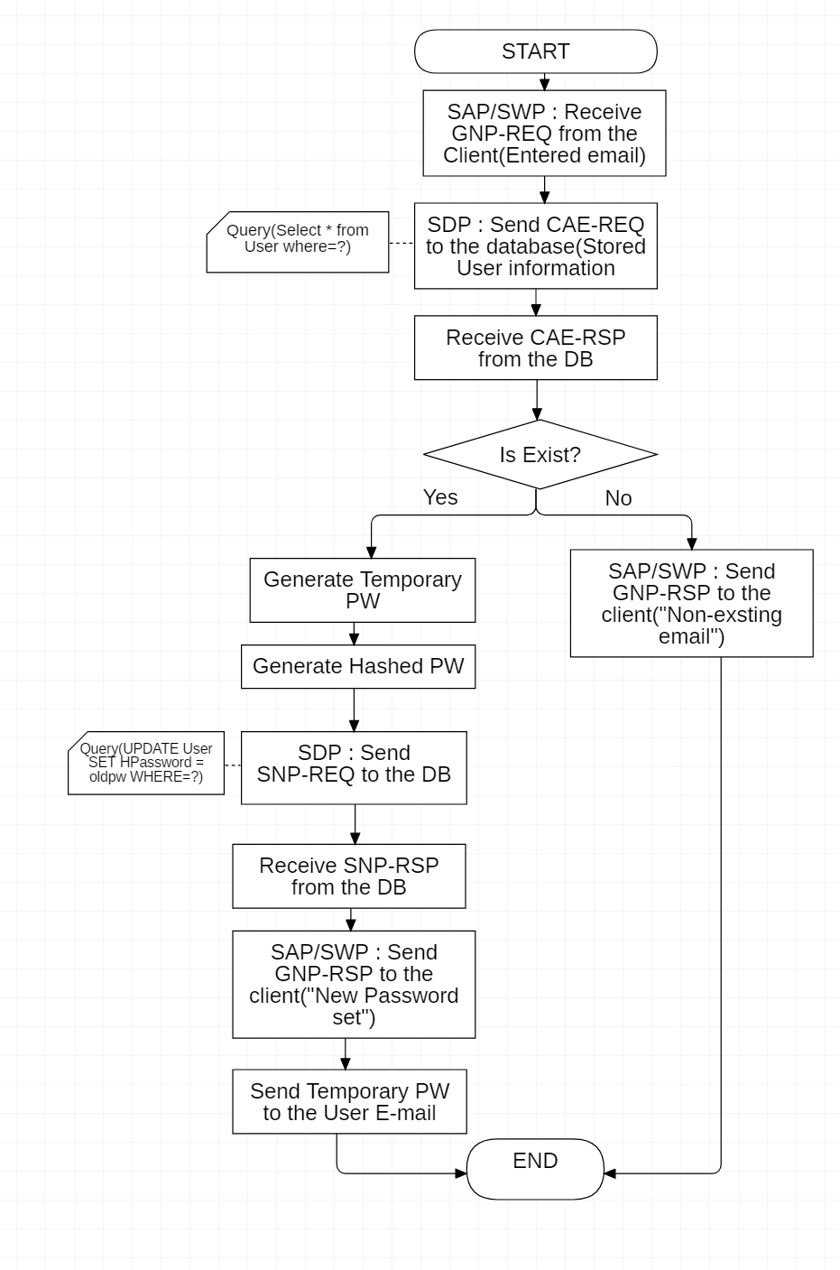

6) ID cancellation

-App & Web

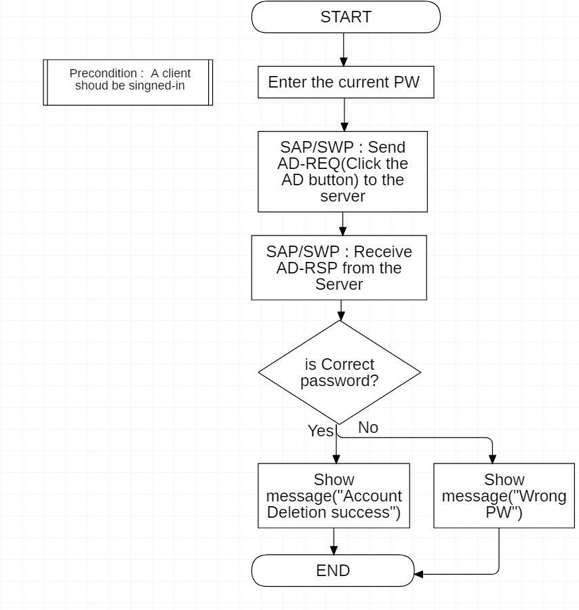

-Server

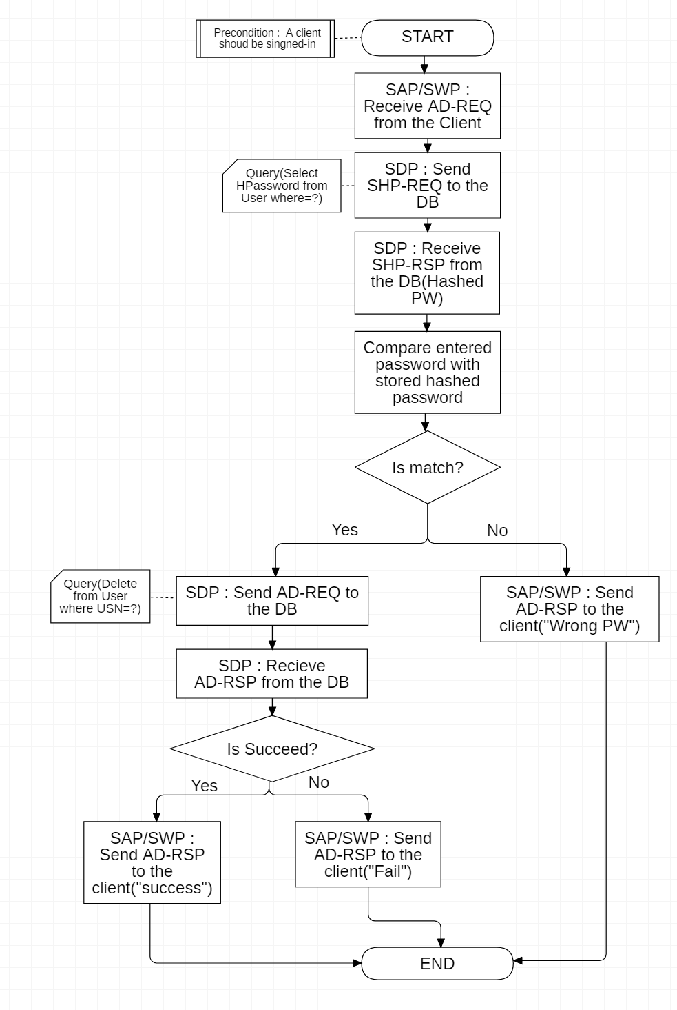

5.2 Sensor Management

1) Sensor registration and association

* Sensor

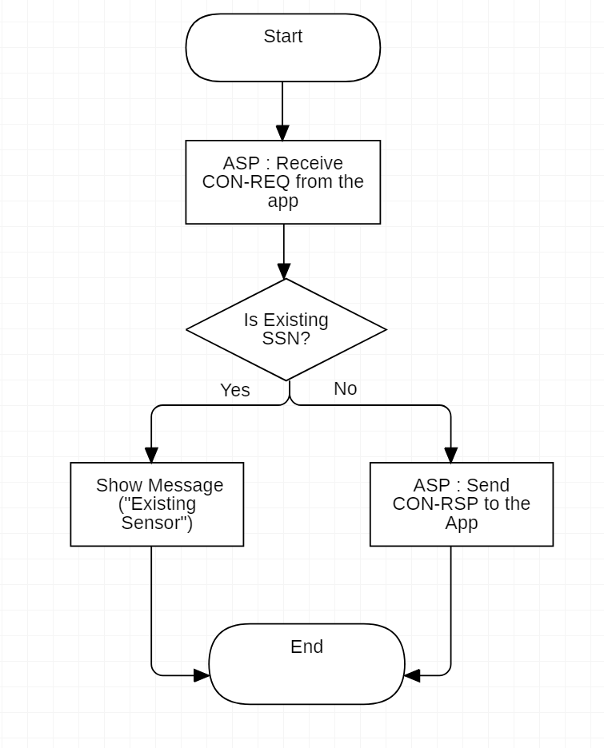

* App

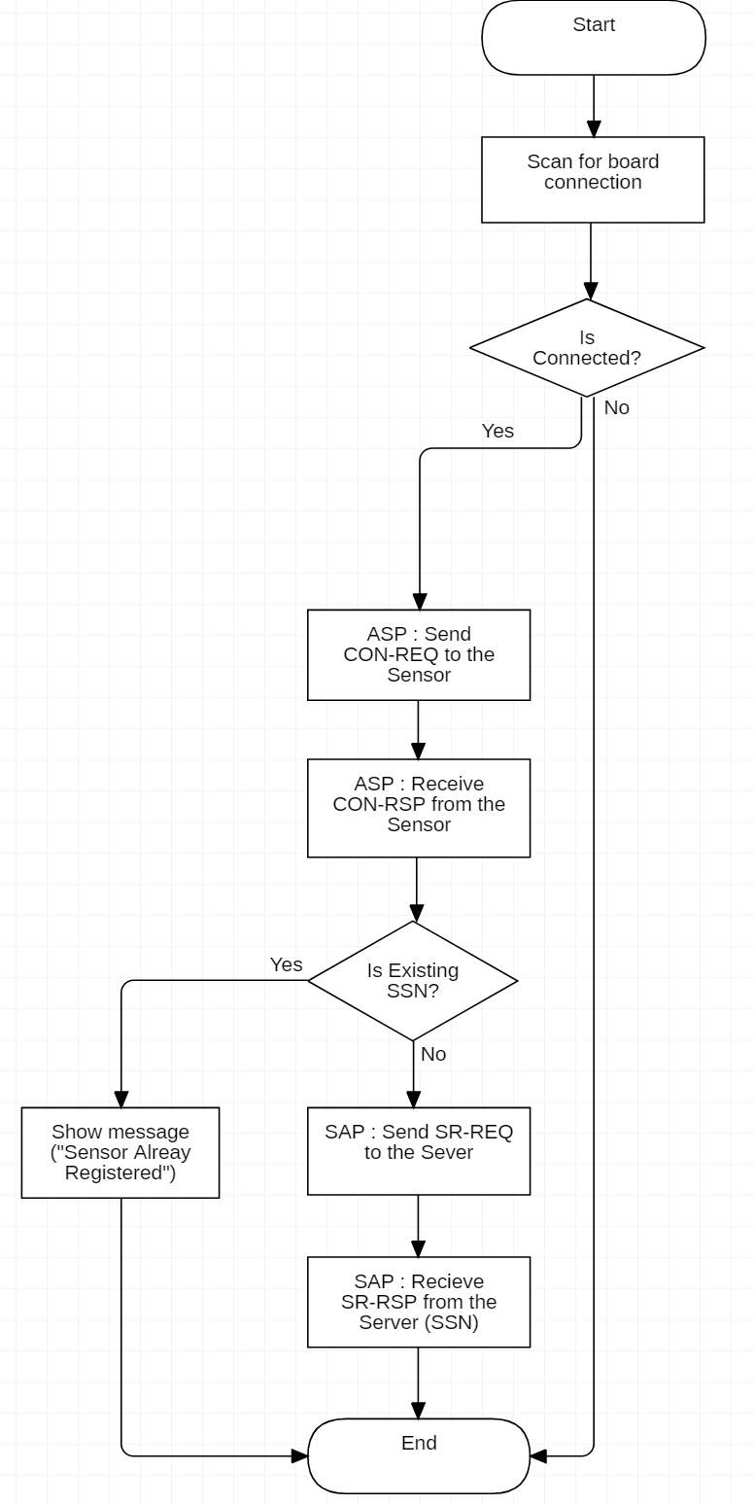

* Server

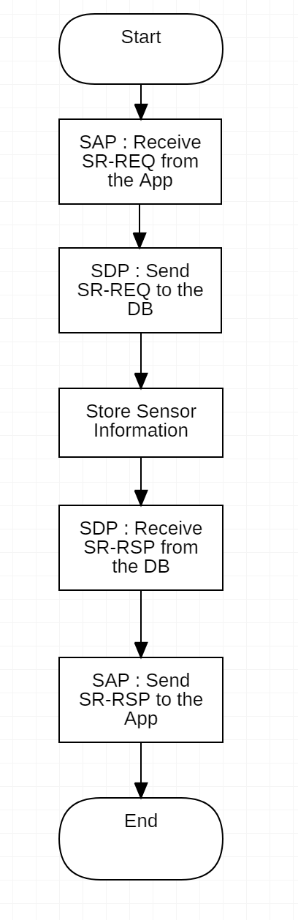

2) Sensor deregistration and disassociation

* App

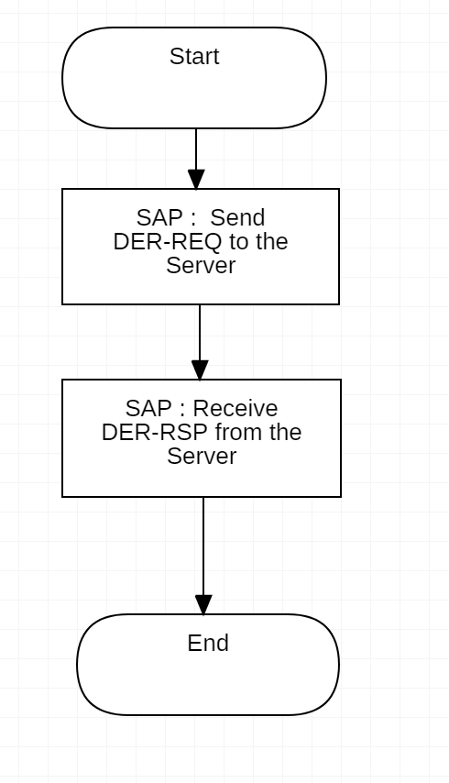

* Server

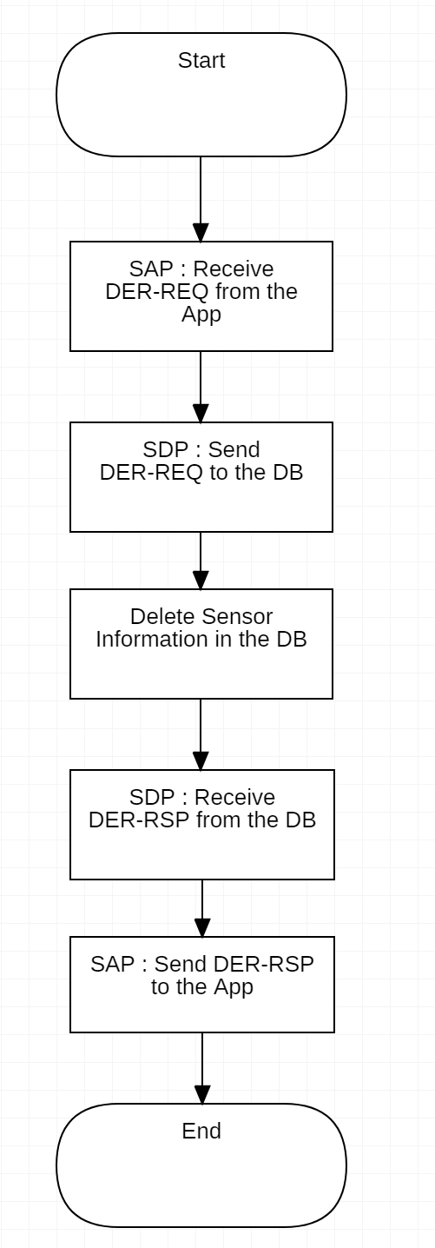

3) Sensor list view

* App & Web

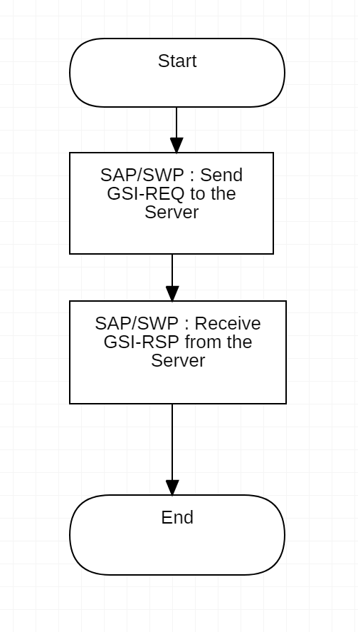

* Server

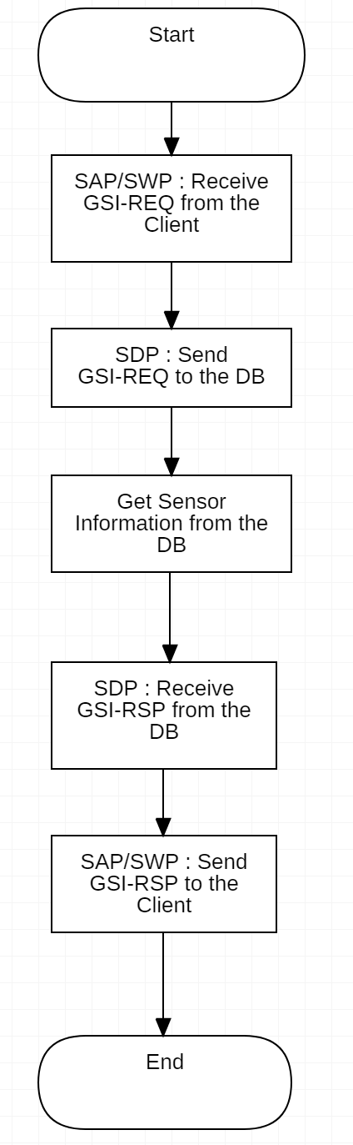

5.3 Data Management

1) Real-time air quality data transfer

-Sensor

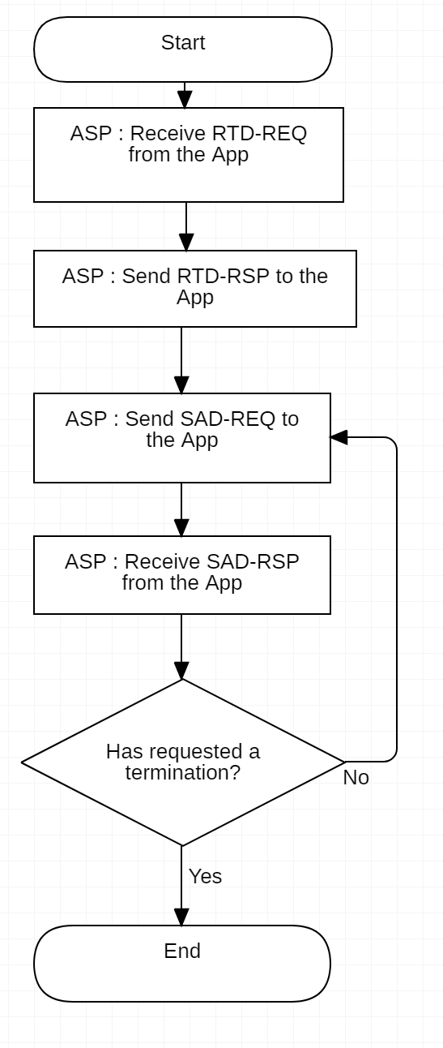

-App

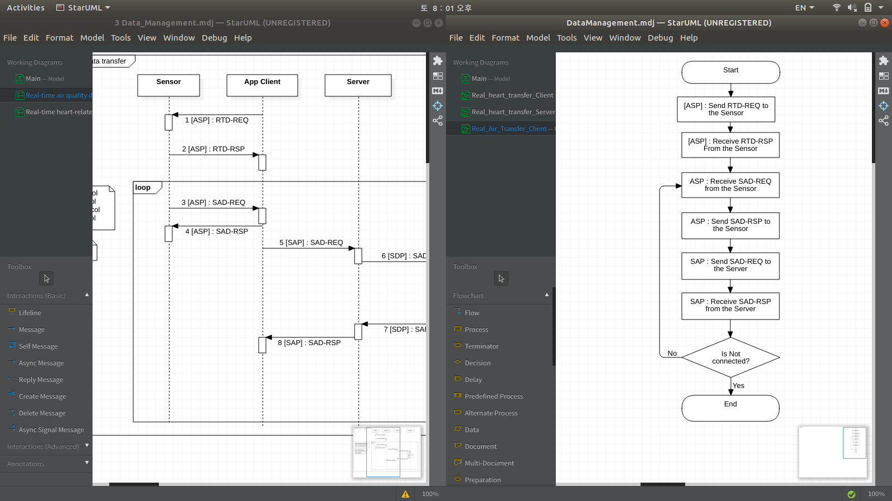

-Server

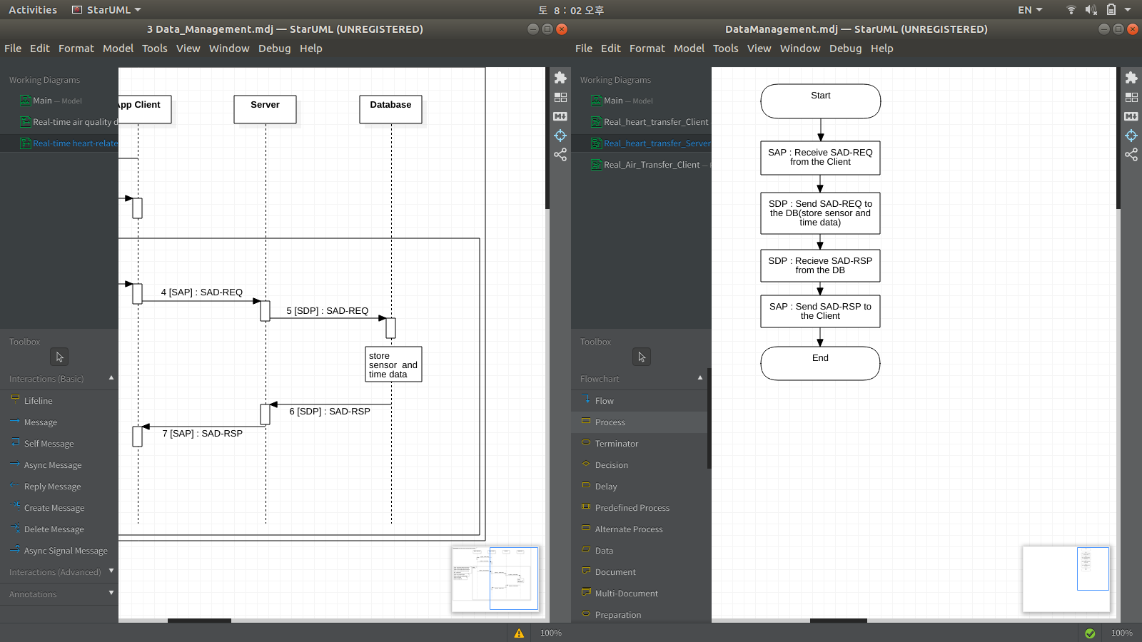

2) Real-time heart-related data transfer

-Sensor

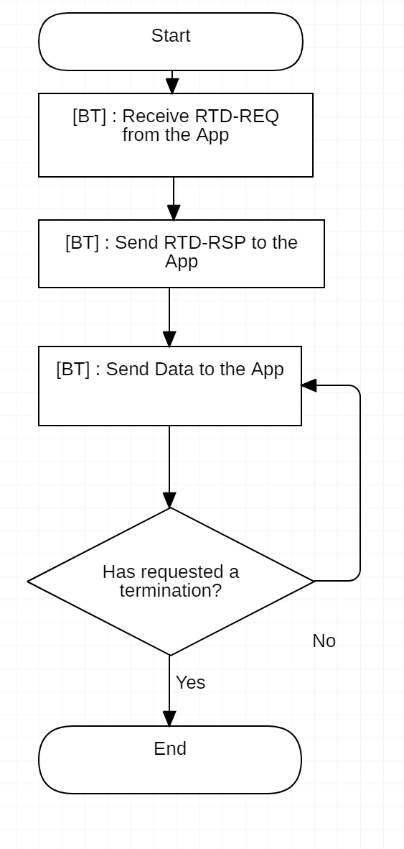

-App

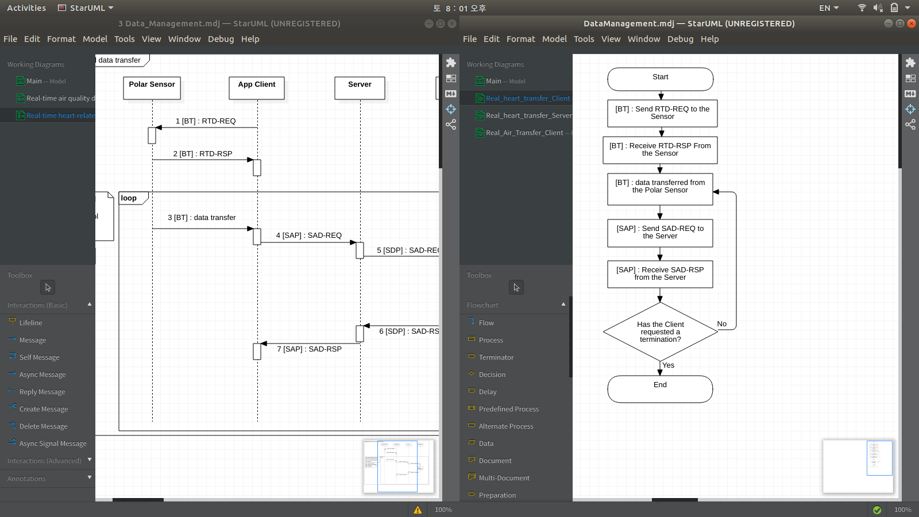

-Server



5.4 Data Monitoring

1) Real-time air quality and heart-related data view

-App & Web

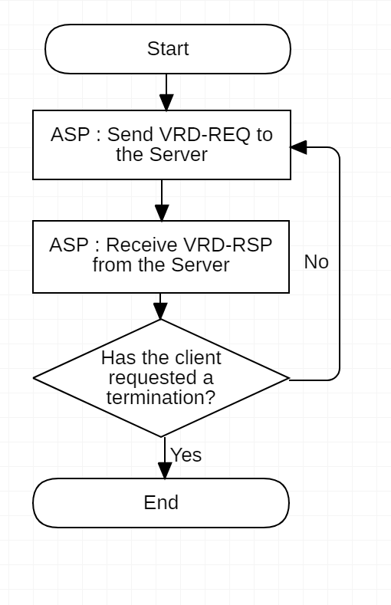

-Server

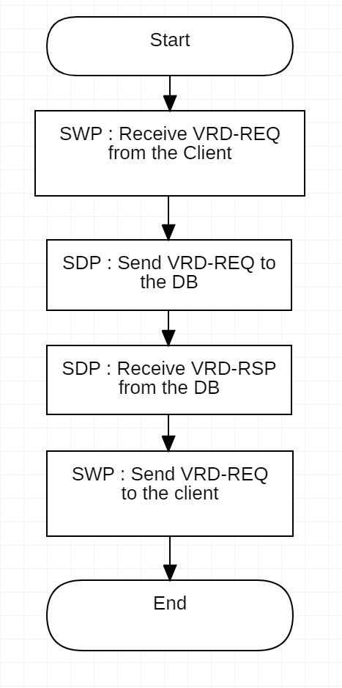

2) Historical air quality data view

-App & Web

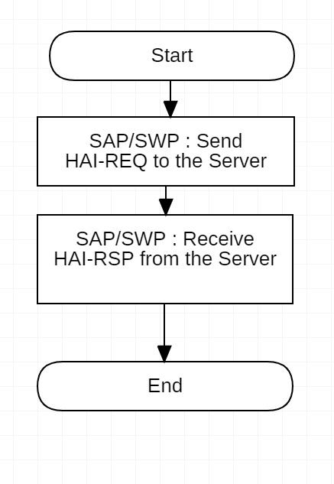

-Server

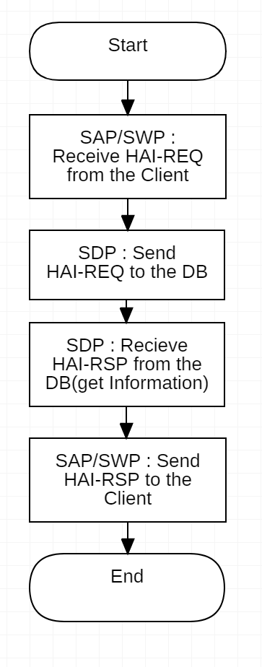

3) Historical heart-related data view

-App & Web

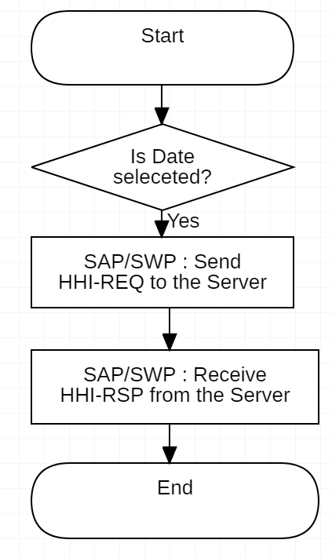

-Server

