# Smart Home Automation System

System Requirements Document

Author: Garrett Kellogg

## Table of Contents

1. Customer Problem Statement and System Requirements

2. Functional Requirement Specification

3. System Sequence Diagram

4. Activity Diagram

5. User Interface Specification

## 1. Customer Problem Statement and System Requirements

### Customer Problem Statement

Modern households often require integrated control over various devices, but managing multiple smart devices independently can become cumbersome. Homeowners want a unified platform to control, schedule, and monitor their devices efficiently. This system is designed to provide a solution that is easy to operate, customizable, and ensures efficient energy usage and security for the household.

### System Requirements

Non-functional Requirements:

• Usability: The system must be intuitive and user-friendly.  
• Performance: The system should operate smoothly with minimal delays.  
• Reliability: Ensure stable operation and accurate status reporting.  
• Security: Access should be controlled based on user roles, with secure data handling.

* Functional Requirements:

• Device Control  
• Role Management  
• Diagnostics  
• Scheduling  
• Notifications and Alerts

## 2. Functional Requirement Specification

### 1. Device Control

Description: Allows users to add, remove, and control devices.  
Actors: Admin, Homeowner.  
Preconditions: User must be logged in with appropriate access.

Flow:

1. 1. User selects a device from the list.  
   2. User can toggle the device on or off.

### 2. Role Management

Description: Admin can assign roles with specific access levels.  
Actors: Admin.  
Preconditions: User must have Admin privileges.

Flow:

1. 1. Admin navigates to user roles.  
   2. Admin selects a user and assigns or modifies the role.

### 3. Scheduling

Description: Users can set device actions to occur at specific times.  
Actors: Homeowner.  
Preconditions: Device must be available and online.

Flow:

1. 1. User selects a device and chooses an action.  
   2. User schedules the action for a specified time.

### 4. Diagnostics

Description: Technicians can run diagnostic tests on devices.  
Actors: Technician.  
Preconditions: Device must be operational.

Flow:

1. 1. Technician selects a device to test.  
   2. System runs diagnostic checks and returns a status report.

### 5. Alerts and Notifications

Description: System sends notifications for device status or scheduled actions.  
Actors: All users.  
Preconditions: Relevant events or schedules are in place.

Flow:

1. 1. User sets notification preferences.  
   2. System sends alerts based on settings.

## 3. System Sequence Diagram

**Sequence Diagram 1**

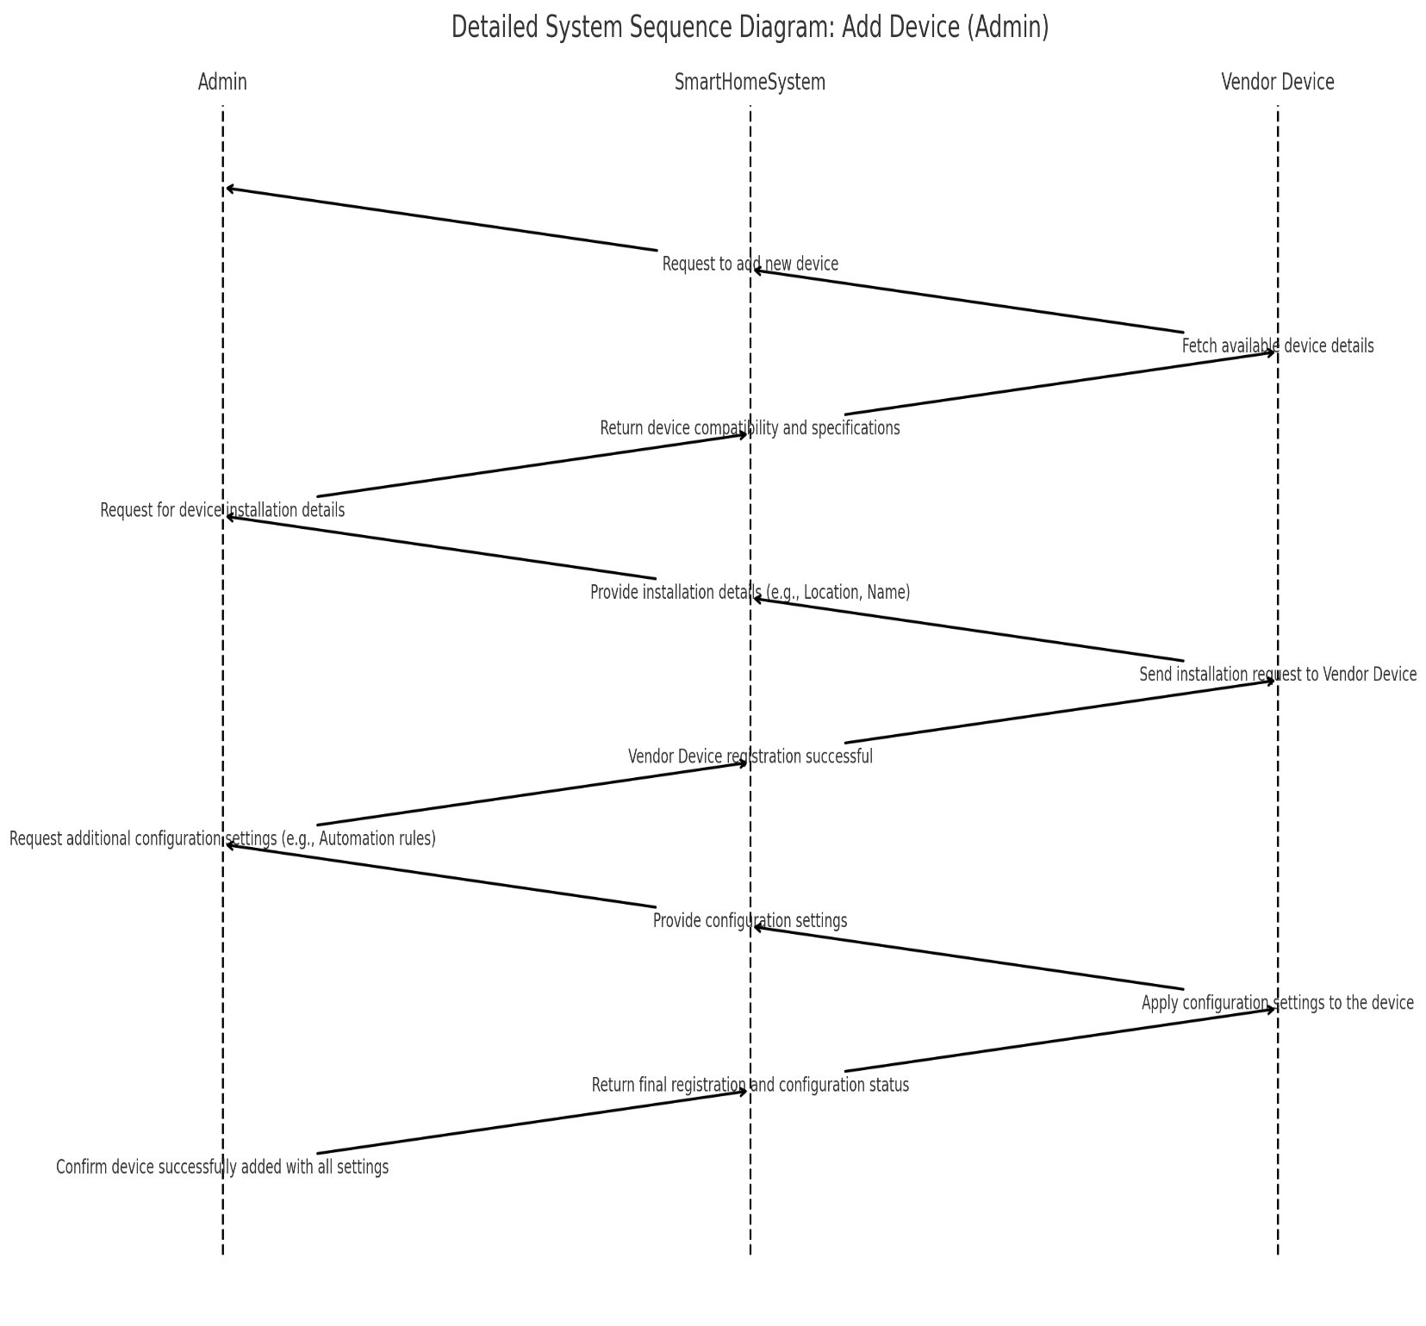

**Sequence Diagram 2**

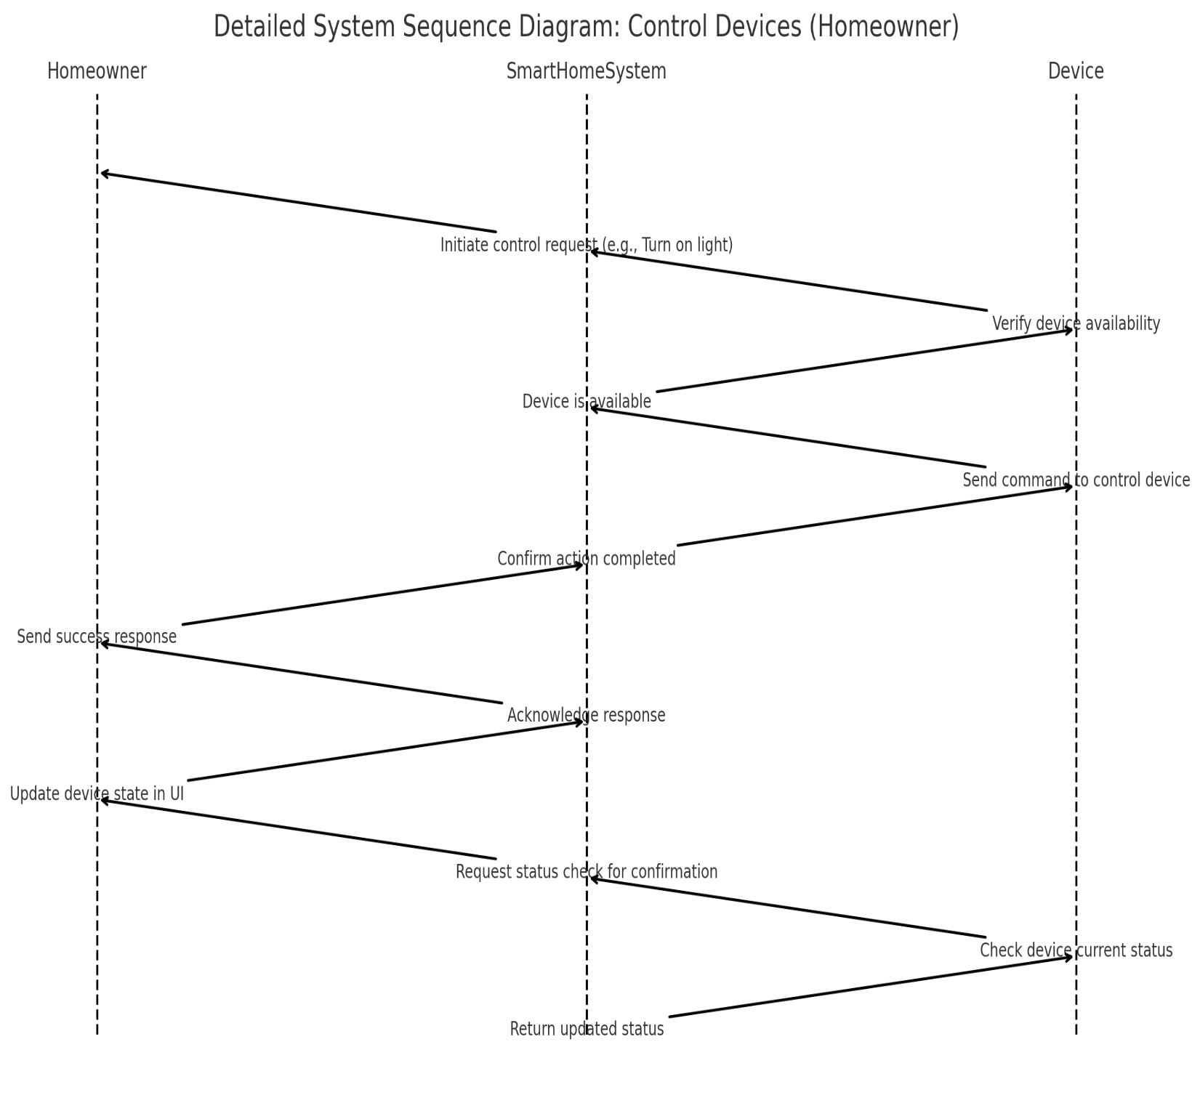

## 4. Activity Diagram

**Activity Diagram 1:**

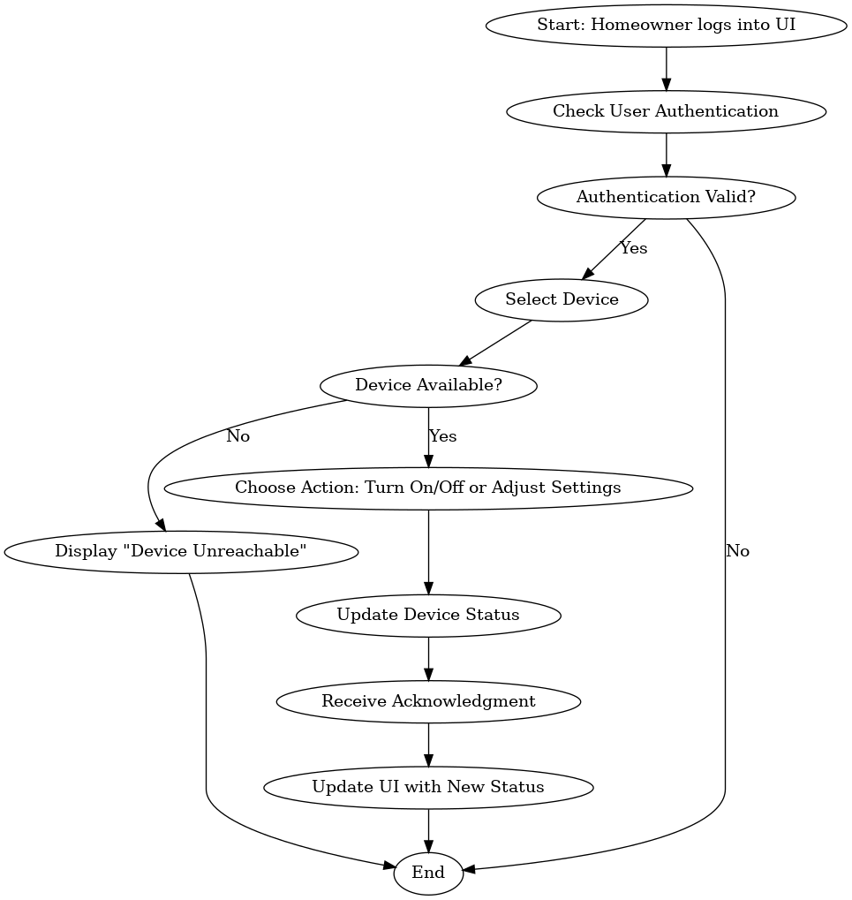

**Activity Diagram 2:**

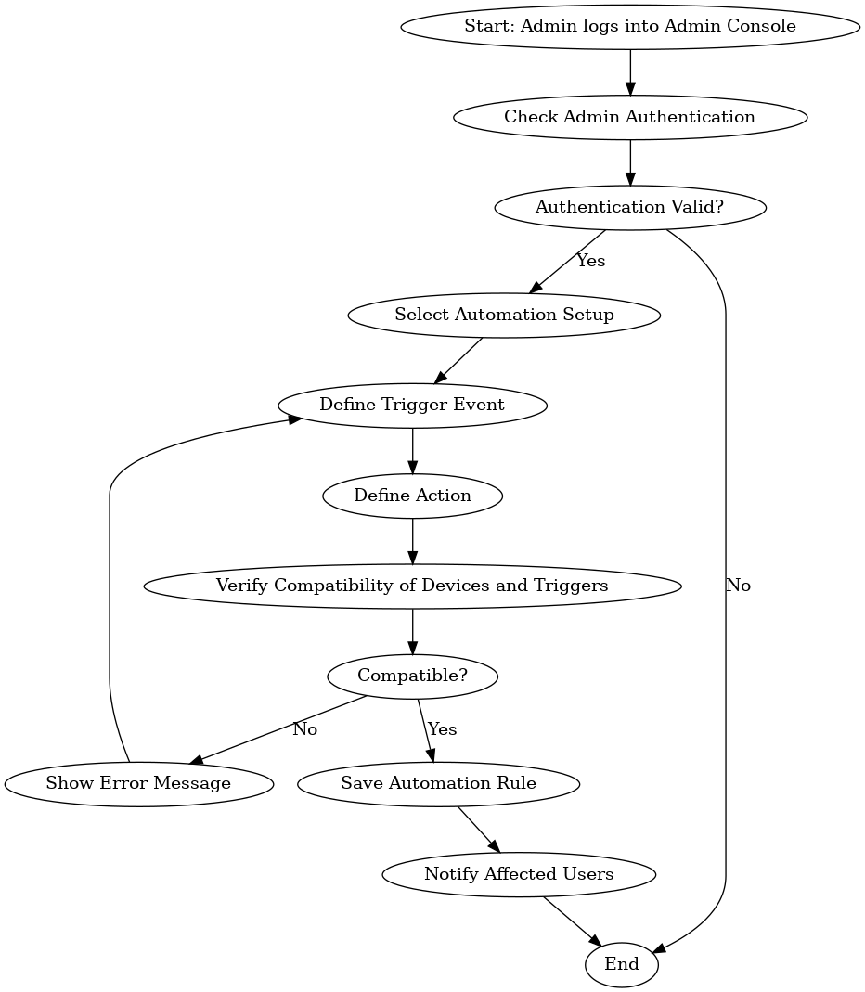

## 5. User Interface Specification

**Main Dashboard**

The central hub for all users, providing quick access to the system's primary functionalities. The dashboard includes a tiled layout where each tile represents a key feature (Manage Devices, User Roles, Scheduling, Diagnostics, Alerts). Users can click on each tile to access specific features. The dashboard is customized based on user roles, displaying relevant features according to the user’s permissions.

**Device Management Screen**

This screen allows users to manage and control connected devices. It displays a list of devices with their names, types, and current statuses. Users with appropriate permissions can add or remove devices from the system, toggle device statuses, and view additional details by selecting a device. Each device in the list includes an on/off toggle switch and a settings option for advanced configurations.

**Role Management Screen**

Designed for Admin users to assign roles and manage user access within the system. The screen displays a list of all registered users along with their assigned roles (Admin, Homeowner, Technician). Admin users can update roles by selecting a user and choosing a new role from a dropdown menu. Changes in role assignments are reflected across the system instantly, impacting the user's access to features.

**Scheduling Screen**

Provides an interface for scheduling actions for specific devices. Users can select a device, choose an action (e.g., Turn On, Turn Off), and set a time or recurrence for the action. The scheduling interface includes an easy-to-use date and time picker, along with options for recurring schedules. Scheduled actions are listed on the screen with details like device name, action, and scheduled time.

**Diagnostics Screen**

The diagnostics screen is accessible to Technicians for troubleshooting and running diagnostic tests on devices. The screen displays a list of devices that can be selected for diagnostics. Users can run tests by selecting a device, which initiates a diagnostic process that checks device connectivity, health, and performance. Test results are displayed on the screen, providing Technicians with data to assess device functionality.

**Alerts and Notifications Screen**

This screen shows all alerts and notifications for the user, including device status changes, scheduled action completions, and system alerts. Each alert displays a brief description, timestamp, and read/unread status. Users can acknowledge alerts by marking them as read, helping them keep track of system activity. Notifications are organized chronologically to ensure that the most recent alerts are easily accessible.o