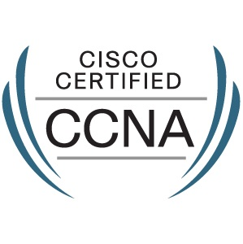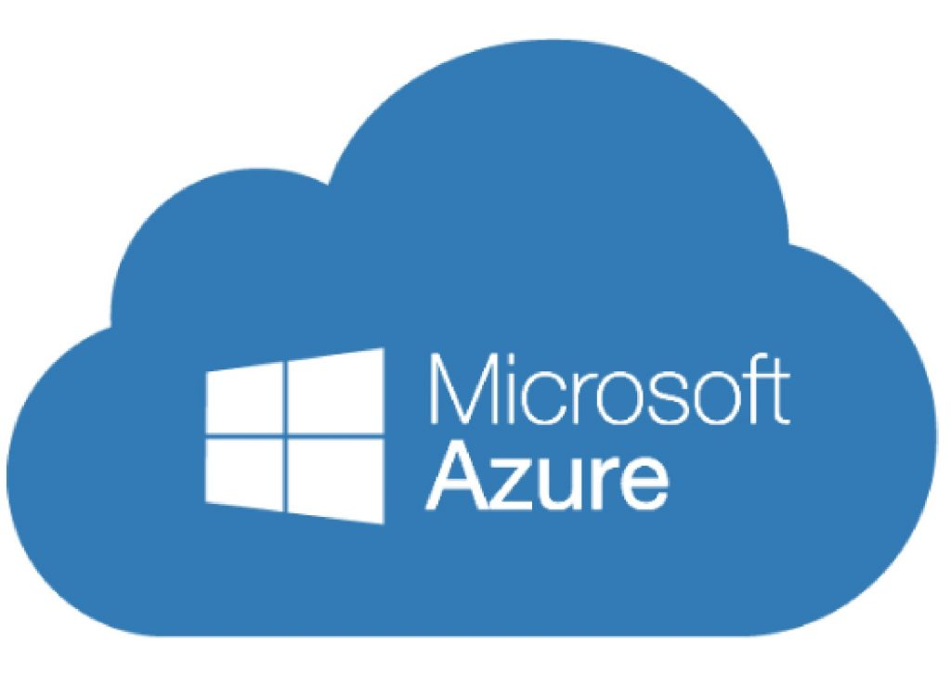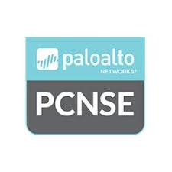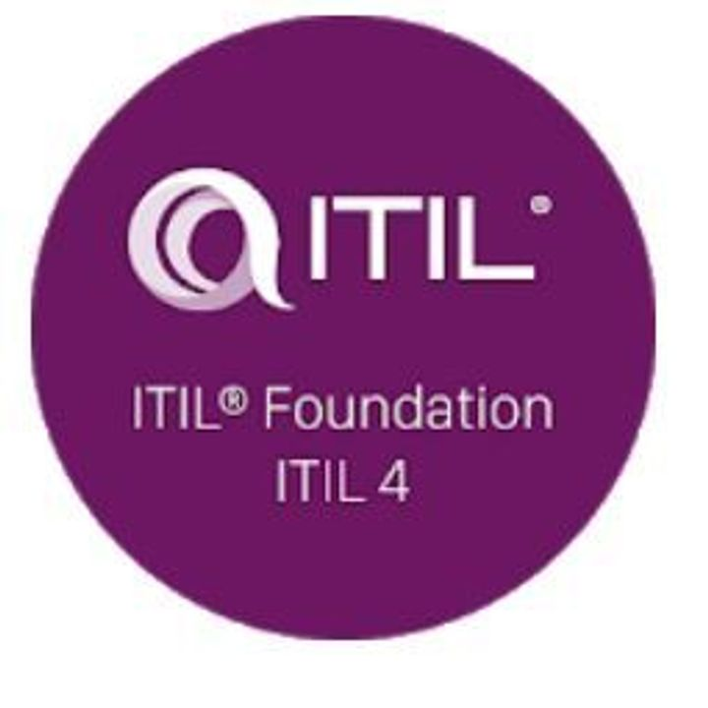Name: Gaurav Khanna
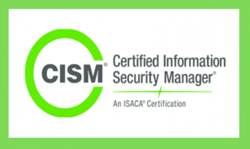
Role: Lead Security Engineer - Network & Cloud Security
Email:grvkhanna06@gmail.com
Location: Greater Toronto Area
Phone: +1-437-421-8560
LinkedIn: www.linkedin.com/in/gaurav-khanna-158093118/
EXPERIENCE SUMMARY
I am a Lead Security Engineer with a total of 13 years of work experience. My main areas of experience have been in IT Service Delivery, Project Management, Datacentre Operations and Network security including Web Application firewalls and cloud Infrastructure.

GENERAL TECHNOLOGICAL EXPERTISE
Below is a list of important hardware, software products, tools, and methods that I have worked with.

Products | Technology | Software Products | Tools
- Palo Alto Firewall  - Panorama  - PRISMA (CASB)  - Starta Cloud Manager  - Cisco Products  - Imperva WAF  - Guardicore  - Netskope  - Load Balancer (F5)  - Sentinel1 & Microsoft defender endpoint | - Network  - Azure/AWS Cloud  - QOS  - VMware  - URL Filtering  - VPN  - Switching Protocols  - Routing Protocols (OSPF, EIGRP, Basic BGP) | - MS-Excel  - MS-Word  - MS-Power point  - MS-Project | - Salesforce  - Meta Solv  - Service Now  - Splunk  - SolarWinds  - Wireshark  - Tufin  - Jira & BMC  - Comptel  - Pants  - Remedy force
ACADEMIC QUALIFICATIONS
Verified By WES (World Education Services) – Ref No: 4259704
Degree and Date | University Name | Major and Specialization
Bachelor of Engineering and Technology 2011 | Lovely Institutes of Technology (PTU), Phagwara | Information Technology

TRAINING / CONTINUING EDUCATION SUMMARY / CERTIFICATIONS

Program or course | Coverage | Dates
CISM | Certified Information Security Manager | 2024
ITIL V4 | Service Management | 2021
Azure (AZ-900) | Azure Fundamentals | 2021
Azure (AZ-104) | Azure Administrator | 2021
Azure (AZ-500) | Cloud Security | 2021
PCNSE | Network Firewall | 2019
CEH | Ethical Hacking | 2019
CCNA | Network | 2013

PROFFESIONAL EXPERIENCE

Maple Leaf Foods Sep 2023 - Present
Lead Security Engineer - Network & Cloud Security

- Acting as a Security Lead responsible for enterprise network, cloud, identity, and security architecture, while managing global network operations to ensure secure, highly available, and high-performance services through cross-regional collaboration
- Develop secure network architectures for hybrid and cloud environments using Palo Alto firewalls, Prisma Access, and Prisma CASB, ensuring all configurations align with industry best practices and organizational standards.
- Standardize security policies, access controls, and configurations to create a unified and robust security posture across multiple environments.
- Create and maintain detailed network documentation, policies, and guidelines, promoting consistent network and security practices across all environments.
- Responsible to Lead the deployment and maintenance of Palo Alto firewall security devices, configuring policies for high availability, decryption, routing, Site-to-Site VPNs, and NAT rules.
- Implement advanced security measures, including Threat Prevention, URL Filtering, Wildfire, and Microsoft defender to protect against malware, data leaks, and other cyber threats.
- Manage a 5,000-user base on Prisma Access, ensuring secure, scalable connectivity and optimizing the user experience through strategic planning and configuration.
- Administer Prisma CASB to provide secure access to cloud and on-premises applications, enforcing data protection policies and preventing unauthorized data access.
- Design network access controls using Azure AD, Prisma Cloud Identity, and Palo Alto NGFW features, implementing zero-trust principles across environments.
- Managing and deploying Policies on Guardicore and Netskope.
- Design and manage Azure networking components, including Vnets, VPN Gateway, ExpressRoute, NSG and UDR enabling secure and seamless connectivity for cloud resources
- Configure and maintain Azure VM firewalls, creating network security policies, managing azure load balancers, and establishing Public IP (PIP) assignments to optimize network security and performance.
- Handle F5-related tickets for VIP configurations, deploy new VIPs, troubleshoot connectivity, and manage SSL certificate issuance and renewal.
- Provide training and support to new security analysts on various technologies, fostering a skilled and self-sufficient team.

Dream May 2023 – Sep 2023
Infrastructure Engineer - Network & Cloud Security

- Provided comprehensive support for all corporate and base building network (BBN) infrastructure across Canada, the US, and Europe, ensuring seamless operations and connectivity.
- Managed and operated Dream’s data centre, encompassing network, server, storage, virtualization, and backup infrastructure to maintain high availability and performance.
- Implemented and maintained BBN to support IoT systems, enhancing connectivity and functionality for smart devices across the organization.
- Collaborated with third-party consultants in the implementation and support of Dream’s network, ensuring best practices and optimized performance.
- Managed and configured Panorama, Palo Alto firewalls and Cisco 9000 series switches, enhancing security and performance for network traffic.
- Responded to technical support incidents via the Remedy force support portal while maintaining service level agreements (SLAs) to ensure timely resolutions.
- Oversaw the operation of server environments, both physical and virtual, to ensure reliability and availability.
- Established standards, policies, procedures, and checklists to ensure network consistency and a high standard of customer experience.
- Ensured all systems were effectively monitored, implementing proactive measures for issue resolution.
- Monitored and administered the backup solution to ensure that all systems were properly backed up for disaster recovery.
- Configured Palo Alto firewall policies, including high availability, application overrides, decryption policies, user-ID, routing, URL filtering, site-to-site VPNs, and NAT rules, to secure network operations.

PricewaterhouseCoopers (PwC) DEC 2018 – May 2023
Senior Network & Cloud Security Engineer (Consultant)

- Led end‑to‑end Global Network Infrastructure Security (NIS) services, advising stakeholders on secure operations, risk mitigation, & service continuity across enterprise environments.
- Acted as a Senior L3 Security Consultant, managing complex escalations, performing root‑cause analysis, and delivering remediation & long‑term security improvements.
- Designed, deployed, and validated secure network and security solutions within data centres, aligned with security best practices & compliance requirements
- Provided strategic governance & oversight of security devices within the Global NIS ecosystem, ensuring consistent security posture & operational resilience.
- Served as a Palo Alto & Prisma subject‑matter expert, implementing security policies, high availability, decryption, User‑ID, routing, URL filtering, and NAT configurations.
- Led change, incident, and problem management activities, assessing risk impact and coordinating timely responses to security alerts to minimize business disruption.
- Performed deep‑dive network traffic analysis using Wireshark & recommended firewall upgrades and performance optimisations.
- Consulted on Azure network and infrastructure security, designing secure VM firewalls, NSGs, UDRs, load balancers, public IPs, and virtual network architectures.
- Designed & implemented secure connectivity solutions, including Site‑to‑Site and remote access VPNs for distributed users.
- Delivered Web Application Firewall (WAF) consulting using Imperva, onboarding applications & configuring security policies, HTTPS redirections, and SSL certificates.
- Acted as the primary Technical Security Point of Contact (POC), owning complex engagements & coordinating cross‑functional delivery.
- Developed security policies, procedures, technical standards, and architecture guidelines to support consistent deployment and long‑term maintainability.
- Mentored security analysts, sharing knowledge across security platforms, tools, & operational best practices.

CSS Corp PVT. LTD. JAN 2017 – NOV 2018
Client: Palo Alto TAC
Sr. Network Security Engineer

- Provided expert assistance to users in the deployment, configuration, and maintenance of Panorama, Prisma and Palo Alto Next-Generation Firewalls, ensuring secure network environments.
- Delivered direct support for VPN services, including IPsec and Global Protect, enabling secure and seamless remote access for users.
- Conducted in-depth packet capture analysis using Wireshark to diagnose and resolve complex network issues, including switching and routing challenges.
- Assisted users with troubleshooting Palo Alto firewall connectivity issues, helping to maintain network stability and security.
- Guided users through the deployment of Panorama as a centralized management solution, enabling efficient configuration and management of multiple Palo Alto firewalls across various locations.
- Configured Panorama logging services, troubleshooting issues between Panorama, firewall log collectors, and Syslog servers for seamless data collection and monitoring.
- Assisted users in configuring firewalls to act as SSL forward proxies for decrypting HTTPS traffic, enhancing visibility and security.
- Guided Users to Set up firewalls to act as SSL forward proxies for HTTPS traffic decryption, providing users with enhanced visibility into network traffic while maintaining security compliance.
- Assisted users in configuring and troubleshooting Global Protect to ensure secure and reliable access for remote users.
- Assisted users with the setup and troubleshooting of Global Protect, Palo Alto’s secure VPN service, ensuring smooth and secure connectivity for remote access users.
- Conducted RCAs for incidents involving Palo Alto devices, providing comprehensive reports and solutions to prevent future occurrences.

Tata Consultancy Services (TCS) July 2016 – Jan2017
Client: National Broadband Network
Senior Associate

- Engaged in network designing and planning using tools such as PNI and PNI Dashboard to create efficient and scalable network architectures.
- Developed comprehensive network designs tailored for the National Broadband Network (NBN) in Australia, ensuring alignment with organizational goals and customer needs.
- Diagnosed and resolved network faults promptly, utilizing analytical skills to ensure minimal downtime and optimal network performance.
- Conducted copper activation processes to establish connectivity and ensure the functionality of the network infrastructure.
- Delivered ISP services to NBN customers, managing service activation and supporting customer inquiries to enhance user satisfaction and experience.

XecuteHR Solutions Pvt ltd Oct 2015 - June 2016
Client: Bharti Airtel
IP Engineer

- Diagnosed and resolved network faults to ensure minimal downtime and optimal performance.
- Provisioned ISP and ILP customer links using Meta Solv (M6) on Provider Edge (PE) routers, ensuring accurate and timely setups.
- Provisioned and configured Layer 2 and Layer 3 devices, including Cisco and Juniper routers, as well as Cisco switches, tailored for ISP and ILP customers.
- Implemented Layer 3 links over the ISP backbone, facilitating efficient data transmission and network connectivity.
- Managed the configuration of Customer Edge (CE) routers for dedicated customers, ensuring adherence to client specifications and performance requirements.
- Developed and configured network solutions to meet diverse business requirements, optimizing network architecture for efficiency and reliability.
- Analysed fault logs to determine root causes of network failures, conducting thorough problem analysis to inform preventive measures and solutions

Creatick Solutions Jan 2013 - July 2015
Network Associate

- Installed, configured, and upgraded hardware and software on Cisco routers and switches while troubleshooting network outages to ensure continuous operations.
- Provided Level 1 network monitoring and support for all network security and server infrastructure, maintaining optimal performance and uptime.
- Built and maintained comprehensive Cisco network documentation for clients, ensuring clear records of network configurations and procedures.
- Conducted Level 1 troubleshooting for DHCP and DNS-related issues, swiftly resolving problems to minimize service disruptions.

