# Electromechanical Energy Conversion

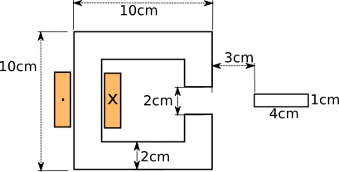

To have 0.5 T in the air gap, let’s assume infinitely permeable core and depth is 1 m.

$$R_{gap}=\frac{g}{µ_{0}*A}=0.8*{10}^{6} \frac{A}{Wb}$$

$$Ø*R_{gap}=N*i$$

$$B*A*R_{gap}=N*i=8000 A$$

Let’s chose

$$N=80$$

$$i=100 A$$

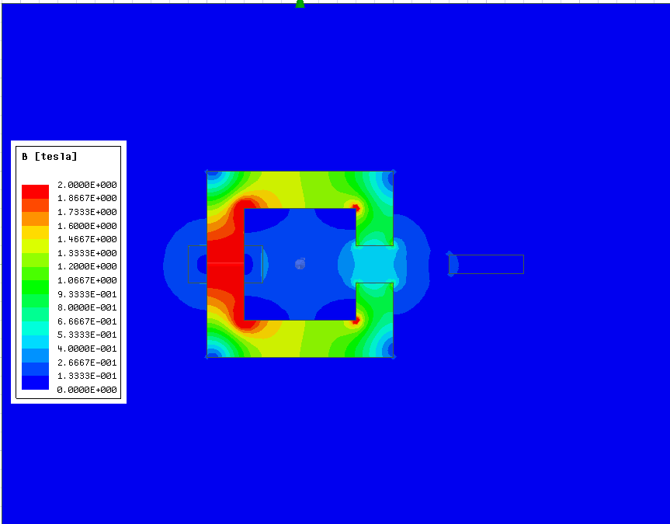

Here, our result is verified. We have 0.5 T at the air gap.

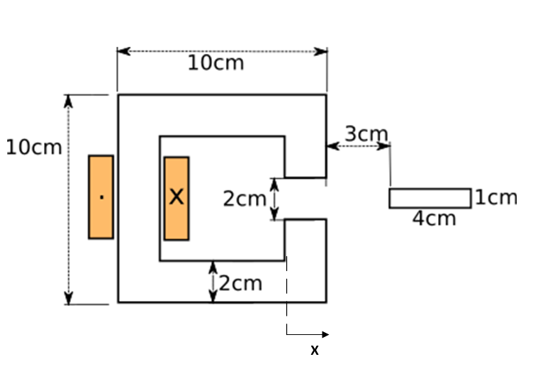

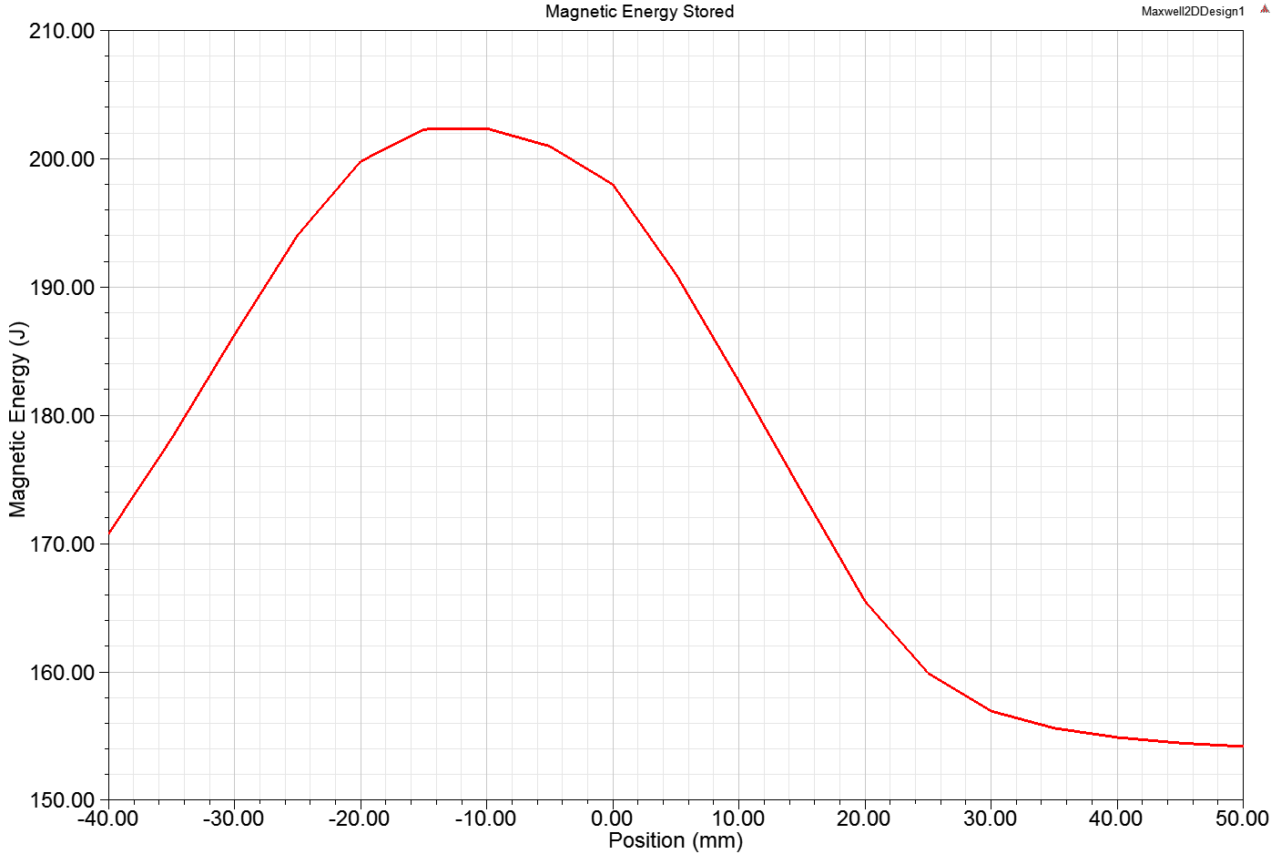

Here, we see total magnetic energy stored in the system. When plunger closes the air gap, reluctance is minimum, inductance is maximum and thus magnetic stored energy is maximum. As plunger goes out, stored energy decreases.

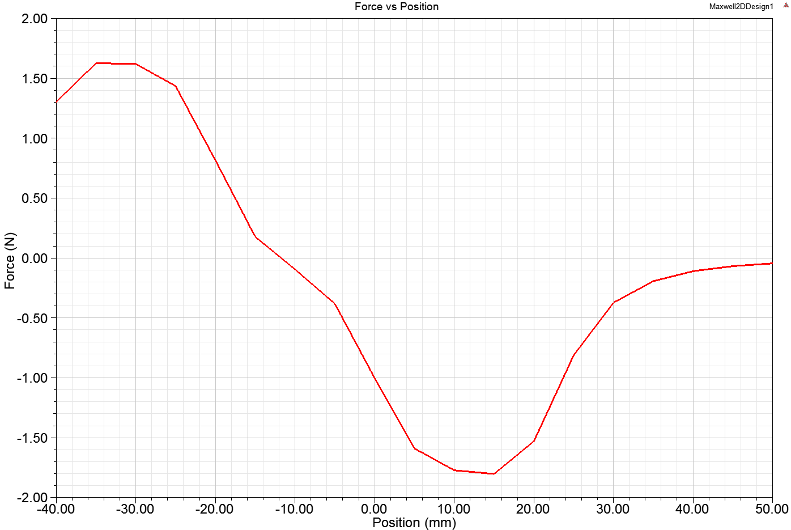

Here, we see minimum reluctance tendency. As plunger goes in +x direction and goes out, magnetic forces tries to pull the plunger to the middle. We have minimum reluctance and maximum inductance at middle position.

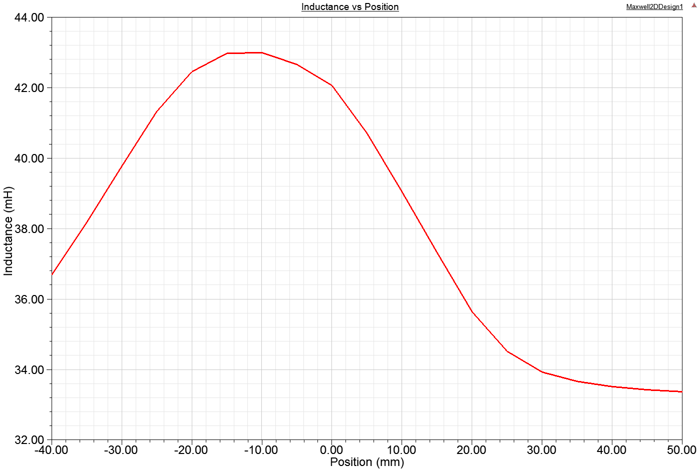

Inductance has similar trend with magnetic stored energy. It is expected since magnetic stored energy is proportional with inductance. Same comments apply here.

