# SBE II: Homework 1

## Experiment-2:

Attached as a code submission is the MATLAB script designed to produce click sequences with different inter-click-intervals (ICI) which experience varying jitter.

Shown in Figures 1, 2, and 3 respectively are the psychometric functions of observing an aperiodic sequence for mean ICI values of $10ms, 30ms,$ and $80ms$. It can be seen that as the ICI value increased, the subject’s ability to perceive aperiodicity decreased, as there were more fluctuations in the waveform. The subject seemed to over-estimate the aperiodicity compared to the smaller ICI equivalent test. A possible explanation for this is that the shift in ICI based on smaller jitter percentages in the higher ICI cases is technically larger, and the subject picked up the absolute aperiodicity rather than the aperiodicity relative to the period of the waveform. The observed boundaries are stated in each caption.

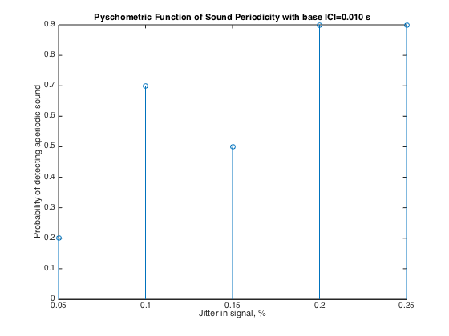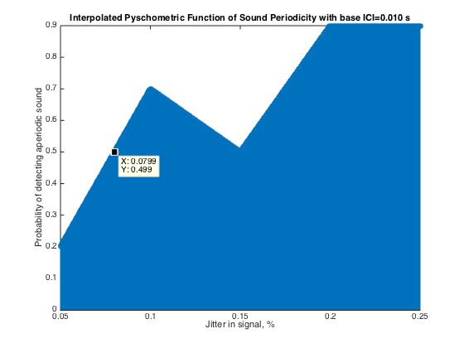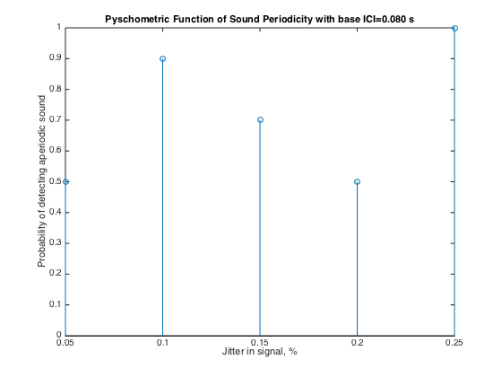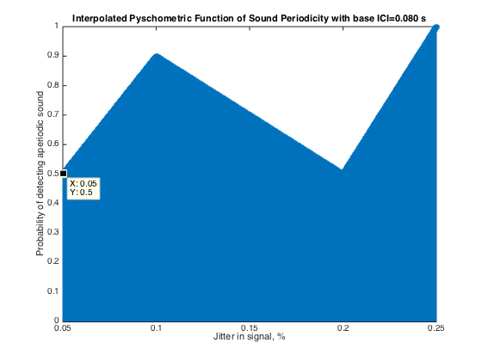

Figure 3: Observed and interpolated psychometric function of jitter perception for a mean ICI of 80 ms. The observed boundary in this case for detection is at $J=5\%$.

Figure 2: Observed and interpolated psychometric function of jitter perception for a mean ICI of 30 ms. The observed boundary in this case for detection appears to be below $J=5\%$, though a dip occurs which would have another threshold being observed at

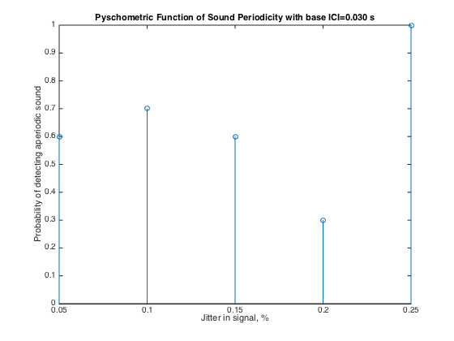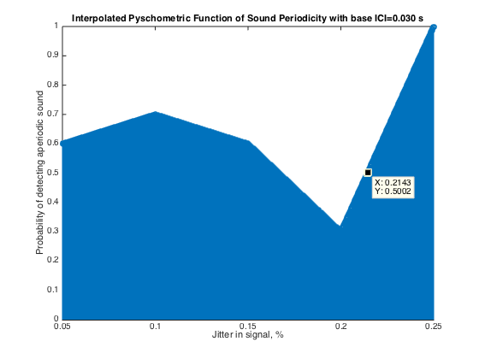

Figure : Observed and interpolated psychometric function of jitter perception for a mean ICI of 10 ms. The observed boundary in this case for detection is at $J=8\%$