# SBE II: Homework 2

## Experiment-2:

Attached as a code submission is the MATLAB script designed to produce the normalized differential response of the CNS neuron, S, for fixed x and varying d.

Shown in Figure 1 is the value of relative resolution of the CNS neurons, $S$, which is dependent on the distribution width of each independent neuron. We can see that this value saturates at approximately a value of $d=10$.

We can see from this data, that when our sensitivity is saturated (i.e. $d≥0$), we are able to predict the value of x, representing the position of stimulus, based on the intensity of the signal perceived by the CNS neuron. The reason for this is that the slope after saturation is linear. This indicates that as the position of stimulus varies, the amplitude of the signal, $G$, will vary linearly as well, in a very predictable way. The hyperacuity phenomena in this sense is supported, as the slope allows a higher resolution of interpolation than that of the neurons which are actually and physiologically present in an individual.

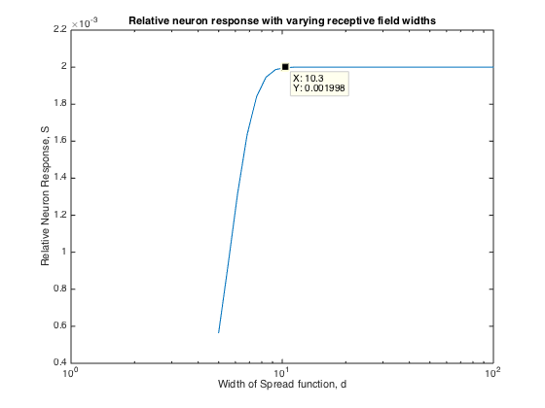

Figure 1: CNS Neuron relative resolution, S, for increasing values of distribution width.