# SBE II: Homework 1

## Experiment-1:

Attached as a code submission is the MATLAB script designed to produce click sequences with varying inter-click-intervals (ICI).

Shown in Figure 1 is the probability of observing a continuous signal, for each click sequence played to the subject. There were 110 samples for 11 different, randomly distributed ICIs. It can be noted that the subject was able to fairly accurately perceive the difference between “continuous” and “discrete/choppy” waveforms during this exercise, as there seems a clear drop-off at the $f_{o}$ boundary.

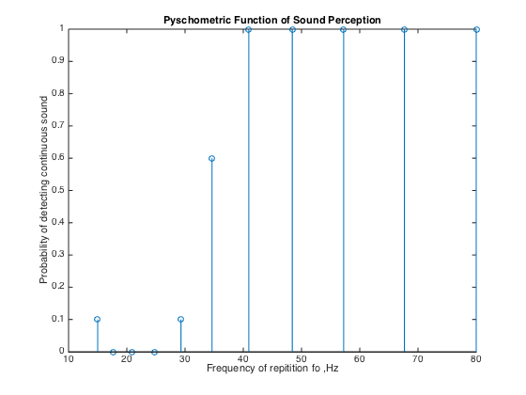

Figure 1: Psychometric function for continuous sound detection

Shown in Figure 2 is the interpolated curve of the probability distribution. From this, we can derive the “boundary $f_{o}$” value to be $f_{o}^{*}=33.6 Hz$.

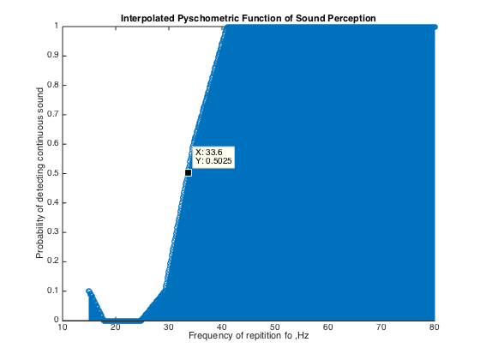

Figure 2: Interpolated Psychometric function for continuous sound detection