# SBE II: Homework 1

## Experiment-3:

Attached as a code submission is the MATLAB script designed to estimate probabilities for varying $β$ threshold values and two overlapping populations.

Shown in Figures 1 and 2 is the receiver operating characteristic (ROC) curves for varying values of $β$ over two populations, which overlap according to the distributions given in parts 1 and 2, respectively. It can be seen that when the populations overlap, a better ROC curve is observed – meaning a threshold can be picked which more optimally achieves true hits and minimizes false alarms.

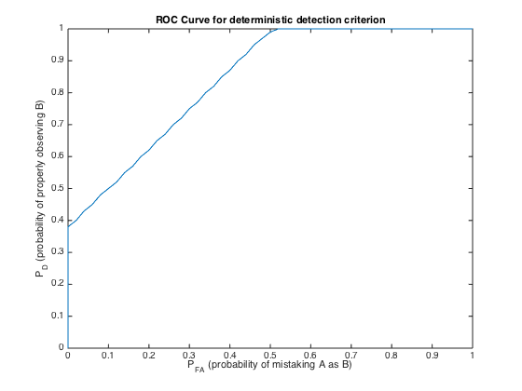

Figure : ROC curve for two uniform distributions from 7.5-12.5 and 10-14, respectively

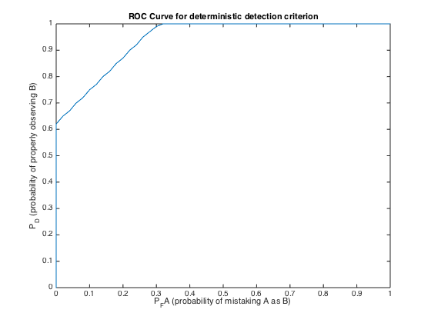

Figure : ROC curve for two uniform distributions from 7.5-12.5 and 11-15, respectively