# SBE II: Homework 10

## Experiment-1:

1. No, the system does not always reach the same equilibrium state. Shown below are two of the many steady states that were reached.

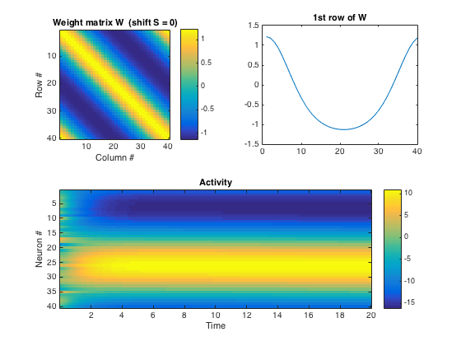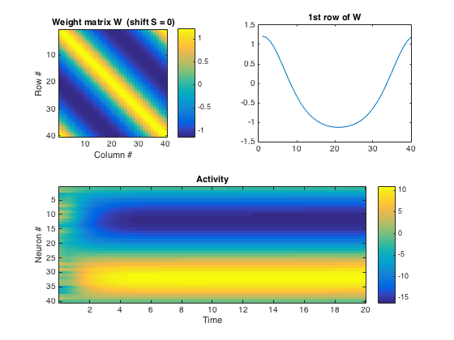

1. The weight parameter, S, affects the “speed” of the traveling bump. The larger the magnitude of S, the more quickly the system will change states and oscillate. The sign of S indicates the direction through which the states are traversed. The left and right figures below indicate S values of -0.5 and 0.5, respectively.

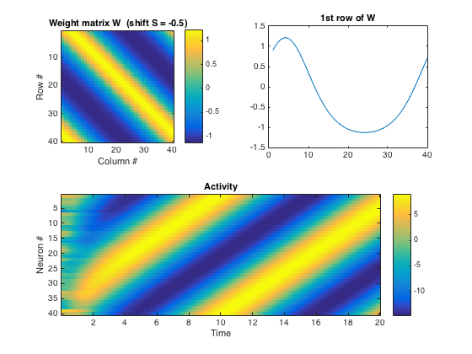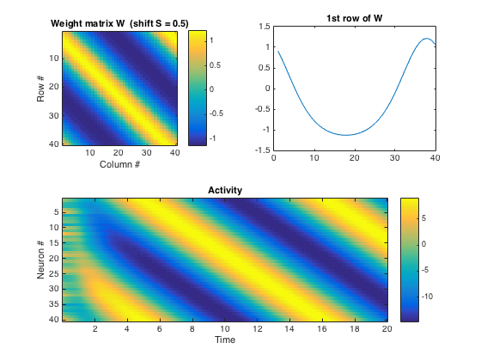

1. In this case, with the reduced intensity of B, the system saturates in all cases of S to the maximum value of approximately 10 – there is a uniform distribution among the neurons and their activity. The plot below illustrates this.

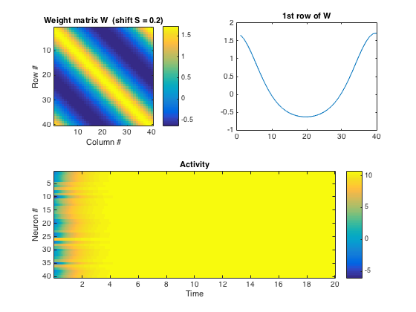

1. When random weights are added to the system, it prevents the system from reaching a steady state. Though the S values from above influence the pattern greatly, the state is still inconsistent due to the randomness of the noise.

