# SBE II: Homework 10

## Experiment-2:

1. When the N value is set to be very high (1000), we notice that the system begins to converge to some steady state. This state can vary greatly based on the initial conditions of the system, as well as the random stimulus presented. In each case, however, all neurons within close proximity to one another are tuned to respond similarly. This is because the adjusted weighting from the Gaussian function influences all nearby neurons to become more similar to one another. Shown below are three of these infinite numbers of possible final states.

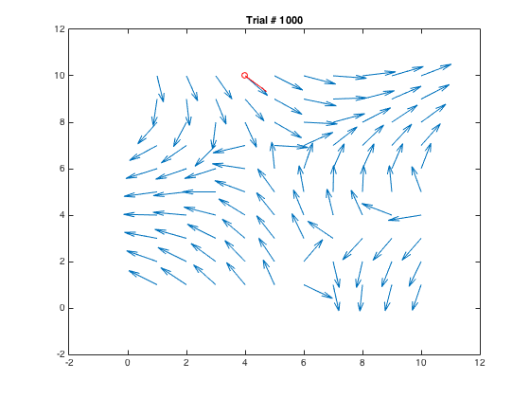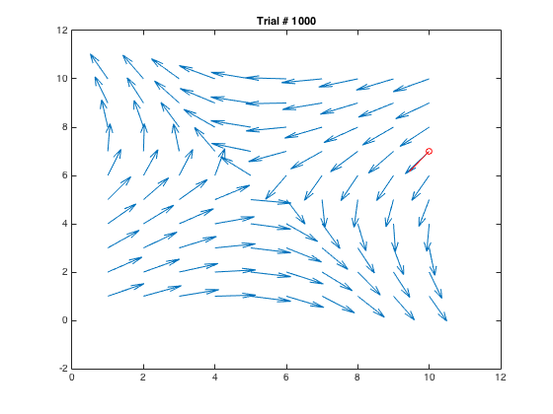

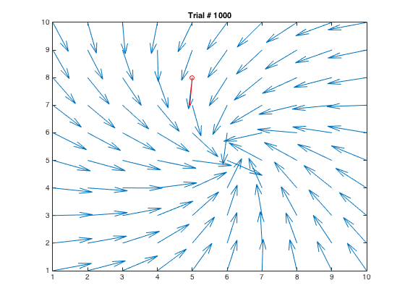

1. In this case, with a small Gaussian neighborhood, we can notice that the system does not converge to any uniform field – or deviate very much at al from the initial state. This is obvious, conceptually, due to the fact that the Gaussian neighborhood is much smaller than distance between points, meaning that each neuron being stimulated will have virtually no effect on any other. A figure showing the final state of this network is below.

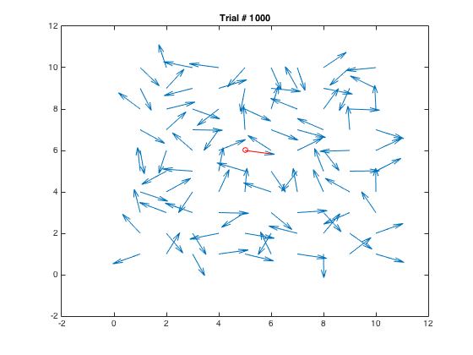

1. In the case of the very wide Gaussian network, we notice that all neurons adapt the same preference, and that this preference is highly subject to change. By this I mean that when a neuron is stimulated, all other neurons will approximately adopt the same orientation preference. When another neuron is stimulated in a vastly different direction, all of the neurons will shift greatly again. This results in a uniform field after many iterations, but that field is very sensitive to noise/change in stimulus direction.

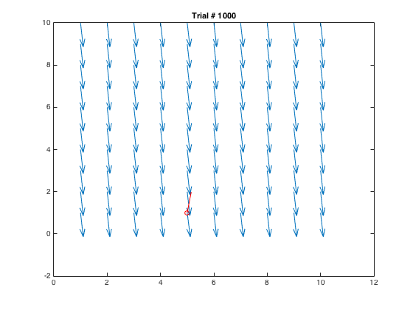

1. When the orientation of stimulus is restricted to being in the upper-half plane (i.e. ranging from $[0, π]$), we notice that all of the neurons adapt an orientation preference pointing in the upper-half plane as well. This is intuitive because as no stimulus is presented in the lower-half plane, neurons will lose their selectivity or preference for observing that type of a signal. Two plots of this system are shown below.

