# SBE II: Homework 2

## Experiment-3:

Attached as a code submission is the MATLAB script designed to produce the normalized differential response of the CNS neuron, S, for fixed x and varying d.

Shown in Figure 1 is the value of relative resolution of the CNS neurons, $S$, which is dependent on the distribution width of each independent neuron. We can see that this value saturates at approximately a value of $d=10$. This plot was formed based on the adjust value of $G$, which was multiplied by an additional power of $k$ in it’s computation.

Though the plots of these two waveforms, meaning those computed in experiments 2 and 3, the values, which are asymptotically reached, are higher in this case. We see that a higher power of $k$ results in a higher hyperacuity, meaning that there is larger differentiation from this CNS neuron between nearby positions of stimulus than in the case where a single power of $k$ influenced the equation.

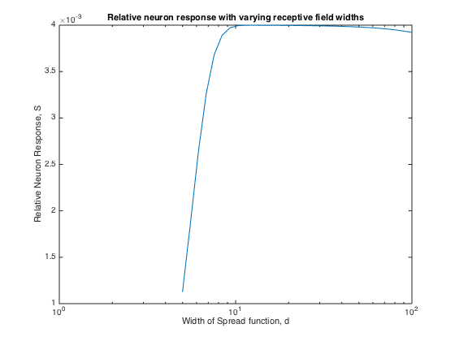

Figure : CNS Neuron relative resolution, S, for increasing values of distribution width.