# SBE II: Homework 2

## Experiment-1:

Attached as a code submission is the MATLAB script designed to produce the CNS neuron, G, response for varying x and d.

Shown in Figure 1 is $G(x,d)$ over $x$ over a range of $d=2,4,8,16,32$. Here, it can clearly be seen that as $d$ increases, the “smoothness” of the neural response, $G$, increases. For the maximum value of $d$ tested, the green line, we observe an almost constant and linear slope over increasing $x$.

Another feature, which we observe, is the fact that higher values of $d$ result in a steeper slope of response. From these two observations we can state that the distribution width of the sensitivity of each individual neuron not only allows for the smoothing of overall neural response, but also increases the amplitude of the response, which can lead to benefits discussed later.

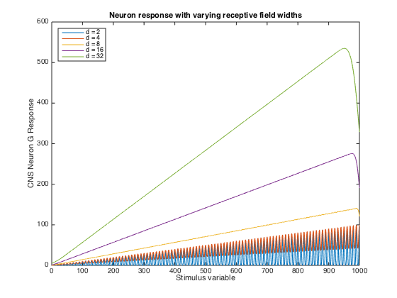

Figure : Neuron (G) responses for increasing x. Each line represents a different distribution width, d.