# SBE II: Homework 3

## Experiment-4:

Show below are two plots of how the burst behavior was maintained, given a reduced value of $μ=0.0121$.

The plot on the left was achieved by increasing the value of $ϵ$ from $0.005$ to $ϵ=0.0088$. This value was increased because when inspecting the $\frac{dCa}{dt}$ equation, the other obvious parameter, which has an influence on the growth of Calcium, is $ϵ$: since $μ$ was decreased and both constants are proportional to the gain in $\frac{dCa}{dt}$ the value of $ϵ$ was increased to compensate.

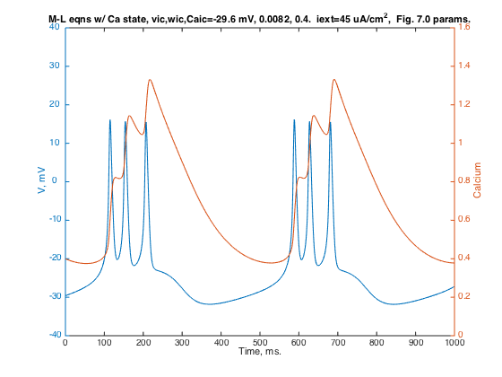

The other variable, which was tuned, was the conductance of the KCa channel. The value here was increased from $0.28$ to $G_{KCa}=0.308$, for reasons similar to those explained in the previous portion. The bursting stops when the Calcium conductance between the KCa channel becomes sufficiently large, if we start the KCa conductance at a higher baseline value, then the cell is more likely to reach this conductance with lower values of Calcium inside of the cell.

