# SBE II: Homework 4

## Experiment-5:

Plotting the previously derived steady-state potential of the semi-infinite cylinder was tasked in this portion, and can be seen below.

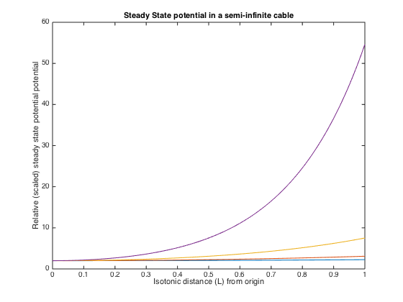

We can see from this plot that the case of the semi-infinite cable is very similar to those of the infinite conductors at DC steady state. We can, electrically, draw the not surprising comparison that as $t→∞$ we approach a DC condition. The only major difference between the growth of the potential here and in the infinite cylinder case is the rate of growth of the potential, V.

Code to produce above plot:

lambda = 1;

L = lambda./[2, 1, 0.5, 0.25];

clf

for j = 1:length(L)

v = @(x) 2.*cosh(x./lambda);

vals = v(0:L(j)/100:L(j));

plot((0:L(j)/100:L(j))./L(j), vals);

hold on;

end

title('Steady State potential in a semi-infinite cable');

xlabel('Isotonic distance (L) from origin');

ylabel('Relative (scaled) steady state potential potential')