# SBE II: Homework 5

## Experiment-1:

Before completing any experiments in this section, an analytical solution for the inverse probability distribution function (alternatively, inverse CDF) was required. Being given the probability density function (PDF) $p_{2}(τ)$ we were able to proceed as follows:

$$F\left(τ\right)=\int_{-∞}^{τ}{p_{2}\left(x\right)dx}= \int_{t_{0}}^{τ}{p_{2}\left(x\right)dx}$$

$$\int_{t_{0}}^{τ}{λe^{-λ\left(τ-t_{0}\right)}dx}=[-e^{-λ\left(τ-t_{0}\right)}|_{t_{0}}^{τ}=-e^{-λ\left(τ-t_{0}\right)}-(-1)$$

$$F\left(τ\right)=1-e^{-λ(τ-t_{0})}$$

From here, we are able to make the following substitution and solve for $F^{-1}(τ)$:

$$u=1-e^{-λ\left(τ-t_{0}\right)}$$

$$\ln{(1-u})=-λ(τ-t_{0})$$

$$τ=\frac{-1}{λ}\ln{(1-u)}+t_{0}$$

Now that we have isolated $τ$ and are able to subsequently estimate the PDF of our distribution, the following plot was made which presents the a) dot-raster plot of 100 simulated spike trains, b) post stimulus time histogram, c) estimated PDF, and d) analytically evaluated PDF. From the following figure it was also computed that the mean firing rate of this neuron given the prescribed conditions was 86.95 spikes/second.

Comments about the similarity between the distribution estimated and computed analytically are on the following page.

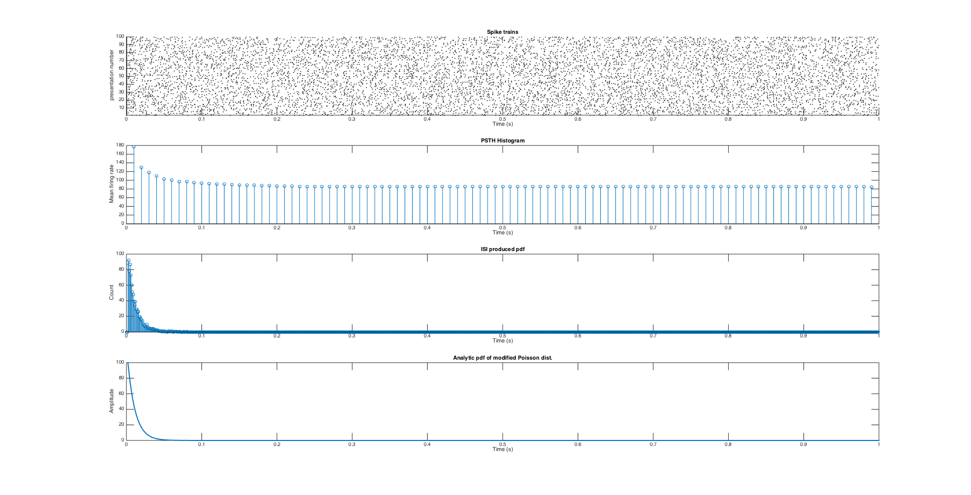

As can be seen in the bottom two graphs in the attached figure, the distributions of the estimated and calculated PDFs are very similar. This makes sense, as the estimated distribution was done-so with knowledge of the analytical form of the PDF. Where the two differ is in that the estimated PDF has noise, as will always be the case in random variable sampling. A possible way to mitigate this noise is to sample the distribution more than 100 times and perform the same estimation.