# SBE II: Homework 5

## Experiment-1:

As was done in the previous step, we here desire a closed-form solution to both the CDF and inverse CDF of our distribution. Since this is not easily solvable analytically, numerical approximations were deemed sufficient for this experiment. Knowing that the CDF, $F(t)$, was the cumulative sum of the PDF evaluated at values in the set ranging from $-∞→t$. Exploiting this, the numerical approximation was made to be a sum of the analytic PDF values up to the value of interest.

The inverse CDF, $F^{-1}(u)$, is designed to return the infinium value of $t$, for which $F\left(t\right)> u$. This was exploited as well in the function definition.

Similarly to the previous part, the figure below shows a) dot-raster plot of 100 simulated spike trains, b) estimated PDF, and c) analytically evaluated PDF for values of k ranging from 1 to 3, from left to right.

Comments about the similarity between the distribution estimated and computed analytically are on the following page.

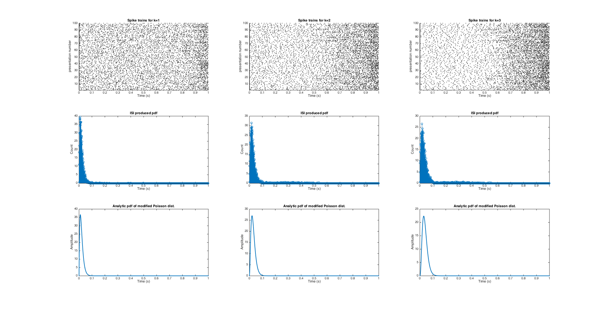

As can be seen in the bottom two rows of graphs in the attached figure, the distributions of the estimated and calculated PDFs are very similar. Though the estimated PDFs were not done-so directly from the analytic expression, reasonable approximations were made such that a numerical solution proved to yield sufficiently similar trends. Again, the largest difference between the estimated and analytic PDFs is the noise in the random variable. Increasing the number of spike trains produced for each scenario can mitigate this error. We also notice from the plots, that as k increases the PDF (both estimated and analytic) shift towards the right, indicating a higher ISI.