# SBE II: Homework 7

## Experiments 1 $→$ N:

In this homework, we are modeling movement of the arm. The initial position of the arm is shown below. Here and forward, $θ=\left[{θ_{s} \atop θ_{e}}\right]=\left[{57 \atop 90}\right]$ in degrees. The parameters used have been taken from the course notes.

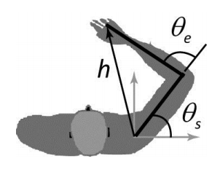

Figure : sketch of the arm (copied from course notes)

1. The (x,y) position of the elbow is given by:
$$e= \left[{d_{1}×cos⁡(θ_{s}) \atop d_{1}×\sin\left(θ_{s}\right)}\right]=\left[{0.1797 \atop 0.2768}\right] m$$

2. The (x,y) position of the hand is given by:
$$h=e+ \left[{d_{2}×cos⁡(θ_{s}+θ_{e}) \atop d_{2}×\sin\left(θ_{s}+θ_{e}\right)}\right]=\left[{0.1840 \atop 0.5110}\right] m$$

3. The inertia matrix is given by:
$$H= \left[{a_{3}+a_{1}d_{1}^{2}+a_{4}+2{a_{2}d}_{1}×\cos\left(θ_{e}\right) a_{2}d_{1}\cos\left(θ_{e}\right)+a_{4} \atop a_{2}d_{1}×\cos\left(θ_{s}\right)+a_{4} a_{4}}\right]=\left[{0.3760 0.1439 \atop 0.1439 0.1439}\right] kg m^{2}$$

4. The Jacobian of this system is given by:
$$Λ= \left[{\frac{dh_{x}}{dθ_{s}} \frac{dh_{x}}{dθ_{e}} \atop \frac{dh_{y}}{dθ_{s}} \frac{dh_{y}}{dθ_{e}}}\right]=\left[{-0.5110 -0.2342 \atop -0.1809 -0.3606}\right] m$$

5. The mass matrix of the system is given by:
$$M={Λ^{-1}}^{T}HΛ^{-1}=\left[{1.7298 -0.6179 \atop -0.6179 1.1796}\right]kg$$

6. Over the range of $θ=[0, 2π]$, plotted below is the resulting effective mass of the arm for different acceleration directions.

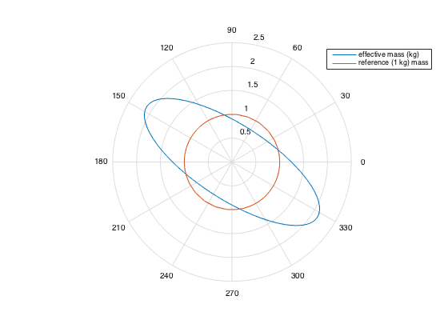

1. The derivative of $J$, the movement utility, is given as follows:
$$J=\frac{α-mcd^{2}T}{1+γT}$$

$$\frac{dJ}{dT}=\frac{d}{dT}\left[\frac{α-mcd^{2}T}{1+γT}\right]$$

$$=\frac{d}{dT}\left(α-\frac{mcd^{2}}{T}\right){\left(1+γT\right)}^{-1}$$

$$=\frac{mcd^{2}/T }{1+γT}-\frac{α-mcd^{2}/T }{{\left(1+γT\right)}^{2}}$$

$$\frac{dJ}{dT}=\frac{mcd^{2}\left(1+2γT\right)-αγT^{2}}{T^{2}{\left(1+γT\right)}^{2}}$$

2. The optimal value of $T$, $T^{*}$, is found by setting this derivative to zero and solving for $T$, as follows:
$$0=\frac{mcd^{2}\left(1+2γT\right)-αγT^{2}}{T^{2}{\left(1+γT\right)}^{2}}$$

$$0= mcd^{2}\left(1+2γT\right)-αγT^{2}$$

$$0= mcd^{2}+mcd^{2}2γT-αγT^{2}$$

$$0= T^{2}+T\left(-\frac{2mcd^{2}}{α}\right)-\frac{mcd^{2}}{αγ}$$

$$T=\frac{2mcd^{2}}{α}+\sqrt{\frac{4m^{2}c^{2}d^{4}}{α^{2}}+\frac{4mcd^{2}}{αγ}} / 2$$

$$T^{*}=\frac{mcd^{2}+\sqrt{c^{2}m^{2}d^{4}+αcmd^{2}γ^{-1}}}{α}$$

3. Over the range of $θ=[0, 2π]$, plotted below is the optimal movement time of an action.

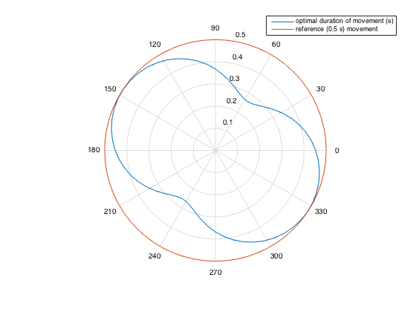

1. Over the range of $θ=[0, 2π]$, plotted below is the optimal utility (i.e. utility corresponding to optimal time) of an action.

