# SBE II: Homework 9

## Experiment-3:

1. Yes, all of these are stationary states in the network. This means that the output will converge to some value and maintain itself at this value each time it updates.
2. When you start in any of the three Test states, you still end up in position C in at most 2 iterations.
3. In the case where we set the initial state to be the binary photo of Nessy, in at most 2 iterations we land in state B.
4. When adding the Nessy image to our initial weight matrix, and using the same image as the source, Nessy becomes a stable/stationary state of our system.
5. Starting from Test3, even with Nessy added, you still end up in the same final state (state C) as before.
6. As can be seen as one example copied below, you can get different final states from this system when starting from a random seed.

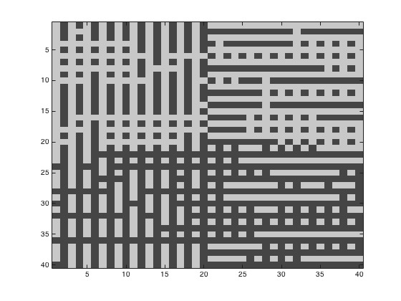

1. The weight rule that we initially set **does** force it to be true that the weights are symmetric. Since we are multiplying a matrix with its transpose in each of the terms included in the weight matrix, each of those results must be a symmetric and square matrix (this is a linear matrix property).
2. After setting 70% of the elements to zero we still do get the same final/steady state from our network as in the earlier portion, consistently. It is worth noting, however, that the network takes longer to converge (on average, one iteration).