Stravaco LLC Project Brief
Client Background:
Stravaco LLC is a NH based tech startup that recently launched a fitness step tracking application.
They've been using AWS for three months, initially setting up their infrastructure quickly to meet launch deadlines.
Now that the product is live, they need to address their cloud security fundamentals. The company has 12 employees who all currently share the AWS root account credentials to access and manage their cloud resources.
This practice started when they were moving quickly to launch, but now their (new) CTO recognizes the security risks this poses.

Current Setup that needs to be evaluated:
- Everyone uses the root account
- No separate permissions for different teams
- No MFA or password policies
- AWS credentials shared via team chat

Current Infrastructure:
- EC2 instances running their application
- S3 buckets storing user data and application assets
- RDS database for user information
- CloudWatch for monitoring
- Several development and production environments

Team Structure & Access Needs (see spreadsheet for details):
- 4 Developers who need EC2 and S3 access
- 2 Operations folks who need full infrastructure access
- 1 Finance Manager who needs cost management access
- 3 Data Analysts who need read-only access to data resources
- 1 Admin/Architect who will be the main Administrator on the AWS account

Deliverable 1: Architecture diagram of current state
Baseline architecture – current situation: Stravaco LLC is using a single AWS VPC, and has all of their infrastructure in a shared environment, although there are separate subnet groupings (public/private) for dev and prod. This is simple and cost-effective. Dev and prod live in the same VPC but in separate subnets/security groups. This works well for the size that the company is today, still.
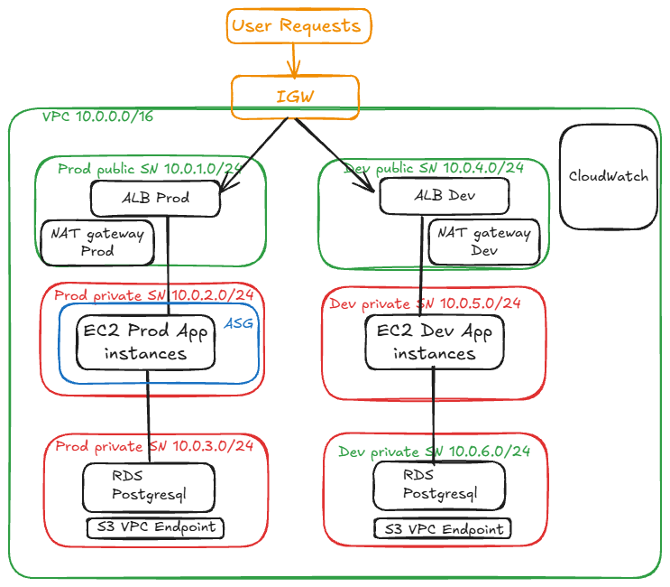
Note: This solution is workable but we had to add some due diligence and confirm that resource tagging was done correctly – Environment=Prod and Environment=Dev
But management has indicated they want to scale to a more robust infrastructure within 12-18 months, as the company will be scaling up and adding to the product suite.
Baseline architecture – goal for 2027: Dev and prod each should get their own fully isolated VPC. And communicate via VPC peering when needed. This will provide more robust isolation, clearer cost attribution. This is a bit more complex to build out. Note: this architecture design is conceptual only at this time, as we are awaiting input from consultants and budget teams
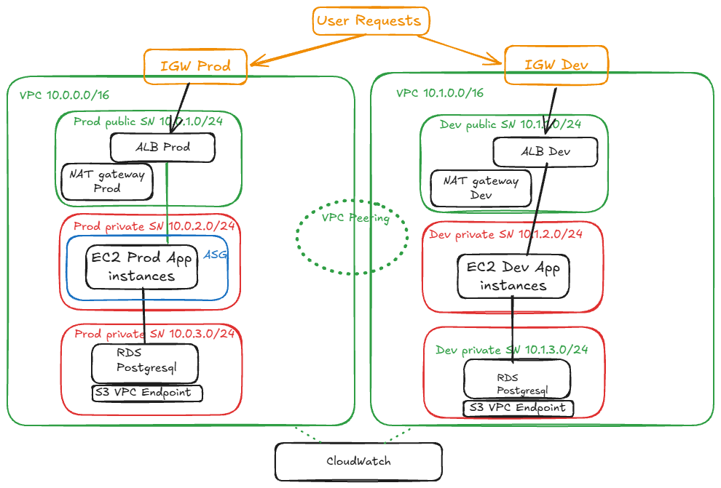
Some notes on the dual VPC solution:
- No shared networking – separate VPC dedicated Internet Gateways, NAT Gateways
- Non-overlapping CIDR blocks are critical for this to work.
- VPC Peering should be narrow. Use security groups and lock this down to only the specific ports and services that actually need to communicate (e.g. a shared internal auth service)
- IAM roles can function still in the new design. We are using the same resource tags (Environment=prod / Environment=dev) to scope access, so the same roles will work across both VPCs without any changes.
- VPC boundary adds network isolation on top of what IAM does
- There is additional cost to consider – therefore the budget team input requirement.

Deliverable 2: Resolving the issues with the Root Account
- Enable MFA (for all users, not just root account) 
- Stop using it for daily operations 
- Store credentials securely 

Related actions:
- Addressing the root user account used to set up the account, and the shared use of this
  - Issue: This was previously shared among the team members.
  - Fix:
    - The root user for the management account is no longer used by the team – the password has been changed using a very strong random character generator, MFA has been enabled on the account and the root password + MFA recovery codes are held a shared vault on 1Password with strict access controls. The current CTO, John Baptiste is investigating whether a hardware YubiKey might be an option to replace the google authenticator solution currently in place.
    - Under AWS Organizations, another AWS Account was setup which will be used for all operational activities
    - For the duration of the engagement, I set up a root user account for myself and enabled MFA and the roles specified. At the end of the consultation engagement my access is removed by members of the Admin team
    - Several groups were created with user members based on functional area. Least privilege was applied where possible, and standalone permissions rather than bundled were used where possible. Notable exceptions are Billing related permissions which are bundled and interrelated
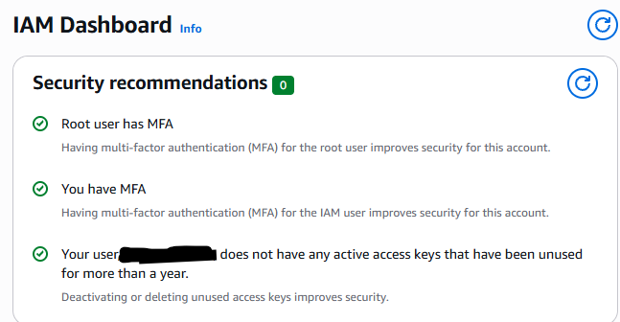

Deliverable 3: Create IAM Users and Groups
- Developer group & users (Developer_Group)
- Operations group & users (Ops_Group)
- Finance group & user (Finance_Group)
- Analyst group & users (Data_Group)
- Administrator group & users (Stravaco_Admin_Group)

Deliverable 4: General Best Security Practice implementation
- Enable MFA for all users 
- Create a strong password policy 
- Ensure users can only access what they need 

Related Actions:

- MFA was set up for all users, with Google Authenticator being preferred by the company as they allow BYOD.
- Password policy: The following password policy is in place:
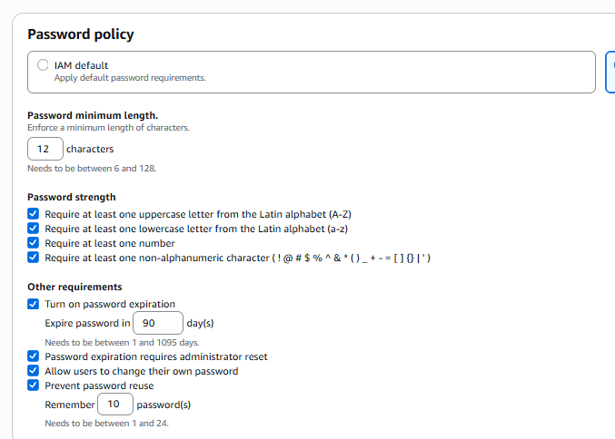
- Users only have access to what they need. All users are members of groups, and in their respective groups they are subject to the permissions set up for said group. In addition, we are considering or implementing the following:

Use of Resource Tagging: Every EC2 instance, RDS database, and S3 bucket is tagged with Environment=prod or Environment=dev. There is no need to create separate IAM roles for each environment. We can use conditions and resource-level permissions to scope access by environment. And - If needed, we can add some more restrictions on certain prod actions
- Up for consideration 1:
  - Affected group: Developers
  - Add a Deny statement on destructive actions (like ec2:TerminateInstances or s3:DeleteObject) when Environment=prod, while still allowing those same actions in dev.
- Up for consideration 2:
  - Affected group: Data Analysts
  - Direct RDS access to might be flagged from a data privacy standpoint.
  - A potential workaround is providing a read replica or use RDS snapshots restored into dev

Deliverable 5: Implement permissions at group level
Developers: (Developer_Group)
- EC2 management: AmazonEC2FullAccess
- S3 access for application files: AmazonS3ReadOnlyAccess
- CloudWatch logs viewing: CloudWatchEventsFullAccess

Operations: (Ops_Group)
- Full EC2: AmazonEC2FullAccess
- CloudWatch access: CloudWatchEventsFullAccess
- Systems Manager access: AmazonSSMFullAccess
- RDS management: AmazonRDSFullAccess

Finance: (Finance_Group)
- Cost Explorer: Billing
- AWS Budgets: Billing
- Read-only resource access: ReadOnlyAccess
Analysts: (Data_Group)
- Read-only S3 access: AmazonS3ReadOnlyAccess
- Read-only database access: AmazonRDSReadOnlyAccess

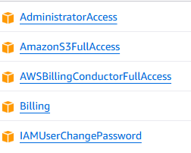
    - The Chief architect will be the only member of the Admin Team currently, although that will likely change in the future. The associated AWS Admin_Group has the AdministratorAccess and Billing permissions
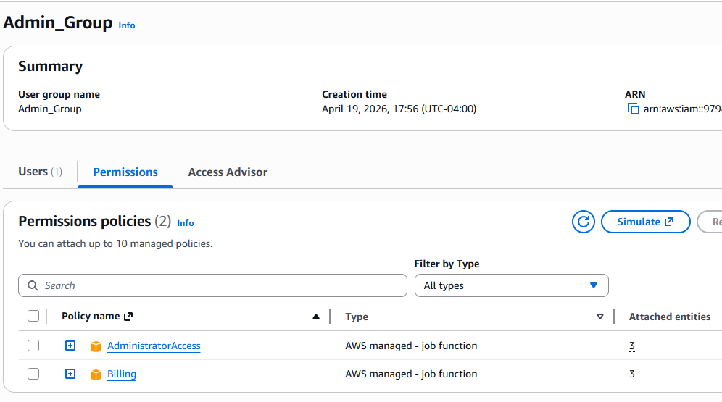
    - The operations team will operate as Administrators for Stravaco, and the two members of the team have been set as members of the AWS Ops_Group, which has the following permissions associated:
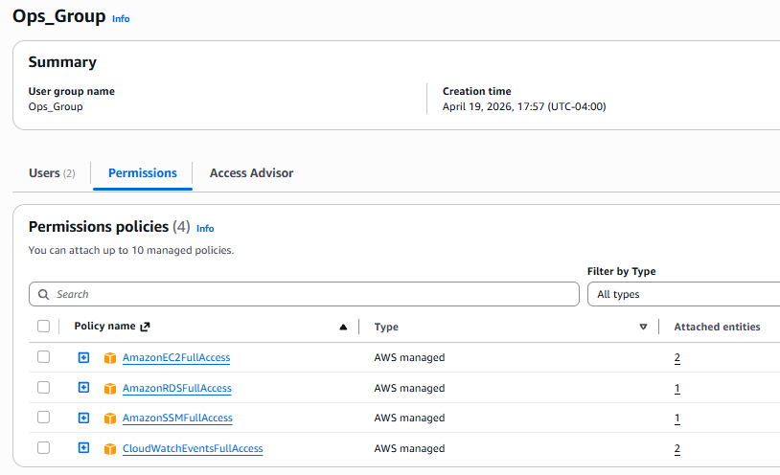
    - Finance_Group:
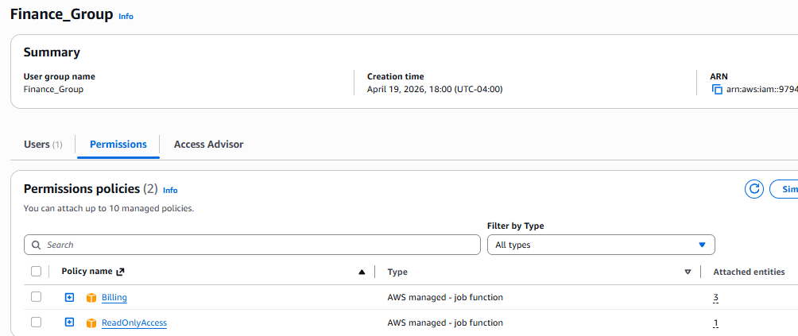
    - Developer_Group:
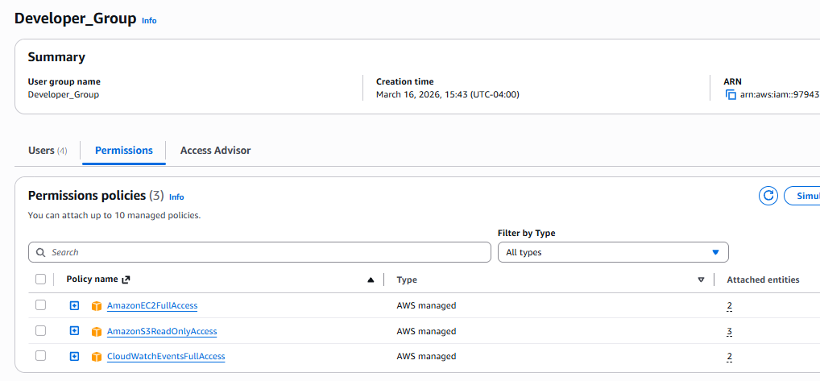
    - Data_Group:
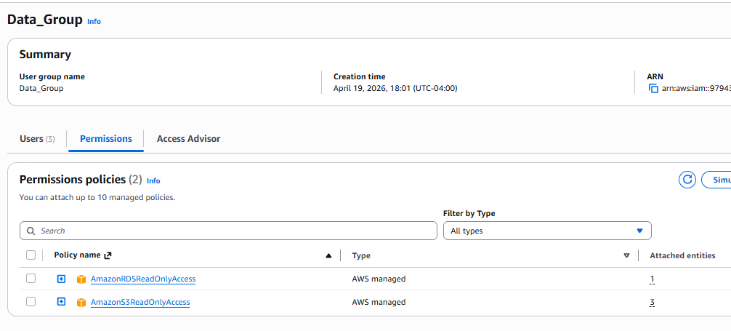

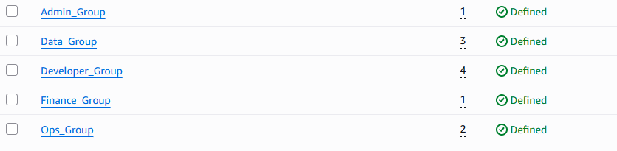

- User details:
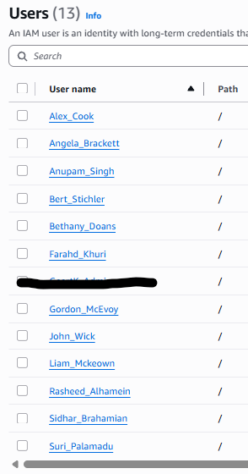
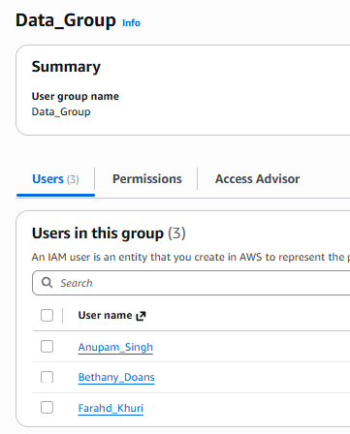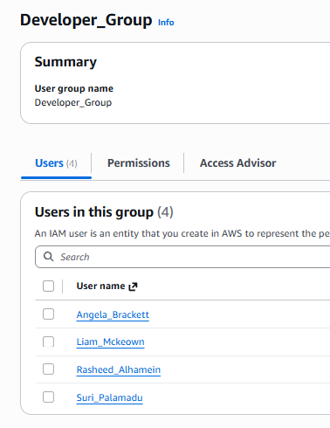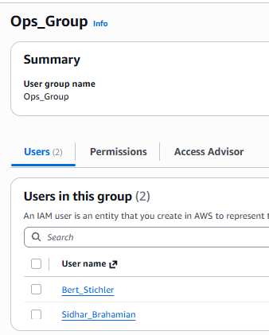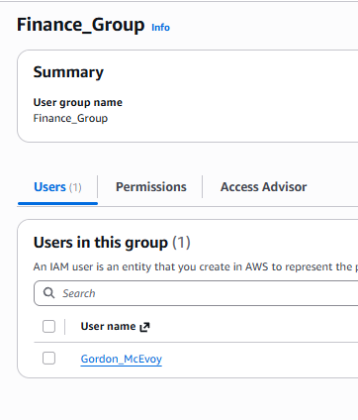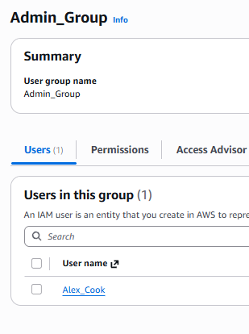

---------Advanced Bonus Challenge --------
Once you've implemented everything via Console, try to recreate your solution using:
- Terraform
- AWS CloudFormation
- AWS CDK
This will help you understand both approaches.

