Terraform
IaC
- Key DevOps practice
- Treat infrastructure as code
- Eliminates manual deployment
- Deployments become repeatable and consistent
- Consistency and Accuracy, reducing human error
- Speed and simplicity – rapid provisioning
- Version control
Terraform: Most Popular IaC tool
- Declarative approach using HCL – you define what should be built and Terraform does the ‘how’
- Cloud agnostic (multi cloud)
- CLI outputs
- Consistency and reproducibility
- Collaboration and version control
- Automated provisioning
- Dependency management
- Cost optimization
- State management: tracked inside state files
- Modular architecture: better management and re-usable
- No longer open source at the enterprise level (now licenses are required)
- Also good for hybrid infrastructures
Windows Installation
Step 1: Download Terraform
- Open your web browser and go to the Terraform download page
- Under the "Windows" section, download the appropriate zip file for your system architecture (32-bit or 64-bit)
Step 2: Extract the Terraform Executable
- Locate the downloaded zip file in your Downloads folder
- Right-click the zip file and select "Extract All..."
- Create a directory named Terraform in your C:\ drive (e.g., C:\Terraform)
- Extract the terraform.exe file to this directory
Step 3: Update System Environment Variables
- Open the Start Menu and search for "Environment Variables"
- Select "Edit the system environment variables"
- In the System Properties window, click the "Environment Variables" button
- Find the "Path" variable in the "System variables" section and click "Edit"
- Click "New" and add the path to your Terraform directory (e.g., C:\Terraform)
- Click "OK" to close all dialog boxes
Step 4: Verify Installation
- Open a new Command Prompt window
- Run the following command:
terraform --version
- You should see the version of Terraform that you installed

Useful terraform commands
- Terraform init
- Terraform plan
- Terraform apply
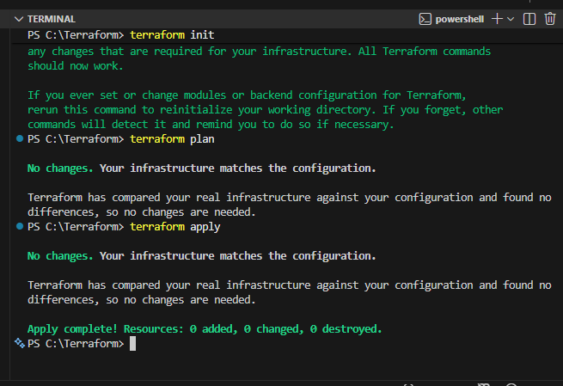

Terraform commands:
- Terraform init
  - Initializes a new or existing terraform configuration
  - Downloads the needed provider plugins
  - Sets up the backend for storing state files
  - When to use:
    - After creating a new configuration
    - When you have added a new provider to an existing configuration
- Terraform plan
  - Creates an execution plan
  - Compares current state to desired state
  - Determines what actions are needed to get to desired state
  - Shows changes that will be made before you make them
- Terraform apply
  - Apply the changes to your infrastructure
  - Executes the actions proposed in the plan (creating/modifying/deleting resources)
  - Same as aws cloudformation deploy command
- Terraform show
  - Displays current state of infrastructure resources in human readable format
  - Useful to inspect your configuration
  - Useful to see relationships between resources
  - Sames as aws cloudformation describe command
- Terraform output
  - Used to retrieve value of outputs (if you have defined those)
  - Useful to retrieve info on IP Addresses, Resource IDs, Metadata
- Terraform destroy
  - Removes all resources managed by your configuration
  - Prompts for confirmation
  - Same as aws cloudformation delete command
- Terraform fmt
  - Formats your Terraform configuration files according to canonical style conventions
  - Helps maintain consistent formatting across your codebase
  - Makes reading and collaboration easier
- Terraform validate
  - Checks the syntax of your Terraform configuration files
  - Ensures proper formatting
  - Useful to catch any errors/issues before applying changes

