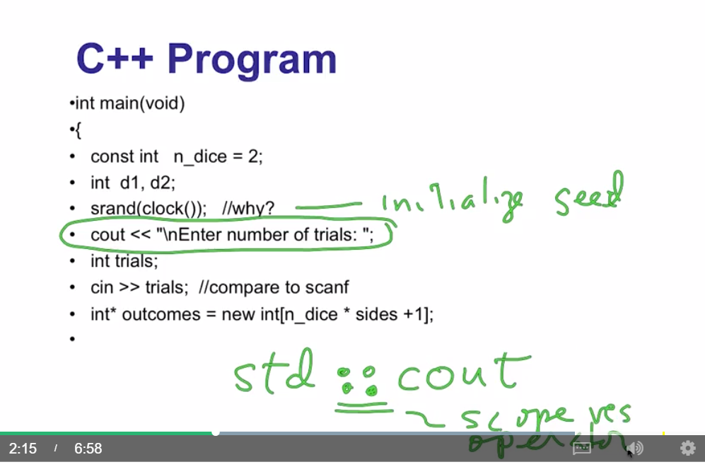

Multiple librbries you can use with namespaces