**Participants:**

Bettina Klimek (BK)

Matteo Pellegrini

Fahad Khan

Katerina Gkirtzou (KG)

Christian Chiarcos (CC)

Penny Labropoulou (PL)

Stefania Racioppa (DFKI)

1. **Module draft 4.7**

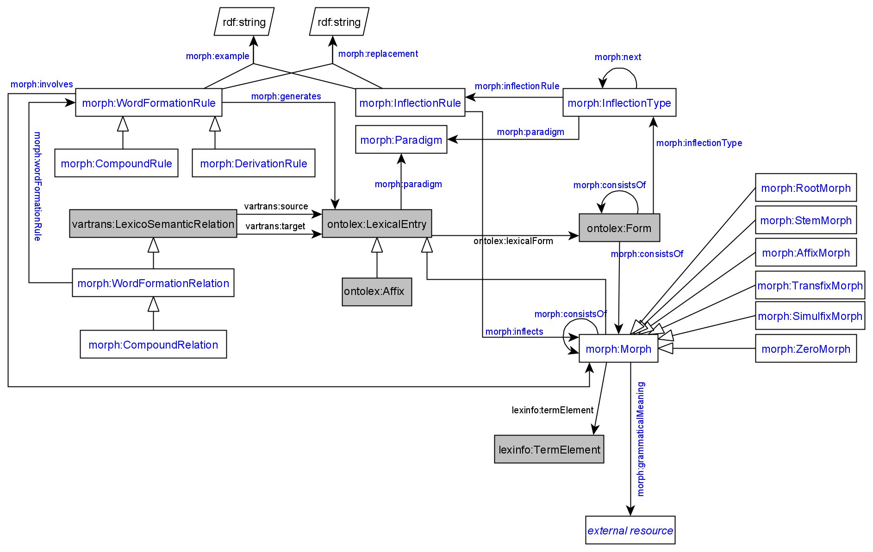

Adaptations included into module draft 4.7:

* MorphValue class removed and lexinfo:TermElement (includes instances lexinfo:inflectionElement) with property lexinfo:termElement used instead
* removed morph:DerivationRelation (CC in favor of eliminating the redundancy between DerivationRelation subclasses and DerivationRule (would make diagram more readable) because the difference between morph:DerivationRelation and morph:DerivationRule can be expressed in morph:DerivationRule alone
* composition with more than 2 elements resolved by CC by using morph:CompositionalRelation and the decomp vocabulary
  + suggestion: use CompositionalRelation *only* to mark the morphological head, modifiers go unmarked

Adaptations to be included into module draft 4.8:

* + morph:CompoundHead is subclass of morph:CompoundRelation
  + object property: morph:baseConstraint with domain: morph:Morph and range: morph:GrammaticalMeaning
  + replace “external resource” as object of morph:grammaticalMeaning with class morph:GrammaticalMeaning
  + one of the affix class merge options

Other proposed changes:

* + merge ontolex:LexicalEntry and ontolex:Affix subclasses, turning ontolex:Affix and morph:Non-Affix subclasses of morph:Morph into ? and sort the morph affix subclasses under ontolex:Affix (still unclear, needs to be explained by CC again)
    - option 1) morph:AffixMorph as a subclass of both morph:Morph and ontolex:Affix
    - option 2) merge morph:AffixMorph into ontolex:Affix and make it a subclass of morph:Morph

1. **Representing compounds with >2 elements**

Example representation by CC using decomp:

* + - Blutspendezentrale Blut spenden Zentrale “blood donation center” (GermaNet: <https://www.sfs.uni-tuebingen.de/GermaNet/documents/compounds/split_compounds_from_GermaNet16.0.txt>)

<entry#Blutspendezentrale>

decomp:subterm <entry#Zentrale> ;

decomp:subterm <entry#spenden> ;

decomp:subterm <entry#Blut> ;

rdf:type ontolex:LexicalEntry ;

ontolex:canonicalForm <form#Blutspendezentrale> .

<form#Blutspendezentrale>

rdf:type ontolex:Form ;

ontolex:writtenRep "Blutspendezentrale" .

<entry#Blut> rdf:type ontolex:LexicalEntry ;

ontolex:canonicalForm <form#Blut> .

<form#Blut> rdf:type ontolex:Form ;

ontolex:writtenRep "Blut" .

<entry#spenden> rdf:type ontolex:LexicalEntry ;

ontolex:canonicalForm <form#spenden> .

<form#spenden> rdf:type ontolex:Form ;

ontolex:writtenRep "spenden" .

<entry#Zentrale> rdf:type ontolex:LexicalEntry ;

ontolex:canonicalForm <form#Zentrale> .

<form#Zentrale> rdf:type ontolex:Form ;

ontolex:writtenRep "Zentrale" .

<rule#0> morph:generates <entry#Blutspendezentrale> ;

morph:example "Blut + spenden > Zentrale" .

# currently, we only create a rule if there is an interfix involved

[] rdf:type morph:CompoundRelation;

vartrans:source <entry#Zentrale>;

vartrans:target <entry#Blutspendezentrale>.q

→ create compound relation between 2 elements (the base “Zentrale” (not the head “Blutspende”) and the result of the composition process “Blutspendezentrale”) only and have all elements as decomp:subterm

Representation in LiLa by Matteo

* did not use decomp
* explicit property to express order: <https://lila-erc.eu/lodview/ontologies/lila/wfl/positionInWFR>
* no head information
* used 3 relations for the 3 elements between the 3 bases (also not the head) and the resulting compound word with each one vartrans:source and vartrans:target and one CompoundRule

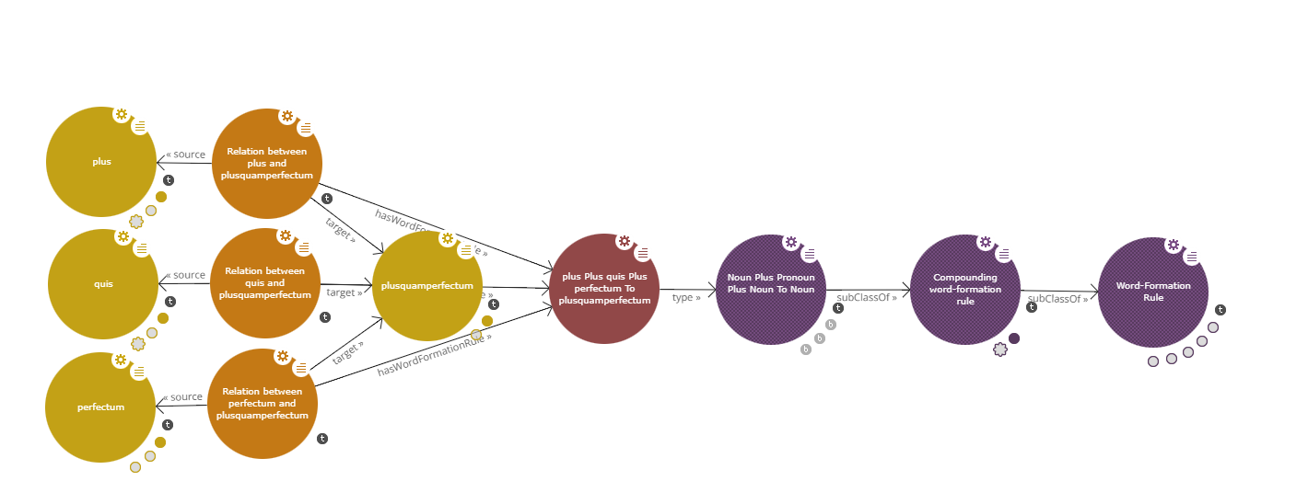

CC:

* attribute needed to mark morphological head
* 1 triple if morph:CompoundHead is subclass of morph:CompoundRelation or
* 2 triples if head should be expressed explicitly

Fahad:

* 2 different analysis: one involving expressing the head and one without
* → then 2 rules are used which indicate the two different analysis, i.e., rules disambiguate analyses

1. **New property to express wordclass constraints in word-formation**

<morph#dNV09%3E> morph:PLEASE_GIVE_ME_A_NAME_FOR_CONSTRAINTS "Nn"

express that a morph is only applicable to a certain part of speech

CC: In mathematical terms, an adequate term would be "domain", but this will be incomprehensible to linguists. I guess it should be an object property because in addition to providing a string value (which we should maintain as it is the original information), we would also want to spell it out in lexinfo features. Maybe "morph:baseConstraint"?

object property: morph:baseConstraint

domain: morph:Morph

range: morph:GrammaticalMeaning

The class morph:GrammaticalMeaning is like a container object containing lexinfo instances other instances which can have a plain string if we don’t have a lexinfo mapping

1. **Greek inflectional data example by Penny**

Used Lexis data (Greek extension of parole/simple)

What was aimed to be represented:

* morphological unit has grammatical category (part of speech) and canonical from, has an inflectional paradigm and is linked to the stems
* inflectional paradigm consists of constraints for part of speech and a set of grammatical features (number, case..) and a number reference to a stem and an ending (a suffix)
* representation of stress movement on syllables with morphophonological change
* representation of of link between morphological unit and graphic morphological unit

1. **Representing the order of morphs**

-------------------------------------------------------------------------------------------------------------------------------------

**ontolex:Form generation workflow diagram**

* for the process of creating the [finnish example data](https://docs.google.com/document/d/1iCv865GtEksO_wd0WC7bfU-at1dEKOOea9HSlFcTTkA/edit) generating:
  + ontolex:Form resources
  + ontolex:Morph resources
  + ontolex:LexicalEntry resources
  + triples: ontolex:LexicalEntry ontolex:lexicalForm ontolex:Form
  + triples: ontolex:Form morph:consistsOf morph:Morph

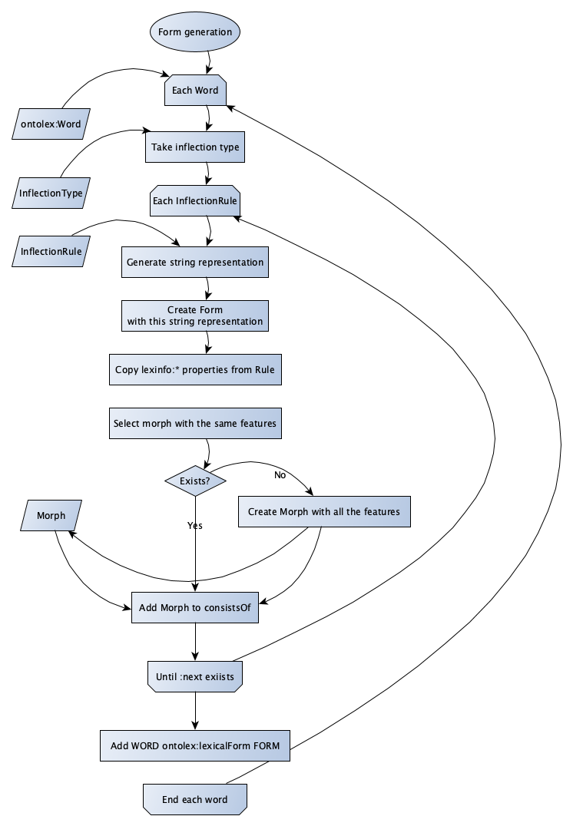

* BK: can we modify this diagram to include ontolex:LexicalEntry wordformation by compounding and derivation as well?

**After x-mas break next telco on January 12th 2022**

**Upcoming topics:**

* Continue discussing Penny’s Greek inflectional data
* Matteo: sends his presentation from 15th December and report on feedback
* Discussion of ordering