**Participants:**

Bettina Klimek (BK)

Christian Chiarcos (CC)

Matteo Pellegrini

Penny Labropoulou (PL)

1. **Module draft 4.5.1**

* removed morph:generates between morph:WordFormationRule and ontolex:LexicalEntry (advantage of morph:generates was to allow interrelations between ontolex:LexicalEntry resources and their underlying word formation processes in a general way without requiring the statements of lexicosemantic relations for the entailed sources and target resources)
* added morph:WordFormationType which represents the process (e.g. verb to noun) and morph:WordFormationRule represents the actual way of implementing it
  + JMC:Relation is between two specific lexical entries (compute/computer). Type represents the linguistic process (add -(e)r). Rule is a computational implementation (add "r" to end of string).

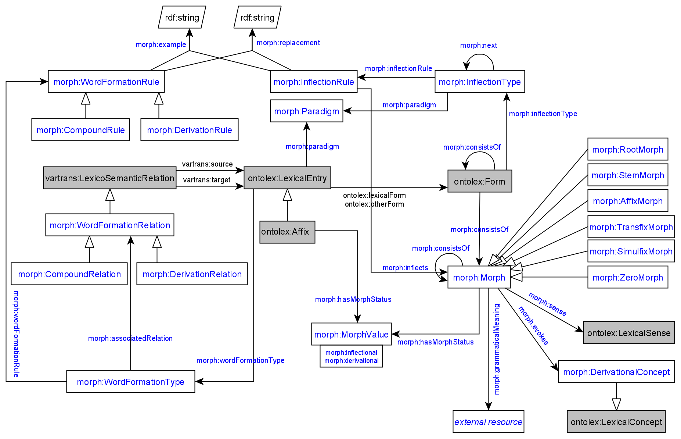

CC tried to convert data with 4.5.1, evaluation:

* WordformationType and WordFormationRule are hard to distinguish in practice and increase the size of data has been created without clear added value
* object property between WordWormationRelation and Morph missing

1. **Module draft 4.5.2**

* morph:Morph as subclass of ontolex:LexicalEntry
* results in morph:sense and morph:evokes being unnecessary (removed)

sample conversion of (complete) German UDer data under <https://github.com/acoli-repo/acoli-morph/blob/main/uder>:

* + transformation (SPARQL): <https://github.com/acoli-repo/acoli-morph/blob/main/uder/sparql/relations.sparql>
  + output (TTL): <https://github.com/acoli-repo/acoli-morph/blob/main/uder/de/DErivBase/0.5/relations.ttl.gz>
  + input (TSV): <https://github.com/lukyjanek/universal-derivations/tree/master/de/DErivBase/0.5> (needs to be built by calling `make`)

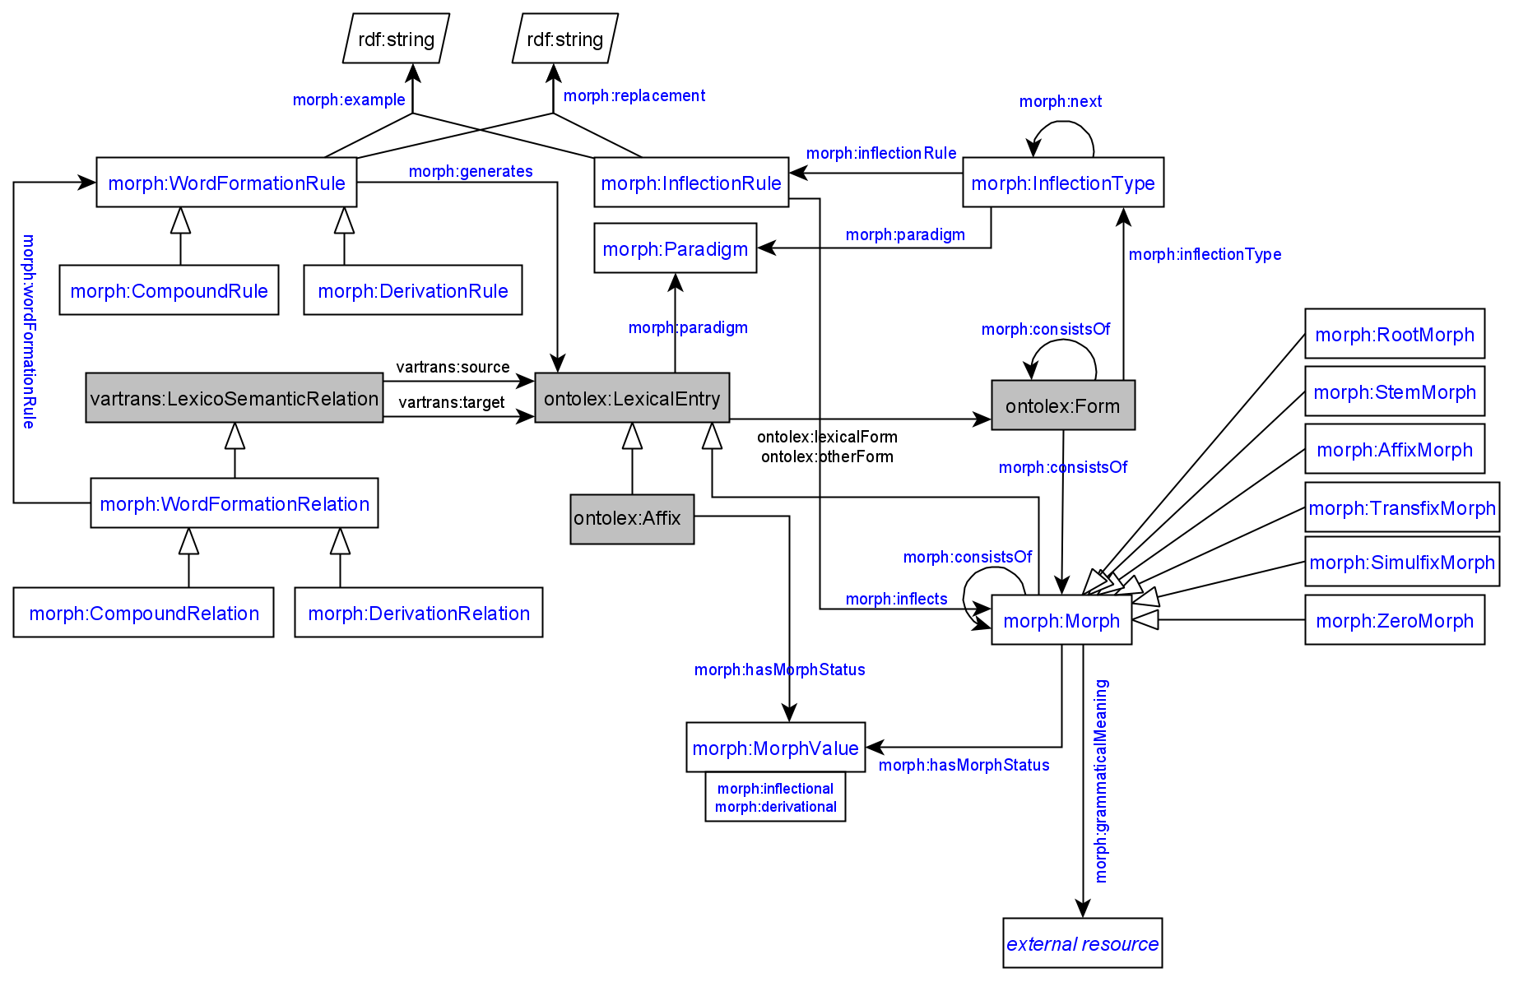

CC tried to convert data with 4.5.2, evaluation:

* vatrans:source could be used because Morph is a subclass of LexicalEntry
* WordFormationType class was not necessary

**URI:**<http://www.w3.org/ns/lemon/ontolex#LexicalEntry>

A **lexical entry** represents a unit of analysis of the lexicon that consists of a set of forms that are grammatically related and a set of base meanings that are associated with all of these forms. Thus, a lexical entry is a word, multiword expression or affix with a single part-of-speech, morphological pattern, etymology and set of senses.

**SubClassOf:** lexicalForm min 1 Form, canonicalForm max 1 Form, semiotics:Expression

**URI:**<http://www.w3.org/ns/lemon/vartrans#source>

The **source** property indicates the lexical sense or lexical entry involved in a lexico-semantic relation as a 'source'.

1. **Module draft 4.5.3**

* added object property morph:contains (for example) between morph:WordFormationRelation and morph:Morph

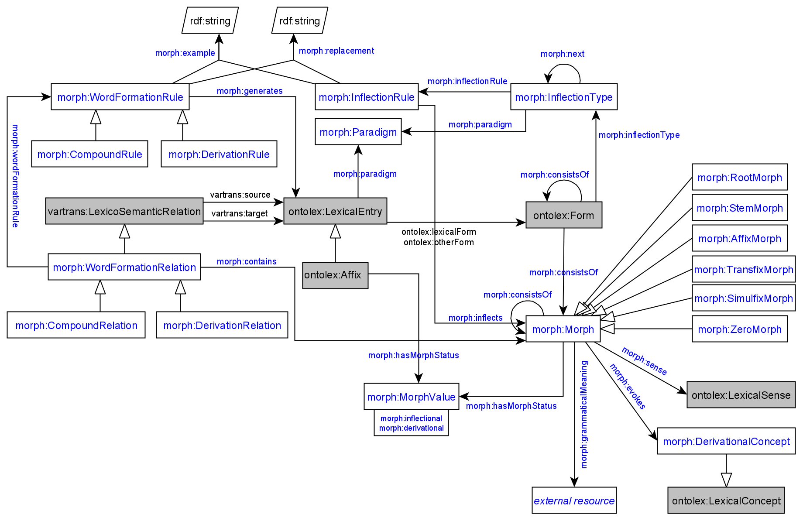

Adaptations of module draft 4.5 to be included for next telco:

* CC in favour of combining 4.5.2 and 4.5.3 because reduced redundancy to have morph:Morph as a subclasss of ontolex:LexicalEntry and since vartrans:source has the restriction “**subClassOf**: relates exactly 2 (ontolex:LexicalEntry OR ontolex:LexicalSense OR ontolex:LexicalConcept)” the additional morph:contains property in draft 4.5.3 is required
* changes:
  + start with 4.5.2: Morph sub LexicalEntry
  + add contains (not more than 2 vartrans:relates/source/target properties)
  + morph value as lexicalForm
  + merge ontolex:LexicalEntry and ontolex:Morph subclasses
  + allomorphs => otherForm
  + morpheme “value” => canonicalForm
  + ?rename morph:consistsOf?
* other changes:
  + not discussed, but CC in favor of eliminating the reundancy between DeroivationRelation and DerivationRule
  + do we need generates, if we have WordFormationRelations

addenda (post-call)

* CC: while converting sample data for composition, I was struggling *a lot*.
  + GermaNet uses n-ary compounds, if these are to be represented as a LexicoSemanticRelation (which is binary), the only way is to say for every subterm invidually that the subterm is source and that the compound is target. In this way, we loose order
  + we loose any information about which consituent is the morphological head (this is annotated in GermaNet)
  + how does a CompoundRule work if it does not access all subterms => I guess it must have access to all subterms, but it is hard to see how to write a replacement rule if the number of subterms and their order is unknown
    - if it does not have access to all subterms, but only to one suberm and the resulting compound, we cannot write replacement rules either
    - I consider this basically unsolvable. but with morph subclass of LexicalEntry, we can resort to decomp, here. we would probably not have a CompoundRule, then, but a CompoundRelation (to mark the morphological head)
  + as a last resort, we might restrict generative morphology to inflection and derivation, only. no compound rule, then

Todos:

* BK: create module diagram draft 4.6
* CC: provide example for Universal Derivations converted data with draft 4.6
  + DONE: commented data snippet under <https://github.com/acoli-repo/acoli-morph/blob/main/uder/Readme.md>
  + NB: sample data for UniMorph (inflection) under https://github.com/acoli-repo/acoli-morph/tree/main/unimorph
* PL: can share Parole Greek data set with inflectional data