**Participants:**

Bettina Klimek (BK)

Katerina Gkirtzou (KG)

John McCrae (JM)

Matteo Pellegrini

Christian Chiarcos CC

1. **Module draft 4.5**

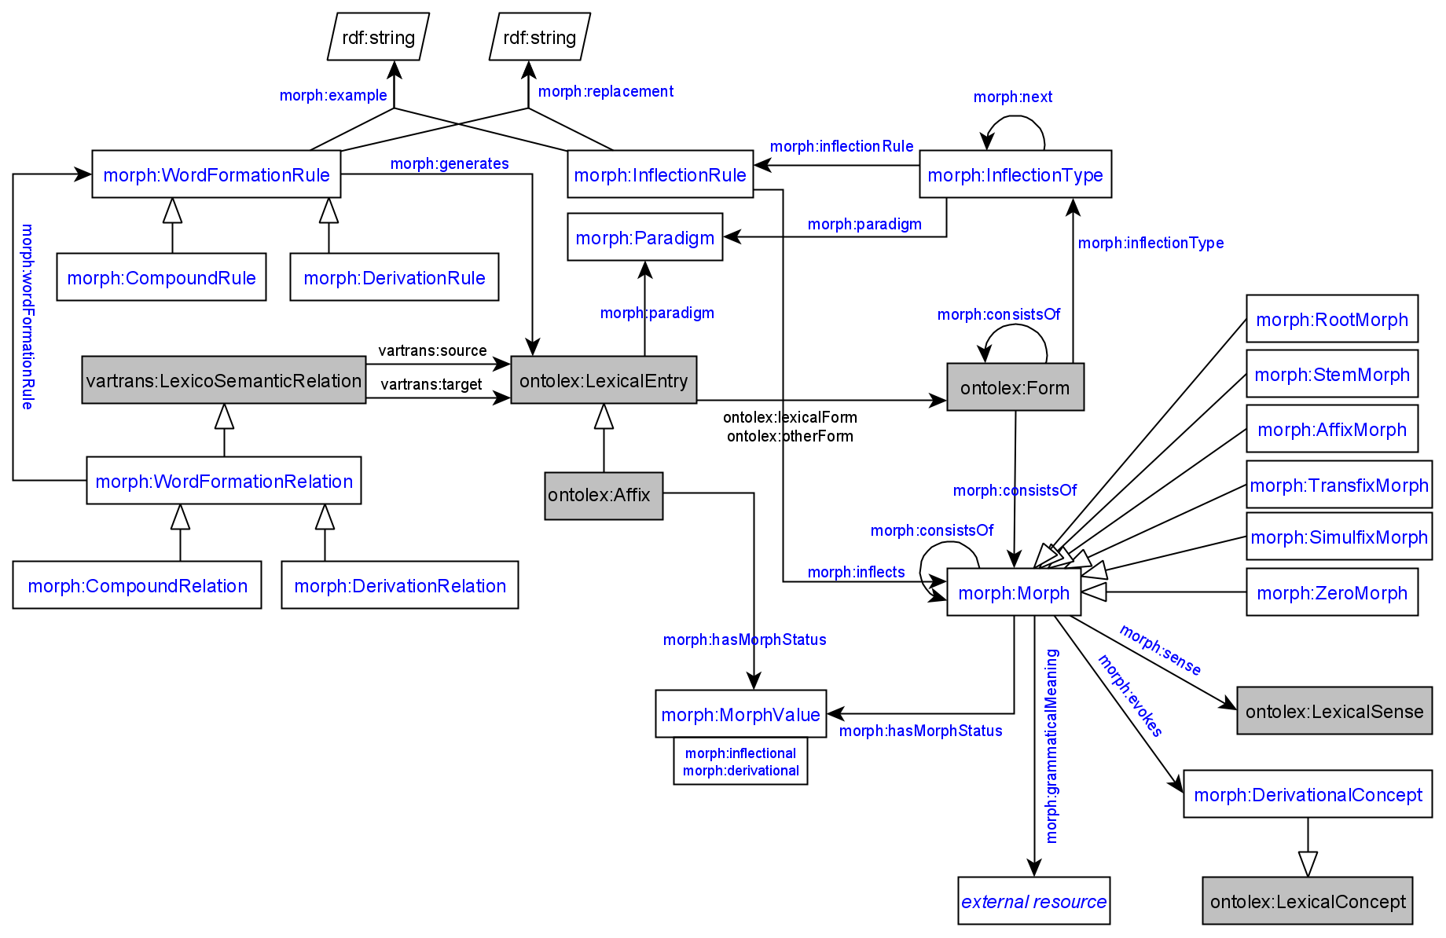

Included adaptations:

* renamed object property morph:hasParadigm to morph:paradigm
* renamed object property morph:hasInflection to morph:inflectionType
* renamed object property morph:generates between morph:InflectionRule and ontolex:Form to morph:inflects and changed the range to morph:Morph
* removed the ex:1 restriction on morph:generates

Adaptations of module draft 4.5 to be included for next telco:

* CC: note that we also need a corresponding rule to morph for derivation relation and compound relation (that is, unless we permit Morph as subject of vartrans:source and take multiple sources)
  + BK: proposal: remove morph:generates between morph:WordFormationRule and ontolex:LexicalEntry (because it seems to me as if it tries to represent the creation of the blank blank node that contains the combination of the derivation/compound elements while the resulting ontolex:LexicalEntry resource is then the product of what is specified in this blank node) and instead create the object property morph:contains (for example) between morph:WordFormationRelation and morph:Morph

General scope of the morph module vocabulary:

BK proposal:

* include vocabulary that describes static morphological data
* exclude vocabulary or modeling elements that are involved in the dynamic process of generating new (static) morphological data, e.g. blank nodes and/or object properties that can be misunderstood as “creating” or “generating” new resources and statements - instead represent morphological data generation processes with workflow diagrams
  + MI: use different namespace for data generation processes
  + MI: in favour of 2 separate diagrams - one for static data representation and one for generation process representation
  + JC: in favour of releasing one diagram containing everything
  + CC: execution of rules is out of scope of the model but the definition of rules should be contained

1. **LIAM Model**

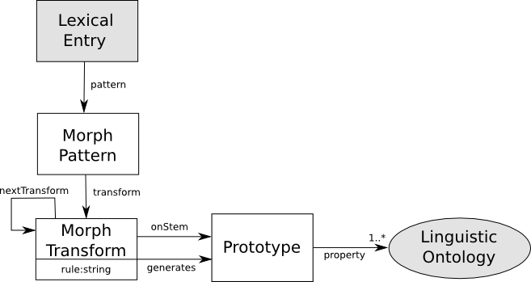

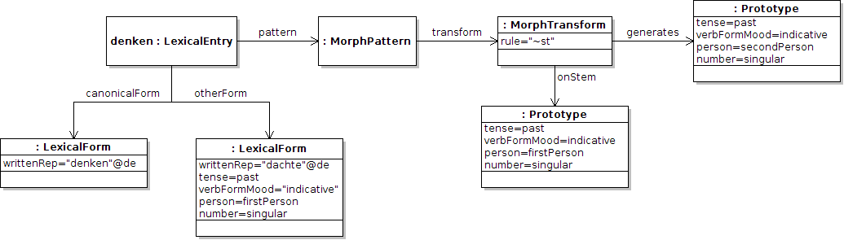

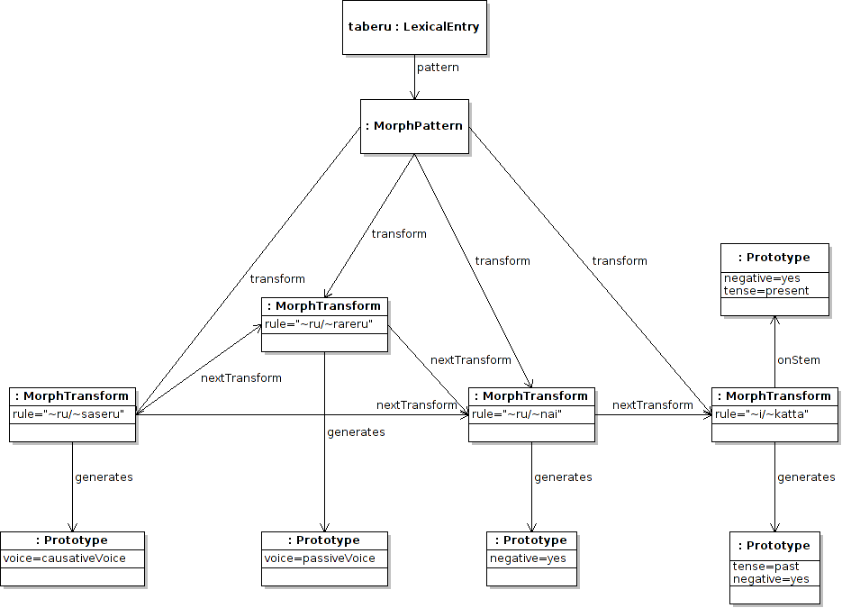

:MorphPattern → morph:InflectionType, morph:WordformationRelation

:MorphTransform → morph:InflectionRule, morph:WordFormationRule

:Prototype → blank node resulting from application of morph:InflectionRule and morph:WordFormationRule