Update for Maltese

Following from our telco 11/1/23 here is a small sample of Maltese data for the strong regular verb kiteb (to write) and some derived forms.

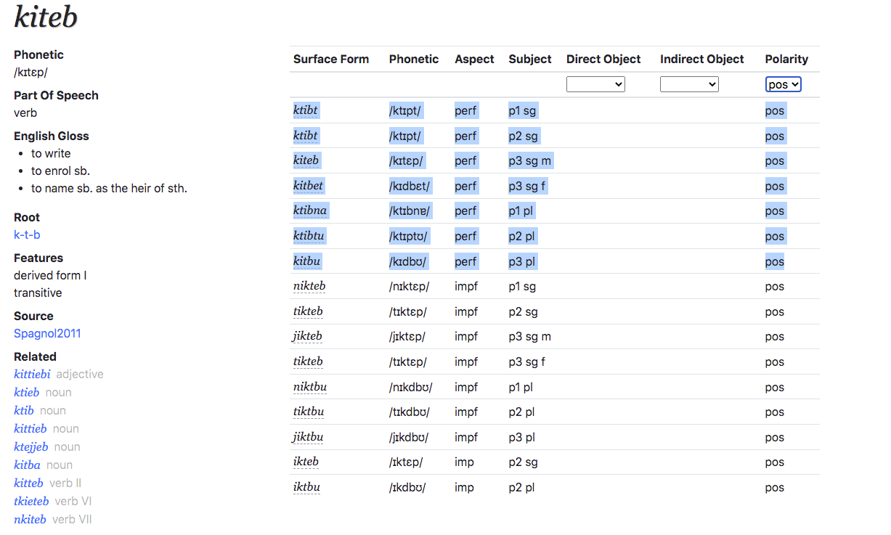

This output is generated from an online system and there is plenty more for many other verbs.

The output can be generated in textual form

There are rules for getting the surface forms from the root in this case k-t-b plus the vocalism - in this case i-e.

e.g. to get 1st and 2nd person sing in so-called imperfective (simple past) as shown with blue background

k-t-b + i-e

(interdigitation)

=> kiteb

suffix t

=> kitebt

delete V1

=> ktibt

Kiteb is a very regular “strong” verb. Its is not always as straightforward as this (e.g. vowels sometimes change) and there are many exceptions. These are based on e.g. syllabic structure and can get pretty complex.

I’d be happy to work with someone trying to create an instance of this - and other examples. Please let me know how to proceed.