**Sports league Usage Instructions**

**All the given requirements are handled, user authentication and authorization is also added**

* **On running the application from IDE, hit the url** [**http://127.0.0.1:8000/login/**](http://127.0.0.1:8000/login/) **or** [**http://127.0.0.1:8000/**](http://127.0.0.1:8000/) **which will take to login page, after registering login**
* **To skip Register/Login, please use this account: username – admin, password- root123**

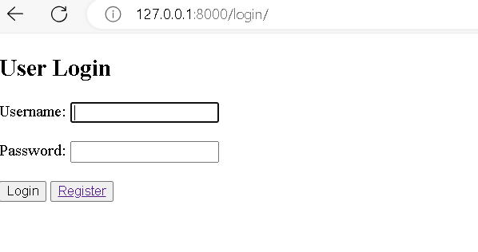

* **Upon login, it will take to the home page as shown below.**
* **Add/Edit/Delete, Upload csv file options are available in the same page.**

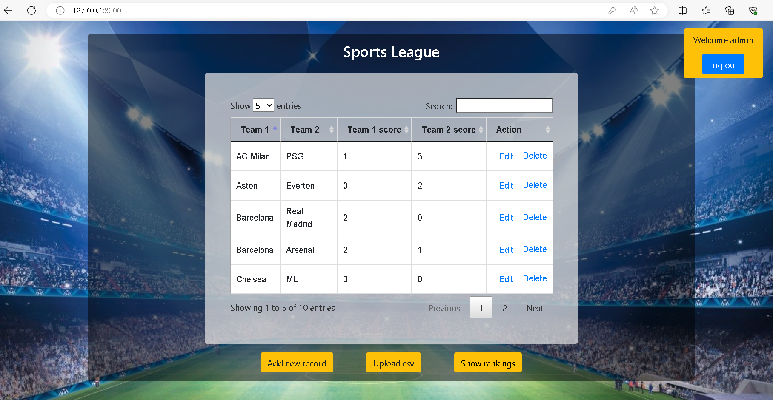

* **Rankings will be displayed on click of Show rankings button as shown below**

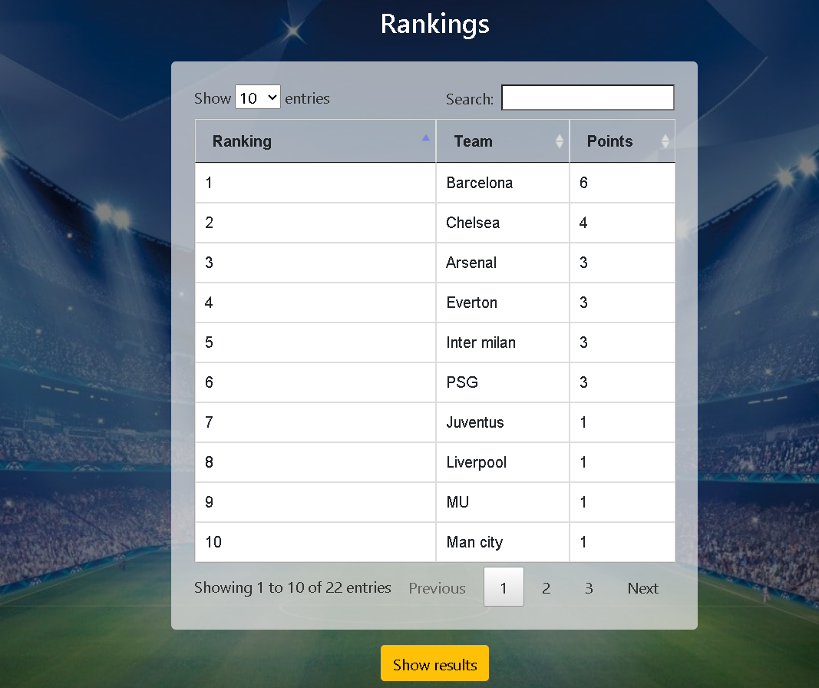

* **To run unit tests, please run the following command: py .\manage.py test ranking.tests**