1.
a.
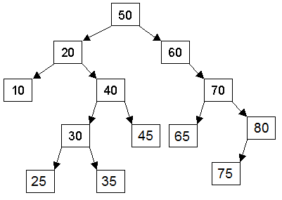
b.
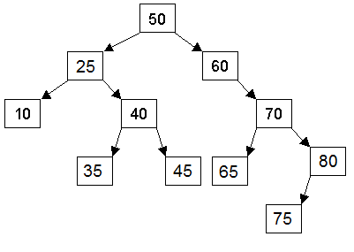

c.
Order the nodes are visited:
50
20
10
20
40
30
25
30
35
30
40
45
40
20
50
60
70
65
70
80
75

in order traversal
---
10
20
25
30
35
40
45
50
60
65
70
75
80

pre order traversal
---
50
20
10
40
30
25
35
45
60
70
65
80
75

post order traversal
---
10
25
35
30
45
40
20
65
75
80
70
60
50

2.
a.

(6
(3
(1)
(2)
(5
(4)
( )
b.
[6][3][5][1][2][4][ ]

c.
(5
(3
(1)
(2)
(4
( )
( )

[5][3][4][1][2][ ][ ]

3.
a.

struct Node{

int data;

Node* parent;

Node* left;
Node* right;
}

b.
// take the current node, and the inserted data. Compare it to the node's data
// if the new data is less than the current node's data, then consider the left Node
// otherwise, consider the node to the right
// if the considered Node pointer is not NULL
//then repeat with the considered Node
// Otherwise if the considered Node IS NULL
//create a new Node at that pointer
//pass it the new data to be inserted
//set its left and right nodes to NULL and set its parent to the current node

4.
a.
Adjacency Matrix:
A B C D E F G H I
A0 1 1 0 0 0 0 0 0
B0 0 0 0 0 0 0 1 0
C0 0 0 1 1 0 0 0 0
D0 1 0 0 0 0 0 1 0
E0 0 0 0 0 0 1 0 0
F0 0 0 0 0 0 1 0 1
G0 0 1 0 0 0 0 1 0
H0 0 0 0 0 0 1 0 0
I0 0 1 0 0 0 0 0 0

Adjacency List:
A -> B C
B -> H
C -> D E
D -> B H
E -> G
F -> G I
G -> C H
H -> G
I -> C

b.
"H" / "G" are sometimes visited twice to check
if the shortest path has been found

E,G,H,C,D,B

E,G,C,D,H,B

E,G,C,D,B,H

