Forestry Scenario
Gordon Klundt
2023-12-21T12:29:01Z

Forestry Scenario
In This Page
- Overview
- Simple Architecture
- Scaling Objectives
  - Multi-Tenant Support
  - Multi-Client & Multi-Region Support
  - Multi-Application/Capability Support
  - Microservice Domains
  - Data Modeling
- Objectives and Key Results
  - Focus on cross-cutting concerns as initial microservices
  - Building Discipline and Rigor with CI/CD practices
  - Build/Replace Functionality with respect to Domain Decomposition
  - Isolate independent microservices when they are ready

Overview
The forestry domain consists of several interdependent sub-domains and operates as a set of systems that are driven by supply and demand. The challenge is to manage commodity resources and reserve levels in order to meet demand at a price point where it is profitable to operate. It is also crucial to consider sustainability and environmental factors that could endanger the supply including over-production, seasonal climate and global trends, seasonal and market market purchasing patterns, supplies and human resources. It is important to understand the nature of the industry in order to make informed decisions about the architecture of the various applications used to manage each aspect of the industry. These aspects can be categorized according to the workflows and kinds of resources being managed at each phase of operations.
- Land Resource Management
- Procurement and Inventory Management
- Field Operations and Harvesting
- Transportation and Dispatch
- Manifest Transfer and Reconciliation
- Finished Product Processing, manufacturing and provenance
- Reporting, Integration and Visualization
It is important for businesses in this industry to operate in a responsible and ethical manner. This introduces several regulatory compliance constraints that must be built into the system in order to satisfy an ever-changing set of reporting and fee requirements. In addition, these requirements must be applied non-uniformly across the entire market which means that different rules apply to different parts of the world, countries, states and municipalities.
A highly complex financial model is required in order to support this landscape of interconnected and regulated processes. Ultimately, the final sale of processed goods to consumers funds the entire operation from the farm to the consumer. It is not easy to predict the market factors that set the price to consumer, especially when the prediction must be made several years in advance of the market. This means that any business in the industry will be funded based on estimations of future production and sales and depends heavily on contracts and careful selection of harvest and production activities that maintain the balance of supply and demand in order to keep operating and capital costs below revenue projections.
The application of software to these business processes must make sense across all aspects of the business. In order to provide end-to-end solutions, it is not only important to understand the users and personas and their individual requirements, but also to understand the workflows, transactions, artifacts and interactions that facilitate the flow of information, goods, services, and money between the users and personas and how they change over time.
The following questions were presented as an architectural challenge to design a multi-tenant, multi-application, multi-region set of microservices capable of facilitating and automating the forestry industry scenarios above.
Questions:
- Provide specifications required for the components (with API call examples) for a scalable microservices architectures providing REST services for multiple multi-tenant web applications.
- Describe how to scale a multi-region system that runs microservices in AWS/Azure, containerized or serverless back end services with scaled databases (will support both mobile and web-based applications).
- Describe the performance considerations required to make an efficient event based architecture utilizing microservices.
- Describe the specifications for an example API design with global data models and examples for transformations to convert data to the model.
- Describe how a data feature that includes machine learning or AI functionality would consume the data to provide an app layer user ability that would consume the data mode via the API.
- Provide a code example (stub code, language of your choice) for a user feature level interface of a search engine, recommendation engine, or other user level feature that would use a large data set (where an ML or AI model could be applied) that considers all of the above that would provide an example for developers to expand on to built out an app.

Simple Architecture
I would like to begin the discussion with a simple diagram of a full stack application that uses a REST API to abstract resource management from a web application.
This representation illustrates at a very high level that a “User” uses some “Client Agent” to access some “Application” that manages “Data” through an “API”.
A key thing to note at this point is that the “microservice” architecture will expand this pattern and create collections for each base component and further categorize each component according to its kind.
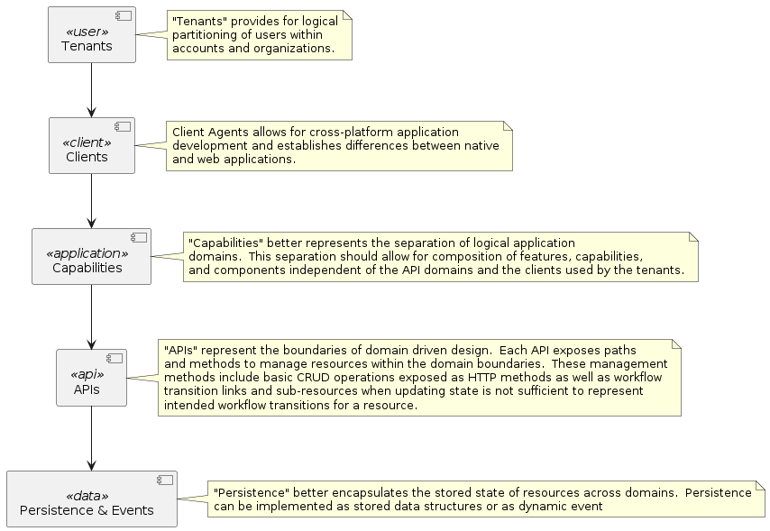
Moving toward a microservice architecture requires modular discipline along loosely coupled, clearly defined domain boundaries and incurs a complexity penalty that initially impedes productivity. Initially, it may be better to build up maturity and rigor around key practices for supporting microservices and isolate functionality when the boundaries are more apparent.

Scaling Objectives
The microservice architecture will address the main concern of deploying single purpose, cohesive, loosely coupled resource domains in isolation. This has the secondary effect of independently scaling the services to meet the load concerns for that domain. Using the simple architecture provided, I want to point out the scaling opportunities and challenges for each component

Multi-Tenant Support
Users must be authenticated using a common authentication provider. The identity provider must implement standards, namely OAuth and OpenID in order to provide a common framework for authentication and authorization across all services.
Scopes and claims identified for each user within the application context should provide the appropriate boundary information to properly access segregated data based on various boundary criteria such as organization context, account context, regional context, role association, etc.
Note that Trimble ID implements the OAuth 2.0 framework and has a fixed set of OpenID claims provided within a scope. It will be necessary to supplement the scope context for authorization in order to fully implement tenancy within the forestry (or any) sector. For this reason, I would suggest implementing a context provider service as a microservice with the single responsibility of setting and providing a partial context graph for a user within the scope of an application. This “partial graph” should include key user associations such as organizational and account affiliations as well as application entitlements (for monetization). The partial graph should also carry domain specific information regarding application role membership for workflow activities and granular access controls for actions and resources within an application and resource domain.
Setup User Context Within Application Scope
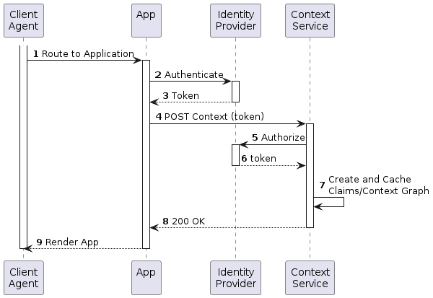
Use User Context To Realize Multi-Tenant Requirement
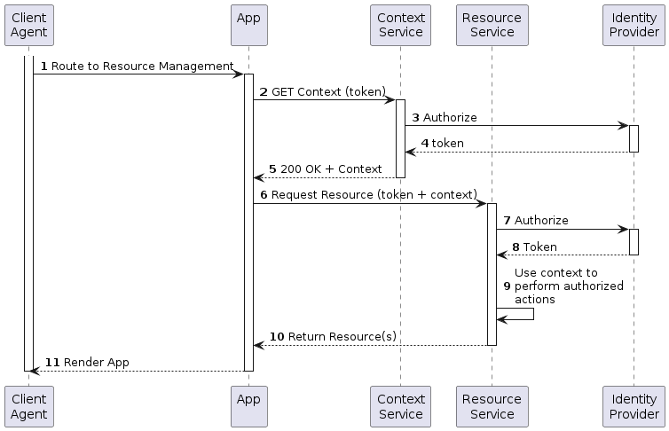

Multi-Client & Multi-Region Support
Applications will be implemented as mobile and web applications. Both types of client agent will need to be routed to the regional distribution of the application or service depending on rules configured in the content delivery network. These rules can be further enhanced with user preferences provided in the context for the application scope provided for the user.
Use AWS CDN to Route to Regional Distributions
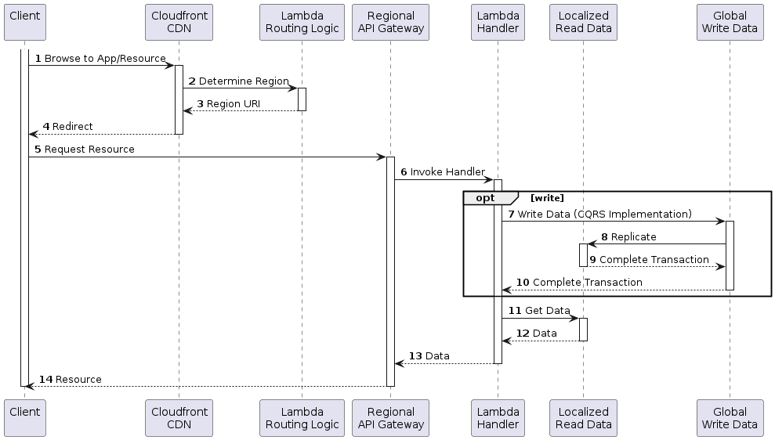
Notes:
The Routing Logic Lambda component in this diagram could determine the best region based on any number of factors. It could use Route 53 latency data to route to regions of lower latency, it could use the clients Geo IP information to route to Geo Isolated regions, it could even use the context microservice to determine regional routing rules based on preferences configured in the user’s context graph.
The Data layer in this diagram assumes a Command Query Responsibility Segregation (CQRS) pattern where read data is replicated to localized regions from a write replica of the source data.
The microservice implementation in this diagram is a serverless implementation that invokes a lambda based on requests to paths defined in the API Gateway. The regional gateway could be replaced with a containerized implementation of the API using ECS services, Kubernetes Services, or even EC2 depending on the requirements.

Multi-Application/Capability Support
Ideally, the UI/UX design will be component based and capabilities should be composable depending on the entitlements and features enabled for the user. The capabilities should be rendered as activities, screens, or components that access the various microservice endpoints and paths. All applications and capabilities must be context aware and based on context provided from the context microservice in order to constrain access to attributes and/or roles defined for the given identity.

Microservice Domains
It is unclear at this point what the demarcation boundaries should be across the forestry domain. We should be cautious of the initial assumption that domain boundaries should be set along business workflow lines. Although this does seem like a logical separation of concerns for the cohesion/coupling responsibilities of microservices, inter-service communication should be minimized based on grouping resources that change together within that service domain. Failure to group resource management will result in tightly coupled microservices and will defeat the purpose of separating the concerns to begin with an create a “fragile system”. It is also possible to inadvertently create services that are too small in scope (low cohesion) that will force deployment of multiple dependent services, thereby creating a “distributed monolith”.
Truly identifying single purpose, loosely coupled, highly cohesive microservice domains will reduce the complexity of inter-service communication. This has severe performance implications for the performance of the microservices with regards to the messaging infrastructure and transaction management for cross-domain transactions. By localizing all cohesive transactions within a service domain, transaction locking for multi-resource updates can be handled efficiently and synchronously in process within the service domain. This also minimizes transactional integrity problems with concurrency in a multi-user/multi-tenant environment by delegating the lock and transaction management to the database subsystem for that domain.

Data Modeling
This is an extremely broad topic and requires a non-trivial level of discipline and governance. Every API resource will reference components defined in a specification. It is easy to gloss over the component definition of a resource in an OpenAPI Specification. For this reason, I would highly recommend using a tool like Stoplight to manage and control component libraries for import of common, versioned models.
Additionally, models defined in component libraries should have corresponding versioned json-schema and, ideally, semantic context defined using json-ld.
By introducing this level of standardization, we can use the features of json-ld to perform transformations based on semantic context mapping rather than directly mapping “field-to-field” transformations on a spec-by-spec basis. The context-based approach of json-ld allows for flattening and canonizing models. This is useful for “recomposing” a model in one context to a semantically equivalent model of another context effectively creating the basis for data transformation based on semantics rather than schema. However, schema is important as well. Data types defined in the json-schema version for a field in one context should match the type of the semantic equivalent in another, but this is not always the case. In most cases, data type mismatches that occur in contextual mapping can be handled by coercing the data to the least restrictive data-type (e.g. integer -> string).
Using the semantic context of json-ld also allows us to realize “data mesh” capabilities for models shared across domains. An example of this is can be illustrated with user context. It is possible to source elements of a user context from a domain service like the “forestry context service” alluded to in this discussion. This context can be composed of domain specific attributes in addition to higher level contexts provided by other context providers. Specifically, context provided by corporate services such as Profiles. Other areas where this mesh capability is useful is by adding forestry specific context to assets from other transportation domains such as Routes, Trucks, Equipment in the logistics domain as well as mapping features and layers for custom roads and alerts in geo data.

Objectives and Key Results
I believe that transitioning to microservice architecture can be measured as an initiative within the following objective categories.
- Focus on cross-cutting concerns as initial microservices
- Building discipline and rigor on CI/CD practices
- Build/Replace Functionality with respect to Domain Decomposition
- Isolate independent microservices when they are ready

Focus on cross-cutting concerns as initial microservices
- Authentication
- Authorization and Context Handling
- Monitoring, Observability, Fault Handling and Logging

Building Discipline and Rigor with CI/CD practices
Build Discipline in continuous integration and deployments
- Regional Routing and Content Delivery
- Feature Flags, Continuous Integration and Continuous Deployment

Build/Replace Functionality with respect to Domain Decomposition
- API Standardization, Tagging, Linting and Maintenance
- Data modeling, semantic, logical and physical (JSON Schema + JSON-LD)

Isolate independent microservices when they are ready
Build or Replace Functionality based on Domain Decomposition
Decomposition Methods
By Business Capability (Disadvantages)
By sub domain (too many microservices and low cohesiveness)
By Transactions
Per Team and capability (API negotiation and dependencies)
Strangler Fig (outside-in replacement)
Transform (create new components on the edges),
Coexist (intercept outside calls and redirect to new components),
Eliminate (retire old functionality from monolith)
Branch by Abstraction (inside-out replacement)
Watch for data consistency issues
Requires change to existing system (expected and good)

Index

