**安装craco**

npm install @craco/craco craco-less

**修改package.json 文件的scripts**

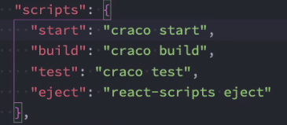

**根目录下创建craco.config.js文件**

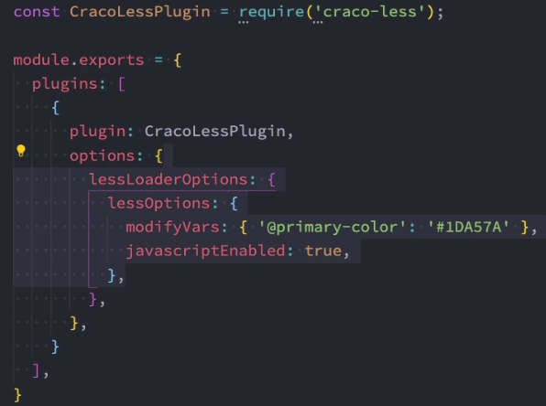

const CracoLessPlugin = require('craco-less');

module.exports = {

plugins: [

{

plugin: CracoLessPlugin,

options: {

lessLoaderOptions: {

lessOptions: {

modifyVars: { '@primary-color': '#1DA57A' },

javascriptEnabled: true,

},

},

},

},

],

};

**起别名配置**



