**Terser(JS压缩)**

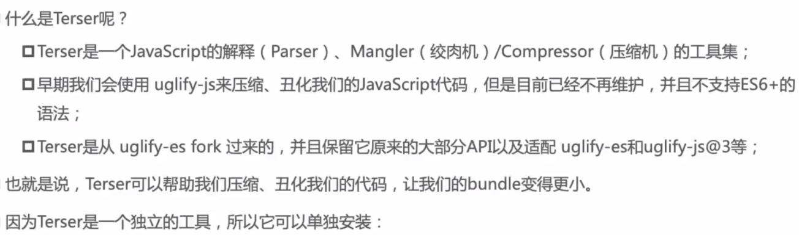



直接调用



Webpack配置

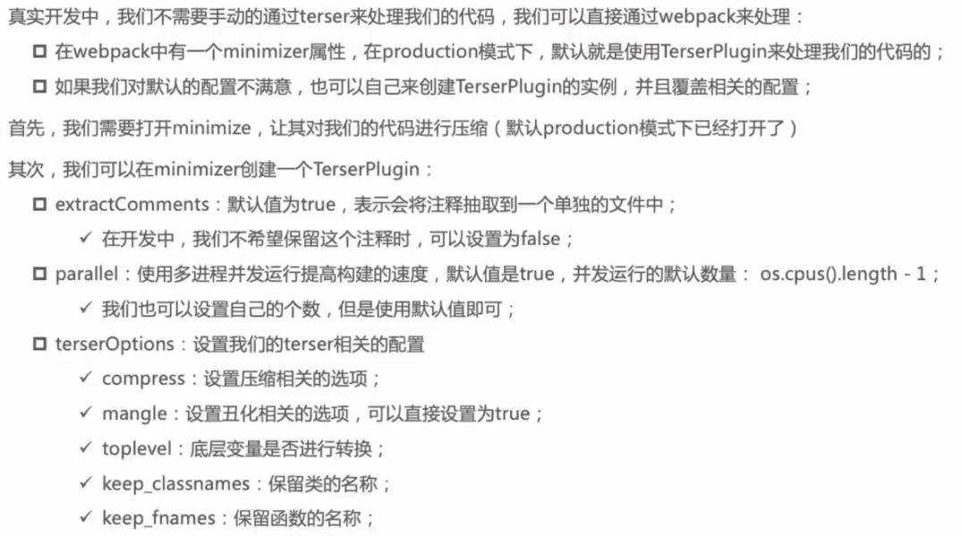



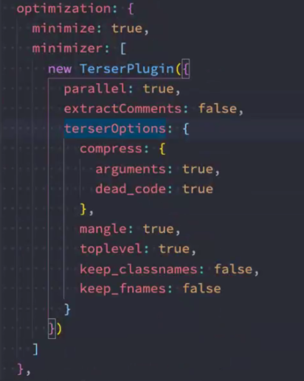

**css-minimizer-webpack-plugin(CSS压缩)**





