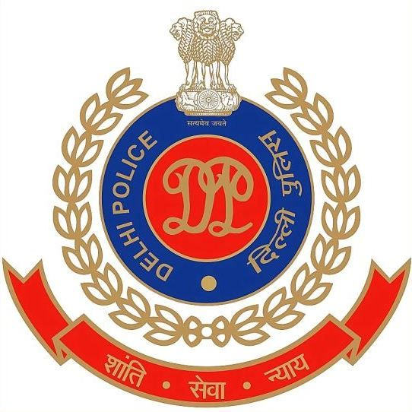
OFFICE OF THE STATION HOUSE OFFICER, CYBER POLICE STATION, NORTH DISTRICT, DELHI, INDIA

Assistant Commissioner of Police Operations Office Complex,
Behind Daulat Ram College, Maurice Nagar, Delhi-110007, INDIA
EMAIL: - shocyber.north@delhipolice.gov.in (Mob No.) +916828402037
No. Cyber Police Station, North Delhi, Dated the / /2026

Subject: Notice under section 94 of the BNS in Cyber CC No. 1010/2026 PS Cyber, North District, Delhi.

Brief facts of the case:
A complaint has been received at PS Cyber North, Delhi, regarding the alleged misuse of AI technology to create a manipulated image depicting the Hon’ble Prime Minister, which was subsequently circulated on multiple social-media platforms. During preliminary inquiry, the said image was found to have been shared through a Facebook account bearing the username “sushil.bhardwaj.5”. The matter is being investigated to ascertain the source, creator and persons responsible for circulation of the said content. You are, therefore, requested to kindly provide the following details in respect of the above-mentioned accounts/profiles:

The alleged Facebook User ID is:

sushil.bhardwaj.5

- Provide complete account/subscriber details, including username, registered email ID(s), mobile number(s), and profile information.
- Provide account creation date, registration IP address, and user-agent details.
- Provide complete login/logout details, including date/time, IP address from account creation till date.
- Provide details of all linked/associated email IDs, mobile numbers, and social-media accounts.
- Kindly provide the origin/creation details of the following Facebook URL, including upload date/time, originating IP, uploader/account details, device and user-agent information, and available details of subsequent shares/reposts:
https://www.facebook.com/story.php?story_fbid=28001991726136342&id=100002566681125&rdid=g6cUsbwyXpTM01Ae#

The said information is required as per the provisions laid out for police investigations under section 94 of BNSS 2023 (India) which reads as follows: “ (1) Whenever any Court or any officer in charge of a police station considers that the production of any document, electronic communication, including communication devices, which is likely to contain digital evidence or other thing is necessary or desirable for the purposes of any investigation, inquiry, trial or other proceeding under this Sanhita by or before such Court or officer, such Court may issue a summons or such officer may, by a written order, either in physical form or in electronic form, require the person in whose possession or power such document or thing is believed to be, to attend and produce it, or to produce it, at the time and place stated in the summons or order. (2) Any person required under this section merely to produce a document, or other thing shall be deemed to have complied with the requisition if he causes such document or thing to be produced instead of attending personally to produce the same.(3) Nothing in this section shall be deemed—(a) to affect sections 129 and 130 of the Bharatiya Sakshya Adhiniyam, 2023 or the Bankers’ Books Evidence Act, 1891; or(b) to apply to a letter, postcard, or other document or any parcel or thing in the custody of the postal authority.”
The above documents/details of the above account may be sent urgently, as these details are required for further investigation. An early response is highly solicited.

SI Renu
CYBER POLICE STATION,
NORTH DELHI, INDIA
TO,
Facebook, Inc.
1601 Willow Road,
Menlo Park, CA 94025

