The ApexPlanet Sales Data Story
Data Analytics Internship — Task 4 Final Narrative

1. Objective
ApexPlanet's 1,000-order sales dataset was cleaned, explored, and segmented across Tasks 1–3. This report pulls those findings into one narrative: what the data shows, what it means for the business, and what to do about it — backed by a formal statistical test rather than a chart that merely looks convincing.

2. The Analysis, in Order

2.1 Getting the data ready (Task 1)
The raw dataset had two real problems: 20 missing Age values, 13 missing City values, and — the standout issue — the Order_ID "ORD100050" was mistakenly reused across 9 different transactions. All three were fixed before any analysis began; without that step, any customer- or order-level finding downstream would have been unreliable.

2.2 What the data shows (Task 2)
Electronics is the single largest category by revenue (₹50.8M, 36.4% of the ₹139.4M total) despite being only 35% of order volume — it earns more per order than any other category. Revenue is right-skewed: a small number of high-ticket orders pull the average order value (₹1,39,399) well above the median.

2.3 Who the customers are (Task 3)
Clustering customers by spend, order frequency, and age split them into three clean groups:
Segment | Customers | Share | Avg Spend | Revenue Share
Low-Value / One-Time | 631 | 66.6% | ₹76,117 | 34.5%
High-Value / Big-Basket | 264 | 27.9% | ₹2,84,833 | 53.9%
Repeat Customers | 52 | 5.5% | ₹3,11,035 | 11.6%
28% of customers generate 54% of all revenue. That's the single most important number in this dataset — but a striking split in a table isn't yet proof it's real and repeatable, rather than an artifact of who happened to be in the data.

3. Putting the Key Finding to the Test
Hypothesis: High-Value / Big-Basket customers have a significantly higher order value than Low-Value / One-Time customers — not just on average in this sample, but as a real, generalizable difference.
- H0 (null): no difference in mean order value between the two segments.
- H1 (alternative): High-Value / Big-Basket customers have a significantly higher mean order value.
Both segments' customers placed exactly one order each, so their order values are independent observations — the right test is an independent two-sample t-test. A Levene's test first confirmed the two groups' variances are significantly different (p = 1.01×10⁻¹⁷), so Welch's t-test (which doesn't assume equal variances) was used.
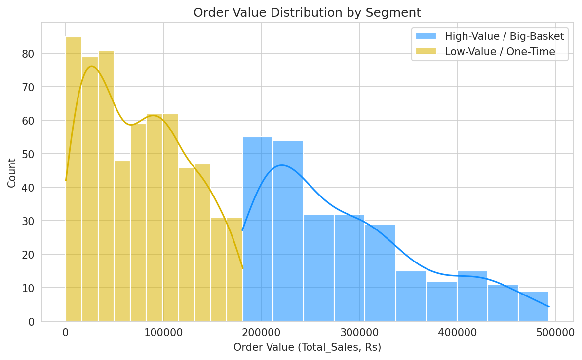
Metric | Value
High-Value / Big-Basket mean order value | ₹2,84,833 (n = 264)
Low-Value / One-Time mean order value | ₹76,117 (n = 631)
Welch's t-statistic | 38.93
p-value | 2.64 × 10⁻¹²⁹
Mean difference (95% CI) | ₹2,08,715 [₹1,98,171 – ₹2,19,260]
Effect size (Cohen's d) | 3.43 (conventionally "large" is 0.8)
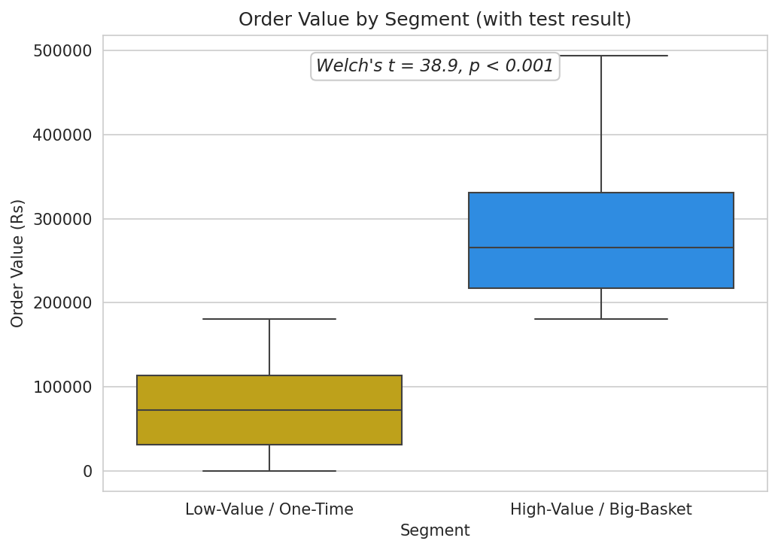
With a sample this large, even a trivial difference can become statistically significant — so the effect size matters as much as the p-value here. A Cohen's d of 3.43 means the two groups barely overlap: this is a large, practically meaningful gap, not a sample-size artifact.

4. Conclusion & Call to Action
The 54%-of-revenue-from-28%-of-customers finding holds up under a formal test — it's a real, large, and statistically confirmed pattern, not noise. That changes it from an interesting chart into something worth acting on.
- Priority action: the ~264 High-Value / Big-Basket customers order only once on average (per Task 3). Converting even a small fraction of them into repeat buyers is now a statistically justified, high-leverage investment — each one is confirmed to be worth roughly ₹2,08,700 more per order than a typical one-time customer.
- Secondary action: the 52 existing Repeat Customers are proof this conversion is achievable. Study what made them come back and turn it into a deliberate second-order incentive for the High-Value segment.
- Category focus: pair the retention push with Electronics, since it already drives the most revenue per order and likely overlaps heavily with the High-Value segment.

5. Deliverables
- GitHub: this report (Data_Story_Report.docx), the hypothesis-testing notebook (ApexPlanet_Hypothesis_Testing.ipynb), and the final presentation deck (Final_Presentation.pptx).
- LinkedIn video: 7–10 min — walk through the segmentation finding, show the hypothesis test as the proof point, and close on the retention recommendation.

