**Get Fit With An Indoor Climbing Wall**

By Jane Blanchard

Not only are climbing walls fun, they're a legitimate way to exercise and keep fit for both kids and adults.

Many people are familiar with climbing walls, but not everybody knows that they can install one in their own home. There are many benefits to using a climbing wall. These benefits go for both adults and children.

If you don't know anything about them, or even if you do, continue reading to discover everything you need to know about putting a climbing wall into your home.

## What's A Climbing Wall?

For the uninitiated, a climbing wall is exactly what it sounds like. Think of it as an artificial rock face made to simulate rock climbing, but far safer. It can consist of materials such as plywood or fiberglass, and harder materials like steel and aluminum. There are even inflatable climbing walls and walls made of any number of other materials.

The wall typically consists of holes, which you can use to place holds securely. The wall itself usually has an uneven texture to simulate a rock wall. But that's not always the case. This is all to simulate and encourage the sport of climbing.

## Why Climb? Are There Benefits?

There are tremendous amounts of benefits to climbing. Not only is it an actual sport, it can also work as a leisurely exercise or a competitive one. In addition, it's plain fun for all ages, which sounds like a cliché, but is absolutely true when it comes to climbing.

As an exercise, it can work wonders. It's a cardiovascular exercise (cardio, aerobic), so it helps with many of the same things that a daily walk, jog, or swim help with. These include:

* Lowering blood pressure and improving circulation
* Strengthening the heart
* Improving your respiratory functions
* Promoting fat loss
* Increased endurance
* Improving metabolism
* Reducing stress
* Improving your mental state and mental capabilities

And that's not even all the benefits that wall climbing offers. There's also the increase in strength and muscle, especially core muscles. Really, you can get a full body workout just by climbing a wall.

### Benefits for Kids

All the benefits that come with wall climbing for you are also relevant for children. Kids love to climb, so why not provide them a safe means to do it? Wall climbing builds confidence, mental dexterity, and strength in children.

For short walls, there's no real worry about safety, just add some padding to the base on the floor, sometimes called a crash-pad. The climbing wall can even form a feature of a child's room. For larger walls, you will need a belayer. This goes for both you and a child.

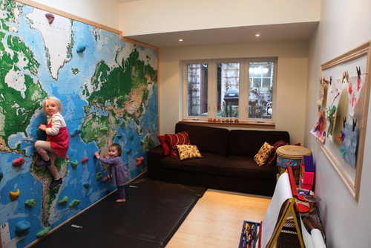

Via [Houzz](http://st.houzz.com/simgs/8591b4600183f187_8-1092/eclectic-kids.jpg)

## Why Put a Climbing Wall in Your Home?

There are many gyms and other places devoted to wall climbing. You can always go out, join a club or get a membership, and climb to your heart's content. But many people like to bring these benefits home.

It's no different from wanting an exercise bike or a treadmill in the basement. You may still go out to the gym, but you like having the gym at home when possible. Some people just don't have access to a wall climbing gym or an outdoor wall climbing facility.

Since a climbing wall is literally just that, a wall, it won't take up a lot of space or intrude in your day-to-day life. It's an enhancement, not a hassle.

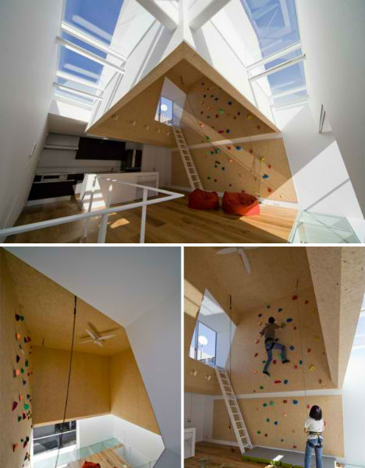

Via [weburbanist.com](http://weburbanist.com/2013/03/25/domestic-daredevils-12-insanely-cool-home-climbing-walls/)

## Climbing Wall Options

There are many options for adding a climbing wall to your home. There are do-it-yourself tutorials all over the Internet. But you may want to either purchase a preconstructed wall, or have a contractor do it for you if you're not handy with a few tools.

First you need a space, practically anywhere will do. Many people like to use the basement or a garage for their indoor climbing wall. It's possible to construct a freestanding outdoor climbing wall as well, but that defeats the purpose of having it indoors.

The DIY option usually involves using plywood. This is the most basic type of climbing wall. It's sometimes referred to as a "woody."

* You start by framing a load-bearing wall
* You take plywood, drill holes into it and place t-nuts
* You mount the plywood, place bolts through the holes, and then you add holds
* You can purchase holds, or you can drill a hole into just about anything sturdy

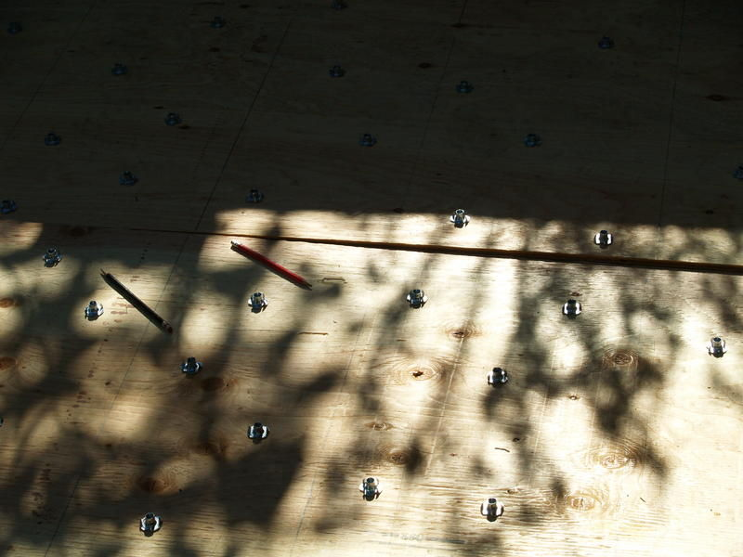

Via [instructables.com](http://www.instructables.com/id/Give-Yourself-a-Woody-Build-a-Home-Climbing-Wall/?ALLSTEPS)

These are, of course, oversimplified instructions. Also, they're for the most basic of straight climbing walls.

A DIY project can go far beyond this if you have the time, tools, and inclination. It's the cheapest option since all you need is some 2x4s for framing and plywood for the wall itself. The nuts and bolts don't cost much and neither does a drill if you don't already have one. It can be a fun weekend project with friends, or you can do it alone.

More advanced walls do require help and the expense will grow as you will need to use more specialized equipment, more tools, and different types of materials. This is if you want textured and irregular walls.

Involving a professional can help you do a lot more with your indoor climbing wall. This is especially true if you're willing to go a custom route rather than using a wall you have available. There's literally an unlimited amount of configurations, options, designs, and ways to implement a climbing wall in your home.

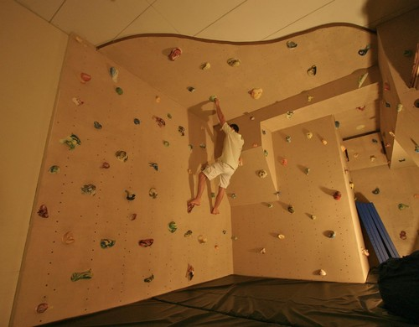

Via [Houzz](http://www.houzz.com/photos/815899/Pirate-Ship-Room-and-Other-Fun-Things-eclectic-home-gym-minneapolis)

## Things to Remember

There are techniques, styles, and even climbing equipment that you can utilize as you practice and become more advanced. But it's important to remember that indoor climbing is not the same as outdoor climbing. And neither is the same as natural rock climbing. So show care and learn the ropes before you try to transition from indoor to anything else.

## Give a Climbing Wall a Try

A climbing wall can be as simple or as complex as you want it to be. The only real constraints are your available space and your budget. But as stated, even a very basic plywood climbing wall can fit virtually anybody's budget. So if you want to add one, then there's nothing stopping you.

A climbing wall represents a fun activity with benefits that can help you stay in shape and give your children something beneficial to do. If you don't know where to start, you can always contact a professional. There are many tutorials, contractors, and climbing wall specific contractors that can point you in the right direction.

To learn more, please visit [Modernize.com.](http://modernize.com/)