

● Name: George Kosmadakis

● Tutor: Alessandro Vinciarelli

● Lab group: B

**Introduction:**

First of all, I would like to tell you that I have tried and I have written all the methods needed for the program to work. However, I don’t reach full functionality this is the fact. I believed that I could have my program work but I got stuck and spent too much time in the section to format the text area of the main GUI. Finally, I found a way to display times, the class names and tutor names but still it is not the correct way. I am not sure if some of my methods are correct, but my logic and the code in most of them are, but I cannot figure out why they don’t work. This is very disheartening for me but I never stopped trying to learn and improve my skills.

Anyway, as a conclusion I believe that through this exercise I have improved myself and this is enough for me because I started to get to know java better, understand its logic, how things work. Besides, this is the purpose of each exercise to learn new things and improve ourselves. The negative is that my improvement probably is not apparent through my program but I can assure you that I have this feeling.

**Assumptions:**

I have taken as assumption that the first line that appears in the main GUI which shows the times is a static field is not changing.

**Deficiencies**:

The deficiencies of my program are:

1. The validation of the delete button is not working.( Probably my code has an error)
2. The validation of the add button is working whatever the user enters.(Probably my code is not correct.)
3. No contents are appearing in the Attendances report window. (I tried too much for this but I didn’t make it)
4. The process of the add a Fitness class is not working( I have written the code about this but it is not working)
5. The process of deleting a class is not working. (Again I have written the code but it is not working)

I spent too much time for the format of the text area in the main GUI and I didn’t have time then to look why process of addition and deletion are not working.

Screen dumps are following to show the program’s functionality and the when it is validating.

**Validation:**

When the user enters an ID that already exists or if there is no available start time

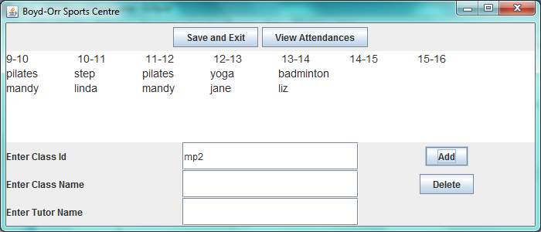

then this window is appearing. But as I mentioned before this validation is taking place every time.

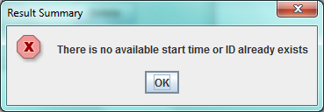

**Program functionality:**

This is the main GUI when you press run. As I mentioned before the first line with the times is static. The other two lines are reading from the file Classes In.

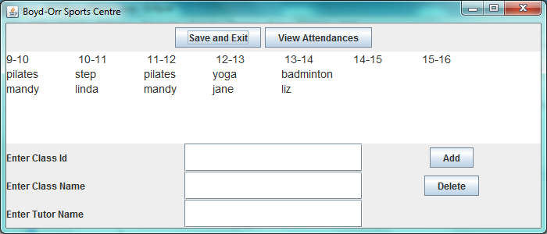

When you press View Attendances this window is appearing

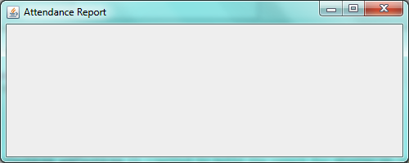

If you close this window the program does not exit.

Finally when you press the button save & exit in the main window the program exits.