COT 6405 Project -- Rod Cutting Problem
Gabor Kovacs -- March, 2018

Problem Definition

The Rod Cutting problem is an optimization problem. The ability to solve these types of problems can be applied to various cost saving and profit optimizing problems in the real world.
We have a rod of length n (where n >0) and we want to cut it into k pieces where k is <= n so that we can sell each piece. The pieces must be integral, meaning that if the rod is 3 units long, then it can be cut into units of size 1, 2, or 3, but not 1.5 for example. More generally, a rod of length n can be cut into 2^{n-1} pieces. The value of each piece p_{i} varies depending on its length. We want to find a way to cut the rod so that we maximize profit. He is a simple example.
Length i | 1 | 2 | 3 | 4
Price p_{i} | 1 | 5 | 8 | 9

There are 8 ways to cut this rod:
Length | Revenue
4 | 9
1,3 | 1+8=8
2,2 | 5+5=10
3,1 | 8+1=9
1,1,2 | 1+1+5=7
1,2,1 | 1+5+1=7
2,1,1 | 5+1+1=7
1,1,1,1 | 1+1+1+1=4

Cutting the rod into 2 pieces of size 2 yields revenue of 10, so that is the optimal way to cut. The objective is to find 2 or more different algorithms which will solve this problem and to show the differences in performance of these algorithms.

Algorithms and RT Analysis

Algorithm 1 (Top-Down-Brute Force):
The recursive top-down implementation uses a brute force approach to solve the problem. It solves the same sub-problem repeatedly which makes it very slow for large n.
Pseudocode:
CUT-ROD(p,n)
if n == 0
return 0
q = -
for i = 1 to n
q = max(q,p[i] + CUT-ROD(p,n-i)
return q

RT Analysis:
1 call to CUT-ROD plus 1 to n sub calls to CUT-ROD which makes T(j) sub calls.
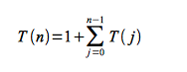
T(n) = 2^{n}

Algorithm 2 (Bottom-Up-Dynamic):
This algorithm will use dynamic programming and will save the result of each sub problem, thereby reducing the overall RT. I’m going with the bottom-up approach for this example which should yield an RT of Θ(n²).
Pseudocode:
BOTTOM-UP-CUT-ROD(p,n)
let r[0..n] be a new array
r[0] = 0
for j = 1 to n
q = -
for i = 1 to j
q = max(q,p[i] + r[j-i])
r[j] = q
return r[n]

RT Analysis:
We need to calculate the RT for the nested for loops.
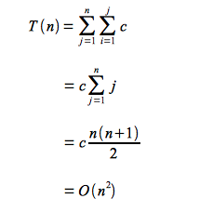

Algorithm 3 (Memoized-Dynamic):
This algorithm will use dynamic programming and will save the result of each sub problem, thereby reducing the overall RT. I’m going with the top-down memorization approach for this example which should yield an RT of Θ(n²).

Pseudocode:
Memoized-CUT-ROD(p,n)
Let r[0..n] be a new array
for i = 0 to n
r[i] = -
return Memoized-CUT-ROD-Aux(p,n,r)

Memoized-CUT-ROD-Aux(p,n,r)
if r[n] >= 0
return r[n]
if n == 0
q = 0
else
q = -
for i = 1 to n
q = max(q, p[i] + Memoized-CUT-ROD-Aux(p,n-I,r))
r[n] = q
return q

RT Analysis:
Same as the bottom up algorithm, O(n²)

Experimental Results
The experiment was performed using Microsoft’s Visual Studio IDE and Visual C#.NET as the programming language. I stuck to using basic data structures (such as arrays) which can be found in other similar languages. I implemented the algorithms from what I found online, however, I had to change most of them since C# has 0 based indexes.
I started with small values of n (n=1 to n=10) for all three algorithms for which I knew the answer (from CLRS book page 362) and verified that all 3 algorithms were producing the same results. Then, once I was satisfied that the algorithms were correct, I wrote a function which produced sample data. This method created an array of x size where each value was 1..30 larger than the previous value.
I was forced to use very different values of n for the three algorithms:
Alg1: Top-Down-Brute-Force
n=10; 15; 20; 25; 26; 27; 28; 29; 30;
Alg2: Bottom-Up-Dynamic
n=1000; 2000; 3000; 4000; 5000; 10000; 15000; 20000; 25000; 30000; 35000; 40000; 45000; 50000;
Alg3: Memoized-Dynamic
n=1000; 2000; 3000; 4000; 5000
The differences in n are due to the fact that algorithm 1 is very slow compared to the other two and that algorithm 3 uses recursion, so there was a limit (between 5k and 10k) to the number of recursive calls I can make before I started receiving stack over flow errors. However, I will include a chart showing the differences as much as possible.
For algorithm 1, Top-Down, I started with n=10 and worked my way up to 30 in increments of 5. There was a severe decrease in performance at around n=25, so I incremented n by ones in the n=25 to n=30 range in order to show a more granular result. After n=30, I stopped because the pattern seemed clear, the time was doubling as you increased n by 1.
For Algorithms 2 and 3, I was able to have some ns in common, specifically n=1000 to 5000 for which I can show differences in performance below.
Each experiment was run 5 times in a row for each of the 3 algorithms. I then averaged the results. At this point I noticed that for each of the 5 tests, test number 1 always ran an order of magnitude slower than tests 2-5, so I used tests 2 to 5 for the average. Below are the screenshots of the 3 experiments. I will attach the code and rename the extension from .cs to .txt so you can open it easily, but I will also paste images of the code into this report so that you can see everything color coded and properly aligned. The experiments show the processing time, but not the actual result (max-value), since it isn’t needed for algorithm comparison. It is however calculated and a line of code can be uncommented to see it.

Results of algorithm 1(Top-Down-Brute Force)
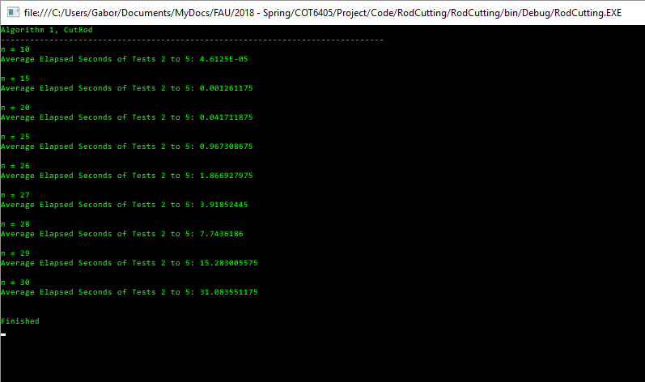

Results of Algorithm 2(Bottom-Up-Dynamic)
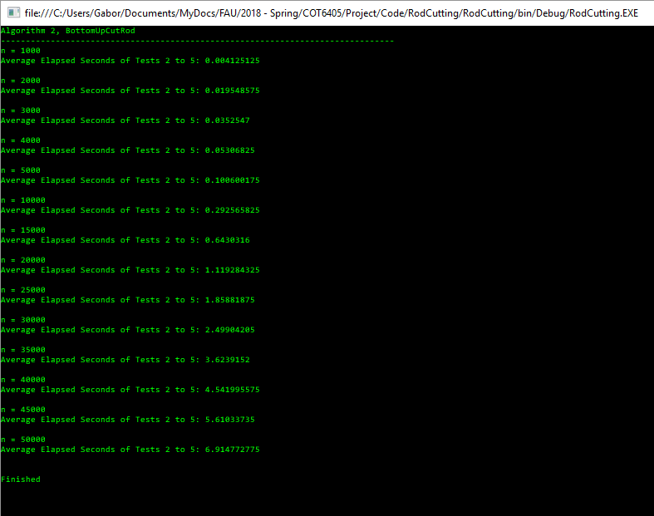
Results of Algorithm 3(Memoized-Dynamic)
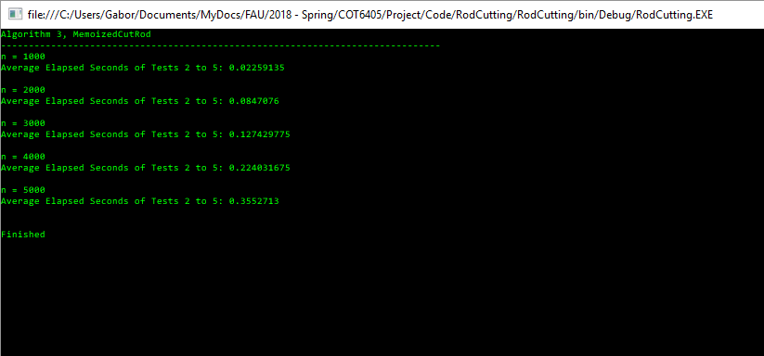

Theoretical vs Empirical RT- Algorithm 1(Top-Down-Brute Force)
n | Empirical RT (sec) | Theoretical RT (2^{n}) | c | c*2^{n}
10 | 0.00005 | 1,024 | 0.000000049 | 0.00005
15 | 0.0013 | 32,768 | 0.000000040 | 0.0016
20 | 0.04 | 1,048,576 | 0.000000038 | 0.0512
25 | 1.0 | 33,554,432 | 0.000000030 | 1.6384
26 | 1.9 | 67,108,864 | 0.000000028 | 3.2768
27 | 3.9 | 134,217,728 | 0.000000029 | 6.5536
28 | 7.7 | 268,435,456 | 0.000000029 | 13.1072
29 | 15.3 | 536,870,912 | 0.000000028 | 26.2144
30 | 31.1 | 1,073,741,824 | 0.000000029 | 52.4288
 |  |  | Max c = 0.0000000488

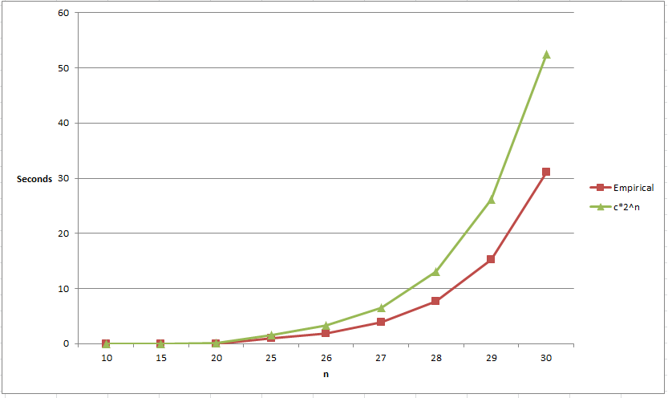
Theoretical vs Empirical RT- Algorithm 2(Bottom-Up-Dynamic)
n | Empirical RT (sec) | Theoretical RT (n²) | c | c*n²
1000 | 0.004 | 1,000,000 | 0.000000004125 | 0.004887144
2000 | 0.02 | 4,000,000 | 0.000000004887 | 0.019548575
3000 | 0.04 | 9,000,000 | 0.000000003917 | 0.043984294
4000 | 0.05 | 16,000,000 | 0.000000003317 | 0.0781943
5000 | 0.1 | 25,000,000 | 0.000000004024 | 0.122178594
10000 | 0.3 | 100,000,000 | 0.000000002926 | 0.488714375
15000 | 0.6 | 225,000,000 | 0.000000002858 | 1.099607344
20000 | 1.1 | 400,000,000 | 0.000000002798 | 1.9548575
25000 | 1.9 | 625,000,000 | 0.000000002974 | 3.054464844
30000 | 2.5 | 900,000,000 | 0.000000002777 | 4.398429375
35000 | 3.6 | 1,225,000,000 | 0.000000002958 | 5.986751094
40000 | 4.5 | 1,600,000,000 | 0.000000002839 | 7.81943
45000 | 5.6 | 2,025,000,000 | 0.000000002771 | 9.896466094
50000 | 6.9 | 2,500,000,000 | 0.000000002766 | 12.21785938
Max c =
0.000000004887

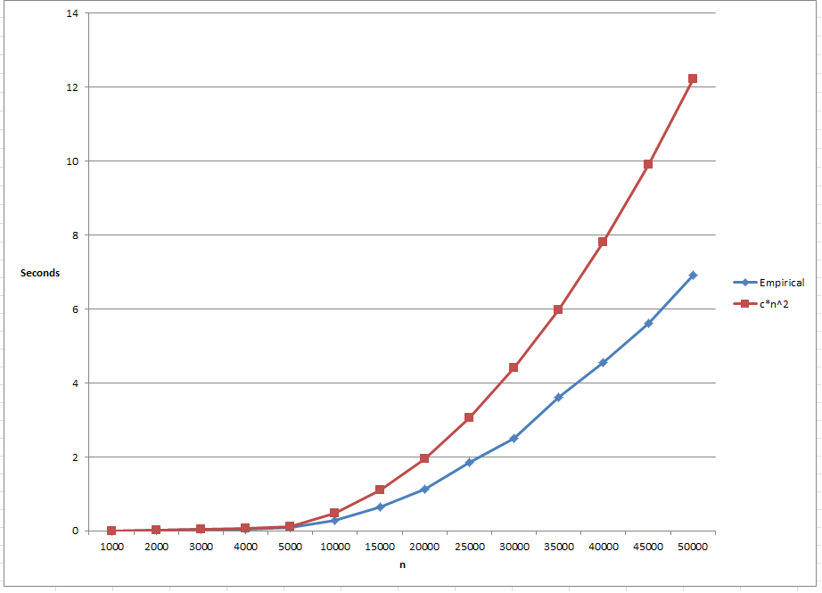

Theoretical vs Empirical RT- Algorithm 3(Memoized-Dynamic)
n | Empirical RT (sec) | Theoretical RT (n²) | c | c*n²
1000 | 0.02 | 1,000,000 | 0.000000022591 | 0.02259135
2000 | 0.08 | 4,000,000 | 0.000000021177 | 0.0903654
3000 | 0.1 | 9,000,000 | 0.000000014159 | 0.20332215
4000 | 0.2 | 16,000,000 | 0.000000014002 | 0.3614616
5000 | 0.4 | 25,000,000 | 0.000000014211 | 0.56478375
Max c =
0.000000022591

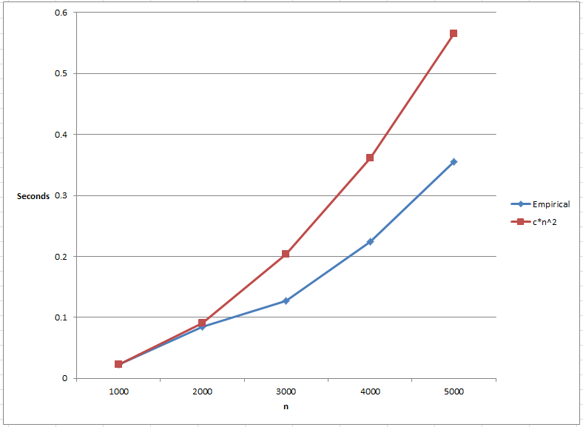

Algorithm Comparison
The differences between algorithm 1(Top-Down/Brute-Force) and algorithms 2 and 3 are so drastic that charting isn’t feasible. The Top-Down approach becomes unusable after n=30/40 because of the waiting time to complete the operation whereas algorithms 2 and 3 complete in well under a second. Algorithm 3 (Memoization) breaks between n=5000 and n=10,000 because there is a limit to how many times you can call a recursive function. We can however, compare Bottom-Up vs Memoization between n=1000 and n=5000. While the theoretical RT on both algorithms is O (n²), the theoretical data shows us that there is a clear difference in performance. By using the Bottom-Up approach, we are able to get much faster results in practice.

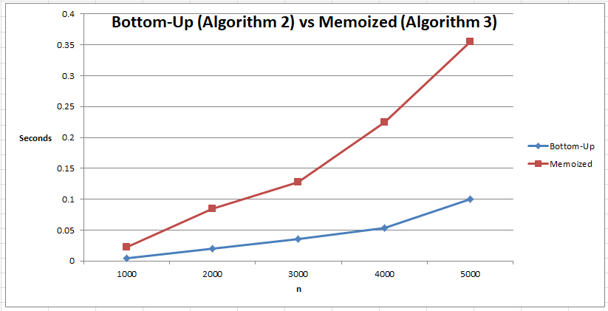

References
- CLRS Book - Chapter 15
- http://faculty.ycp.edu/~dbabcock/PastCourses/cs360/lectures/lecture12.html
- http://www.radford.edu/~nokie/classes/360/dp-rod-cutting.html
- http://www.cs.miami.edu/home/odelia/teaching/csc317.sp15/syllabus/Algorithms7aClass_Continued.pdf
- http://www.cs.ust.hk/mjg_lib/Classes/COMP3711H_Fall14/lectures/IntroDP_Handout.pdf
- https://www.geeksforgeeks.org/dynamic-programming-set-13-cutting-a-rod/

