**How to execute the ‘Integration Test Automation Script’?**

**Pre-requisites:**

* SoapUI 5.3.0+ Free Version
* Hermes JMS ( Topics / Queues should be configured for Interaction, RSP, Contacts )
* Authentication Token JARs to be kept in SoapUI \ Ext folder ( TokenGenMulti2 )
* P12 Files kept under SoapUI \ Bin folder ( Interaction - APP3531349 and Contacts - APP3531347 applications )
* Excel JARs kept under SoapUI \ Ext folder ( **POI** - poi-3.9, poi-ooxml-3.9-sources, poi-ooxml-schemas-3.9, **JXL** - jxl-2.6.12)

All the above supporting files and tools installation done, follow the steps to execution the Integration Test Automation script.

1. Configure the below mentioned properties in the ‘**Config.properties’** file as these properties will be utilized in the script

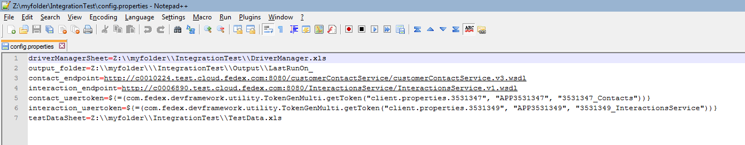

1. In the next step, we need to set up the Driver Manager spreadsheet. In that, add TestSuite’s name, configure the **Run** flag for each test suite as shown in the below sample screenshot. Make sure the TestSuite name must be similar with the **SoapUI** project

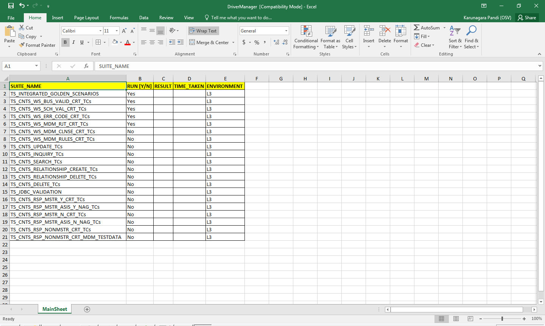

1. Open the **TestData.xls** spreadsheet and prepare the test data before the execution. Ex:

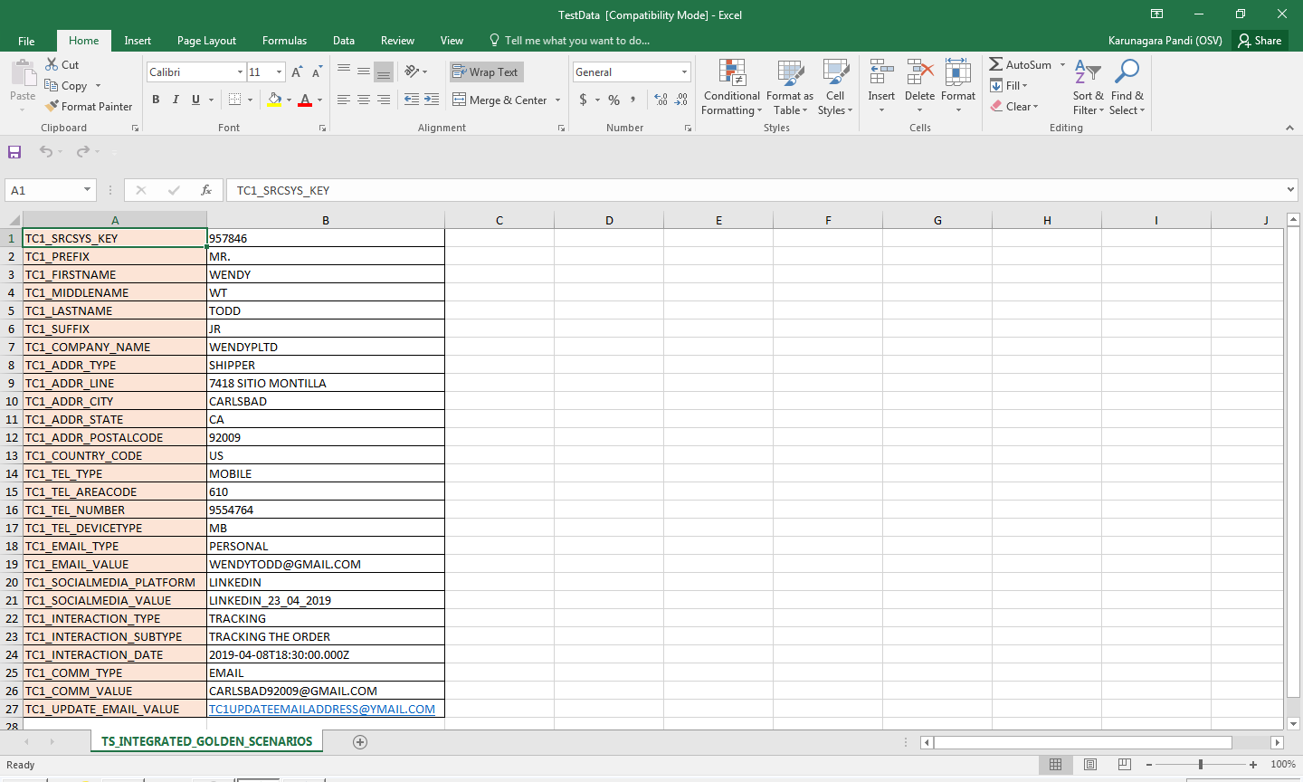

**Note:** All the test data will be read by the script and stored in Custom Properties. Then, we need to parameterize the Custom Properties to respective Request XMLs

1. Launch the **SoapUI tool** and import the project **Ex:** *ECDC_GoldenTCs_IntegrationTesting.xml*. Once imported, SoapUI will load the project contents like interfaces, test suites. Project tree will be looking like this.

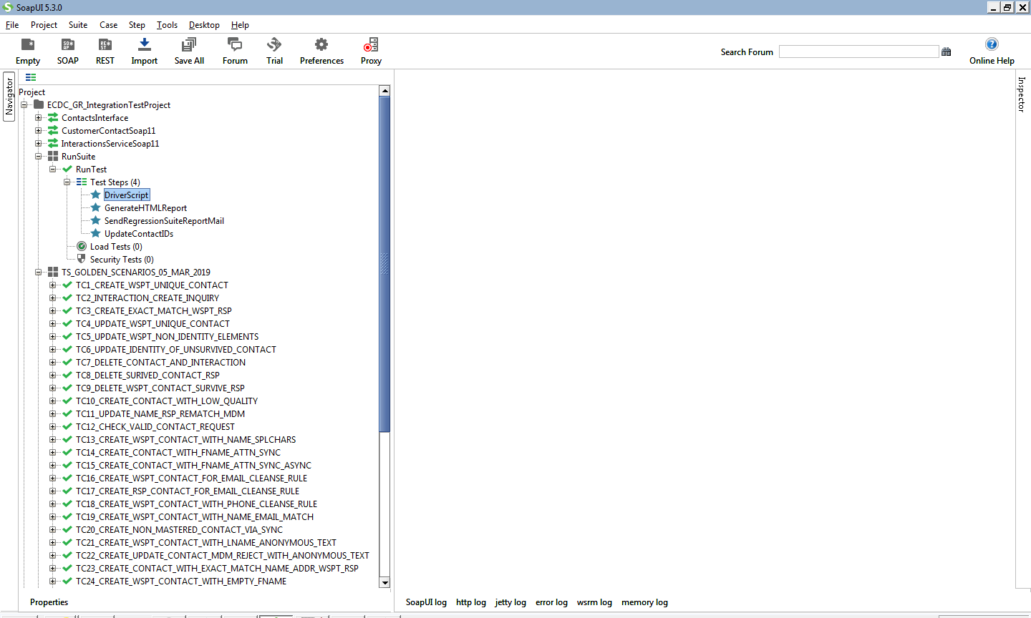

1. Double click on **ECDC_GR_IntegrationTestProject => RunTestSuite => RunTest => DriverScript** step

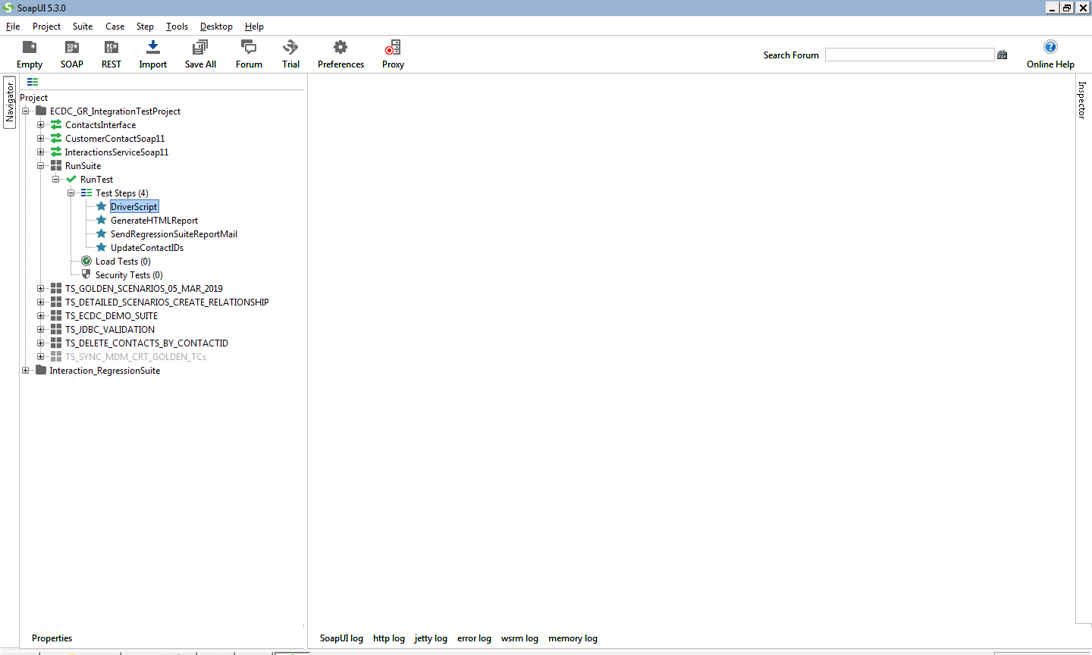

1. Navigate to the bottom of the script window and make sure the **config.properties** file path is properly given in the **loadProperties()** method.

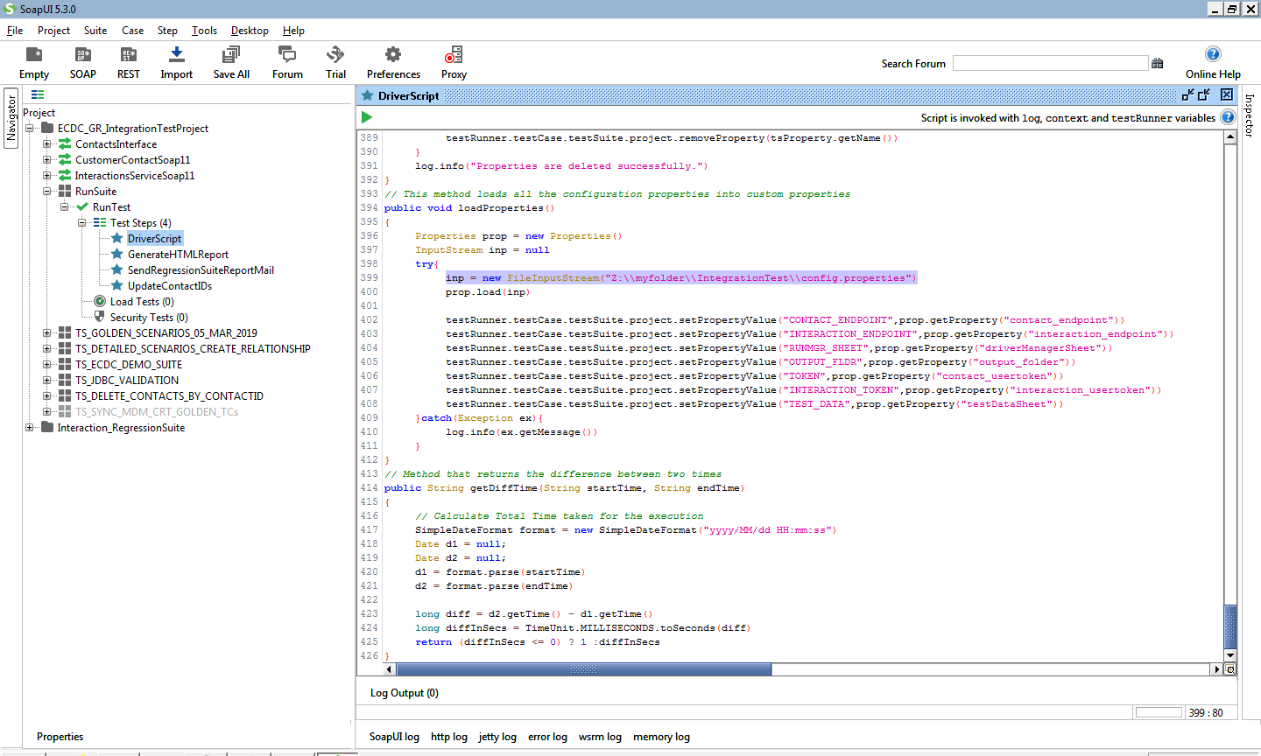

1. Once all set up are done properly, we can start the execution. To do this, Run the **Driver Script**

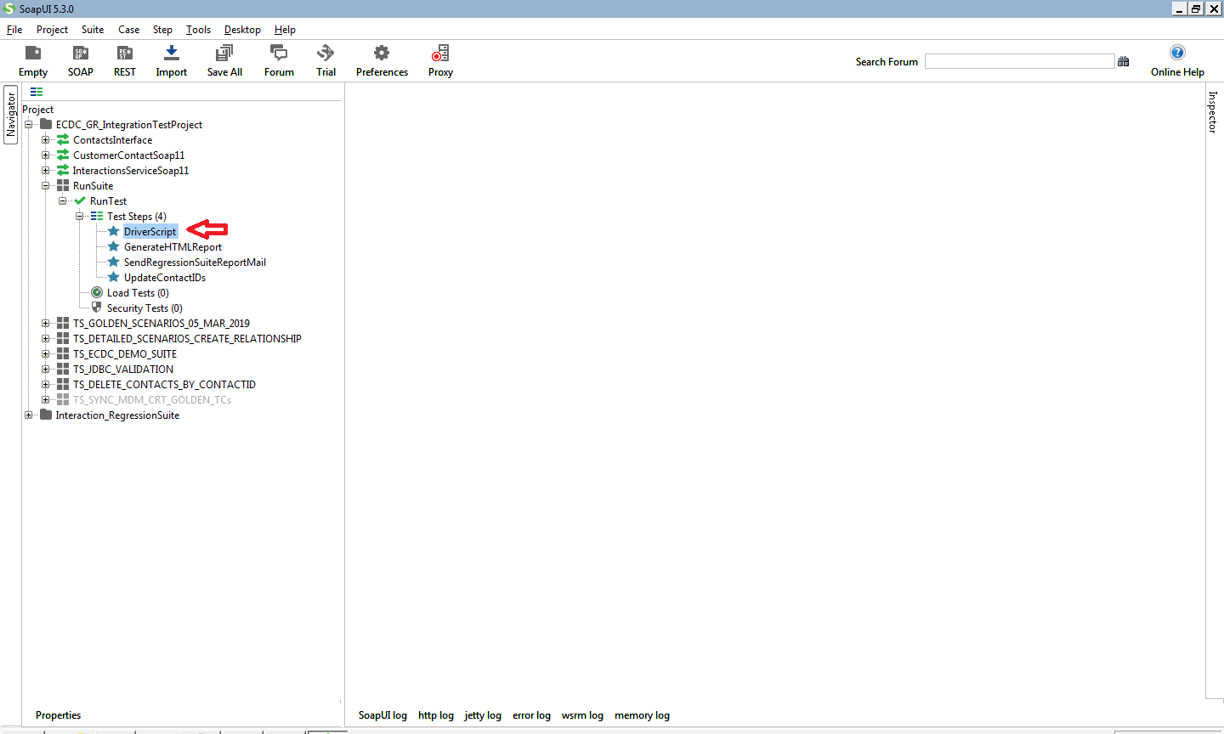

1. Execution logs will be shown in the Console window. When the execution done, an Output folder will be created in “**YourLocalDrive**”\IntegrationTest\Output\
2. Under the **Output** folder, another folder would be created with last run date time format. Ex: 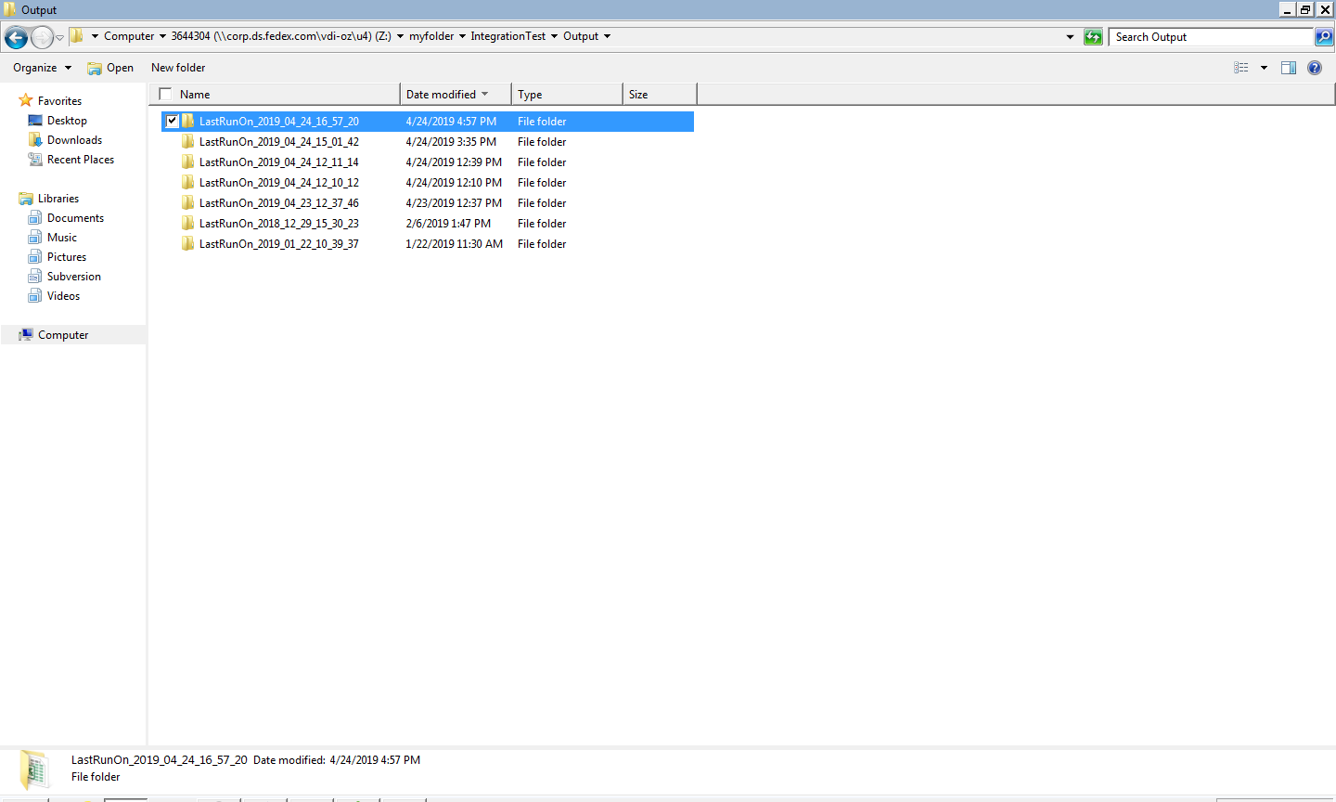
3. Open the **LastRunOn_** folder which then contains subfolders with the name of each Test Suite’s and an Excel file name called “**IntegrationSuiteReport.xls**”. Subfolder contains list of Text Files which contains the Request and Response XMLs

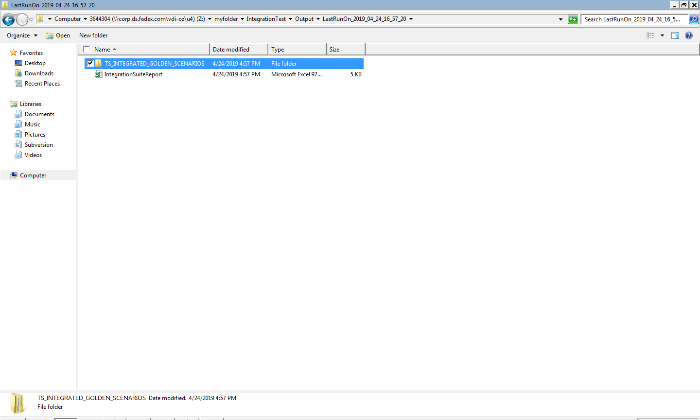

1. In the Excel file, all the test cases and their execution status will be captured according to the test suite. Look at the below screenshot for your reference.

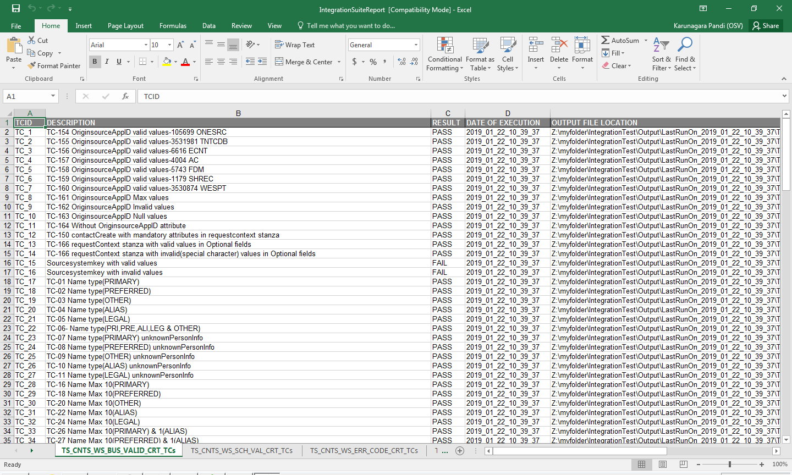

1. Open **DriverManager.xls** spreadsheet in which we have captured each TestSuite status, Execution Time based on execution

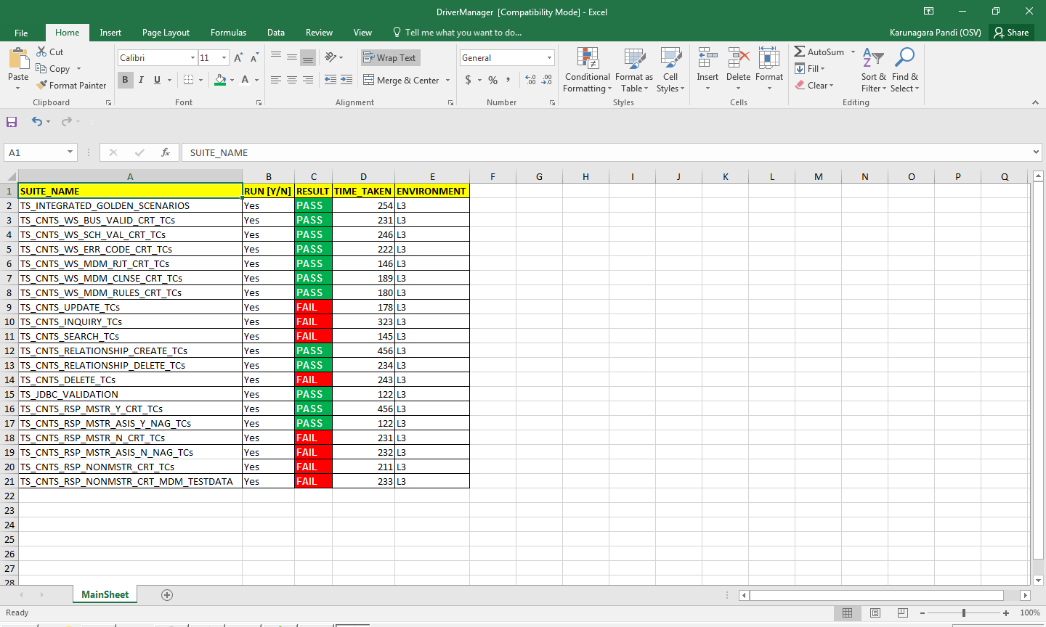

1. In order to send email to the given email addresses after the execution and generate an HTML based report, uncomment the below lines in the **DriverScript**.

