Maven

1. Download Ant 1.9.10 from the below url

<https://ant.apache.org/bindownload.cgi>

1. Download zip and extract
2. Set environment variable

ANT_HOME = folder path

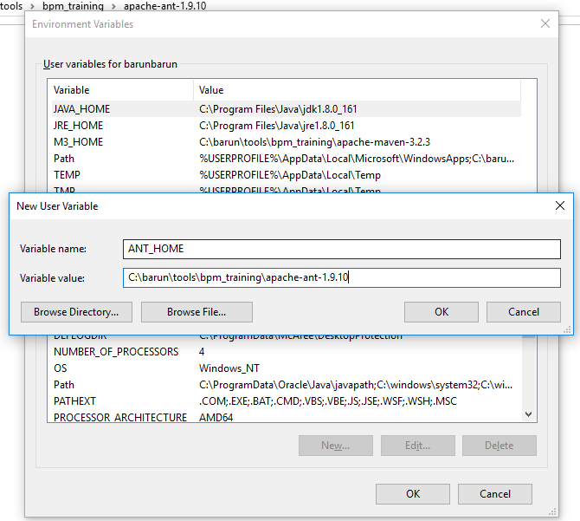

1. Edit path and add the path till bin folder

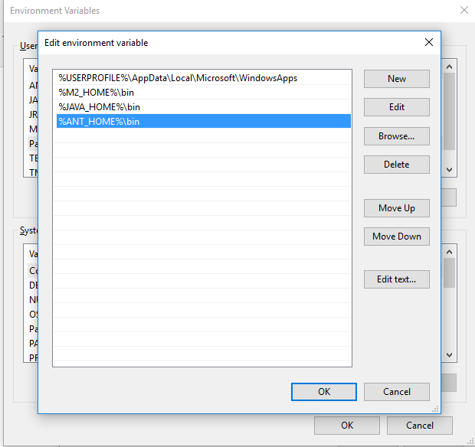

1. Open command prompt and type ant -v

