MariaDb :

1. Download mariadb from the below URL

<https://downloads.mariadb.org/mariadb/5.5.29/#os_group=linux_generic&os_group=windows&file_type=tar_gz&file_type=zip>

1. Extract the zip file
2. Go to <Extracted_folder>/bin
3. Run the following command mysqld –console

You will see below screen

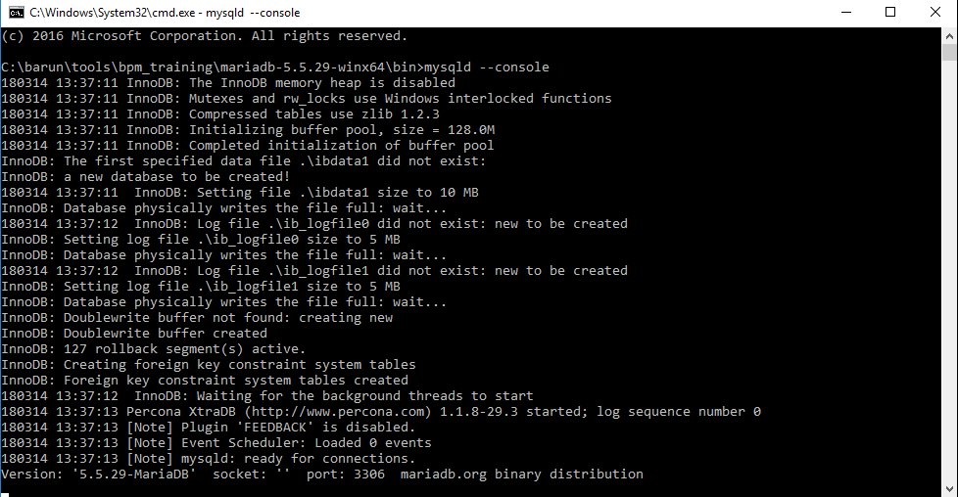

**Do not close the above screen.**

1. Download workbench from the below url

<https://dev.mysql.com/downloads/workbench/5.2.html>

download zip archive

1. Extract mysql workbench zip archive
2. Go to extracted folder, Double click on mysqlworkbench it open a dialoge

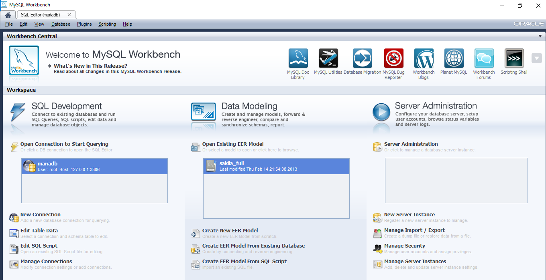

1. Click on new connection

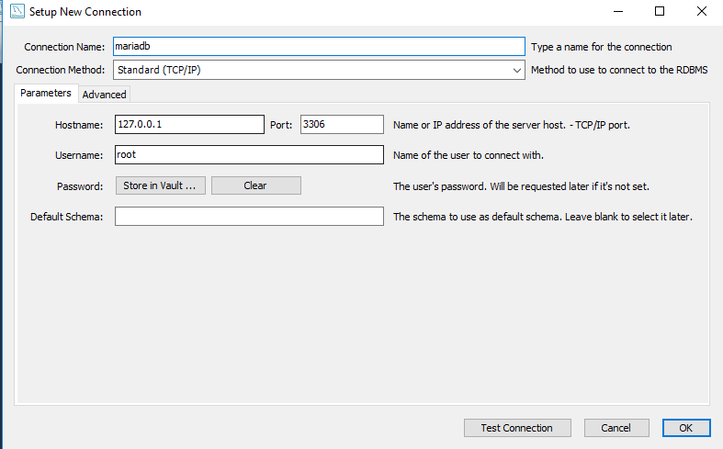

No password is required

1. Click on test connection

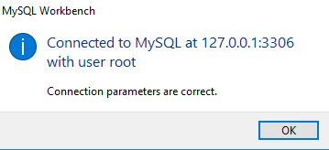

Click on ok button

1. Click on ok button
2. In Open connection to start querying tab you will find new connection

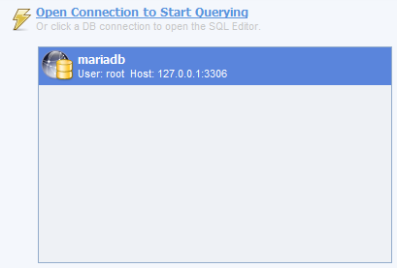

1. Double click on mariadb to open the sql editor.