Maven

1. Download maven 3.2.3 from the below url

<https://archive.apache.org/dist/maven/maven-3/3.2.3/binaries/>

1. Download zip and extract
2. Set environment variable

M2_HOME = folder path

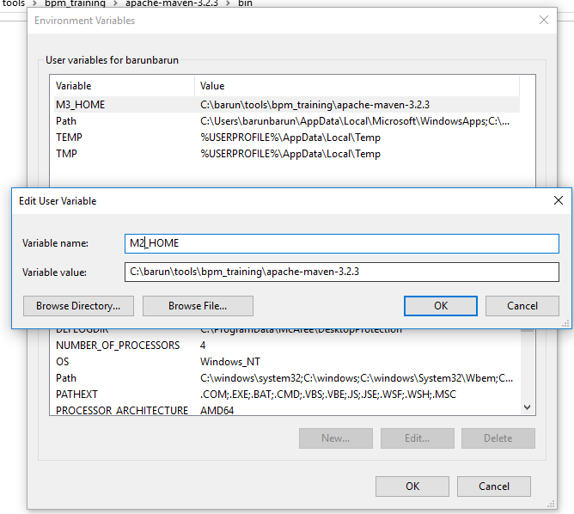

1. Edit path and add the path till bin folder

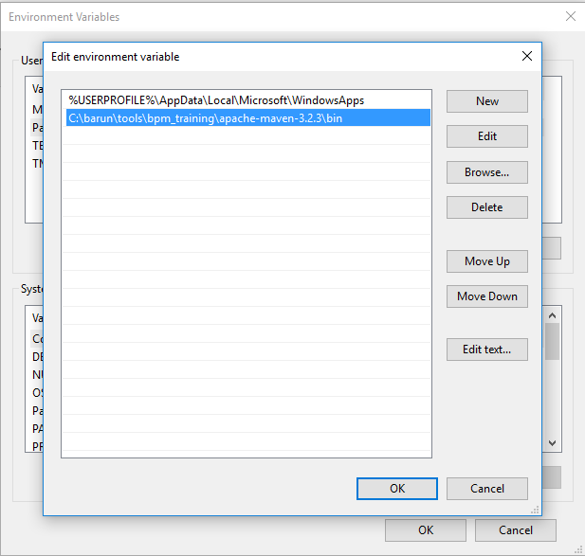

1. Open command prompt and type mvn -v

