Tomcat

1. Download tomcat -7.0.85 from the below url

<https://tomcat.apache.org/download-70.cgi>

1. Download zip and extract
2. Set environment variable

CATALINA_HOME = folder path

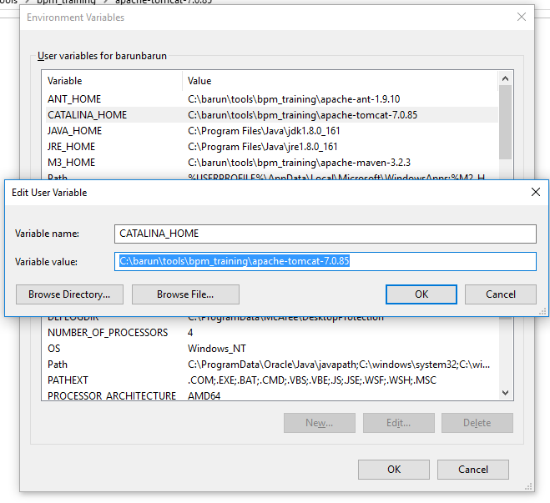

1. Edit path and add the path till bin folder

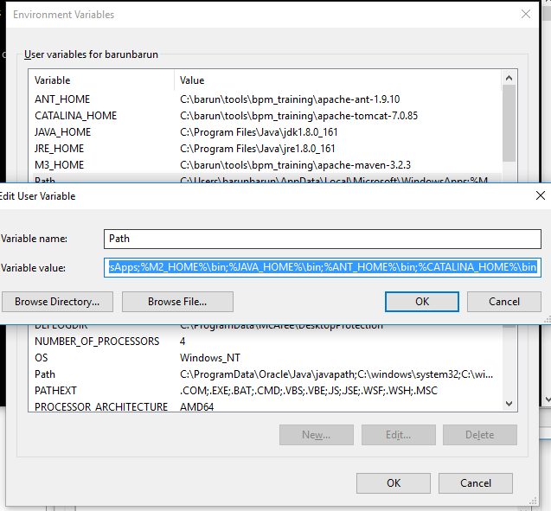

1. Open command prompt and type startup.bat

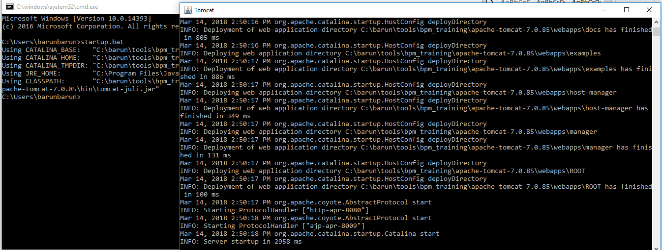

1. Open browser and type the below

<http://localhost:8080/>

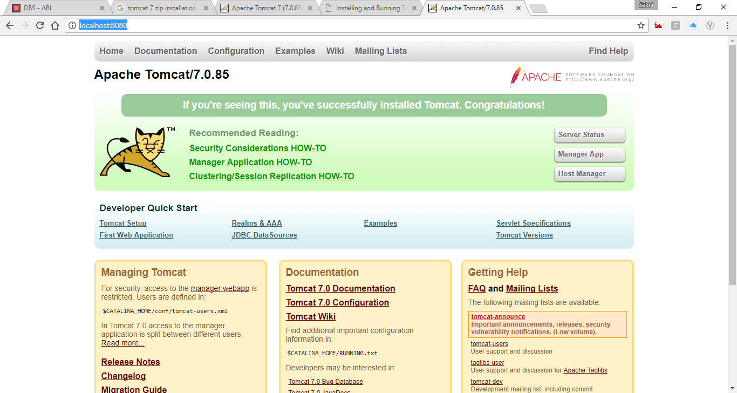

1. To shutdown tomcat type shutdown.bat in command prompt.