gfa^/nvoteeA,

**Invoice**

**From:**

DEMO - SHced Invoices

Suite 5A-1204

123 Somevrtiere Street

Your Qty AZ 12345 [admin@slicednvoices.com](mailto:admin@slicednvoices.com)

|  |  |
| --- | --- |
| Invoice Number | INV-3337 |
| Order Number | 12345 |
| Invoice Date | January 25,2016 |
| Due Date | January 31,2016 |
| **Total Due** | **S93.50** |

**To:**

Test Business

123 Somevrtiere St Melbourne, VIC3000 [test@test.com](mailto:test@test.com)

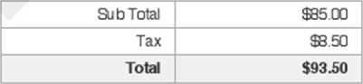

|  |  |  |  |  |
| --- | --- | --- | --- | --- |
| **Hrs/Qty** | **Service** | **Rate/Price** | **Adjust** | **Sub Total** |
| 1.00 | V\feb Design  This is a sam pie de sen puion . .. | $85.00 | 0.00% | $85.00 |

ANZ Bank

ACC# 1234 1234

BSB#4321 432

Payment is due within 30 days from date of invoice. Late payment is subject to fees of 5% per month. Thanks for choosing CEMO - Sliced Invoices I [admin@slicedinvoices.com](mailto:admin@slicedinvoices.com)

Page 1/1