

The Claxton-Hepburn Contract Management System has been designed to easily store, edit, and view your department’s contracts. Separately, the data stored in the CMS can be used for reporting to assist in managing these contracts. This document has been created to cover the basic functionality of the CMS.

The CMS has three main functions: **Adding** New Contracts, **Viewing** Existing Contracts and **Editing** Existing Contracts.

 ***Adding a New Contract***

From the Home screen click the ‘new contract’ button.

A form will be displayed that can be filled out and submitted. Required fields are indicated and must be filled in (not all fields are required).

If a required field is missed a notification will appear when the ‘submit’ button is clicked.

Files can be uploaded with the ‘new contract’ form as well. Browse and select a file to upload, multiple files can be uploaded at once.

 ***View Contract Details***

Once a contract is entered into the system the Full Display view will appear on the screen with a message indicating that the new contract was entered into the database.

The information that was just entered will be displayed in 4 separate sections: *Contract Details*, *Service* *Evaluation Details*, *Files* and *Cost Info*.

* Contract Details – Includes most of the information on the selected contract
* Service Evaluation Details – Indicates the Service Evaluation Period (Annual/Bi-annual) and displays the Last Evaluation Date and the Next Evaluation Date (based on the period)
* Files – Displays only those files which have been uploaded. Click on the magnifying glass to view or download the file.
* Cost Info – Displays the cost information associated with the contract.

A new contract does not need to be entered to view existing contracts. Clicking the ‘existing contracts’ button from the Home screen will open the search feature which will allow a user to search for a specific contract by Vendor Name, Department Name or with a text search.

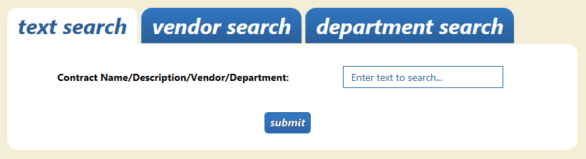

After clicking ‘Submit’ your results will be displayed. Select one of the contracts from the results and click ‘Review Selected Contract’. This will open the Full Display view.

*** Editing Contract Details***

From the Full Display view, users with access are able to enter the Edit view for each of the four Display view sections. Clicking the ‘Edit’ button in the upper left corner of the *Contract Details*, *Service* *Evaluation Details*, *Files* or *Cost Info* sections will enable editing for the corresponding section.

***edit*** contract ***details***

In the *Edit Contract Details* section only one field can be edited at a time. Click the ‘Pencil’ icon next to the field that needs to be edited. From here you will be able to enter the updated information and click ‘Update’. A message will appear that the field has been successfully updated, or that it has failed to update.

service evaluation details

The *Edit Service Evaluation Info* section has three editable fields.

* Service Evaluation Period – Annual or Bi-Annual
* Last Evaluation Date – The date of the last service evaluation. This should be updated when the service evaluation is performed.
* Next Evaluation Date – The date that the next service evaluation needs to be done by.

Not all fields need to be changed, for example you can change the Last Evaluation Date without changing the Service Evaluation Period or Next Evaluation Date.

Changing the Last Evaluation Date will automatically calculate the Next Service Evaluation Date based on the Service Evaluation Period (adds 6 months or 1 year, depending).

The Next Evaluation Date cannot be less than the Last Evaluation Date. If you change the Next Service Evaluation Date and not the Last Service Evaluation Date the system will notify you that you may want to update the Last Evaluation Date.

edit files

The Edit Files section will display the files that you have uploaded for the contract, as well as any files that have not yet been uploaded. Files under the section titled ‘Uploaded Files’ are files that are currently stored for the selected contract. The section titled ‘files not uploaded’ displays a form for uploading files that have not yet been uploaded.

* Archiving Files – If a file gets uploaded using the form in the ‘Uploaded Files’ section, the existing file gets archived and the new file gets uploaded in its place. Once a file is archived it will be stored indefinitely. Archived files can be viewed from the Full Display view in the ‘Files’ section by clicking the ‘View Archived Files’ button. If there are archived files for the contract they will be displayed in a list with the date that the file was archived. From this screen you can view the archived files by clicking the *magnifying glass* icon next to the appropriate file.

**Deleting Archived files** – After a file goes to the archive it can then be deleted permanently. By clicking the red ‘X’ button next to the appropriate archived file you can delete and remove a file from the database and from the directory where the file is actually stored. **CAUTION! Once this is done the file is gone and cannot be recovered.**

edit cost info

The Edit Cost Info section allows the annual costs of the contract to be edited. Up to 10 years can be accounted for. A total cost will be displayed at the bottom of the Cost section on the Full Display view. The cost fields are currently free text fields, meaning that any characters can be entered into them. Only numbers or decimals should be used in these fields to ensure that the cost information will be useful and accurate.

 ***Reporting***

Reports written against the Contract database will be located on our report server which will be accessible from the CMS. The ‘Reports’ link will open the report server folder where any reports written for the CMS will be located.

*** Issues with the CMS can be reported to the helpdesk @ x4357 ***