BLOCKCHAIN EVAULT FOR LEGAL RECORDS

BACHELOR OF TECHNOLOGY IN
COMPUTER SCIENCE AND ENGINEERING

Use Case Report
submitted by
G.K.R.V.KOUSHIK
23501A0541
Under the guidance of
Mr. A. Prashant, Asst. Prof.



Department of Computer Science and Engineering Prasad V Potluri Siddhartha Institute of Technology (Permanently affiliated to JNTU-Kakinada, Approved by AICTE) (An NBA & NAAC accredited and ISO 9001:2015 certified institute) Kanuru, Vijayawada-520 007

2026-27

Prasad V Potluri Siddhartha Institute of Technology (Permanently affiliated to JNTU-Kakinada, Approved by AICTE) (An NBA & NAAC accredited and ISO 9001:2015 certified institute) Kanuru, Vijayawada-520 007

CERTIFICATE

This is to certify that the Use Case report entitled “Blockchain E-Vault for Legal Records” that is being submitted by G.K.R.V.KOUSHIK (23501A0541), as part of Assignment-1 and Assignment-2 for the Blockchain Technology(23CS4701B) course in 4-1 during the academic year 2026-27.

Course Coordinator Mr. A. Prashant Assistant Professor, Department of CSE, PVPSIT, Vijayawada
Head of the Department Dr. A. Jayalakshmi, Professor and Head, Department of CSE, PVPSIT, Vijayawada

MARKS ASSIGNMENT-1: /5
ASSIGNMENT-2: /5

INDEX

S. No. | Chapter | Page No.
1 | Introduction | 1
2 | Background | 3
3 | Blockchain Basics | 7
4 | Use Case Overview | 9
5 | Implementation | 12
6 | Benefits | 17
7 | Challenges | 19
8 | Conclusion | 21
9 | SDGs Addressed | 22
10 | References | 23
11 | Appendix A | 24

INTRODUCTION

Overview of Blockchain Technology

Blockchain technology is a decentralized and distributed ledger system that records transactions across multiple nodes, ensuring transparency, security, and immutability. Unlike traditional databases, blockchain operates on a peer-to-peer network, eliminating the need for central authorities. Each block in the chain contains a cryptographic hash of the previous block, making data tampering virtually impossible. Originally designed for cryptocurrency transactions, blockchain has now expanded into various domains, including finance, supply chain, healthcare, and digital warranty management. [2]

Relevance of Blockchain in Digital Warranty Systems

Traditional legal record management often involves physical documents, paper-based filing systems, and centralized digital repositories. These methods can create difficulties in retrieving documents, maintaining consistent records, identifying unauthorized modifications, and sharing information among authorized individuals. Physical records may also be lost or damaged, while centralized digital systems can be vulnerable to unauthorized changes or service interruptions.

A blockchain-based eVault offers an alternative approach by associating legal documents with records maintained through a blockchain network. When a document is registered, relevant metadata can be recorded through a smart contract. A cryptographic hash can also be used as a digital fingerprint to check whether a document's contents have changed. If the document is modified, its newly calculated hash will generally differ from the previously registered hash, indicating a possible integrity issue.

Smart contracts written in Solidity can define rules for registering documents and managing selected operations. The blockchain transaction history can provide a traceable record of document-related actions, helping users examine when records were registered and which blockchain account initiated a transaction. These capabilities can reduce dependence on manually maintained records and improve transparency in document management.
The eVault application also provides a web interface through which users can interact with document-management functions. Features such as document upload, document listing, retrieval, and sharing can make legal records easier to organize and access. The combination of a web application, backend services, and blockchain-based records illustrates a practical approach to integrating decentralized technology into an existing digital workflow.

The proposed BlockVault system focuses on demonstrating the use of Solidity-based smart contracts in legal document management. It aims to provide a simple platform for organizing documents and maintaining blockchain-backed records while illustrating the benefits and limitations of decentralized recordkeeping. Although blockchain can support integrity verification and traceability, it does not independently guarantee the truthfulness of a document, the identity of its creator, confidentiality of its contents, or its legal admissibility. These aspects require additional technical, procedural, and legal safeguards.

BACKGROUND

This chapter discusses the existing approaches to legal record management, the problems associated with conventional document storage, and the need for a blockchain-based eVault system. The discussion follows the structure of your reference report, adapted to the Blockchain-Based Legal Evidence and Document Provenance System (BlockVault)

2.1 Traditional Legal Record Management
Legal record management involves the creation, collection, organization, storage, retrieval, and preservation of documents associated with legal proceedings and transactions. These documents may include contracts, affidavits, property records, court orders, agreements, and digital evidence. Maintaining the accuracy and availability of these records is essential for legal professionals, organizations, and individuals.
Traditionally, legal documents have been maintained in physical files and archives managed by courts, law firms, government departments, and other institutions. Although this approach provides a familiar method of recordkeeping, it can make document retrieval time-consuming and requires physical storage facilities. Paper documents may also deteriorate, become misplaced, or be damaged by environmental conditions.
With the adoption of digital technologies, many organizations have transitioned to electronic document management systems. These systems allow documents to be stored in digital formats, organized into folders, and retrieved through search interfaces. Digital storage reduces dependence on physical archives and makes document sharing more convenient.
However, conventional digital systems frequently depend on centralized databases or storage services controlled by a particular organization. Administrators with sufficient privileges may be able to modify records, and users may have limited visibility into the history of changes. Although access controls, backups, and audit logs can mitigate these risks, their effectiveness depends on the system's design, implementation, and administrative practices.
A blockchain-based eVault extends digital record management by maintaining verifiable records of document-related transactions on a distributed ledger. Rather than relying exclusively on a conventional database to establish the integrity of a record, the system can use cryptographic hashes and blockchain transactions to support independent verification.

2.2 Loss or Damage of Legal Documents
The loss or damage of legal documents is a significant concern in traditional recordkeeping environments. Physical documents can be misplaced during transportation, damaged by moisture or fire, or lost because of inadequate filing and archival procedures. Recovering these documents may require considerable time and effort, particularly when duplicate copies are unavailable.
Digital document management reduces some of these risks, but it introduces other concerns. Files may be accidentally deleted, storage devices may fail, and inadequate backup procedures can lead to permanent data loss. Unauthorized access or malicious activity can also affect the availability of digital records.
A digital eVault can help address these problems by providing structured document registration, storage references, and retrieval mechanisms. Where appropriate, backup storage and redundant copies can improve availability. Blockchain records can additionally preserve evidence that a document was registered at a particular point in time.
However, blockchain should not be treated as a replacement for file backups. Recording a document's hash on a blockchain does not recover the original document if the file itself is lost. Therefore, reliable off-chain storage, backup policies, and recovery procedures remain necessary components of the proposed system.

2.3 Document Tampering and Authenticity Verification
Document tampering refers to the unauthorized modification of a document's contents or associated information. In legal environments, even a small alteration to a contract, affidavit, or piece of digital evidence can create disputes regarding its authenticity and reliability. Conventional digital files can be modified using document-editing software, and it may be difficult to determine whether a file has been altered if reliable verification mechanisms are not available.
Centralized systems may maintain access logs and version histories to identify changes. However, the reliability of these mechanisms depends on how the system records and protects its audit information. If records are not adequately protected, unauthorized modifications may be difficult to detect or investigate.
Blockchain technology provides a mechanism for verifying document integrity through cryptographic hashing. A hash function converts a document's contents into a fixed-length value that acts as a digital fingerprint. When a document is registered, its hash can be recorded on the blockchain. Later, the system can calculate the hash of the retrieved document and compare it with the registered value.
If both values match, the document's contents are consistent with the version associated with the registered hash, assuming the hash function and verification process are implemented correctly. If the values differ, the system can indicate that the document has changed or that a different file is being examined.
This mechanism supports document integrity verification, but it does not prove that the original document was truthful or legally valid. The proposed BlockVault system uses this principle to demonstrate how blockchain-backed records can help detect unauthorized document modifications.

2.4 Chain of Custody and Document Provenance
Chain of custody refers to the chronological record of the collection, handling, transfer, storage, and examination of evidence. It is particularly important when digital evidence is used during investigations or legal proceedings because the reliability of the evidence depends partly on whether its handling history can be established.
In conventional systems, information about document transfers and handling activities may be recorded through manual registers, emails, or centralized audit logs. These records can become fragmented across different organizations, making it difficult to reconstruct the complete history of a document.
Blockchain can support chain-of-custody management by recording document-related events as transactions. For example, the registration of a digital evidence file, the granting of access, or a transfer of responsibility can be represented through structured records, subject to the capabilities of the application and smart contract.
Because blockchain transactions are linked to the ledger's history, they provide a traceable record of recorded activities. Authorized users can inspect these transactions to establish a chronology of events and identify discrepancies in the documented history.
In BlockVault, document provenance focuses on maintaining a verifiable association between a document and its recorded history. The system can use document identifiers, cryptographic hashes, blockchain transaction records, and relevant timestamps to support this process.
Nevertheless, a blockchain entry alone does not establish that every real-world event occurred as recorded. Reliable provenance also requires appropriate identity verification, authorized event submission, secure key management, and procedures for handling errors or disputed records.

2.5 Accessibility and Information Sharing
Legal documents are frequently accessed by different stakeholders, including clients, lawyers, investigators, and authorized officials. Efficient information sharing is important because delays in retrieving relevant documents can affect administrative processes and collaboration.
Physical filing systems restrict access to documents that must be retrieved from specific locations. Conventional digital systems improve accessibility, but users may still encounter difficulties when documents are distributed across incompatible platforms or when different organizations apply different access procedures.
A centralized repository can simplify document retrieval within one organization, but access across organizational boundaries may require additional permissions, integrations, and coordination. Differences in data formats and document identification methods can also complicate information exchange.
A web-based eVault can provide a common interface for registering, searching, retrieving, and verifying documents. Blockchain integration can provide a consistent record of registered document metadata and relevant transactions, while the application manages user interactions and access permissions.
The proposed system aims to make document management more organized by combining web application functionality with blockchain-based recordkeeping. Its practical effectiveness will depend on the quality of the user interface, the efficiency of retrieval operations, the availability of the underlying storage service, and the correct implementation of access controls.

2.6 Security, Privacy, and Access Control
Legal documents may contain confidential information, personal details, financial records, or sensitive evidence. Consequently, a legal record management system must prevent unauthorized access while ensuring that legitimate users can retrieve the information required for their responsibilities.
Traditional digital systems commonly use authentication, role-based permissions, encryption, and administrative controls to protect documents. However, weak authentication, excessive privileges, compromised credentials, and inadequate key management can expose confidential information.
Blockchain introduces additional security considerations. Transactions may be publicly visible on a public blockchain, and data recorded on an immutable ledger may be difficult to remove. Storing complete legal documents or personally identifiable information directly on a public blockchain can therefore create serious confidentiality and data-management concerns.
A more appropriate architecture for sensitive records is to store the original documents in controlled off-chain storage and place only the necessary hashes, identifiers, timestamps, or other carefully selected metadata on the blockchain. Access to the actual files can then be controlled by the application and its storage infrastructure.
For BlockVault, the distinction between on-chain records and off-chain files is important. The blockchain can support integrity verification and transaction traceability, while the web application and backend enforce authentication and file-access rules. These mechanisms must be implemented together; blockchain by itself does not guarantee confidentiality or prevent unauthorized users from obtaining an exposed file.

2.7 Need for a Blockchain-Based eVault System
The challenges described above demonstrate the need for a document management approach that combines convenient digital access with reliable integrity verification and traceable recordkeeping.
A blockchain-based eVault can address selected weaknesses of conventional systems through the following capabilities:
- Integrity verification: Cryptographic hashes can be used to check whether a document matches its registered version.
- Traceable recordkeeping: Blockchain transactions can preserve a chronological history of document-registration activities.
- Smart contract enforcement: Solidity smart contracts can define rules for registering records and performing authorized blockchain operations.
- Centralized document access through a web interface: A user-friendly application can simplify document upload, retrieval, and verification.
- Improved accountability: Blockchain transaction records can help identify the account associated with a recorded operation.
- Integration with digital storage: Off-chain storage can accommodate document files without placing their complete contents directly on the blockchain.
The proposed BlockVault system applies these concepts to legal evidence and document provenance. It combines a web application, backend services, and Solidity-based smart contracts to demonstrate the registration and verification of legal documents.
The objective is not to claim that blockchain eliminates every security risk or replaces existing legal record management infrastructure. Instead, the system provides an additional verification and traceability layer that can complement conventional storage and administrative controls.
.

BLOCKCHAIN BASICS

Blockchain technology is a distributed ledger system that ensures secure, transparent, and tamper-proof transactions. Unlike traditional systems that rely on intermediaries, blockchain enables trustless peer-to-peer interactions, reducing the need for third parties in financial transactions, supply chain management, and digital warranty verification. Its decentralized nature enhances security and transparency, making it an ideal solution for many industries. Below are the key concepts that define blockchain technology:

Decentralization

Traditional databases are managed by centralized authorities, such as banks or corporations, which creates a single point of failure and makes them vulnerable to hacks or data manipulation. Blockchain, on the other hand, operates on a decentralized network, where multiple independent nodes validate and store data. This ensures that no single entity has full control over the system, making it resistant to censorship and fraud. Additionally, decentralized structures provide greater security, as compromising one node does not affect the integrity of the entire network. Since all transactions are recorded and verified across multiple nodes, blockchain also enhances transparency, allowing participants to independently verify transactions. [2]

Immutability

One of blockchain’s defining characteristics is immutability, meaning once a transaction is recorded, it cannot be altered or deleted. [2] This is achieved through cryptographic hashing, where each block is linked to the previous one, forming a secure chain that prevents unauthorized modifications. The integrity of the blockchain is maintained through consensus mechanisms, ensuring that all network participants agree before new data is added. Since tampering with a single block would require modifying all subsequent blocks—an operation that demands enormous computational power—fraud and unauthorized changes become nearly impossible. This feature makes blockchain particularly useful for audit trails, financial transactions, and warranty tracking.

Transparency

Blockchain transactions are publicly verifiable, meaning anyone with access to the network can audit the transaction history. This transparency is ensured by distributed ledger technology (DLT), where every participant has access to an identical copy of the data, eliminating the risk of hidden alterations. Public blockchains, such as Bitcoin and Ethereum, offer complete transparency, fostering trust among users. This openness reduces the possibility of corruption and fraudulent activities, as any attempt to manipulate records would be instantly detected by the network. [2]

Smart Contracts

Smart contracts are self-executing contracts with predefined conditions embedded in the blockchain. Once the specified conditions are met, the contract automatically executes the agreed-upon actions, eliminating the need for manual processing. This automation ensures trustless execution, reducing fraud and disputes between parties. By removing intermediaries, smart contracts also lower operational costs and increase efficiency. In the context of a digital warranty system, smart contracts can automatically transfer warranty ownership, validate claims, and process warranty expirations without human intervention.[2] [4]

Consensus Mechanisms

Blockchain networks rely on consensus mechanisms to validate transactions and maintain system integrity. The most widely used mechanism is Proof of Work (PoW), where miners solve complex mathematical puzzles to confirm transactions, as seen in Bitcoin. Another approach, Proof of Stake (PoS), selects validators based on the number of tokens they hold, which is used in Ethereum 2.0. A more efficient variation, Delegated Proof of Stake (DPoS), involves electing a smaller group of nodes to verify transactions, improving scalability and reducing energy consumption. These consensus models prevent malicious actors from manipulating the system and ensure that only valid transactions are recorded on the blockchain. [5]

Cryptographic Security

Blockchain security relies on advanced cryptographic techniques to protect user data and transactions. Each transaction is authenticated using public and private keys, ensuring that only authorized individuals can initiate transactions. Hash functions further enhance security by converting data into fixed-length unique codes, making it nearly impossible to reverse-engineer original information. Additionally, blockchain uses encryption to protect sensitive data, ensuring that unauthorized users cannot access confidential records. This high level of security makes blockchain an ideal technology for digital warranties, financial transactions, and identity management.

By combining these key features—decentralization, immutability, transparency, smart contracts, and cryptographic security—blockchain provides a robust and efficient foundation for various industries, including digital warranty management. It ensures secure, automated, and verifiable transactions, reducing fraud and increasing trust in warranty claims and ownership transfers.
These fundamental blockchain principles make it secure, transparent, and efficient, enabling applications in finance, healthcare, supply chains, and digital warranties.

USE CASE OVERVIEW

4.1 Overview
The Blockchain-Based eVault for Legal Records, named BlockVault, is a web-based application designed to organize legal documents and maintain blockchain-backed records. It combines a React frontend, a Node.js/Express backend, and Solidity smart contracts to support document management and blockchain interactions.
The system aims to improve document traceability, accessibility, and integrity verification. It provides a common interface for users to manage their documents while using blockchain transactions to record relevant information.

4.2 Objectives of the System

The main objectives of BlockVault are:
- To provide a digital platform for uploading and managing legal documents.
- To maintain document-related records using Solidity smart contracts.
- To support document retrieval and sharing through a web interface.
- To improve traceability through blockchain transaction records.
- To support document integrity checks using cryptographic hashes where implemented.
- To demonstrate the practical application of blockchain technology in legal record management.

4.3 System Users

The system is intended to support the following user categories:
- Clients: Upload, organize, retrieve, and manage their legal documents.
- Legal Professionals: Access and manage documents relevant to their work, subject to the application's permissions.
- Administrators: Manage application-level operations and user access where administrative functionality is implemented.
These are the intended user categories; the actual roles and permissions depend on the implemented application.

4.4 Major Modules

The system can be described through the following modules:

1. User Authentication Module
Provides the interface for user registration and login, allowing users to access the application.

2. Document Management Module
Supports document upload, listing, retrieval, editing, and sharing through the web application, according to the available functionality.

3. Smart Contract Module
Uses Solidity smart contracts to maintain document-related records and execute supported blockchain operations.

4. Blockchain Interaction Module
Connects the backend application with the blockchain network to submit transactions and retrieve relevant records.

5. User Dashboard Module
Provides a central interface for accessing document-management operations and viewing available document information.

4.5 System Workflow

The proposed workflow consists of the following steps:
- The user logs in to the BlockVault application.
- The user opens the dashboard and selects a document-management operation.
- When uploading a document, the application processes the file through the backend.
- The backend interacts with the Solidity smart contract to record the relevant document information.
- The user can view available document records and perform supported retrieval or sharing operations.
- Where document hashing and verification are implemented, the document can be checked against its registered hash to identify content changes.
The original document and blockchain metadata may be handled separately. The blockchain provides a record of transactions, while document storage and retrieval depend on the application's storage implementation.

4.6 Proposed System Architecture
The proposed BlockVault system follows a layered architecture that integrates a web-based user interface, backend services, document storage, and Solidity-based smart contracts. Each layer performs a specific function, enabling users to manage legal documents while maintaining blockchain-backed records. The architecture separates document processing from blockchain transactions, making the application easier to develop and maintain.

1. Frontend Layer
The frontend is developed using React.js and provides the interface through which users interact with the system. It includes the home page, authentication screens, dashboard, document upload interface, document listing, and available document-management options. Users can initiate operations such as uploading, viewing, retrieving, and sharing documents through this layer. The frontend sends requests to the backend and displays the corresponding results.

2. Backend Layer
The backend is implemented using Node.js and Express.js. It processes requests received from the frontend and coordinates document-management operations. Its responsibilities include handling uploaded files, validating request data, communicating with the storage system, and interacting with the blockchain through a suitable blockchain library. The backend also manages application-level operations and returns success or error responses to the frontend.

3. Document Storage Layer
This layer manages the actual legal document files and supports their retrieval when required. Keeping the complete documents off-chain avoids the cost and limitations associated with storing large files directly on a blockchain. The backend maintains the necessary references and metadata to locate the files. The specific storage mechanism depends on the configuration of the implementation.

4. Blockchain Layer
The blockchain layer uses Solidity smart contracts to maintain document-related records and execute supported operations. Relevant information, such as document identifiers, ownership details, hashes, or storage references, can be recorded through blockchain transactions according to the smart contract's implementation. These records provide a traceable history of registered information. Since blockchain records are difficult to alter after confirmation, this layer can support document integrity checks and accountability.

5. Database and Application Data Layer
The application database manages the off-chain information required by the backend, such as user-related data and document metadata, depending on the configured schema. The database supports efficient retrieval and organization of application information, while the blockchain maintains the records assigned to the smart contract. Separating these responsibilities reduces the need to store all application data on-chain.

6. Document Retrieval and Verification
When a user requests a document, the backend retrieves the file using the relevant storage reference and obtains the corresponding blockchain record when verification is supported. The application can calculate the document's cryptographic hash and compare it with the registered hash. A matching value indicates that the file's contents are consistent with the registered version; a mismatch indicates a possible modification or incorrect file. This process helps verify integrity but does not independently establish the document's legal validity or authorship.

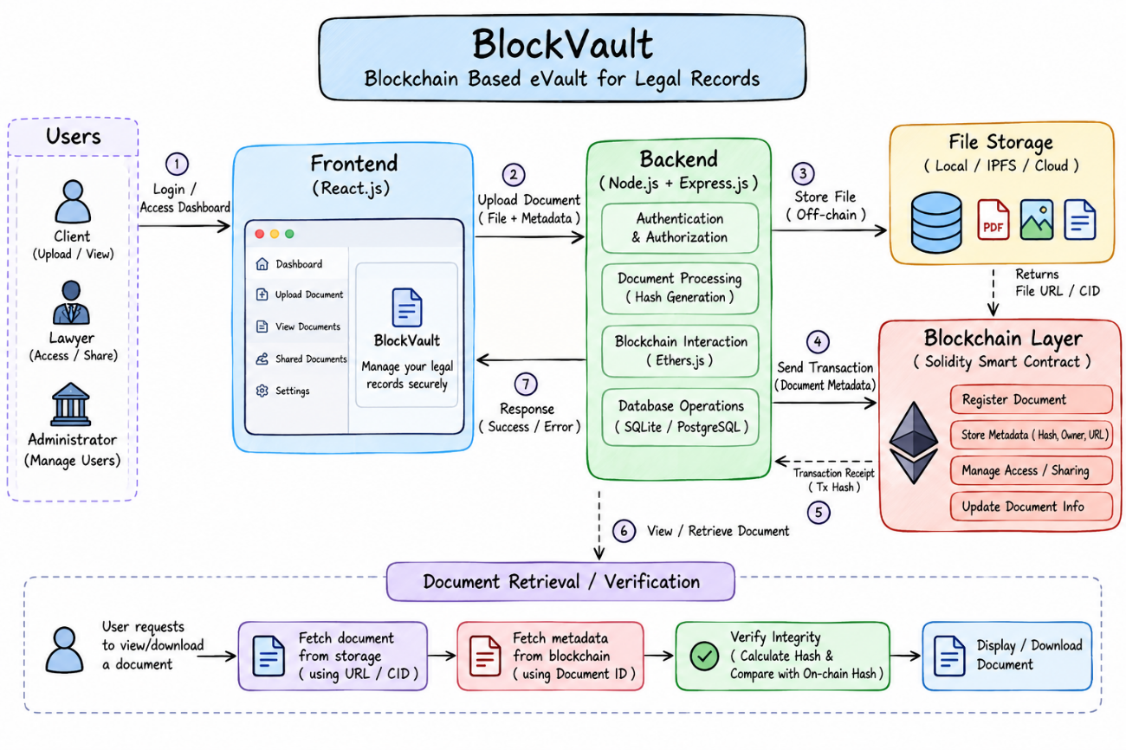

Figure 4.1: Proposed System Architecture of BlockVault — Blockchain-Based eVault for Legal Record
5. IMPLEMENTATION

The implementation chapter for BlockVault is structured according to your Digital Warranty System sample. Each subsection explains a specific implementation component, followed by the relevant Solidity code from your DocumentRegistry smart contract.
One important distinction: the supplied contract supports user registration, role assignment, document registration, document retrieval, sharing, and editing. It does not directly implement file uploads, encryption, or cryptographic hash generation; those operations must be handled by the application or other components.

5.1. Setting Up the Blockchain Environment
To implement the blockchain-based eVault system, a development environment compatible with Ethereum smart contracts is required. Solidity is used to develop the smart contract, while tools such as Hardhat or Truffle can be used for compilation, deployment, and testing. Ganache or a local Hardhat network can provide a blockchain environment for development and testing. MetaMask can be used to manage blockchain accounts and authorize transactions when connected to the frontend.
The DocumentRegistry contract uses Solidity version ^0.8.0 and defines the functions required to register users, store document metadata, retrieve document records, manage access, and update document information. After the development environment is configured, the contract can be compiled and deployed to a local blockchain. The deployed contract can then be connected to the backend application for interaction with its functions.
The frontend and backend communicate with the blockchain through a compatible library, such as Ethers.js. The contract address and ABI are required for the application to invoke the deployed smart contract.

5.2. Defining Smart Contracts
The smart contract is the core component responsible for maintaining document records and managing user-related operations on the blockchain. The DocumentRegistry contract defines two structures, Document and User, to organize document metadata and user information.
The contract uses mappings to associate document content hashes with document records, blockchain addresses with user details, and user addresses with lists of document identifiers. It also defines an administrative access modifier to restrict selected operations to the administrator.

5.2.1. Writing the Smart Contract for Document Management
The DocumentRegistry contract stores the document identifier, document type, content hash, owner address, and creator address. The Document structure represents each registered document, while the User structure maintains the user's name, blockchain address, verification status, and role.
The contract maintains a mapping from content hashes to document records and another mapping from blockchain addresses to registered users. A separate mapping maintains lists of document hashes associated with users. These data structures enable the contract to organize document metadata and support document retrieval.

contract DocumentRegistry {
address public admin;

struct Document {
string docId;
string docType;
string contentHash;
address owner;
address creator;
}

struct User {
string name;
address addr;
bool verified;
string role;
}

mapping(string => Document) private documents;
mapping(address => string[])
private documentsCreatedByUser;
mapping(address => User) private users;
}

5.2.2. Registering Users and Managing Roles

User registration is restricted to the administrator through the onlyAdmin modifier. The createUser function accepts a user's name and blockchain address and creates a new user record. It checks whether the address has already been registered to prevent duplicate registrations.
The grantRole function allows the administrator to assign a role to an existing user and mark that user as verified. The getUser function retrieves the stored details of a user associated with a given blockchain address.
modifier onlyAdmin() {
require(
msg.sender == admin,
"Only admin can perform this operation"
);
_;
}

function createUser(
string memory _name,
address _addr
) external onlyAdmin {
require(
users[_addr].addr == address(0),
"User with this address already exists"
);

users[_addr] = User({
name: _name,
addr: _addr,
verified: false,
role: "User"
});
}

function grantRole(
address _userAddr,
string memory _roleType
) external onlyAdmin {
User storage user = users[_userAddr];

require(
user.addr != address(0),
"User doesn't exist"
);

user.role = _roleType;
user.verified = true;
}

5.2.3. Storing Document Records

The storeDocument function registers document metadata on the blockchain. It accepts the document ID, document type, content hash, owner address, and creator address as parameters.
Before registering the document, the function verifies that both the owner and creator are registered users. It also checks whether the supplied content hash has already been used for a document. If the checks pass, the document information is stored in the mapping, and its hash is added to the associated users' document lists.

function storeDocument(
string memory _docID,
string memory _docType,
string memory _contentHash,
address _owner,
address _creator
) external {
require(
users[_owner].addr == _owner,
"Owner doesn't exist"
);

require(
users[_creator].addr == _creator,
"Creator doesn't exist"
);

require(
bytes(documents[_contentHash].contentHash).length == 0,
"Document already exists"
);

documents[_contentHash] = Document({
docId: _docID,
docType: _docType,
contentHash: _contentHash,
owner: _owner,
creator: _creator
});

documentsCreatedByUser[_owner].push(_contentHash);

if (_owner != _creator) {
documentsCreatedByUser[_creator].push(_contentHash);
}
}

5.2.4. Viewing Documents Associated with a User

The contract provides two functions for retrieving document information. The fetchMyIds function returns the list of document hashes associated with the calling user's blockchain address. The fetchDocumentById function retrieves the details of a specific document using its content hash.
The document retrieval function checks whether the record exists and whether the caller is the document owner or creator. If the caller satisfies these conditions, the function returns the document ID, type, content hash, owner address, and creator address.
function fetchMyIds()
external
view
returns (string[] memory)
{
return documentsCreatedByUser[msg.sender];
}

function fetchDocumentById(
string memory _contentHash
)
external
view
returns (
string memory,
string memory,
string memory,
address,
address
)
{
Document storage doc = documents[_contentHash];

require(
bytes(doc.contentHash).length > 0,
"Document not found"
);

require(
doc.owner == msg.sender ||
doc.creator == msg.sender,
"You don't have permission for this document"
);

return (
doc.docId,
doc.docType,
doc.contentHash,
doc.owner,
doc.creator
);
}

5.2.5. Sharing Document Access

The shareUserAccess function provides a mechanism for associating a document hash with another registered user's document list. The function accepts the document content hash and the recipient's blockchain address.
The contract verifies that the recipient is registered, checks that the document exists, and confirms that the caller owns the document. It then adds the document hash to the recipient's list.
function shareUserAccess(
string memory _contentHash,
address _toAddress
) external {
require(
users[_toAddress].addr == _toAddress,
"User not registered"
);

Document storage doc = documents[_contentHash];

require(
bytes(doc.contentHash).length > 0,
"Document not found"
);

require(
doc.owner == msg.sender,
"You are not the owner of this document"
);

documentsCreatedByUser[_toAddress].push(
_contentHash
);
}

5.2.6. Editing Document Information

The editDocument function allows the document owner to update the document type and content hash associated with a document. It first verifies that the existing record is present and that the caller is the owner. After these checks, the function updates the specified fields.

function editDocument(
string memory _contentHash,
string memory _newDocType,
string memory _newContentHash
) external {
Document storage doc = documents[_contentHash];

require(
bytes(doc.contentHash).length > 0,
"Document not found"
);

require(
doc.owner == msg.sender,
"You don't own this document and can't edit"
);

doc.docType = _newDocType;
doc.contentHash = _newContentHash;
}

5.2.7. Administrative Access Control
The contract assigns administrative privileges to the address that deploys it. The onlyAdmin modifier restricts functions that use it to this address. In the supplied implementation, user registration and role assignment are protected by this modifier.
address public admin;
constructor() {
admin = msg.sender;
}
modifier onlyAdmin() {
require(
msg.sender == admin,
"Only admin can perform this operation"
);
_;
}

5.3. Deploying and Integrating with the Frontend

After developing the smart contract, it must be compiled and deployed tocompatible blockchain network. A local development network, such as Ganache or Hardhat Network, can be used to test the contract before considering deployment to a public test network.
Component | Responsibility
React.js | Provides the user interface and dashboard.
Node.js and Express.js | Processes requests and coordinates application operations.
Solidity smart contract | Maintains document records and implements supported rules.
Ethers.js | Connects the backend to the blockchain.
Database and file storage | Manage application data and document files according to the configuration.

5.4. Workflow

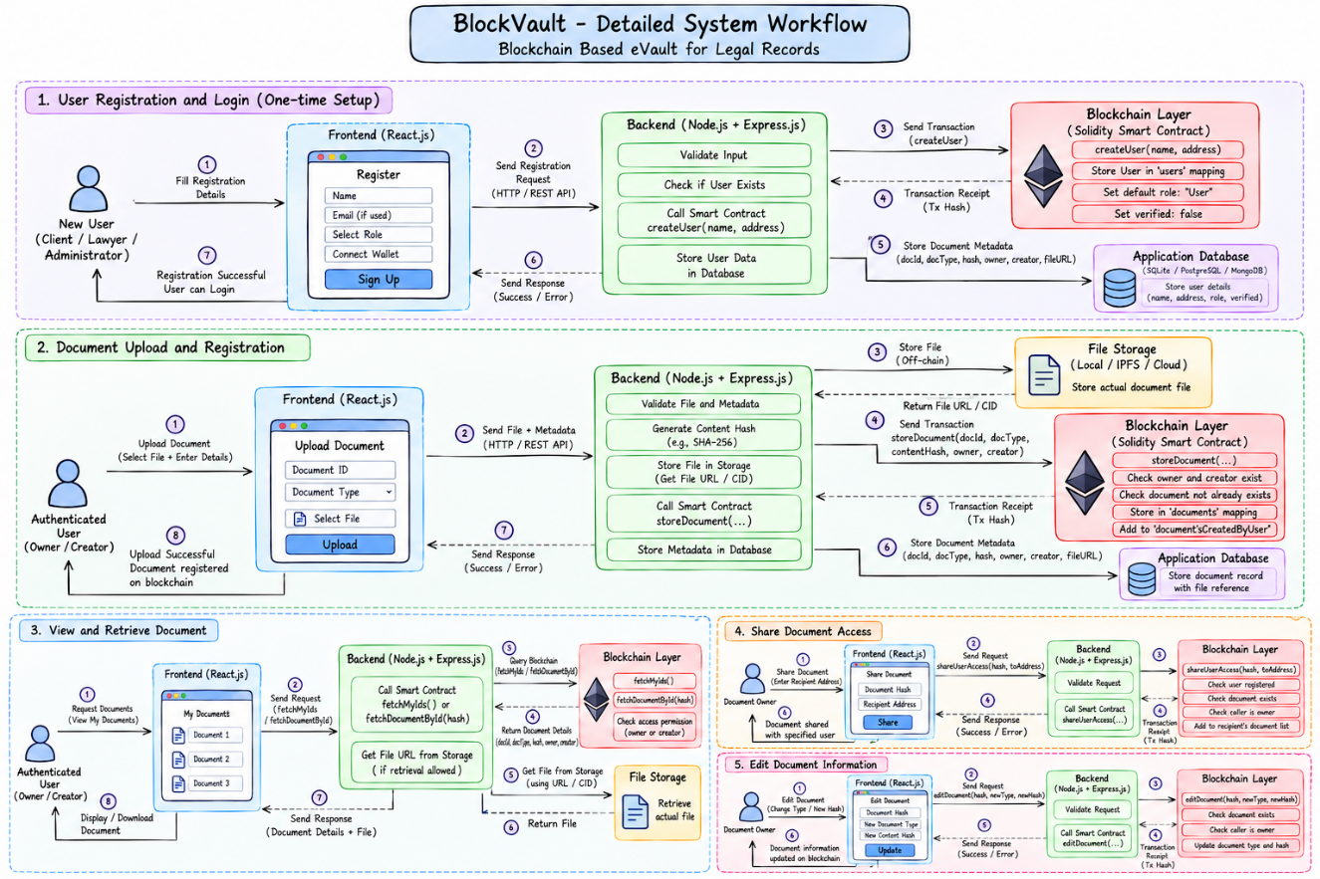

6. BENEFITS

6.1. Improved Document Management

BlockVault provides a centralized web interface for organizing and accessing legal documents. Users can manage document-related operations through the dashboard, reducing dependence on manual recordkeeping and making document retrieval more convenient.

6.2. Blockchain-Based Record Integrity

The system uses Solidity smart contracts to maintain document-related records on a blockchain. Recording document metadata and content hashes can help users identify changes to registered documents when hash verification is implemented correctly.

6.3. Transparency and Traceability

Blockchain transactions provide a traceable record of operations performed on the smart contract. These records can help identify the blockchain account associated with a document-registration transaction and support the review of document-related activities.

6.4. Smart Contract Automation

The DocumentRegistry contract automates selected operations, including user registration, role assignment, document registration, retrieval, and metadata updates. Programmed validation checks help enforce rules such as preventing duplicate user registration and restricting certain operations to authorized accounts.

6.5. Convenient Document Access

The React.js frontend and Node.js/Express backend provide an interface for document-management operations. The application can simplify document upload, listing, retrieval, and sharing according to the implemented functionality.

6.6. Reduced Dependence on Manual Verification

Cryptographic hashes and blockchain records can support the verification of document integrity without relying exclusively on manually maintained records. However, the application must correctly calculate and compare hashes for this benefit to be realized.

6.7. Support for Document Provenance

The contract records the owner and creator addresses associated with a document. This information can help establish the relationship between a document and the blockchain accounts recorded during registration. Additional event logging and identity verification would be required for a complete chain-of-custody system.

6.8. Scope for Future Enhancement

The modular design provides opportunities to introduce stronger access controls, improved document verification, secure file storage, more detailed audit logs, and additional user roles. These enhancements could improve the system's suitability for more demanding legal document management requirements.

7. CHALLENGES

7.1. Smart Contract Limitations
Smart contracts must be carefully designed and tested because errors in their logic can affect document registration, retrieval, and access management. The current DocumentRegistry contract has limitations in its sharing and editing mechanisms. These functions require further refinement to ensure that permissions and document references remain consistent.

7.2. Data Privacy and Confidentiality
Legal documents may contain confidential information that should not be accessible to unauthorized users. Blockchain transactions can expose information depending on the network and the data recorded. Therefore, sensitive document contents should not be stored directly on a public blockchain. Appropriate access controls, encryption, and secure off-chain storage are necessary to protect confidential information.

7.3. Document Storage and Availability
Blockchain networks are not designed to store large document files efficiently. Storing complete files on-chain can increase transaction costs and storage requirements. The application must therefore rely on a suitable off-chain storage mechanism. If a document is lost or its storage service becomes unavailable, the blockchain record alone cannot restore the original file.

7.4. Scalability and Transaction Costs
Blockchain transactions require network resources and may involve transaction fees. As the number of registered documents and users increases, transaction processing time and costs may become significant, particularly on public networks. The system must select an appropriate blockchain environment and minimize unnecessary state-changing transactions.

7.5. Access Control and User Verification
The current smart contract provides basic administrative controls and checks document ownership during retrieval and editing. However, its permission model is limited. For example, the sharing function adds a document hash to another user's list, but the retrieval function does not recognize that shared user as authorized. Additional permission tracking and validation are required for reliable sharing.

7.6. Document Integrity Verification
Blockchain can preserve a registered content hash, but the application must calculate and compare document hashes correctly to detect modifications. The supplied contract accepts the hash as an input rather than calculating it internally. Consequently, the reliability of integrity verification depends on the backend's hashing process and correct association between files and their registered records.

7.7. Integration and Configuration
Integrating the frontend, backend, database, and blockchain requires consistent configuration. Incorrect contract addresses, outdated contract ABIs, blockchain connectivity problems, or backend errors can interrupt application operations. Proper configuration, testing, and error handling are necessary to ensure reliable communication between components.

7.8. Legal and Regulatory Considerations
A blockchain record does not automatically establish the legal validity or admissibility of a document. Legal evidence may require proof of authorship, identity verification, proper collection procedures, and a reliable chain of custody. The prototype demonstrates document-related blockchain operations, but additional technical and procedural measures would be necessary for real-world legal use.

8 . CONCLUSION

The Blockchain-Based eVault for Legal Records, BlockVault, demonstrates the application of blockchain technology in digital legal document management. The system integrates a React.js frontend, Node.js and Express.js backend, and Solidity smart contracts to support document registration, retrieval, user management, and selected access-control operations.

The DocumentRegistry smart contract maintains document metadata, including document identifiers, document types, content hashes, owner addresses, and creator addresses. It also provides functions for user registration, role assignment, document retrieval, sharing, and editing. These features illustrate how smart contracts can establish structured rules for managing document-related records on a blockchain.

The system highlights the potential benefits of blockchain-based recordkeeping, including traceability, transparency, and document integrity verification when supported by appropriate hashing mechanisms. It also demonstrates how blockchain functionality can be integrated into a conventional web application to simplify document management.

However, the prototype has limitations in its access-control mechanisms, document-sharing workflow, and metadata-update functionality. Additional improvements, including stronger permission validation, reliable hash verification, secure off-chain storage, and comprehensive testing, would be required to improve its reliability and security.

In conclusion, BlockVault provides an academic demonstration of blockchain-based legal document management using Solidity smart contracts. With further development and validation, the system could serve as a foundation for exploring more reliable and transparent digital recordkeeping solutions.

9. SDGs Addressed

The BlockVault system aligns with selected United Nations Sustainable Development Goals (SDGs) by demonstrating the use of blockchain technology for digital record management, transparency, and accountability.

9.1. SDG 9: Industry, Innovation and Infrastructure

BlockVault demonstrates the application of blockchain technology and smart contracts in digital infrastructure. By integrating Solidity-based smart contracts with a web application, the system explores an innovative approach to maintaining document-related records and supporting digital transformation.

9.2. SDG 16: Peace, Justice and Strong Institutions

This is the most directly relevant SDG for BlockVault. The system aims to support transparent and traceable legal record management through blockchain transactions. Document metadata and associated blockchain records can help improve accountability and facilitate the verification of registered information.
The application demonstrates how digital technologies can support more reliable recordkeeping practices relevant to legal and administrative processes.

9.3. SDG 12: Responsible Consumption and Production
BlockVault supports digital document management, which can reduce dependence on printing and physical document storage when adopted in place of paper-based workflows. Digital records can also simplify document retrieval and organization.
However, the actual environmental benefit depends on how the system is used and the resources required to operate its infrastructure.

REFERENCES

- Jeba, N., Anas, S., Anuragav, S., Abhishek, R., and Sachin, K. (2024). Evault for Legal Records. arXiv preprint arXiv:2403.01186. Available at: https://arxiv.org/abs/2403.01186

- Viperadnan-git. (n.d.). Blockdoc: Blockchain-Based E-Vault Created Using Smart Contracts for SIH 2023. GitHub repository. Available at: https://github.com/viperadnan-git/blockdoc

- Solidity. (n.d.). Solidity Documentation. Available at: https://docs.solidity.org/en/latest/

- Ethereum Foundation. (n.d.). Ethereum Developer Documentation. Available at: https://ethereum.org/en/developers/docs/

- React. (n.d.). React Documentation. Available at: https://react.dev/

- Express.js. (n.d.). Express.js Documentation. Available at: https://expressjs.com/

- Ethers.js. (n.d.). Ethers.js Documentation. Available at: https://docs.ethers.org/

APPENDIX A

https://drive.google.com/drive/folders/1d9ALuyTox5rx3k0THdyHRbeV8igztMYY?usp=drive_link

https://github.com/gkrvkoushik/BlockVault



