**Week-06 HandsOn Solution**

* **ReactJS-HOL**

**Question 1: Introduction to React & Creating First App**

* **Code:**

import logo from './logo.svg';

import './App.css';

function App() {

    return (

        <h1>Welcome the First Session of React</h1>

    );

}

export default App;

* **Output:**

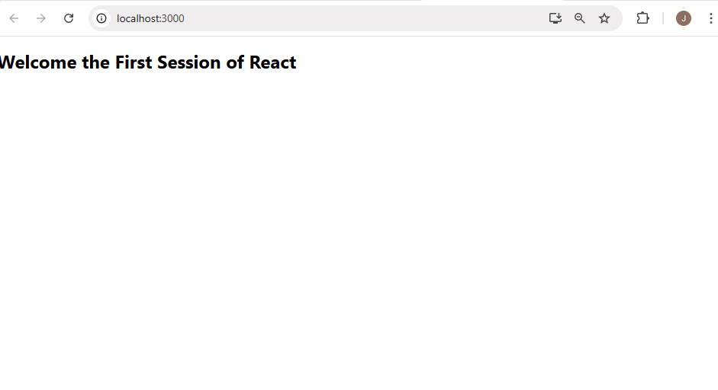

**Question 2: Class Components in React**

* **Code:**

**//About.js**

import React, { Component } from 'react';

class About extends Component {

    render() {

        return (

            <div>

                <h3>Welcome  to the About page of Student Mangement Portal </h3>

            </div>

        );

    }

}

export default About;

**//Contact.js**

import React, { Component } from 'react';

class Contact extends Component {

    render() {

        return (

            <div>

                <h3>Welcome to Contact page of Student Mangement Portal</h3>

            </div>

        );

    }

}export default Contact;

**//Home.js**

import React, { Component } from 'react';

class Home extends Component {

    render() {

        return (

            <div>

                <h3>Welcome to the Home Page of Student Management Portal </h3>

            </div>

        );

    }

}

export default Home;

* **Output:**

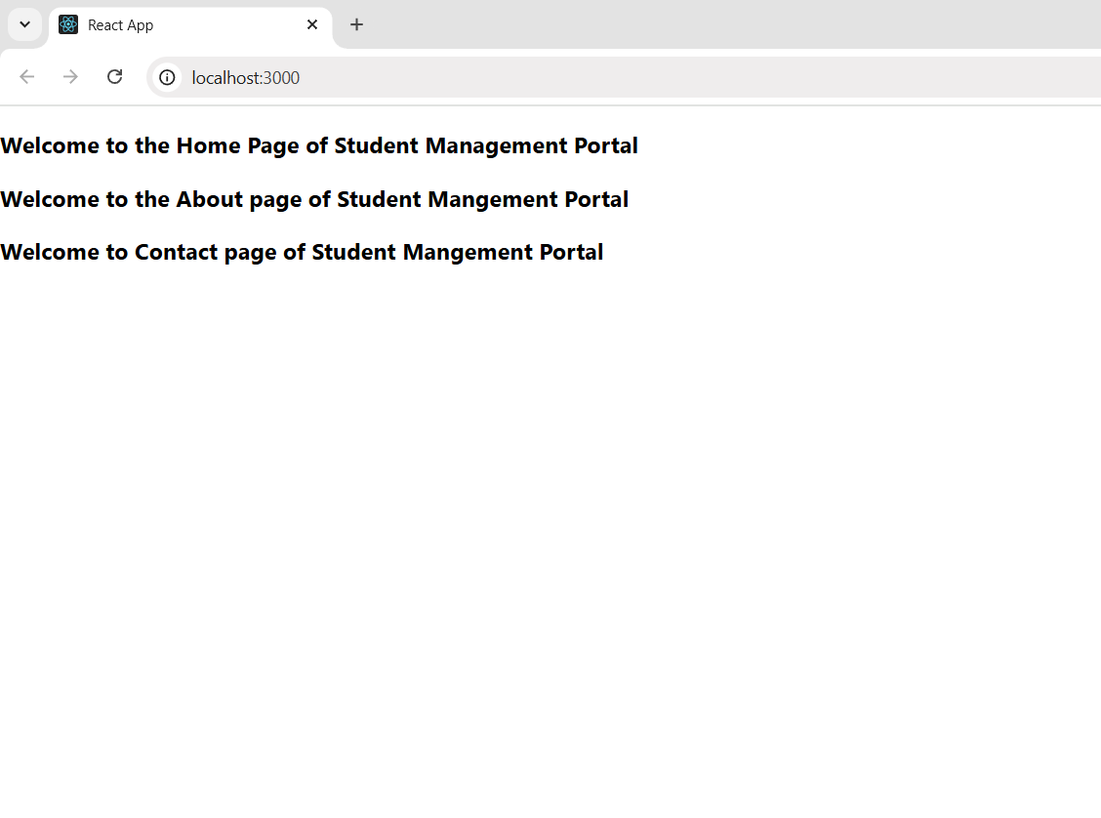

**Question 3: Functional Components & Styling**

* **Code:**

import './Stylesheets/mystyle.css'

const percentToDecimal = (decimal) => {

    return (decimal.toFixed(2) + '%')

}

const calcScore = (total, goal) => {

    return percentToDecimal(total / goal)

}

export const CalculateScore = ({ Name, School, total, goal }) => (

    <div className='formalstyle'>

        <h1><font color="Brown">Student Details : </font></h1>

        <div className='Name'>

            <b> <span>Name : </span></b>

            <span>{Name}</span>

        </div>

        <div className='School'>

            <b><span>School : </span></b>

            <span>{School}</span>

        </div>

        <div className='Total'>

            <b><span>Total : </span></b>

            <span>{total}</span>

            <span>Marks</span>

        </div>

        <div className='Score'>

            <b>Score : </b>

            <span>{calcScore(total, goal)}</span>

        </div>

    </div>)

* **Output:**

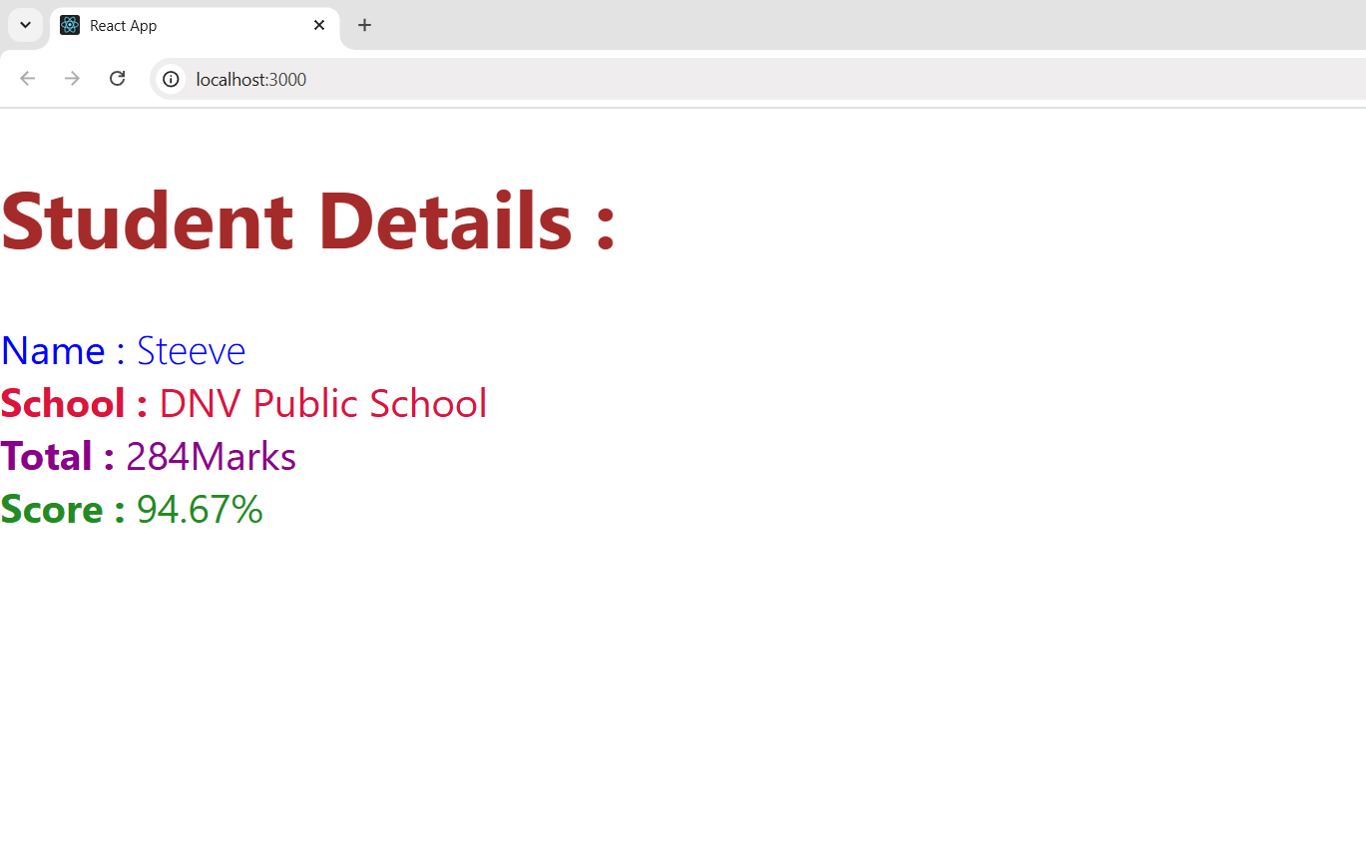

**Question 4: React Component Lifecycle Methods**

* **Code:**

import Post from "./Post";

import React from "react";

class Posts extends React.Component {

    constructor(props) {

        super(props);

        this.state = {

            posts: []

        };

    }

    loadPosts() {

        fetch('https://jsonplaceholder.typicode.com/posts')

            .then((response) => response.json())

            .then((data) => {

                const obj = data.map(value => new Post(value.id, value.title, value.body));

                this.setState({ posts: obj });

            })

            .catch((error) => {

                console.error("Error in Fetching : ", error);

            });

    }

    componentDidMount() {

        this.loadPosts();

    }

    render() {

        const { posts } = this.state;

        return (

            <>

                <ul>

                    {posts.map(post => (

                        <li key={post.id}>

                            <h1>{post.title}</h1>

                            <p>{post.body}</p>

                        </li>

                    ))

                    }

                </ul>

            </>

        );

    }

    componentDidCatch(error, info) {

        console.error("Error in Posts Component: ", error);

}

}

export default Posts;

* **Output:**

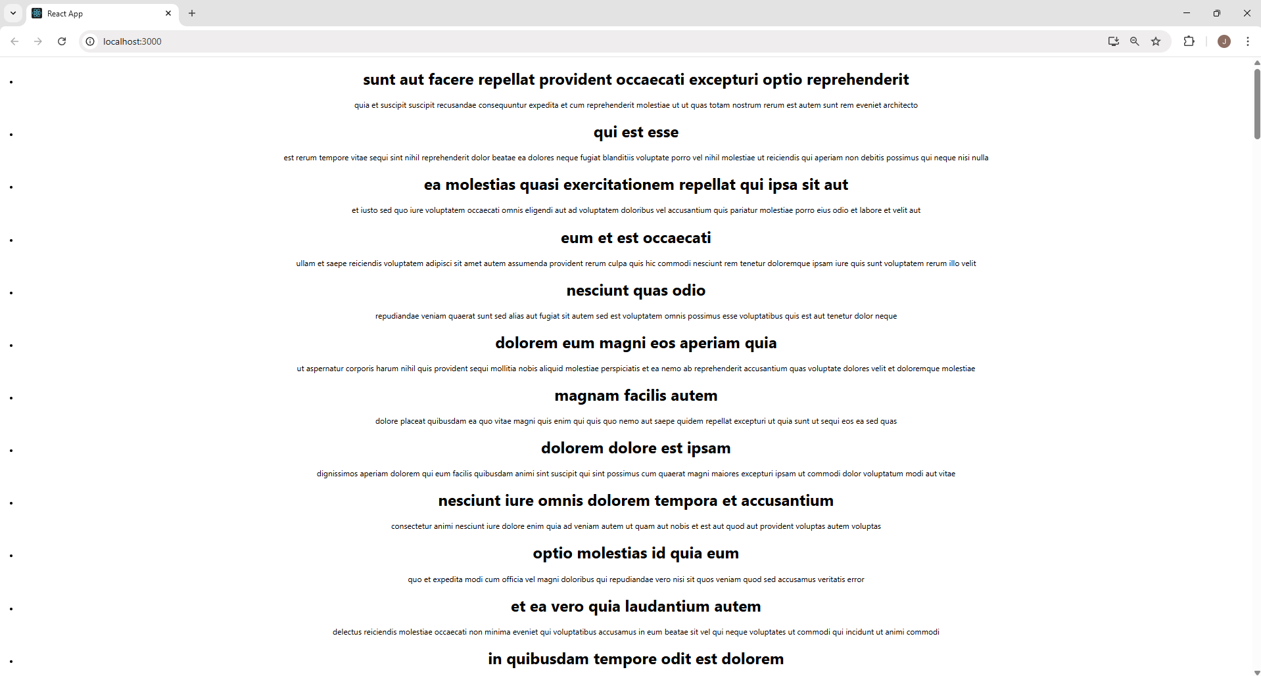

**Question 5: Styling React Components with CSS Modules**

* **Code:**

**//App.js**

import logo from './logo.svg';

import './App.css';

import { CohortsData} from './Cohort'

import CohortDetails from './CohortDetails';

function App() {

  return (

  <div>

    <h1>Cohorts Details</h1>

    {CohortsData.map(cohort => <CohortDetails cohort={cohort}/>)}

  </div>

  );

}

export default App;

**//Cohort.js**

class Cohort {

    constructor(cohortCode,

        startDate,

        technology,

        trainerName,

        coachName,

        currentStatus) {

        this.cohortCode = cohortCode;

        this.coachName = coachName;

        this.trainerName = trainerName;

        this.technology = technology;

        this.startDate = startDate;

        this.currentStatus = currentStatus;

    }

}

const CohortsData = [

    new Cohort('INTADMDF10', '22-Feb-2022', '.NET FSD', 'Jojo Jose', 'Aathma', 'Scheduled'),

    new Cohort('ADM21JF014', '10-Sep-2021', 'Java FSD', 'Elisa Smith', 'Apoorv', 'Ongoing'),

    new Cohort('CDBJF21025', '24-Dec-2021', 'Java FSD', 'John Doe', 'Aathma', 'Ongoing'),

    new Cohort('INTADMJF12', '22-Feb-2022', 'Java FSD', 'To Be Assigned', 'Ibrahim', 'Scheduled'),

    new Cohort('CDE22JF011', '24-Dec-2021', 'Java FSD', 'Emma Swan', 'Apoorv', 'Ongoing'),

    new Cohort('INTADMDF09', '22-Feb-2022', 'Dataware Housing', 'Babjee Rao', 'Aathma', 'Scheduled'),

    new Cohort('ADM22DF001', '10-Sep-2021', '.NET FSD', 'Marie Curie', 'Ibrahim', 'Ongoing'),

];

export { Cohort, CohortsData };

* **Output:**

