**Week-07 HandsOn Solution**

* **ReactJS-HOL**

**Question 9: ES6 Features with Map, Arrow Functions, and Destructuring in React Cricket App.**

* **Code:**

import React, { useState } from 'react';

import './App.css';

function App() {

  const [flag, setFlag] = useState(true);

  return (

    <div className="App">

      <h1>Cricket Players Dashboard</h1>

      <button onClick={() => setFlag(!flag)}>

        Toggle View ({flag ? "List View" : "Indian Players"})

      </button>

      {flag ? <ListofPlayers /> : <IndianPlayers />}

    </div>

  );

}

function ListofPlayers() {

  const players = [

    { id: 1, name: "Virat Kohli", score: 120 },

    { id: 2, name: "Rohit Sharma", score: 65 },

    { id: 3, name: "KL Rahul", score: 45 },

    { id: 4, name: "Rishabh Pant", score: 78 },

    { id: 5, name: "Hardik Pandya", score: 85 },

    { id: 6, name: "Jasprit Bumrah", score: 12 },

    { id: 7, name: "Ravindra Jadeja", score: 55 },

    { id: 8, name: "Mohammed Shami", score: 8 },

    { id: 9, name: "Shreyas Iyer", score: 92 },

    { id: 10, name: "Yuzvendra Chahal", score: 15 },

    { id: 11, name: "Bhuvneshwar Kumar", score: 25 }

  ];

  const lowScorers = players.filter(player => player.score < 70);

  return (

    <div>

      <h2>All Players</h2>

      <ul className="player-list">

        {players.map(player => (

          <li key={player.id}>

            {player.name} - <span className="score">{player.score}</span>

          </li>

        ))}

      </ul>

      <h2>Players with Score Below 70</h2>

      <ul className="player-list">

        {lowScorers.map(player => (

          <li key={player.id}>

            {player.name} - <span className="low-score">{player.score}</span>

          </li>

        ))}

      </ul>

    </div>

  );

}

function IndianPlayers() {

  const players = ["Virat", "Rohit", "Dhoni", "Rahul", "Pant", "Bumrah", "Jadeja"];

  const [first, second, ...others] = players;

  const oddPlayers = players.filter((_, index) => index % 2 === 0);

  const evenPlayers = players.filter((_, index) => index % 2 !== 0);

  const t20Players = ["Hardik", "Chahal", "Surya"];

  const ranjiPlayers = ["Pujara", "Rahane", "Vihari"];

  const allPlayers = [...t20Players, ...ranjiPlayers];

  return (

    <div>

      <h2>Indian Players Analysis</h2>

      <h3>Destructured Players</h3>

      <p>First: {first}, Second: {second}, Others: {others.join(", ")}</p>

      <h3>Odd vs Even Team</h3>

      <div className="team-container">

        <div>

          <h4>Odd Team</h4>

          <ul>

            {oddPlayers.map((player, index) => (

              <li key={index}>{player}</li>

            ))}

          </ul>

        </div>

        <div>

          <h4>Even Team</h4>

          <ul>

            {evenPlayers.map((player, index) => (

              <li key={index}>{player}</li>

            ))}

          </ul>

        </div>

      </div>

      <h3>Merged Players (T20 + Ranji)</h3>

      <ul>

        {allPlayers.map((player, index) => (

          <li key={index}>{player}</li>

        ))}

      </ul>

    </div>

  );

}

export default App;

* **Output:**

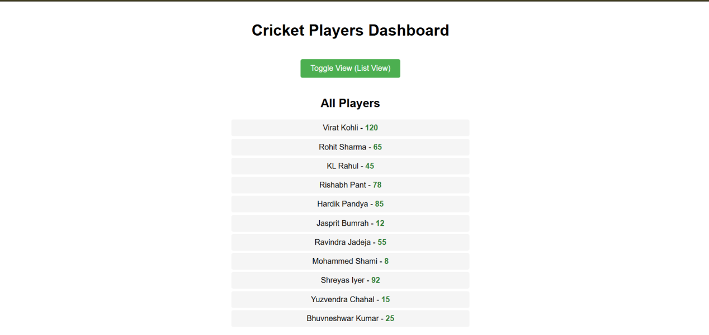

**Question 10: JSX & Inline CSS in React**

* **Code:**

import React from 'react';

import './App.css';

function App() {

  const offices = [

    { id: 1, name: "Downtown Office", rent: 55000, address: "123 Main St", image: "https://via.placeholder.com/300x200?text=Office+1" },

    { id: 2, name: "Tech Park Suite", rent: 75000, address: "456 Tech Ave", image: "https://via.placeholder.com/300x200?text=Office+2" },

    { id: 3, name: "Executive Plaza", rent: 65000, address: "789 Business Blvd", image: "https://via.placeholder.com/300x200?text=Office+3" },

    { id: 4, name: "Innovation Hub", rent: 45000, address: "321 Creative Lane", image: "https://via.placeholder.com/300x200?text=Office+4" }

  ];

  return (

    <div className= "App" >

    <h1>Office Space Rental </h1>

      < div className = "office-list" >

      {

        offices.map(office => (

          <div key= { office.id } className = "office-card" >

          <img src={ office.image } alt = { office.name } />

          <h2>{ office.name } </h2>

          < p > Address: { office.address } </p>

        < p style = {{ color: office.rent < 60000 ? 'red' : 'green', fontWeight: 'bold' }} >

        Rent: ₹{ office.rent.toLocaleString() }

  </p>

    </div>

        ))

}

</div>

  </div>

  );

}

export default App;

* **Output:**

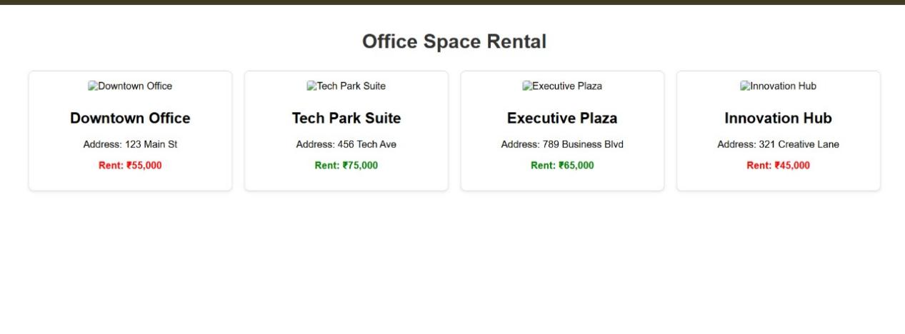

**Question 11: Event Handling in React**

* **Code:**

import React, { useState } from 'react';

import './App.css';

function App() {

  const [count, setCount] = useState(0);

  const [message, setMessage] = useState('');

  const [rupees, setRupees] = useState('');

  const [euros, setEuros] = useState('');

  const increment = () => {

    setCount(count + 1);

    sayHello();

  };

  const sayHello = () => {

    setMessage('Hello! Welcome to React Events!');

  };

  const sayWelcome = (msg) => {

    setMessage(msg);

  };

  const handleClick = (e) => {

    console.log(e);

    setMessage('I was clicked!');

  };

  const handleConversion = () => {

    const rate = 0.011; // 1 INR = 0.011 EUR

    setEuros((rupees * rate).toFixed(2));

  };

  return (

    <div className= "App" >

<h1>React Event Examples </h1>

      < div className = "counter-section" >

        <h2>Counter: { count } </h2>

          < button onClick = { increment } > Increment(+1 and Say Hello) </button>

            < button onClick = {() => setCount(count - 1)

}> Decrement </button>

  </div>

  < div className = "message-section" >

    <h3>{ message } </h3>

    < button onClick = {() => sayWelcome('Welcome to React!')}>

      Say Welcome

        </button>

        < button onClick = { handleClick } >

          Click Me(Synthetic Event)

            </button>

            </div>

            < div className = "converter-section" >

              <h2>Currency Converter </h2>

                < div >

                <label>

                Indian Rupees:

<input

              type="number"

value = { rupees }

onChange = {(e) => setRupees(e.target.value)}

            />

  </label>

  < button onClick = { handleConversion } > Convert to Euros </button>

    </div>

{ euros && <p>₹{ rupees } = €{ euros } </p> }

</div>

  </div>

  );

}

export default App;

* **Output:**

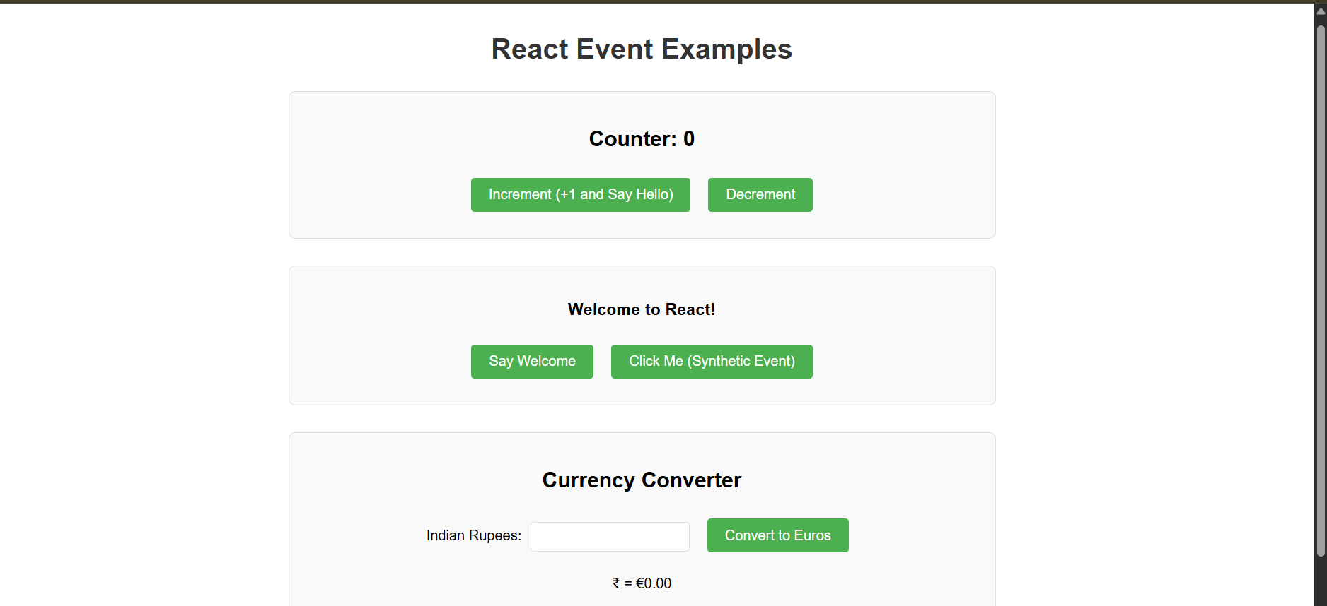

**Question 12: Conditional Rendering with Login/Logout in React Ticket Booking App.**

* **Code:**

import React, { useState } from 'react';

import './App.css';

function App() {

  const [isLoggedIn, setIsLoggedIn] = useState(false);

  const flights = [

    { id: 1, flightNo: 'AI101', from: 'Delhi', to: 'Mumbai', time: '10:00 AM' },

    { id: 2, flightNo: 'AI202', from: 'Mumbai', to: 'Chennai', time: '12:30 PM' },

    { id: 3, flightNo: 'AI303', from: 'Bangalore', to: 'Delhi', time: '03:15 PM' }

  ];

  return (

    <div className= "App" >

<h1>Flight Ticket Booking </h1>

      < button

  onClick = {() => setIsLoggedIn(!isLoggedIn)

}

className = { isLoggedIn? 'logout-btn': 'login-btn' }

  >

  { isLoggedIn? 'Logout': 'Login' }

  </button>

{

  isLoggedIn ? (

    <div className= "user-view" >

    <h2>Welcome User! </h2>

      < div className = "booking-form" >

        <h3>Book Your Flight </h3>

          <select>

  {

    flights.map(flight => (

      <option key= { flight.id } value = { flight.flightNo } >

      { flight.flightNo }: { flight.from } to { flight.to }({ flight.time })

    </option>

    ))

  }

  </select>

    < input type = "date" placeholder = "Travel Date" />

      <input type="number" placeholder = "Passengers" min = "1" />

        <button className="book-btn" > Book Now </button>

          </div>

          </div>

      ) : (

    <div className= "guest-view" >

    <h2>Available Flights </h2>

      < table >

      <thead>

      <tr>

      <th>Flight No </th>

        < th > From </th>

        < th > To </th>

        < th > Time </th>

        </tr>

        </thead>

        <tbody>

  {

    flights.map(flight => (

      <tr key= { flight.id } >

      <td>{ flight.flightNo } </td>

      < td > { flight.from } </td>

      < td > { flight.to } </td>

      < td > { flight.time } </td>

      </tr>

    ))

  }

  </tbody>

    </table>

    < p > Please login to book tickets </p>

      </div>

      )

}

</div>

  );

}

export default App;

* **Output:**

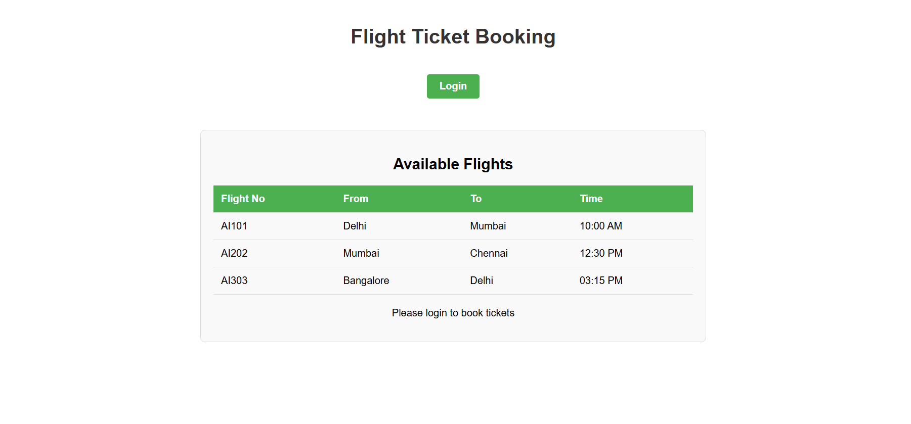

**Question 13: Conditional Rendering in React**

* **Code:**

import React, { useState } from 'react';

import './App.css';

function App() {

  const [activeTab, setActiveTab] = useState('books');

  // Sample data

  const books = [

    { id: 1, title: 'React Basics', author: 'John Doe', pages: 200 },

    { id: 2, title: 'Advanced JavaScript', author: 'Jane Smith', pages: 350 }

  ];

  const blogs = [

    { id: 1, title: 'Getting Started with React', author: 'Alex Johnson', date: '2023-05-15' },

    { id: 2, title: 'ES6 Features You Should Know', author: 'Sarah Williams', date: '2023-06-20' }

  ];

  const courses = [

    { id: 1, title: 'React Fundamentals', duration: '4 weeks', level: 'Beginner' },

    { id: 2, title: 'Advanced React Patterns', duration: '6 weeks', level: 'Advanced' }

  ];

  return (

    <div className= "App" >

<h1>Blogger App </h1>

      < div className = "tabs" >

        <button

          onClick={ () => setActiveTab('books') }

  className = { activeTab === 'books' ? 'active' : ''

}

        >

  Books

  </button>

  < button

onClick = {() => setActiveTab('blogs')}

className = { activeTab === 'blogs' ? 'active' : ''}

        >

  Blogs

  </button>

  < button

onClick = {() => setActiveTab('courses')}

className = { activeTab === 'courses' ? 'active' : ''}

        >

  Courses

  </button>

  </div>

  < div className = "content" >

    { activeTab === 'books' && (

      <div className="book-details" >

        <h2>Book Details </h2>

          <ul>

{

  books.map(book => (

    <li key= { book.id } >

    <h3>{ book.title } </h3>

    < p > Author: { book.author } </p>

    < p > Pages: { book.pages } </p>

  </li>

  ))

}

</ul>

  </div>

        )}

{

  activeTab === 'blogs' && (

    <div className="blog-details" >

      <h2>Blog Details </h2>

        <ul>

  {

    blogs.map(blog => (

      <li key= { blog.id } >

      <h3>{ blog.title } </h3>

      < p > By { blog.author } on { blog.date } </p>

    </li>

    ))

  }

  </ul>

    </div>

        )

}

{

  activeTab === 'courses' && (

    <div className="course-details" >

      <h2>Course Details </h2>

        < table >

        <thead>

        <tr>

        <th>Title </th>

        < th > Duration </th>

        < th > Level </th>

        </tr>

        </thead>

        <tbody>

  {

    courses.map(course => (

      <tr key= { course.id } >

      <td>{ course.title } </td>

      < td > { course.duration } </td>

      < td > { course.level } </td>

      </tr>

    ))

  }

  </tbody>

    </table>

    </div>

        )

}

</div>

  </div>

  );

}

export default App;

* **Output:**

