**Week-08 HandsOn Solution**

* **Git-HOL**

**Question 1: Write the Git commands to create a local repo, add welcome.txt, and push it to GitLab.**

* **Command:**

KIIT@BT-22052206 MINGW64 ~

$ git clone https://gitlab.com/gks0930-group/git01.git

cd git01

Cloning into 'git01'...

info: please complete authentication in your browser...

remote: Enumerating objects: 3, done.

remote: Counting objects: 100% (3/3), done.

remote: Compressing objects: 100% (2/2), done.

remote: Total 3 (delta 0), reused 0 (delta 0), pack-reused 0 (from 0)

Receiving objects: 100% (3/3), done.

KIIT@BT-22052206 MINGW64 ~/git01 (main)

$ echo "Welcome to Git" > welcome.txt

git add welcome.txt

git commit -m "Initial commit"

warning: in the working copy of 'welcome.txt', LF will be replaced by CRLF the next time Git touches it

[main a410227] Initial commit

1 file changed, 1 insertion(+)

create mode 100644 welcome.txt

KIIT@BT-22052206 MINGW64 ~/git01 (main)

$ echo "*.log" > .gitignore

echo "logs/" >> .gitignore

git add .gitignore

git commit -m "Added rules to ignore .log files and logs folder"

warning: in the working copy of '.gitignore', LF will be replaced by CRLF the next time Git touches it

[main 71c23e7] Added rules to ignore .log files and logs folder

1 file changed, 2 insertions(+)

create mode 100644 .gitignore

KIIT@BT-22052206 MINGW64 ~/git01 (main)

$ git push origin main:master

Enumerating objects: 7, done.

Counting objects: 100% (7/7), done.

Delta compression using up to 8 threads

Compressing objects: 100% (4/4), done.

Writing objects: 100% (6/6), 608 bytes | 152.00 KiB/s, done.

Total 6 (delta 0), reused 0 (delta 0), pack-reused 0 (from 0)

remote:

remote: To create a merge request for master, visit:

remote: https://gitlab.com/gks0930-group/git01/-/merge_requests/new?merge_request%5Bsource_branch%5D=master

remote:

To https://gitlab.com/gks0930-group/git01.git

* [new branch] main -> master

* **Output:**

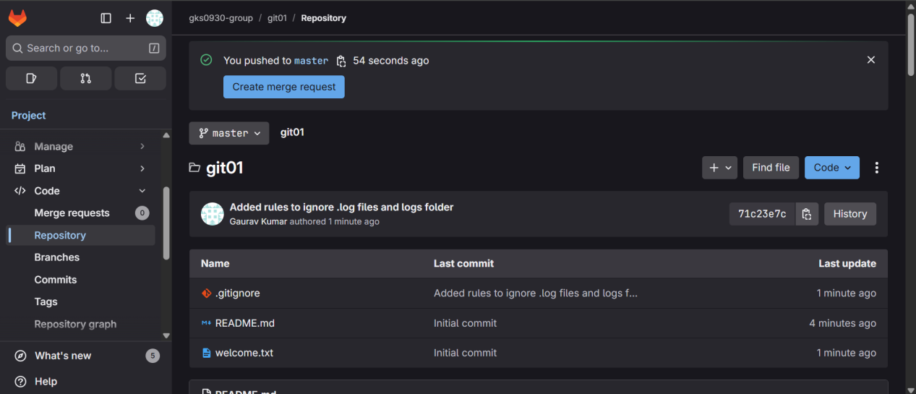

**Question 2: Write the Git commands to create a .gitignore that ignores .log files and the logs/ folder, then push it to GitLab.**

* **Command:**

KIIT@BT-22052206 MINGW64 ~/git02 (main)

$ echo "*.log" > .gitignore

echo "logs/" >> .gitignore

KIIT@BT-22052206 MINGW64 ~/git02 (main)

$ git add .gitignore

git commit -m "Added rules to ignore .log files and logs folder"

warning: in the working copy of '.gitignore', LF will be replaced by CRLF the next time Git touches it

[main 8ce7a20] Added rules to ignore .log files and logs folder

1 file changed, 2 insertions(+)

create mode 100644 .gitignore

KIIT@BT-22052206 MINGW64 ~/git02 (main)

$ git branch -M master

git push origin master

Enumerating objects: 4, done.

Counting objects: 100% (4/4), done.

Delta compression using up to 8 threads

Compressing objects: 100% (2/2), done.

Writing objects: 100% (3/3), 312 bytes | 312.00 KiB/s, done.

Total 3 (delta 0), reused 0 (delta 0), pack-reused 0 (from 0)

remote:

remote: To create a merge request for master, visit:

remote: https://gitlab.com/gks0930-group/git02/-/merge_requests/new?merge_request%5Bsource_branch%5D=master

remote:

To https://gitlab.com/gks0930-group/git02.git

* [new branch] master -> master

KIIT@BT-22052206 MINGW64 ~/git02 (master)

$ git clone https://gitlab.com/gks0930-group/git03.git

cd git03

Cloning into 'git03'...

remote: Enumerating objects: 3, done.

remote: Counting objects: 100% (3/3), done.

remote: Compressing objects: 100% (2/2), done.

remote: Total 3 (delta 0), reused 0 (delta 0), pack-reused 0 (from 0)

Receiving objects: 100% (3/3), done.

* **Output:**

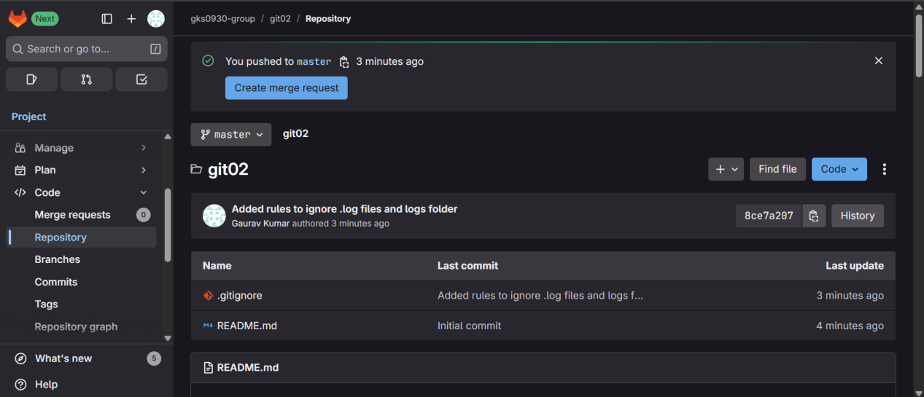

**Question 3: Write the Git commands to create a branch GitNewBranch, add a file in it, push it, and merge it into master.**

* **Command:**

KIIT@BT-22052206 MINGW64 ~/git03 (main)

$ git branch -M master

KIIT@BT-22052206 MINGW64 ~/git03 (master)

$ git checkout -b GitNewBranch

Switched to a new branch 'GitNewBranch'

KIIT@BT-22052206 MINGW64 ~/git03 (GitNewBranch)

$ echo "This is from GitNewBranch" > branchfile.txt

git add branchfile.txt

git commit -m "Added branchfile.txt in GitNewBranch"

warning: in the working copy of 'branchfile.txt', LF will be replaced by CRLF the next time Git touches it

[GitNewBranch b102e1a] Added branchfile.txt in GitNewBranch

1 file changed, 1 insertion(+)

create mode 100644 branchfile.txt

KIIT@BT-22052206 MINGW64 ~/git03 (GitNewBranch)

$ git push origin GitNewBranch

Enumerating objects: 4, done.

Counting objects: 100% (4/4), done.

Delta compression using up to 8 threads

Compressing objects: 100% (2/2), done.

Writing objects: 100% (3/3), 325 bytes | 162.00 KiB/s, done.

Total 3 (delta 0), reused 0 (delta 0), pack-reused 0 (from 0)

remote:

remote: To create a merge request for GitNewBranch, visit:

remote: https://gitlab.com/gks0930-group/git03/-/merge_requests/new?merge_request%5Bsource_branch%5D=GitNewBranch

remote:

To https://gitlab.com/gks0930-group/git03.git

* [new branch] GitNewBranch -> GitNewBranch

KIIT@BT-22052206 MINGW64 ~/git03 (GitNewBranch)

$ git checkout master

git pull origin master

git branch -d GitNewBranch

Switched to branch 'master'

Your branch is up to date with 'origin/main'.

fatal: couldn't find remote ref master

error: the branch 'GitNewBranch' is not fully merged

hint: If you are sure you want to delete it, run 'git branch -D GitNewBranch'

hint: Disable this message with "git config set advice.forceDeleteBranch false"

KIIT@BT-22052206 MINGW64 ~/git03 (master)

$ git clone https://gitlab.com/gks0930-group/git04.git

cd git04

git branch -M master

Cloning into 'git04'...

remote: Enumerating objects: 3, done.

remote: Counting objects: 100% (3/3), done.

remote: Compressing objects: 100% (2/2), done.

remote: Total 3 (delta 0), reused 0 (delta 0), pack-reused 0 (from 0)

Receiving objects: 100% (3/3), done.

* **Output:**

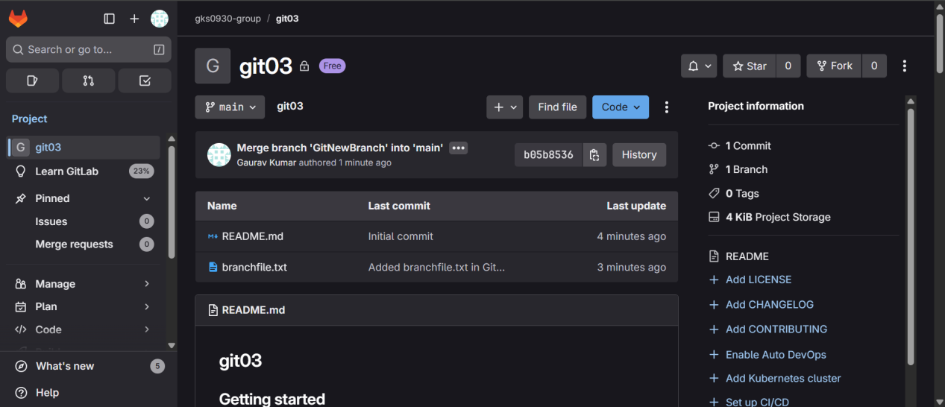

**Question 4: Write the Git commands to create a merge conflict with hello.xml, resolve it, and push the changes to GitLab.**

* **Command:**

KIIT@BT-22052206 MINGW64 ~/git04 (master)

$ git checkout -b GitWork

echo "<message>Hello from GitWork branch</message>" > hello.xml

git add hello.xml

git commit -m "Added hello.xml in GitWork branch"

Switched to a new branch 'GitWork'

warning: in the working copy of 'hello.xml', LF will be replaced by CRLF the next time Git touches it

[GitWork 94d0f60] Added hello.xml in GitWork branch

1 file changed, 1 insertion(+)

create mode 100644 hello.xml

KIIT@BT-22052206 MINGW64 ~/git04 (GitWork)

$ git push origin GitWork

Enumerating objects: 4, done.

Counting objects: 100% (4/4), done.

Delta compression using up to 8 threads

Compressing objects: 100% (2/2), done.

Writing objects: 100% (3/3), 337 bytes | 168.00 KiB/s, done.

Total 3 (delta 0), reused 0 (delta 0), pack-reused 0 (from 0)

remote:

remote: To create a merge request for GitWork, visit:

remote: https://gitlab.com/gks0930-group/git04/-/merge_requests/new?merge_request%5Bsource_branch%5D=GitWork

remote:

To https://gitlab.com/gks0930-group/git04.git

* [new branch] GitWork -> GitWork

KIIT@BT-22052206 MINGW64 ~/git04 (GitWork)

$ git checkout master

echo "<message>Hello from master branch</message>" > hello.xml

git add hello.xml

git commit -m "Added hello.xml in master branch"

git push origin master

Switched to branch 'master'

Your branch is up to date with 'origin/main'.

warning: in the working copy of 'hello.xml', LF will be replaced by CRLF the next time Git touches it

[master fb3d41f] Added hello.xml in master branch

1 file changed, 1 insertion(+)

create mode 100644 hello.xml

Enumerating objects: 4, done.

Counting objects: 100% (4/4), done.

Delta compression using up to 8 threads

Compressing objects: 100% (2/2), done.

Writing objects: 100% (3/3), 329 bytes | 109.00 KiB/s, done.

Total 3 (delta 0), reused 0 (delta 0), pack-reused 0 (from 0)

remote:

remote: To create a merge request for master, visit:

remote: https://gitlab.com/gks0930-group/git04/-/merge_requests/new?merge_request%5Bsource_branch%5D=master

remote:

To https://gitlab.com/gks0930-group/git04.git

* [new branch] master -> master

KIIT@BT-22052206 MINGW64 ~/git04 (master)

$ git merge GitWork

Auto-merging hello.xml

CONFLICT (add/add): Merge conflict in hello.xml

Automatic merge failed; fix conflicts and then commit the result.

KIIT@BT-22052206 MINGW64 ~/git04 (master|MERGING)

$ git checkout -b GitWork

echo "<message>Hello from GitWork branch</message>" > hello.xml

fatal: a branch named 'GitWork' already exists

KIIT@BT-22052206 MINGW64 ~/git04 (master|MERGING)

$ git checkout master

hello.xml: needs merge

error: you need to resolve your current index first

KIIT@BT-22052206 MINGW64 ~/git04 (master|MERGING)

$ nano hello.xml

KIIT@BT-22052206 MINGW64 ~/git04 (master|MERGING)

$ git add hello.xml

warning: in the working copy of 'hello.xml', LF will be replaced by CRLF the next time Git touches it

KIIT@BT-22052206 MINGW64 ~/git04 (master|MERGING)

$ git commit -m "Resolved merge conflict in hello.xml"

[master 7176cd8] Resolved merge conflict in hello.xml

KIIT@BT-22052206 MINGW64 ~/git04 (master)

$ git push origin master

Enumerating objects: 7, done.

Counting objects: 100% (7/7), done.

Delta compression using up to 8 threads

Compressing objects: 100% (2/2), done.

Writing objects: 100% (3/3), 363 bytes | 121.00 KiB/s, done.

Total 3 (delta 0), reused 0 (delta 0), pack-reused 0 (from 0)

remote:

remote: To create a merge request for master, visit:

remote: https://gitlab.com/gks0930-group/git04/-/merge_requests/new?merge_request%5Bsource_branch%5D=master

remote:

To https://gitlab.com/gks0930-group/git04.git

fb3d41f..7176cd8 master -> master

* **Output:**

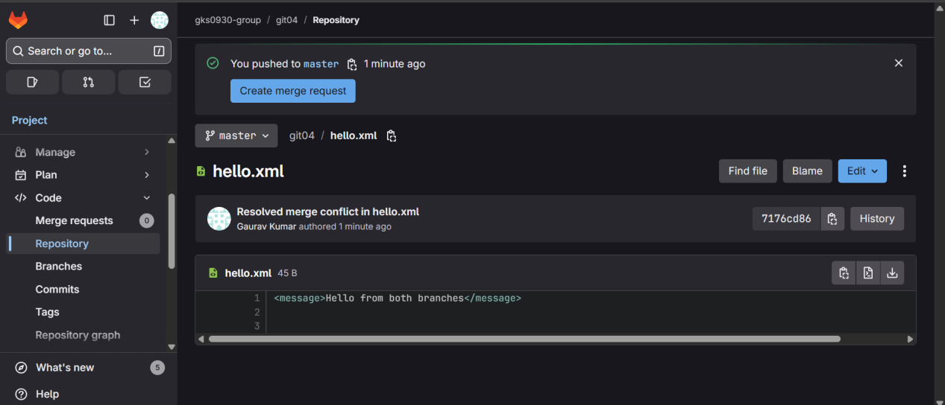

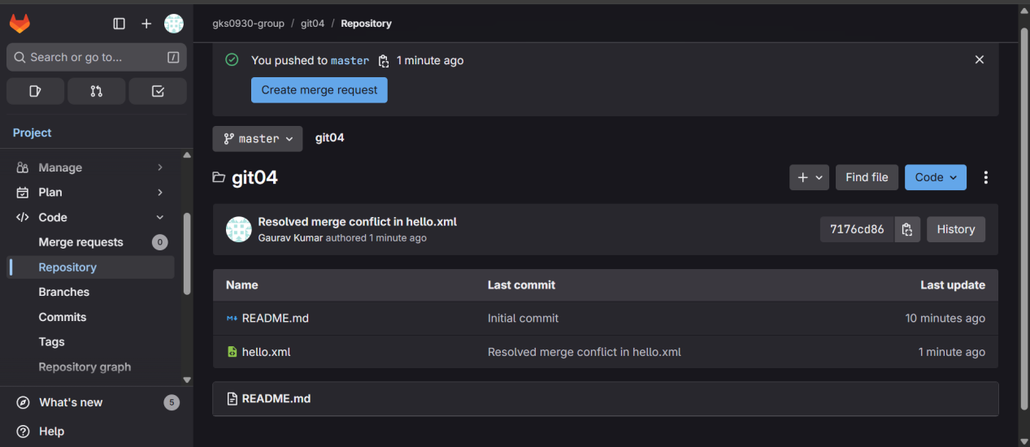

**Question 5: Write the Git commands to pull the latest changes from the remote repo into master and push them back after merging.**

* **Command:**

KIIT@BT-22052206 MINGW64 ~

$ git clone https://gitlab.com/gks0930-group/git05.git

cd git05

git branch -M master

Cloning into 'git05'...

remote: Enumerating objects: 3, done.

remote: Counting objects: 100% (3/3), done.

remote: Compressing objects: 100% (2/2), done.

remote: Total 3 (delta 0), reused 0 (delta 0), pack-reused 0 (from 0)

Receiving objects: 100% (3/3), done.

KIIT@BT-22052206 MINGW64 ~/git05 (master)

$ ^C

KIIT@BT-22052206 MINGW64 ~/git05 (master)

$ git status

On branch master

Your branch is up to date with 'origin/main'.

nothing to commit, working tree clean

KIIT@BT-22052206 MINGW64 ~/git05 (master)

$ git branch -a

* master

remotes/origin/HEAD -> origin/main

remotes/origin/main

KIIT@BT-22052206 MINGW64 ~/git05 (master)

$ git pull origin master

fatal: couldn't find remote ref master

KIIT@BT-22052206 MINGW64 ~/git05 (master)

$ ^C

KIIT@BT-22052206 MINGW64 ~/git05 (master)

$ git pull origin main

From https://gitlab.com/gks0930-group/git05

* branch main -> FETCH_HEAD

Already up to date.

KIIT@BT-22052206 MINGW64 ~/git05 (master)

$ git checkout -b GitWork

echo "<message>Hello from GitWork branch</message>" > hello.xml

git add hello.xml

git commit -m "Added hello.xml in GitWork branch"

git push origin GitWork

Switched to a new branch 'GitWork'

warning: in the working copy of 'hello.xml', LF will be replaced by CRLF the next time Git touches it

[GitWork ef732cb] Added hello.xml in GitWork branch

1 file changed, 1 insertion(+)

create mode 100644 hello.xml

Enumerating objects: 4, done.

Counting objects: 100% (4/4), done.

Delta compression using up to 8 threads

Compressing objects: 100% (2/2), done.

Writing objects: 100% (3/3), 334 bytes | 111.00 KiB/s, done.

Total 3 (delta 0), reused 0 (delta 0), pack-reused 0 (from 0)

remote:

remote: To create a merge request for GitWork, visit:

remote: https://gitlab.com/gks0930-group/git05/-/merge_requests/new?merge_request%5Bsource_branch%5D=GitWork

remote:

To https://gitlab.com/gks0930-group/git05.git

* [new branch] GitWork -> GitWork

KIIT@BT-22052206 MINGW64 ~/git05 (GitWork)

$ git checkout master

echo "<message>Hello from master branch</message>" > hello.xml

git add hello.xml

git commit -m "Added hello.xml in master branch"

git push origin master

Switched to branch 'master'

Your branch is up to date with 'origin/main'.

warning: in the working copy of 'hello.xml', LF will be replaced by CRLF the next time Git touches it

[master c27064a] Added hello.xml in master branch

1 file changed, 1 insertion(+)

create mode 100644 hello.xml

Enumerating objects: 4, done.

Counting objects: 100% (4/4), done.

Delta compression using up to 8 threads

Compressing objects: 100% (2/2), done.

Writing objects: 100% (3/3), 332 bytes | 166.00 KiB/s, done.

Total 3 (delta 0), reused 0 (delta 0), pack-reused 0 (from 0)

remote:

remote: To create a merge request for master, visit:

remote: https://gitlab.com/gks0930-group/git05/-/merge_requests/new?merge_request%5Bsource_branch%5D=master

remote:

To https://gitlab.com/gks0930-group/git05.git

b0babfa..c27064a master -> master

KIIT@BT-22052206 MINGW64 ~/git05 (master)

$ git merge GitWork

Auto-merging hello.xml

CONFLICT (add/add): Merge conflict in hello.xml

Automatic merge failed; fix conflicts and then commit the result.

KIIT@BT-22052206 MINGW64 ~/git05 (master|MERGING)

$ git add .

KIIT@BT-22052206 MINGW64 ~/git05 (master|MERGING)

$ git commit -m "Complementing Git-T03-HOL_002 lab changes"

[master 9f91759] Complementing Git-T03-HOL_002 lab changes

KIIT@BT-22052206 MINGW64 ~/git05 (master)

$ git push origin master

Enumerating objects: 7, done.

Counting objects: 100% (7/7), done.

Delta compression using up to 8 threads

Compressing objects: 100% (3/3), done.

Writing objects: 100% (3/3), 402 bytes | 201.00 KiB/s, done.

Total 3 (delta 0), reused 0 (delta 0), pack-reused 0 (from 0)

remote:

remote: To create a merge request for master, visit:

remote: https://gitlab.com/gks0930-group/git05/-/merge_requests/new?merge_request%5Bsource_branch%5D=master

remote:

To https://gitlab.com/gks0930-group/git05.git

c27064a..9f91759 master -> master

KIIT@BT-22052206 MINGW64 ~/git05 (master)

$ git log --oneline -n 3

9f91759 (**HEAD** -> **master**, **origin/master**) Complementing Git-T03-HOL_002 lab changes

c27064a Added hello.xml in master branch

ef732cb (**origin/GitWork**, **GitWork**) Added hello.xml in GitWork branch

* **Output:**

