PART -1 (Active MQ through UI and command line)

Twitter API + JMS Service (Active MQ) + Processing (Spark + Python) + UI (Jupyter Notebook)

Objective: - The simple goal is the integration of open source technology together to achieve something meaningful. Here we will use Twitter as the data source, so the ActiveMQ producer is supposed to extract the data and put it into queue through which SPARK will work as consumer and consumes the data from ActiveMQ. We will do data cleansing, aggregation and some type of complex processing in Spark and will present the data in Jupyter UI.

Work flow diagram:-

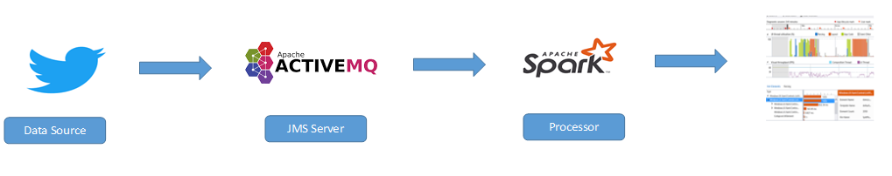

We will divide this complete process in 3 parts.

1. Active MQ through UI and command line.
2. Active MQ producer+ Twitter API.
3. SPARK as Active MQ consumer.
4. Spark processing and visualization.

This document is purely on ActiveMQ through command line.

Active MQ through UI and command line.

Download ActiveMQ 5.15.2 zip file from below link.

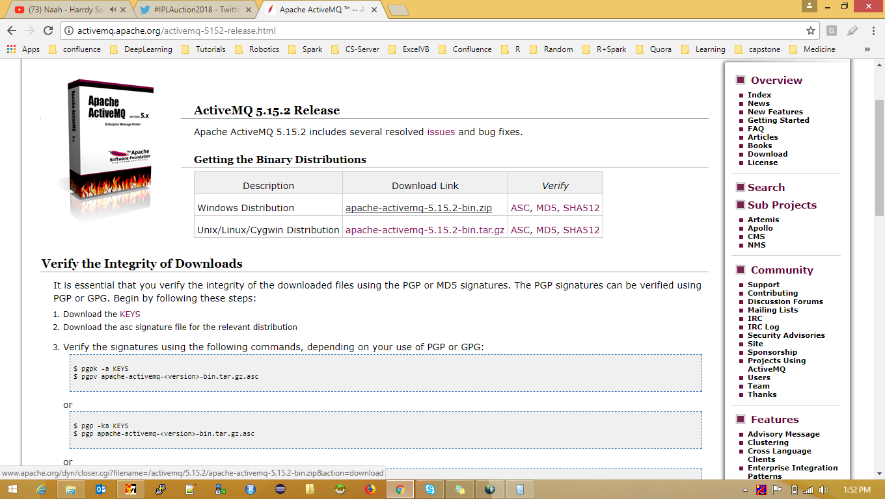

Unzip the software.

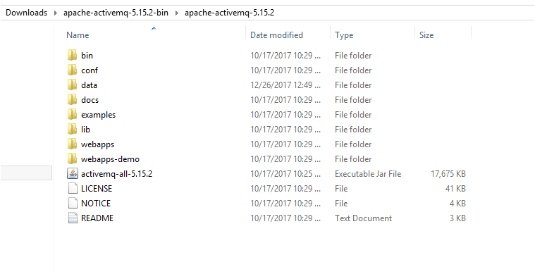

Open a command line in bin directory and type activemq.bat start. This will start the ActiveMQ server.

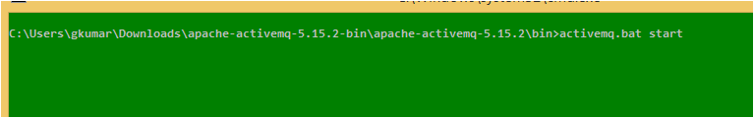

In the below image you can see the server has started.

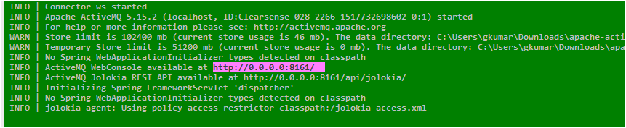

In UI you can browse ActiveMQ on 8161 port.

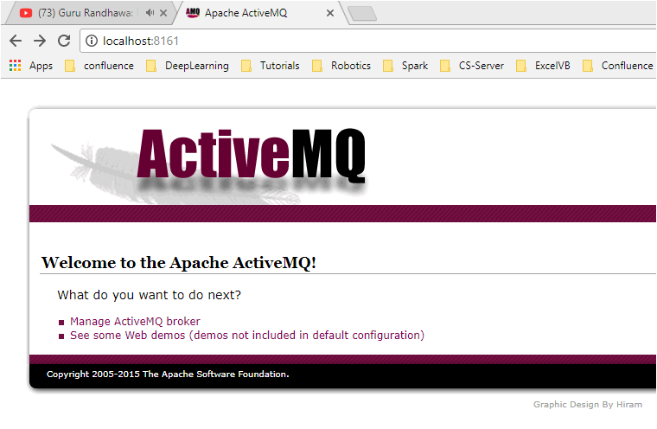

Click on Manage ActiveMQ broker. Username and password is admin and admin.

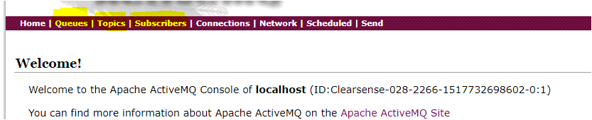

All the JMS service in this world works on the concept of Producer and Subscriber. Producer is one which produces and Subscriber is one which consumes. Consider the queue and topic as channel `through which data flows. Producer produces data and put onto one end of the channel (Queue/Topic) and consumer consumes from the second end. Consumer and Subscriber are plain java codes.

So when to us Queue and when to use topic?

Queue: - Where there is only one consumer. Example: - You collect twitter data and just want to dump in database.

Topic: - Where there is more than one consumer. Example: - You collect twitter data and you want to dump in database and at the same time you want to send it to UI. Hence there is two consumer of your data one is your database and other is UI.

Let’s see how to create queue and topic. Click on queues give some name in text box and click create.

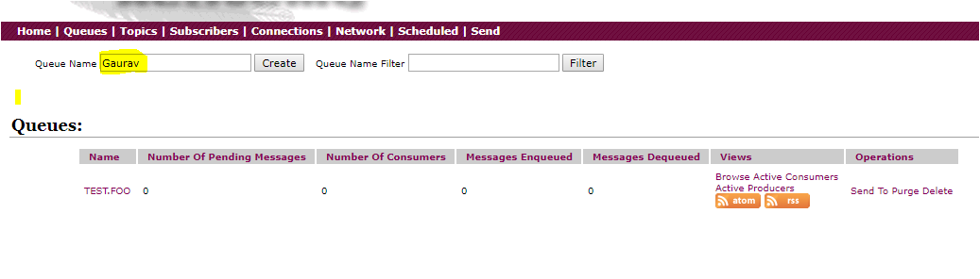

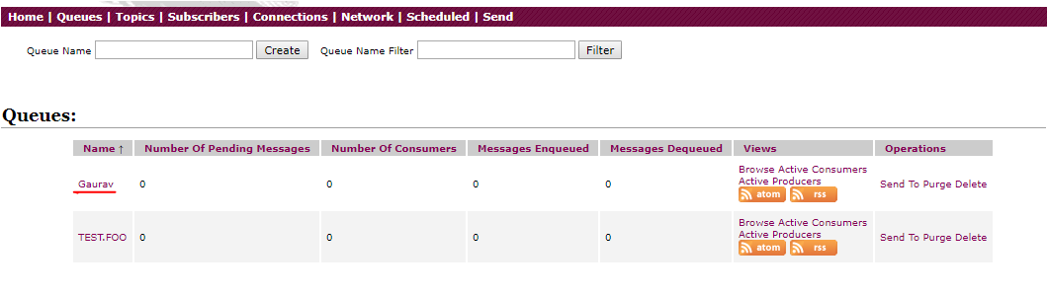

Similarly create on topics, give some name in text box and click create. You can create topics and queue through java code too.

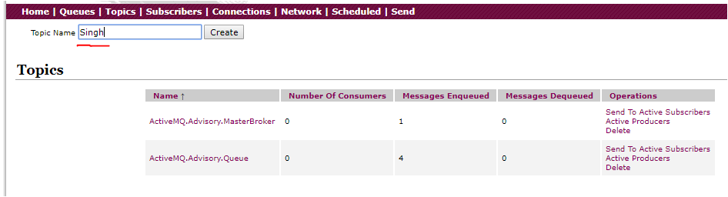

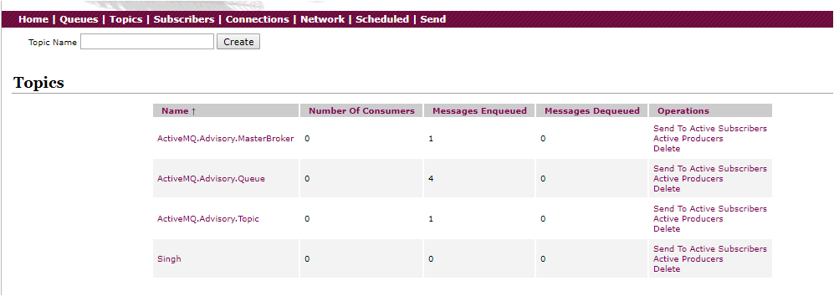

ActiveMQ from command line commands:-

1. activemq-admin query -QQueue=\*
2. activemq producer --message "My message Gaurav here" --messageCount 10 --destination queue://Gaurav
3. activemq-admin purge TEST

Output of command ‘a’. Gives the status of all the queue.

Here it shows there is no data in queue. Let’s check from UI.

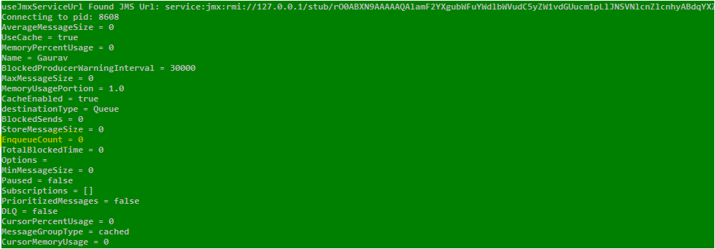

In UI also there is no records in the queue name Gaurav.

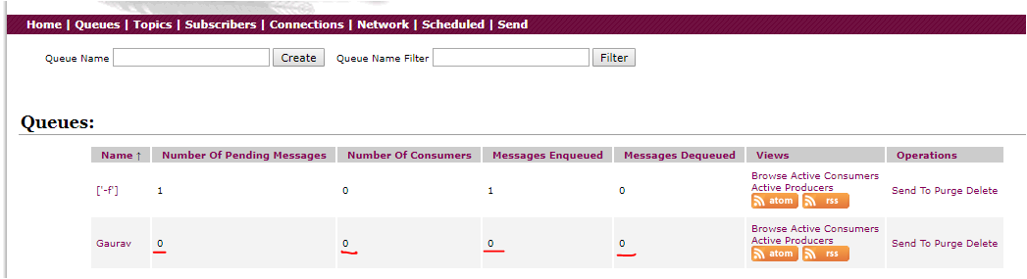

Output of command ‘b’. Inserts 10 records in the queue.

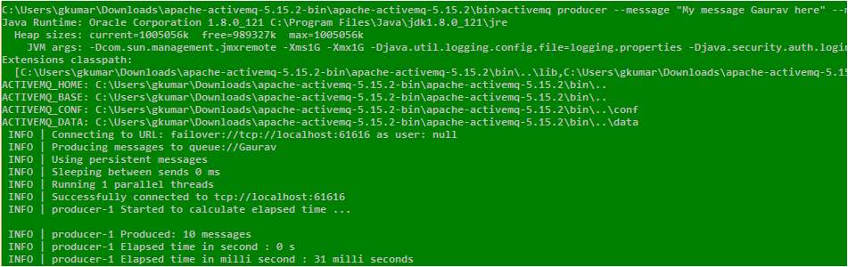

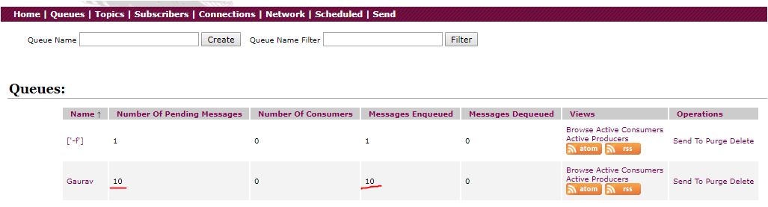

Output of command ‘c’. Purge the queue.

Purge means the data will be deleted from the queue. See the count has moved to Message Dequeued.

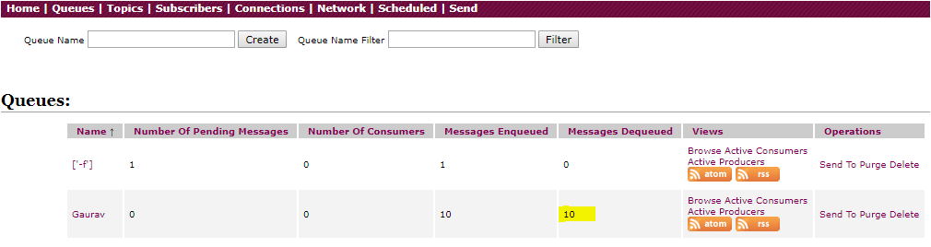

Some important links:-

<http://activemq.apache.org/version-5-examples.html>

<http://activemq.apache.org/activemq-command-line-tools-reference.html>