Stars, Words and Friends
Forecasting Yelp ratings with text and social networks

Course: Analysis of Complex Data (ACD)
Institution: Faculty of Engineering, University of Porto (FEUP)
Data: Yelp Open Dataset, California subset (Santa Barbara metropolitan area)
Companion files: ACD_final_project.ipynb (complete, executed analysis) and ACD_final_presentation.pptx
Date: November 2026

Abstract
Online ratings shape consumer decisions, yet it is unclear how far a business's future ratings can be predicted, and whether the social ties among its reviewers carry predictive information. This report analyses 348,014 Yelp reviews of 5,164 businesses written by 155,252 users in the Santa Barbara area between 2005 and 2022. It combines text processing, aspect-based sentiment analysis, social network analysis, a recommender system and time-series forecasting within a single design that forbids look-ahead, requires every model to beat a simple baseline on unseen data, and uses placebo tests to check network effects.
The next-quarter mean stars of 932 businesses can be forecast modestly: walk-forward models lower the mean squared error (MSE) by 6-9 % relative to a strong empirical-Bayes baseline, and much of the remaining error is sampling noise. Lagged sentiment adds a small gain before COVID (0.7 %, p = 0.014). Network inputs add nothing to this forecast and do not beat a scrambled network. By contrast, at the level of the individual, a friend's rating written in the previous 30 days reduces the root mean squared error (RMSE) of a person's rating from 0.946 to 0.864, while a matched non-friend adds nothing. A magnitude calculation reconciles the two results: few reviews are exposed to a recent friend's review (about 1.3 %), so this channel moves a business's quarterly mean by about 0.005 stars, against sampling noise of about 0.39 stars. Further analyses find that service is the strongest correlate of ratings and of sharp rating changes; that the first review by an influencer has no detectable effect on later stars or sentiment; that well-connected businesses did not recover faster from COVID; and that a hybrid recommender outperforms popularity, with friend data adding no value. The data are observational, so the findings establish prediction and association, and not causation.
Keywords: social network analysis; time-series forecasting; aspect-based sentiment analysis; recommender systems; social influence; Yelp.

Contents
Abstract 2
Contents 3
1. Introduction 5
1.1 Motivation 5
1.2 Research question and objectives 5
1.3 Main contributions 6
2. Data and preprocessing 6
2.1 Source and scope 6
2.2 Cleaning decisions 6
2.3 Exploratory analysis 7
3. Methodological framework 8
4. Text processing 8
4.1 Pipeline 8
4.2 Representation 9
4.3 Experiment: which preprocessing helps? 9
5. Sentiment analysis 9
5.1 Benchmark of sentiment models 9
5.2 Aspect-based sentiment 11
5.3 The sentiment-star gap 13
6. Social network analysis 13
6.1 The friendship network 13
6.2 Homophily 14
6.3 Communities and central users 14
6.4 Testing for influence 15
6.5 Yearly co-review networks 17
7. Recommender system 18
7.1 Task and evaluation design 18
7.2 Models 18
7.3 Metrics 19
7.4 Results 19
7.5 Cold start 20
8. Time-series forecasting 20
8.1 Aggregated series: diagnostics 21
8.2 Aggregated series: models 21
8.3 Business panel: design 23
8.4 Business panel: results 25
9. Integration: does the network help to forecast the stars? 25
9.1 Safeguards 26
9.2 Results of adding inputs 26
9.3 Why the network does not help 27
9.4 Which inputs matter, and the sentiment-star gap 27
9.5 Where the network does help: individual ratings 29
9.6 Review volume 29
10. Extensions 30
10.1 Influencer event study 30
10.2 COVID recovery and the network 31
10.3 Why did a rating change? Change points and aspects 33
10.4 Do reviews trigger reviews? A self-exciting model 33
11. Discussion 35
11.1 Answers to the research questions 35
11.2 Interpretation 35
11.3 Practical implications 35
11.4 Decisions revised during the analysis 35
11.5 Limitations 36
12. Conclusion and future work 36
References 37

1. Introduction

1.1 Motivation
Review platforms concentrate three kinds of information: a numeric judgement (stars), a verbal explanation (text) and, on Yelp, a social structure (friendships among reviewers). Most analyses use these separately. Combining them raises a substantive question. If friends influence one another's opinions, then the social network should help to forecast ratings, and a business's rating trajectory would partly reflect social processes and not just its quality. If they do not, the network is of little use for forecasting, however interesting its structure may be.
The practical interest is direct. Business owners want early warning of a decline, platforms want better recommendations, and analysts need to know which signals justify the cost of collecting and processing them.

1.2 Research question and objectives
The project is organised around one main question: can the ratings of a business be forecast, and does the social network of its reviewers add anything beyond the rating history and the text of the reviews? It is broken down into six research questions:
- RQ1. How well can next-period mean stars be forecast, compared with simple baselines?
- RQ2. Does the sentiment of earlier reviews improve that forecast?
- RQ3. Does the social network improve that forecast, and at which level (individual review, business, community)?
- RQ4. Are ratings and visits of friends more similar than expected, once homophily and shared context are addressed as far as observational data allow?
- RQ5. What do reviewers talk about, and which aspects explain ratings and sharp changes in ratings?
- RQ6. Do friends' data improve recommendations, particularly for users with little history?
The assessment criteria of the course translate into the objectives in Table 1, each mapped to the corresponding section of this report.
Table 1. Assessment criteria, objectives and where they are addressed.
Criterion | Objective | Section
(i) Data processing and analysis | Build a clean, reproducible dataset and let exploration drive the modelling choices | 2, 3
(ii) Recommender system | Build and evaluate content, collaborative, sentiment-aware, social and hybrid recommenders | 7
(iii) Text processing | Build a text pipeline and test empirically which preprocessing steps help | 4
(iv) Advanced sentiment analysis | Benchmark five sentiment approaches; add aspect-based sentiment and the sentiment-star gap | 5
(v) Social network | Build the friendship and dated co-review networks; extract structural and behavioural knowledge | 6
(vi) Time series | Create aggregated and panel series, forecast them and evaluate out of time | 8
(vii) SNA + time series | Measure what network inputs add to forecasts, with placebo tests | 9
(viii) Creativity and complexity | Influence tests, event study, yearly networks, change points, self-excitation, COVID analysis | 6, 9, 10

1.3 Main contributions
- An integrated design in which sentiment, network and forecasting components share one time-respecting framework.
- A two-level answer on social influence: a clear effect on individual ratings, invisible in business-level forecasts, with a calculation explaining why.
- Placebo networks and a noise floor that show how much can be learned at all, and protect against false discovery.
- Reporting of null results and corrected inferences, including a raw event-study effect that does not survive a check on the pre-event trend.

2. Data and preprocessing

2.1 Source and scope
The data come from the Yelp Open Dataset. Reviews of businesses with state = "CA" and the users who wrote them were extracted. In practice this subset is the Santa Barbara metropolitan area, and it should not be read as representing California as a whole. This region was selected because of its coherent geography and because it is large enough for network and time-series work while remaining feasible on a 16 GB machine without a GPU.

2.2 Cleaning decisions
Table 2. Data-cleaning decisions and the reasoning behind them.
Step | Decision | Reason
Geography | Unify city names; remove cities with fewer than 20 businesses | Spelling variants split cities; stray entries (Reno, Truckee) are outside the area
Duplicates | Remove duplicate review identifiers | A review must count once
Vote counts | Set negative votes to 0 | Negative counts are invalid
Categories | Assign one of 12 macro categories by priority rule | Yelp's detailed categories are too numerous for comparison
Elite status | Parse Elite years; repair the entry where 2020 is written as "20,20" | Allows Elite status to be checked at the time of each review
Forecast inputs | Exclude end-of-data user and business counters (review count, fans, average stars, business stars, is open) | These values describe the end of the data, so using them would leak the future
Language | Flag a review only when common Spanish, German, French or Italian words outnumber common English words | An initial stop-word rule wrongly flagged short English reviews; the revised rule flags 355 reviews (0.10 %)
Privacy | User names are not loaded; users are integer indices | Names are not needed for the analysis

Table 3. Summary of the cleaned dataset.
Quantity | Value
Reviews (raw -> cleaned) | 348,856 -> 348,014
Businesses / users | 5,164 / 155,252
Period | March 2005 - January 2022
Mean / median stars | 3.96 / 5
Median reviews per business / per user | 20 / 1
Users with a single review | 66.7 %
Businesses with at least 100 reviews | 802 (70 % of reviews)
Median words per review | 71
Friendship edges within the subset | 471,089
Users with a friend in the subset | 41.3 %
Reviews written by users with a friend | 55.4 %
Reviews written while Elite | 12.5 %

2.3 Exploratory analysis
The exploration concentrated on properties that condition modelling (Figure 1). Star ratings are J-shaped: 54.5 % of reviews give five stars, which is typical of voluntary reviewing. Volume grew until about 2018 and fell sharply with COVID. Mean stars move slowly within a narrow band, which means an overall stars series has little to predict. Activity has a very long tail, so most users and businesses have little data. Unhappy reviewers write longer reviews.
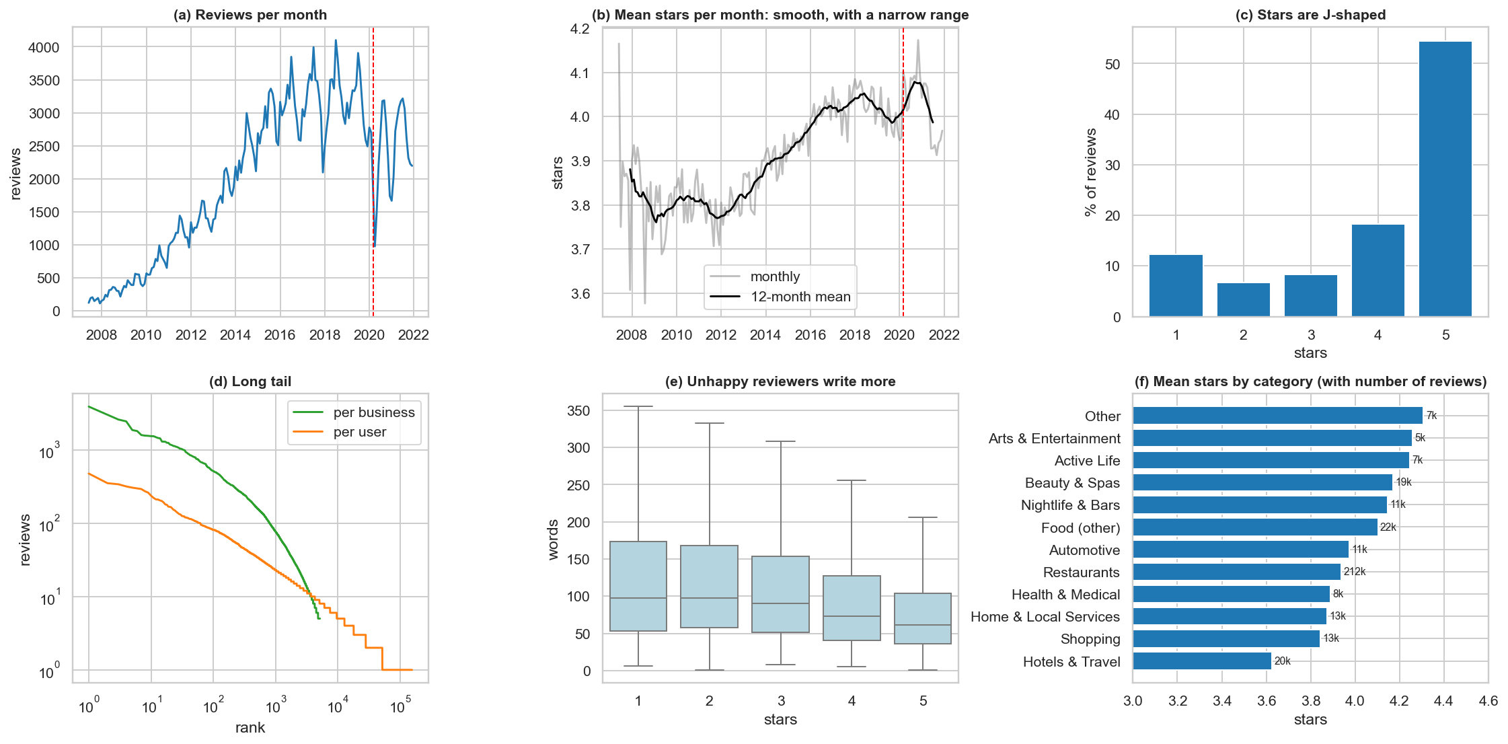
Figure 1. Exploratory overview: (a) reviews per month; (b) mean stars per month; (c) distribution of stars; (d) long tail of activity; (e) length of reviews by stars; (f) mean stars by category. The red line marks March 2020.
A simple variance decomposition is informative. Businesses explain about 21 % of the variance of a single rating, and users with at least five reviews about 26 %. A single rating is therefore noisy, which places a low ceiling on any forecast. Three design consequences follow:
1. The main forecast uses business-quarter cells. Business-month cells have a median of only 2 reviews, against 6 per quarter among frequently reviewed businesses.
2. Forecast errors are weighted by the number of reviews, and a noise floor is estimated (Section 8.3).
3. The recommender needs a filter for minimal history, plus a separate analysis of users with little history.

3. Methodological framework
Four rules apply throughout the project. They are stated first because they explain many later choices.
- No look-ahead. Every split is by time, and a feature for a forecast only uses reviews written before the forecast date. A random split would let models learn from the future, and would produce optimistic results.
- A review's own sentiment is never an input for its own stars. The text nearly reveals the rating (Spearman correlation 0.80), so such a model would look excellent and be useless. Sentiment enters forecasts only through earlier reviews.
- Baselines first. A model counts only if it beats a simple baseline on data it has not seen.
- Association is not causation. Friends may rate alike because of influence, similar tastes or joint visits. Each test states what it can and cannot exclude.
Table 4. Time-based splits used by each component.
Component | Training data | Evaluation data | Purpose of the cut
Sentiment models | Before 2017, 5-fold cross-fitting | 2019 onwards (benchmark) | Every review is scored by a model that did not see it
Text preprocessing test | 30,000 reviews before 2017 | 10,000 reviews, 2017-2018 | Compares variants on future reviews
Recommender, validation | Before 2017 | 2017 | Hyperparameters and hybrid weights
Recommender, test | Before 2018 | 2018-2019 | Final evaluation before COVID
Aggregated series | Expanding window from 2012 | 2018-2019 and 2020-2021 | Rolling origin, 1-3 months ahead
Business panel | All earlier targets | 2018Q1-2021Q4 (walk-forward) | 16 test quarters; 2016-2017 used for tuning

Slow steps are cached so that the notebook can be rerun and resumed. All random procedures use a fixed seed (42). Multiple testing is handled with the Holm correction (Holm, 1979) within each family of tests, and with false discovery rate control (Benjamini and Hochberg, 1995) in the change-point scan, where hundreds of businesses are tested. Corrections were not applied across the entire notebook, so isolated p-values near 0.05 should be read as weak evidence.

4. Text processing

4.1 Pipeline
Texts are normalised (lower case, URLs removed, whitespace collapsed), filtered by language, tokenised and then converted to features. Rather than assuming that standard preprocessing is beneficial, each step is treated as a hypothesis and tested on future reviews.

4.2 Representation
Documents are represented with sublinear TF-IDF. For term t in document d, with N documents and df_{t} documents containing t:
$$w_{t,d} = \left(1 + \log{{tf}_{t,d}}\right) · \left(\log{\frac{1 + N}{1 + {df}_{t}}} + 1\right)$$ | (1)

Vectors are then normalised to unit length. Negation tags carry negation to the next word ("not good" also yields the token not_good) because a bag of words otherwise loses this information. Classification uses logistic regression over the five star classes, trained by averaged stochastic gradient descent. Each review's score is the expected number of stars, a continuous measure that keeps the ordering information in the rating:
$${\hat{s}}_{i} = \sum_{k=1}^{5}{k · \hat{p}\left(k | x_{i}\right)}$$ | (2)

4.3 Experiment: which preprocessing helps?
Table 5. Text preprocessing variants: same classifier, trained on 30,000 reviews before 2017, tested on 10,000 reviews from 2017-2018. F1 and accuracy use three classes (1-2, 3, 4-5 stars).
Variant | Macro-F1 | Accuracy | MAE (stars) | Spearman | Vocabulary
Counts, unigrams | 0.708 | 0.880 | 0.430 | 0.763 | 17,716
TF-IDF, unigrams | 0.694 | 0.873 | 0.448 | 0.757 | 17,716
TF-IDF + stop-word removal | 0.681 | 0.866 | 0.479 | 0.741 | 17,424
TF-IDF + lemmas | 0.697 | 0.873 | 0.455 | 0.750 | 13,820
TF-IDF + bigrams | 0.728 | 0.891 | 0.425 | 0.780 | 143,867
TF-IDF + bigrams + negation tags | 0.735 | 0.893 | 0.419 | 0.782 | 145,703

Bigrams with negation tags perform best (macro-F1 0.73 against 0.69 for plain TF-IDF unigrams). Removing stop words lowers quality because it deletes words such as "not". Lemmatisation adds almost nothing while requiring a much slower pipeline (about 4 minutes against seconds). The chosen configuration for the full model uses 1-2 grams, minimum document frequency 5, maximum document share 0.5, and up to 400,000 features. Stop-word removal and lemmas are kept for topic modelling, where readability matters more than classification.

5. Sentiment analysis

5.1 Benchmark of sentiment models
Star ratings serve as weak labels for sentiment: 1-2 stars are negative, 3 neutral, 4-5 positive. Five approaches from four families were compared on the same 6,000 reviews written in 2019 or later:
- Lexicon: VADER (Hutto and Gilbert, 2014), rule-based, requires no training.
- Supervised: TF-IDF with logistic regression, learning Yelp's own vocabulary from earlier reviews.
- Transfer learning: MiniLM sentence embeddings (all-MiniLM-L6-v2) with a logistic regression trained on 15,000 reviews.
- Pretrained transformers: DistilBERT trained on SST-2 movie-review sentences (Sanh et al., 2019), and RoBERTa trained on tweets (cardiffnlp/twitter-roberta-base-sentiment-latest).
Pretrained models and VADER do not output stars, so each was mapped to the star scale by a logistic regression fitted on 2,000 earlier reviews. All methods therefore give expected stars and are evaluated with the same metrics. For a set of classes C, with per-class precision P_{c} and recall R_{c}:
$$Macro-F1 = \frac{1}{|C|}\sum_{c∈C}{\frac{2 P_{c}R_{c}}{P_{c} + R_{c}}}$$ | (3)

Macro-F1 was preferred to accuracy because 73 % of reviews are positive, so accuracy would reward predicting the majority class.
Avoiding leakage. The TF-IDF model was trained on reviews before 2017. Reviews from before 2017 were scored by 5-fold cross-fitting, and later reviews by the model fitted on all training reviews. No review is therefore scored by a model that saw it, which matters because these scores become forecast inputs.
Table 6. Sentiment benchmark on 6,000 reviews from 2019 onwards. Speeds are approximate, on a 12-thread CPU.
Model | Macro-F1 (95 % CI) | Accuracy | MAE | Spearman | Training reviews | Reviews/s
TF-IDF + LR | 0.747 (0.733-0.763) | 0.903 | 0.424 | 0.801 | 171,224 | about 10,000
RoBERTa (calibrated) | 0.668 (0.653-0.682) | 0.875 | 0.578 | 0.711 | 2,000 (calibration) | about 10
DistilBERT (calibrated) | 0.661 (0.647-0.675) | 0.866 | 0.623 | 0.715 | 2,000 (calibration) | about 20
MiniLM + LR | 0.650 (0.639-0.662) | 0.846 | 0.558 | 0.723 | 15,000 | about 70
VADER (lexicon) | 0.588 (0.573-0.603) | 0.811 | 0.836 | 0.527 | 2,000 (calibration) | about 10,000

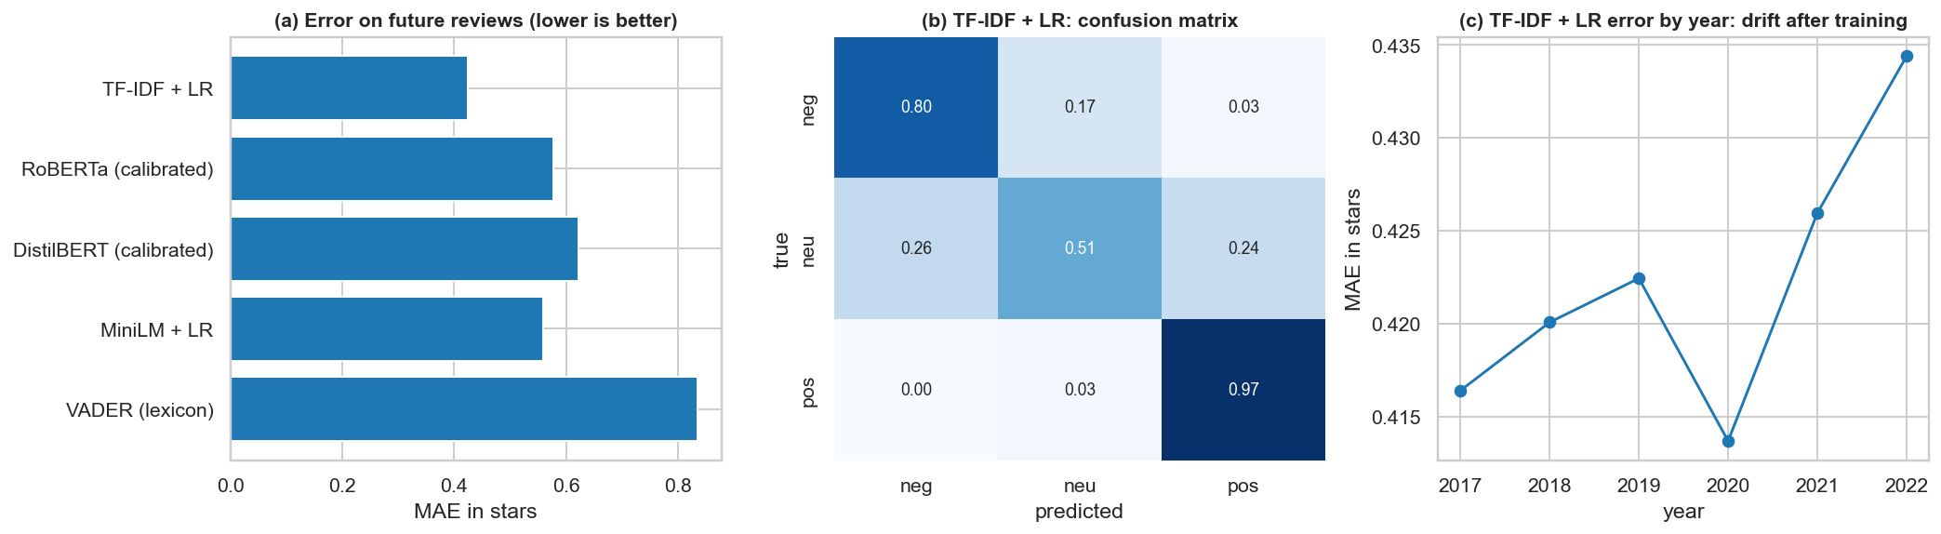
Figure 2. Sentiment benchmark: (a) error on future reviews; (b) confusion matrix of the best model; (c) error of TF-IDF + LR by year after training.
TF-IDF with logistic regression wins clearly. This comparison is not fully even: it learned from 171,224 Yelp reviews, MiniLM's classifier from 15,000, and the pretrained transformers were not fine-tuned on Yelp, as fine-tuning would require a GPU. The fair conclusion is that a simple model trained on the domain beats models trained elsewhere, and not that TF-IDF is better than transformers in general. All methods find the neutral class hardest because 3-star reviews mix praise and complaints. Error rises only slightly after training (MAE about 0.42 to 0.43), so the model ages well. Its largest errors include genuine contradictions between text and stars, which motivates the sentiment-star gap below.
The TF-IDF model was chosen for the forecasting features, since it is the most accurate and, unlike the transformers, can score all 348,014 reviews on this hardware.

5.2 Aspect-based sentiment
Overall sentiment says that a review is negative; aspect-based sentiment (Pontiki et al., 2014) says why. Reviews were split into sentences, and each sentence mentioning an aspect, through a curated dictionary, was scored by VADER. With S_{ij} the set of sentences of review i that mention aspect j:
$$a_{ij} = \frac{1}{|S_{ij}|}\sum_{s∈S_{ij}}{VADER\left(s\right)}$$ | (4)

The score is missing when the review does not mention the aspect. Six aspects are used: food, service, price, ambience, wait and cleanliness. VADER was deliberately chosen here because it involves no training on stars, so these features cannot leak ratings into later models. Aspects are mentioned in 65 %, 54 %, 30 %, 22 %, 30 % and 10 % of reviews respectively.

5.2.1 Topic check with NMF
To check that the dictionary reflects what reviewers discuss, topics were discovered with non-negative matrix factorisation (Lee and Seung, 1999) on the lemmatised TF-IDF matrix X of 40,000 reviews, with 14 topics:
$$\min_{W,H ≥ 0}{{\left\|X - WH\right\|}^{2}}$$ | (5)

Table 7. NMF topics and the aspect dictionary they overlap with most. "(business type)" means no aspect has at least 2 matching words.
Topic | Top words | Closest aspect
0 | order, chicken, salad, sandwich, eat, burger, fry, fresh, sauce | food
1 | work, tell, need, ask, customer, day, car, experience, bad | (business type)
2 | love, amazing, favorite, absolutely, atmosphere, year, awesome, kid, super | (business type)
3 | food, service, excellent, restaurant, delicious, atmosphere, customer, mexican, amazing | food
4 | room, stay, hotel, clean, beach, nice, location, bed, night | (business type)
5 | santa, barbara, visit, favorite, stop, restaurant, area, trip, live | (business type)
6 | wine, tasting, taste, tour, winery, glass, bottle, fun, enjoy | food
7 | recommend, highly, amazing, definitely, wedding, professional, work, job, experience | (business type)
8 | taco, salsa, mexican, fish, chip, burrito, tortilla, asada, bean | food
9 | price, reasonable, quality, sushi, high, decent, worth, reasonably, portion | price
10 | pizza, crust, topping, cheese, salad, sauce, slice, beer, pepperoni | food
11 | friendly, staff, helpful, super, nice, clean, dog, attentive, definitely | service
12 | drink, bar, beer, sit, table, wait, hour, happy, bartender | food
13 | coffee, breakfast, cream, ice, egg, shop, flavor, latte, chocolate | food

Food, service and price appear directly as topics, whereas others mark types of business (hotels, weddings, wine tasting). Topic 1, with words such as "tell", "ask", "customer" and "bad", describes service complaints. The topics thus support the dictionary and also show that part of the review content concerns the kind of business and not an evaluative aspect.

5.2.2 Check against a dedicated aspect model
No hand-labelled aspect data exist here, so there is no gold standard. As an indirect check, 3,000 sentence-aspect pairs (500 per aspect) were scored by DeBERTa ABSA (yangheng/deberta-v3-base-absa-v1.1), which reads the aspect in context.
Table 8. Aspect scores from VADER compared with the DeBERTa aspect model.
Aspect | Agreement | Cohen's kappa | Spearman (scores) | Spearman (VADER, stars) | Spearman (ABSA, stars)
ambience | 0.648 | 0.232 | 0.503 | 0.251 | 0.238
clean | 0.712 | 0.411 | 0.653 | 0.529 | 0.546
food | 0.496 | 0.205 | 0.429 | 0.330 | 0.282
price | 0.498 | 0.219 | 0.439 | 0.385 | 0.525
service | 0.670 | 0.326 | 0.493 | 0.557 | 0.514
wait | 0.308 | 0.005 | 0.368 | 0.290 | 0.445
ALL | 0.555 | 0.250 | 0.527 | 0.414 | 0.451

Agreement is modest overall (kappa 0.25), and the dedicated model predicts stars a little better (0.45 against 0.41). The difference is large for wait (kappa near 0; 0.44 against 0.29) and price (0.53 against 0.38): a phrase such as "we waited 40 minutes" contains no emotional words for a lexicon. The wait and price scores are therefore the weakest parts of this method and are interpreted with care. At about 26 pairs per second, scoring at least 700,000 review-aspect pairs would take many hours on this CPU, which is why the dedicated model serves as a check and not as the main method.

5.2.3 Which aspects explain ratings?
For each category, stars were regressed on standardised aspect sentiment z_{ij} (unmentioned set to neutral) and on a mention indicator m_{ij}, with robust standard errors:
$$s_{i} = β_{0} + \sum_{j}{\left(β_{j}z_{ij} + γ_{j}m_{ij}\right)} + ε_{i}$$ | (6)

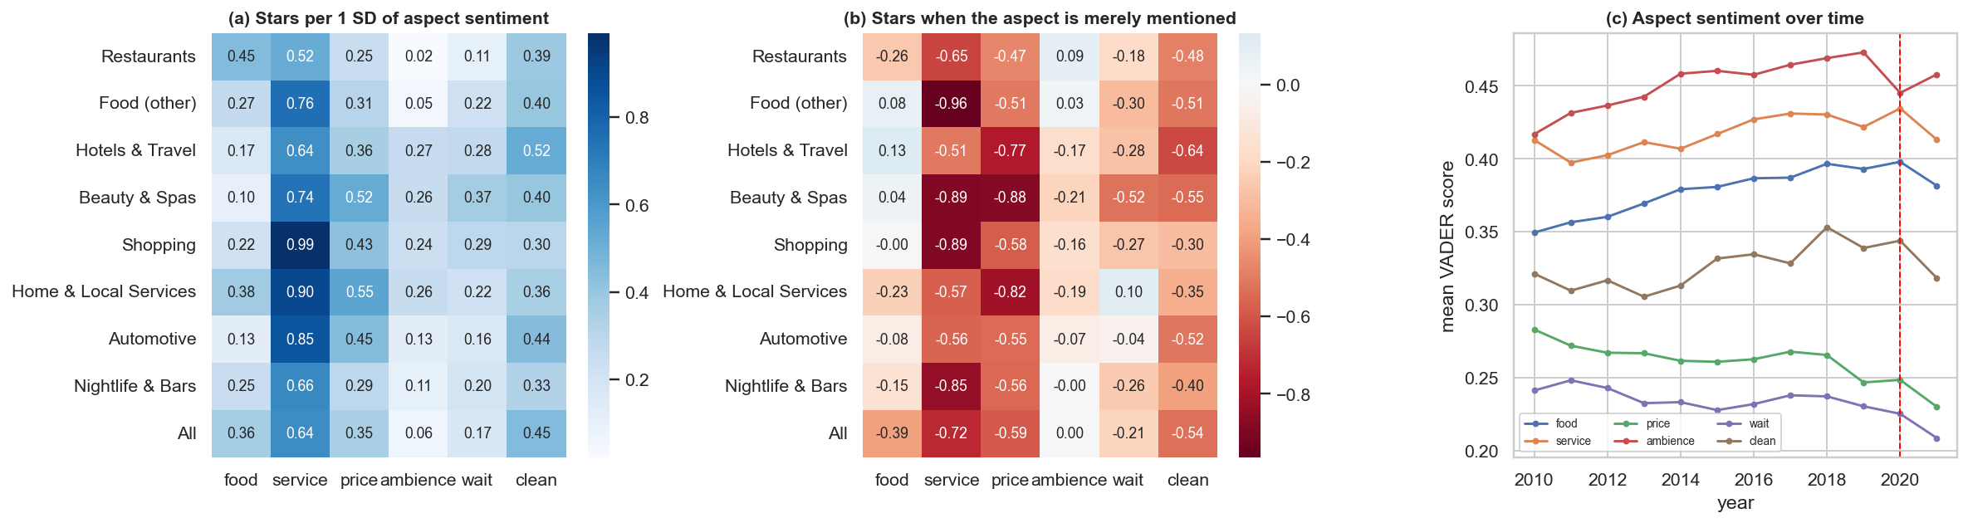
Figure 3. Aspects and ratings: (a) stars per one standard deviation of aspect sentiment; (b) stars associated with merely mentioning an aspect; (c) aspect sentiment over time.
Service has the strongest coefficient in every category, even in restaurants (0.52 against 0.45 for food). Merely mentioning service, price or cleanliness goes with fewer stars (for example -0.72 for service overall): people bring these topics up mostly when something went wrong. Stars and text are written together, so this explains a rating in a descriptive sense only, and these same-review scores are not used as forecast inputs.

5.3 The sentiment-star gap
A novel feature is the difference between the rating expected from the text and the actual rating:
$$g_{i} = {\hat{s}}_{i} - s_{i}$$ | (7)

A negative gap means that the text is more negative than the rating, such as a polite four stars with an unhappy text. If people soften their ratings more than their words, a falling gap could warn of later rating declines. Because predictions regress towards the middle, the gap is mechanically related to stars (Figure 4), so later analysis measures it relative to the business's own past and controls for recent stars. The hypothesis is tested in Section 9.4.
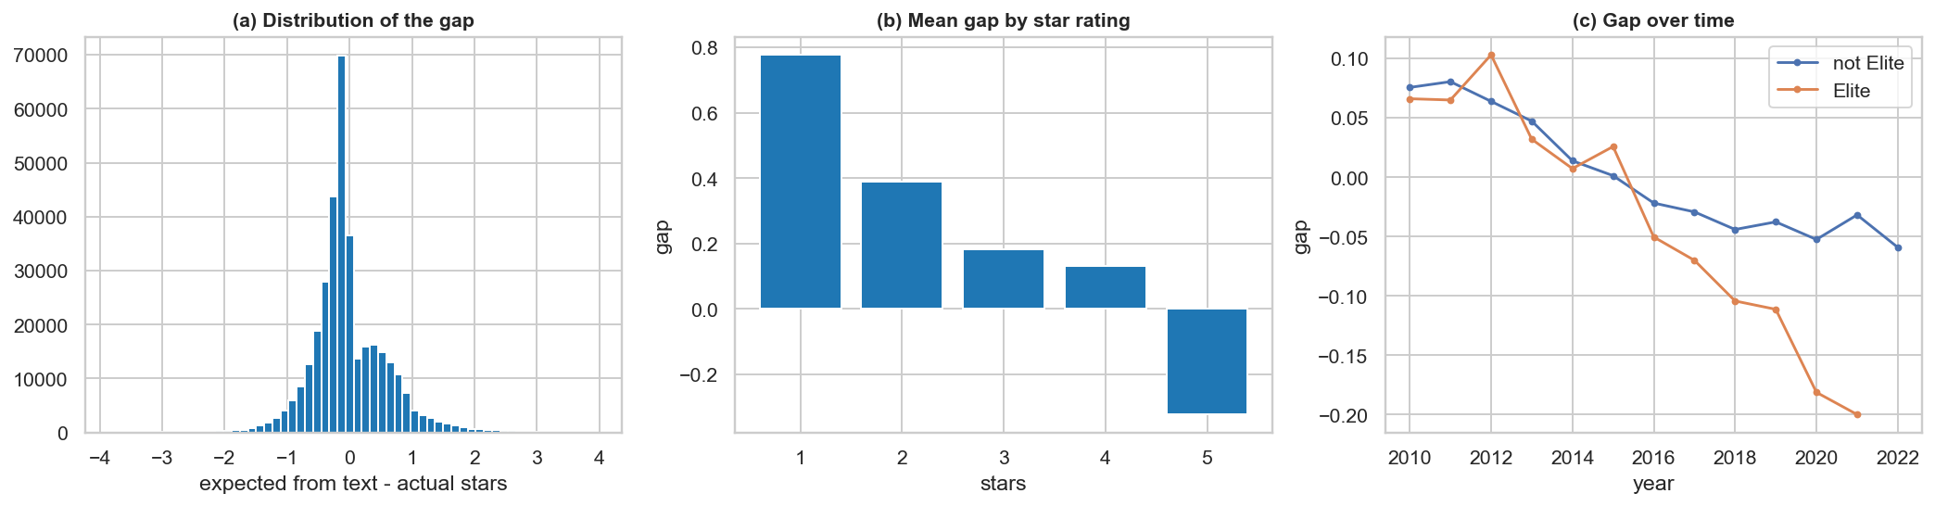
Figure 4. Sentiment-star gap: (a) distribution; (b) mean by star rating, showing the mechanical relation; (c) over time, by Elite status.

6. Social network analysis

6.1 The friendship network
Users are nodes, and friendships are undirected edges restricted to users in the subset. Key descriptors for a graph with n nodes and edge set E include density, local clustering (with T_{v} the triangles through node v of degree k_{v}), PageRank and Louvain modularity (Blondel et al., 2008):
$$D = \frac{2|E|}{n(n - 1)}, C_{v} = \frac{2T_{v}}{k_{v}\left(k_{v} - 1\right)}$$ | (8)

$$PR\left(v\right) = \frac{1 - α}{n} + α \sum_{u∈N(v)}{\frac{PR\left(u\right)}{k_{u}}}, α = 0.85$$ | (9)

$$Q = \frac{1}{2m}\sum_{u,v}{\left[A_{uv} - \frac{k_{u}k_{v}}{2m}\right] δ\left(c_{u}, c_{v}\right)}$$ | (10)

Table 9. Friendship network. The null model is a random network with the same degree sequence. Betweenness uses 100 sampled sources because exact computation is too slow.
Measure | Value | Measure | Value
Nodes (users with a friend) | 64,154 | Mean / median / max degree | 14.7 / 4 / 2,007
Edges | 471,089 | Components; largest | 1,093; 96.3 %
Density | 0.000229 | Louvain communities | 1,676
Mean clustering (null) | 0.098 (0.020) | Modularity Q (another seed) | 0.526 (0.518)
Mean path length (null) | 4.26 (3.72) | Adjusted Rand index, two seeds | 0.57

The network has a heavy-tailed degree distribution and a small-world structure: clustering is about five times that of a random network with the same degrees, at a similar path length. Louvain reveals clear community structure, but the adjusted Rand index of 0.57 between two seeds shows that exact boundaries are not stable, so communities are treated as useful groupings and not as exact facts.

6.2 Homophily
The assortativity of an attribute x is its Pearson correlation across the two ends of a friendship (Newman, 2002):
$$r = Corr\left(x_{u}, x_{v} | (u,v) ∈ E\right)$$ | (11)

Significance is judged against 100 permutations of the attribute among nodes, which destroys the relation between attribute and position.
Table 10. Assortativity of user attributes in the friendship network. Opinion attributes use users with at least 3 reviews.
Attribute | Assortativity | Null mean | z vs null | Edges used
log degree | 0.298 | -0.000 | 195.6 | 471,089
log number of reviews | 0.166 | -0.000 | 127.1 | 471,089
join year | 0.495 | 0.000 | 351.0 | 471,089
Elite ever | 0.452 | -0.000 | 295.4 | 471,089
mean stars given (3+ reviews) | 0.053 | -0.001 | 17.7 | 100,164
mean text sentiment (3+ reviews) | 0.055 | -0.001 | 19.2 | 100,164
service sentiment (3+ reviews) | 0.008 | -0.001 | 2.3 | 88,173
food sentiment (3+ reviews) | 0.045 | -0.001 | 13.7 | 94,828

Friendship is sorted mainly by activity: when users joined (0.50) and being Elite (0.45). Opinions are much less sorted: mean stars 0.05 and mean sentiment 0.06. These are far above chance but small in size. Friends resemble each other much more in how they use Yelp than in how they rate. This is an early hint for the forecasting results: a friendship tie carries little general information about opinions (McPherson et al., 2001).

6.3 Communities and central users
Table 11. Communities with at least 5,000 reviews, which hold about half of all reviews. Lift is a category's share in the community divided by its overall share.
Community | Users | Reviews | Mean join year | Elite reviews % | Santa Barbara % | Reviews per user | Mean stars | Top category (lift)
C0 | 17,263 | 59,445 | 2013.1 | 4.6 | 77.3 | 3.44 | 4.04 | Health & Medical (1.64)
C4 | 7,119 | 41,500 | 2012.5 | 32.2 | 73.8 | 5.83 | 4.04 | Food (other) (1.22)
C1 | 10,771 | 27,294 | 2010.9 | 45.3 | 82.7 | 2.53 | 4.01 | Arts & Entertainment (1.74)
C2 | 9,188 | 24,402 | 2010.4 | 40.3 | 82.7 | 2.66 | 4.00 | Hotels & Travel (1.40)
C5 | 5,962 | 15,358 | 2014.3 | 17.9 | 58.2 | 2.58 | 3.94 | Nightlife & Bars (1.25)
C3 | 7,822 | 13,160 | 2011.8 | 5.3 | 81.2 | 1.68 | 4.07 | Hotels & Travel (1.60)

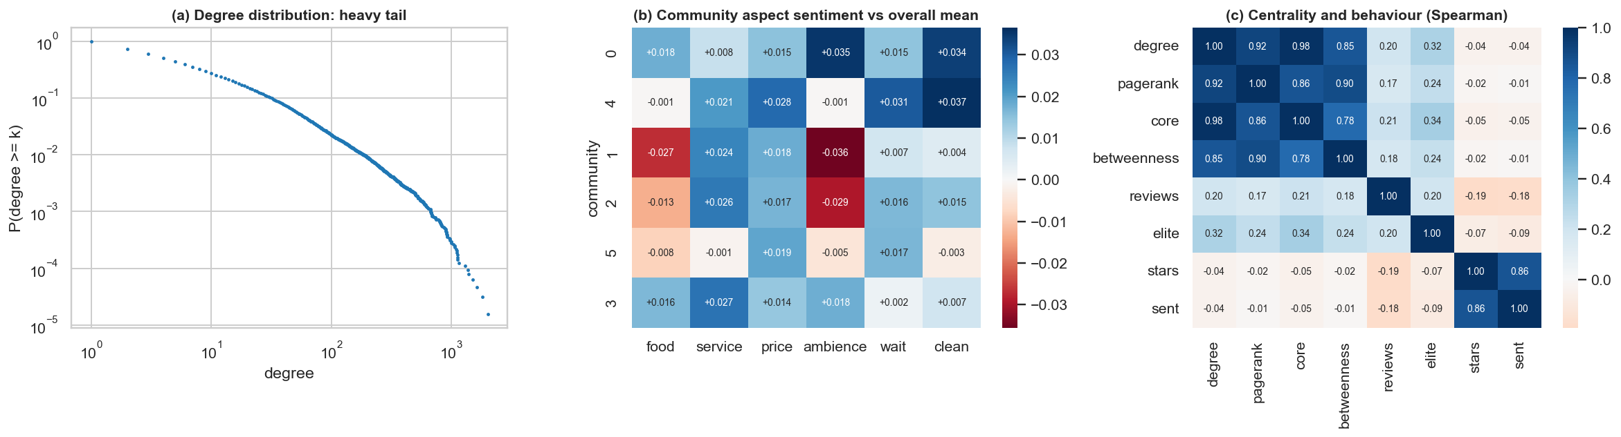
Figure 5. Network structure: (a) degree distribution; (b) aspect sentiment of communities relative to the overall mean; (c) Spearman correlations of centrality and behaviour.
Communities differ in character. C1 and C2 are older, Elite-heavy groups (40-45 % of their reviews are by Elite users); C0, the largest, contains few Elite reviews (5 %); C3 has few reviews per user and leans towards hotels and travel, which suggests visitors. Differences in aspect sentiment are small. Centrality measures largely overlap (Spearman 0.78-0.98), and they are only weakly related to how much a person reviews in this subset (0.17-0.21) or to their mean rating (close to 0), so central users are not systematically more generous.

6.4 Testing for influence
Yelp has no record of who read what, so influence must be inferred. The main threats are homophily (friends share tastes; Aral et al., 2009) and joint visits (friends go together). Three tests are designed around these threats. A previous version in the project's exploratory notebook returned zero matched pairs for the visit test, so that test was rewritten here.

6.4.1 Test A: rating conformity, friend against matched non-friend
Consider review i by user v of business b, preceded by a review from a friend of v. It is paired with an earlier review of b by a non-friend written as close as possible in time to the friend's, which holds the business and period nearly fixed. Deviations are measured from the business's mean before review i, m_{bi}, and the regression includes L, each person's usual generosity (their mean deviation in earlier reviews elsewhere), plus business and quarter fixed effects α_{b} and τ_{q}. Standard errors are clustered by user:
$$y_{i} = β_{f}x_{i}^{f} + β_{n}x_{i}^{n} + λ_{1}L_{v} + λ_{2}L_{f} + λ_{3}L_{n} + α_{b} + τ_{q} + ε_{i}$$ | (12)

Table 12. Rating conformity: effect of an earlier review's deviation on one's own deviation.
Time since friend's review | Pairs | Friend (SE) | Non-friend (SE) | Difference (SE) | p
all lags (1+ days) | 30,937 | 0.127 (0.008) | 0.010 (0.006) | 0.117 (0.010) | <0.001
same day (joint visits?) | 933 | 0.904 (0.023) | 0.002 (0.020) | 0.902 (0.029) | <0.001
1-30 days | 4,187 | 0.374 (0.023) | 0.044 (0.013) | 0.330 (0.027) | <0.001
31-180 days | 7,726 | 0.109 (0.016) | 0.005 (0.011) | 0.104 (0.019) | <0.001
181-730 days | 11,257 | 0.054 (0.012) | 0.011 (0.009) | 0.044 (0.015) | 0.004
over 2 years | 7,767 | 0.081 (0.015) | 0.002 (0.012) | 0.079 (0.020) | <0.001

A friend's earlier rating is far more informative than a matched stranger's (0.127 against 0.010). The effect is 0.37 within 30 days and fades to about 0.05-0.08 after 6 months. Same-day reviews reach 0.90, most likely reflecting joint visits, which is why they are reported separately. In addition, a non-friend who is a friend of a friend is not more similar than a complete stranger (extra effect 0.010, p = 0.50), so the similarity appears tied to direct contact and not to a broad social neighbourhood.

6.4.2 Test B: do people go where friends went?
In a matched case-control design, each case (user v reviews b on a given day; 59,369 pairs) is paired with a control: another user with a similar number of friends, active in the same city and month, who had not yet reviewed b. Matching on these variables removes differences in sociability, location and timing. With n₁₀ pairs in which only the case is exposed and n₀₁ pairs in which only the control is exposed, the conditional odds ratio and its confidence interval are:
$$OR = \frac{n_{10}}{n_{01}}, 95\% CI = exp\left[\log{OR} ± 1.96 \sqrt{\frac{1}{n_{10}} + \frac{1}{n_{01}}}\right]$$ | (13)

Table 13. Matched case-control test of visits.
A friend reviewed the place | % cases exposed | % controls exposed | Discordant pairs | Odds ratio (95 % CI)
1-30 days | 2.31 | 0.90 | 1,120 | 4.49 (3.86-5.23)
31-180 days | 4.09 | 2.48 | 2,056 | 2.40 (2.18-2.64)
over 180 days | 10.33 | 8.06 | 6,421 | 1.65 (1.57-1.74)
any earlier friend | 16.73 | 11.44 | 9,597 | 1.97 (1.89-2.06)

6.4.3 Test C: mood contagion with a lead placebo
Is a user's rating at any business related to how favourably their friends rated in the previous month? For user u in month t, F_{u,t} is the mean deviation of the friends' reviews in that month. The friends' next month serves as a placebo, as it cannot have influenced an earlier rating:
$${dev}_{i} = φ_{1}F_{u,t-1} + φ_{2}F_{u,t+1} + λ L_{u} + τ_{t} + ε_{i}$$ | (14)

The previous month's coefficient is 0.029 (SE 0.009), but the placebo is not significantly smaller (0.016; difference p = 0.33). There is thus no clear evidence of general mood contagion; the association looks more like shared tastes and common shocks.
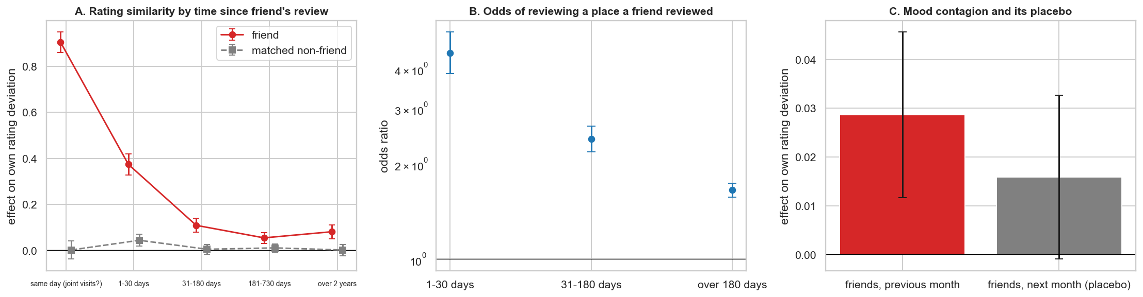
Figure 6. Influence tests: (A) rating similarity by time since the friend's review; (B) odds of reviewing a place a friend reviewed; (C) mood association and its lead placebo. Bars are 95 % confidence intervals.
What can be claimed. The decay over time and the absent friend-of-friend effect favour something specific to direct friends over general homophily. However, reviews within 30 days may still be joint visits written up on different days, which cannot be observed. The evidence is compatible with influence and does not prove it.

6.5 Yearly co-review networks
The friendship graph is a single undated snapshot. To obtain a network that really changes over time, for each year two active users (at least 2 reviews that year) are linked if they reviewed at least two of the same businesses that year. One shared business says little, because popular places link almost everyone.
Growth in reviews can change a network's structure by itself. Each year is therefore compared with a null network in which the businesses of that year's reviews are randomly reassigned, keeping each user's activity and each business's popularity.
The same data provide dated inputs for forecasting: a yearly business-to-business graph in which each reviewer u with k_{u} businesses that year contributes a weight of 1/(k_{u} − 1) (Newman, 2001), so that very active users do not dominate:
$$W_{bc} = \sum_{u ∈ U(b) ∩ U(c)}{\frac{1}{k_{u} - 1}}$$ | (15)

Table 14. Yearly co-review networks and their null networks.
Year | Active users | Edges | Null edges | Modularity (null) | Clustering (null) | Top 1 % retained % | Top 1 % Elite % | Friend ties % (null)
2009 | 911 | 1,010 | 958 | 0.536 (0.422) | 0.307 (0.338) |  | 22.2 | 2.57 (1.04)
2010 | 1,443 | 2,314 | 1,812 | 0.515 (0.418) | 0.381 (0.335) | 0.0 | 42.9 | 2.59 (1.88)
2011 | 2,205 | 4,746 | 4,042 | 0.467 (0.376) | 0.399 (0.377) | 4.5 | 27.3 | 2.06 (1.53)
2012 | 2,601 | 4,849 | 3,780 | 0.438 (0.371) | 0.422 (0.432) | 30.8 | 42.3 | 2.45 (2.49)
2013 | 3,300 | 6,026 | 4,773 | 0.458 (0.389) | 0.390 (0.369) | 12.1 | 33.3 | 2.26 (1.93)
2014 | 4,454 | 8,399 | 6,618 | 0.451 (0.392) | 0.394 (0.334) | 11.4 | 20.5 | 1.75 (2.19)
2015 | 5,372 | 12,891 | 9,300 | 0.420 (0.371) | 0.438 (0.389) | 9.4 | 35.8 | 2.06 (2.22)
2016 | 5,682 | 13,248 | 8,402 | 0.461 (0.420) | 0.428 (0.354) | 14.3 | 41.1 | 2.05 (2.26)
2017 | 5,894 | 12,365 | 8,070 | 0.456 (0.407) | 0.431 (0.338) | 15.5 | 60.3 | 2.89 (3.64)
2018 | 5,902 | 11,564 | 8,423 | 0.432 (0.387) | 0.413 (0.393) | 13.6 | 55.9 | 2.33 (2.86)
2019 | 5,672 | 11,251 | 7,999 | 0.423 (0.375) | 0.450 (0.389) | 17.9 | 62.5 | 2.94 (3.39)
2020 | 4,141 | 5,071 | 3,276 | 0.522 (0.513) | 0.354 (0.290) | 14.6 | 58.5 | 2.50 (2.78)
2021 | 4,550 | 8,408 | 6,251 | 0.444 (0.391) | 0.419 (0.403) | 13.3 | 66.7 | 1.53 (1.97)

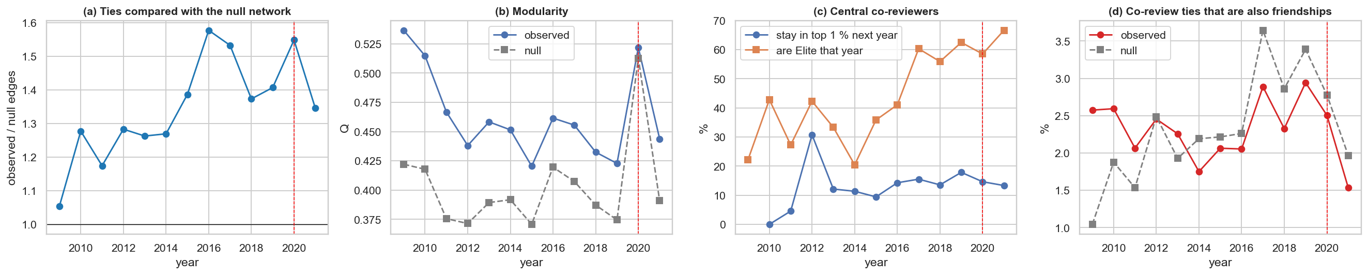
Figure 7. Yearly co-review networks: (a) ties relative to the null; (b) modularity; (c) persistence and Elite share of the most central users; (d) share of co-review ties that are also friendships.
The comparison with the null prevents false conclusions:
- Observed ties exceed the null by about 1.2-1.6 times since 2010, so co-reviewing is more than chance given activity and popularity. The excess grew until 2016.
- Modularity looks high every year, but much of that is present in the null as well. The jump in 2020 occurs in both: fewer reviews produce a sparser network, which raises modularity by itself. Reading this as communities closing up during COVID would be wrong.
- Co-review ties are not more often friendships than in the null (about 1.5-3.5 % in both, and lower than the null in most recent years). Sharing a place and being friends are largely separate on Yelp.
- Central co-reviewers change quickly (mostly about 10-20 % stay in the top 1 % the next year) and are increasingly Elite (55-67 % from 2017).

7. Recommender system

7.1 Task and evaluation design
The task is to recommend businesses that a user has not yet reviewed and to predict the rating they would give. A random split would let models learn from the future, so evaluation is by time: training before 2018, testing on 2018-2019, and choosing hyperparameters on an earlier split (train before 2017, evaluate on 2017). COVID years were excluded because the shock would dominate. Users and businesses are iteratively filtered to those with at least 5 training reviews, using only pre-split data, which leaves 7,031 users, 2,344 businesses and 75,365 training interactions (density 0.46 %), with 7,239 new pairs in the test period.

7.2 Models
Bias model. With global mean μ and regularised user and business effects b_{u} and b_{i}, fitted by alternating updates:
$${\hat{r}}_{ui} = μ + b_{u} + b_{i}$$ | (16)

Biased matrix factorisation (Koren et al., 2009) adds user and item factors p_{u} and q_{i}, fitted by alternating least squares on the residuals (k = 10 and λ = 15, selected on validation):
$$\min_{p,q}{\sum_{(u,i)}{{\left(r_{ui} - μ - b_{u} - b_{i} - p_{u}^{T}q_{i}\right)}^{2}} + λ \left(\sum_{u}{{\left\|p_{u}\right\|}^{2}} + \sum_{i}{{\left\|q_{i}\right\|}^{2}}\right)}$$ | (17)

Implicit ALS (Hu et al., 2008) models whether a visit occurred, with confidence c_{ui} = 1 + α x_{ui} where x_{ui} indicates a review (k = 20, λ = 5, α = 10). The reason for including it is that with sparse data, where people go may say more than how they rate:
$$\min_{p,q}{\sum_{u,i}{c_{ui}{\left(x_{ui} - p_{u}^{T}q_{i}\right)}^{2}} + λ \left(\sum_{u}{{\left\|p_{u}\right\|}^{2}} + \sum_{i}{{\left\|q_{i}\right\|}^{2}}\right)}$$ | (18)

Other models. Item kNN: cosine similarity on mean-centred ratings with shrinkage, 50 neighbours. Content: a TF-IDF profile of each business's reviews, compared with a user profile of liked and disliked businesses. Aspect: user-specific weights over aspects (ridge regression on the user's residual ratings) multiplied by business aspect scores. Social: for each business, with c friends who reviewed it and s the sum of their ratings minus 3, the score is log(1 + c) + s / (c + 2). Popularity: the most reviewed places.
Hybrid. Each model's score is standardised for each user and combined. The weights come from a random search over 40 Dirichlet draws on validation only, maximising NDCG@10:
$$score\left(u, b\right) = \sum_{m}{w_{m} · z_{m}\left(u, b\right)}$$ | (19)

Validation put most weight on content (0.43), aspect (0.20), implicit ALS (0.18) and kNN (0.15), and little on popularity (0.03) and social (0.02). A second hybrid excludes the social model so that the network's contribution can be isolated.

7.3 Metrics
Rating prediction uses RMSE and MAE. Ranking counts a test review of 4+ stars as relevant, and all candidate businesses are ranked instead of a small sample, because sampled ranking metrics can mislead (Krichene and Rendle, 2020). Beyond accuracy, coverage is the share of the catalogue ever recommended, and novelty measures how unpopular the recommended places are:
$$DCG@K = \sum_{k=1}^{K}{\frac{{rel}_{k}}{\log_{2}\left(k + 1\right)}}, NDCG@K = \frac{DCG@K}{IDCG@K}$$ | (20)

$$Novelty\left(i\right) = - \log_{2}\frac{{pop}_{i} + 1}{\sum_{j}{{pop}_{j}} + 1}$$ | (21)

7.4 Results
Table 15. Rating prediction, 2018-2019 (7,239 new user-business pairs).
Model | RMSE | MAE
Hybrid | 1.1909 | 0.9306
Bias model | 1.1923 | 0.9235
Biased MF | 1.1927 | 0.9240
Item kNN | 1.1928 | 0.9239
Social | 1.1966 | 0.9108
Aspect | 1.2599 | 0.9414
Global mean | 1.3391 | 1.1087

Table 16. Ranking over all candidate businesses, 2018-2019 (1,641 users with relevant test items).
Model | NDCG@10 | Recall@10 | HitRate@10 | Coverage % | Novelty (bits)
Hybrid (no network) | 0.0422 | 0.0612 | 0.1432 | 33.1 | 8.86
Hybrid (all) | 0.0393 | 0.0588 | 0.1395 | 44.4 | 9.15
Implicit ALS | 0.0388 | 0.0559 | 0.1335 | 16.5 | 8.73
Popularity | 0.0336 | 0.0441 | 0.1085 | 1.0 | 7.50
Content (TF-IDF) | 0.0212 | 0.0313 | 0.0786 | 59.7 | 9.99
Social | 0.0203 | 0.0285 | 0.0810 | 59.6 | 10.51
Biased MF | 0.0084 | 0.0115 | 0.0390 | 1.1 | 11.76
Bias model | 0.0082 | 0.0112 | 0.0378 | 0.6 | 11.77
Item kNN | 0.0080 | 0.0116 | 0.0384 | 1.7 | 11.77
Aspect | 0.0008 | 0.0013 | 0.0043 | 19.2 | 12.94

Table 17. Paired bootstrap over users.
Comparison | NDCG@10 difference | 95 % CI
Hybrid (no network) - Popularity | +0.0086 | +0.0018 to +0.0156
Hybrid (no network) - Implicit ALS | +0.0033 | -0.0001 to +0.0071
Hybrid (all) - Popularity | +0.0058 | -0.0009 to +0.0126
Hybrid (all) - Implicit ALS | +0.0005 | -0.0038 to +0.0046
Hybrid (all) - Hybrid (no network) | -0.0028 | -0.0054 to -0.0005
Social - Popularity | -0.0133 | -0.0199 to -0.0064

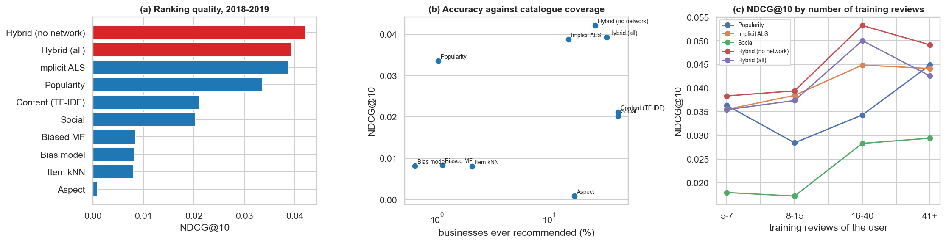
Figure 8. Recommender results: (a) ranking quality; (b) accuracy against catalogue coverage; (c) quality by the number of training reviews of the user.
For rating prediction, the bias model already does most of the work (RMSE 1.19 against 1.34 for the global mean), and factor models add almost nothing at this density. For ranking, models trained to predict ratings do badly (NDCG@10 about 0.008) because they promote highly rated niche places. Knowing where people go matters more: implicit ALS is the strongest single personalised model (0.039), ahead of popularity (0.034).
The best model is the hybrid without the network (0.042). It reliably beats popularity (+0.009, CI +0.002 to +0.016), and its lead over implicit ALS is borderline. Its clearest advantage is coverage: about a third of the catalogue, against 1 % for popularity. Adding friends' signals slightly but reliably lowers NDCG (-0.003), while widening coverage to 44 %. Absolute NDCG values are low, which is common when most users have very few relevant items among thousands of candidates.

7.5 Cold start
Users with 1-4 earlier reviews and at least one friend were evaluated separately (4,000 sampled at most; those with relevant test items). For the 2,150 whose friends were active, popularity reaches NDCG@10 of 0.0384, friends alone 0.0234, and the combination 0.0391, using a weight fixed in advance so as not to tune it on these users. The difference between the combination and popularity is +0.0007 (CI -0.0030 to +0.0044), so friend data did not solve cold start here. This should be read as an upper bound on friends' value, since the undated friendship list includes ties formed after the training cut-off.

8. Time-series forecasting
Two levels are analysed, because they answer different questions. Aggregated monthly series allow classical modelling on clean series. The business panel is the main forecast: a single business's series is too short and noisy for its own complex model, but many businesses can share what is learned.

8.1 Aggregated series: diagnostics
Mean stars per month from 2012 were analysed for the overall market and for the six communities with at least 5,000 reviews. STL decomposition (Cleveland et al., 1990) separates trend T, seasonal S and remainder R, with strengths:
$$F_{T} = max\left(0, 1 - \frac{Var\left(R\right)}{Var\left(T + R\right)}\right), F_{S} = max\left(0, 1 - \frac{Var\left(R\right)}{Var\left(S + R\right)}\right)$$ | (22)

Table 18. Stationarity tests. KPSS p-values are bounded to the range 0.01-0.10.
Series (before COVID) | ADF p | KPSS p
stars, level | 0.293 | 0.01
stars, first difference | 0.000 | 0.10
seasonal difference (12) | 0.786 | 0.01

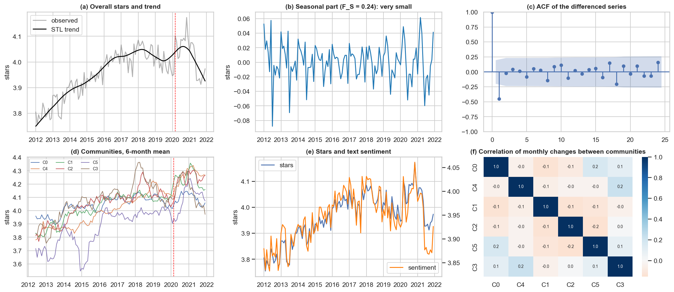
Figure 9. Diagnostics of the aggregated series: (a) stars and trend; (b) seasonal part; (c) autocorrelation of the differenced series; (d) communities; (e) stars and sentiment; (f) correlation of monthly changes between communities.
The trend is strong (F_{T} = 0.88) and seasonality very weak (F_{S} = 0.24). The ADF test fails to reject a unit root in levels and rejects it after first differencing, in line with KPSS. A first version of the models used d = 0; given these diagnostics they were changed to d = 1.

8.2 Aggregated series: models
With backshift operator B, the main model is ARIMA(0,1,1), which is closely related to simple exponential smoothing and tracks a slowly moving level:
$$\left(1 - B\right)y_{t} = \left(1 + θB\right)ε_{t}$$ | (23)

Comparison models are the long-run mean, last value, 12-month mean, seasonal naive, SES, ARIMA(1,1,1) and SARIMA(0,1,1)(1,0,0)₁₂. ARIMAX models then add inputs lagged one month: sentiment and sentiment-star gap of the same series; and a network lag, which is the integration between network and time series at this level. For community c, it is the stars of the other communities, weighted by the share W_{cd} of friendship ties from c to d:
$$l_{c,t} = \sum_{d ≠ c}{W_{cd}y_{d,t}}$$ | (24)

At each origin, models are refitted using data up to that month and forecast 1-3 months ahead. For the 3-month forecast, the last known exogenous value is held constant, so that no future value is used. Accuracy is reported with MASE (Hyndman and Koehler, 2006), where values below 1 mean better than the in-sample one-step naive forecast. The Diebold-Mariano test (Diebold and Mariano, 1995), with the small-sample correction of Harvey et al. (1997), compares squared-error loss differentials d_{t} between two models:
$$MASE = \frac{mean\left(|y_{t} - {\hat{y}}_{t}|\right)}{\frac{1}{n - 1}\sum_{t=2}^{n}{|y_{t} - y_{t-1}|}}, DM = \frac{\overline{d}}{\sqrt{\operatorname{Var}{\overline{d}}}}$$ | (25)

Table 19. Rolling-origin results, mean over the six communities. All models are compared on the same series because the network lag exists only for communities. Before COVID unless stated.
Model | MAE, h=1 | MAE, h=3 | MASE, h=1 | MASE, h=3 | MAE COVID, h=1 | MASE COVID, h=1
ARIMAX + sentiment | 0.086 | 0.085 | 0.702 | 0.706 | 0.110 | 0.888
SES | 0.086 | 0.086 | 0.702 | 0.710 | 0.109 | 0.892
ARIMA(0,1,1) | 0.086 | 0.086 | 0.706 | 0.710 | 0.109 | 0.893
ARIMAX + network | 0.087 | 0.086 | 0.712 | 0.715 | 0.108 | 0.880
12-month mean | 0.087 | 0.085 | 0.711 | 0.704 | 0.117 | 0.951
ARIMA(1,1,1) | 0.087 | 0.086 | 0.715 | 0.709 | 0.110 | 0.896
ARIMAX + both | 0.087 | 0.086 | 0.716 | 0.715 | 0.107 | 0.867
SARIMA(0,1,1)(1,0,0,12) | 0.087 | 0.089 | 0.716 | 0.734 | 0.112 | 0.916
Last value | 0.106 | 0.111 | 0.860 | 0.922 | 0.133 | 1.093
Seasonal naive | 0.117 | 0.115 | 0.946 | 0.936 | 0.179 | 1.442
Long-run mean | 0.137 | 0.134 | 1.144 | 1.121 | 0.202 | 1.675

Table 20. One month ahead, compared with ARIMA(0,1,1) on the same six community series (Diebold-Mariano test at 5 %).
Period | Model | Mean MSE ratio | Series with lower MSE | Significantly better | Significantly worse
COVID | ARIMAX + both | 0.982 | 3 of 6 | 0 | 0
COVID | ARIMAX + network | 0.987 | 4 of 6 | 0 | 0
COVID | SES | 0.987 | 5 of 6 | 0 | 0
COVID | ARIMAX + sentiment | 1.001 | 3 of 6 | 0 | 0
before COVID | SES | 0.990 | 5 of 6 | 0 | 0
before COVID | ARIMAX + sentiment | 1.001 | 3 of 6 | 0 | 1
before COVID | ARIMAX + network | 1.024 | 1 of 6 | 0 | 0
before COVID | ARIMAX + both | 1.038 | 1 of 6 | 0 | 1

Simple level-tracking models win: SES and ARIMA(0,1,1) are as good as anything else. The long-run mean and seasonal naive are clearly worst, as the diagnostics suggested. Lagged sentiment and the network lag give no reliable gain on community series. During COVID the network lag has slightly lower error (mean ratio 0.98-0.99), though not significantly.

8.2.1 Granger tests
Granger causality (Granger, 1969) asks only whether lags of one series help to predict another; it says nothing about mechanism. Tests used monthly changes before COVID with 3 lags, Holm-corrected over 27 tests. No relation survives correction. Six of the 27 tests have unadjusted p below 0.05, which is more than chance alone would suggest but too weak to rely on, so none is reported as a finding.

8.3 Business panel: design
Businesses. At least 50 reviews before 2018, so that selection does not depend on the future. This leaves 932 businesses and 239,470 reviews (69 %). A rule based on total reviews would have favoured businesses that later succeeded.
Target. The mean stars of the business in the next quarter, kept when that quarter has at least 3 reviews, which gives 21,190 rows with a median of 6 reviews in the target quarter. Errors are weighted by the number of reviews w_{bt}, because a mean of 40 reviews is more reliable than a mean of 3.
Empirical-Bayes baseline. Ratings behave like a noisy signal around a stable level, so the baseline shrinks a business's long-run mean towards the market mean, more so when a business has few reviews. With cumulative stars S_{bt}, cumulative count N_{bt}, market mean m_{t} and κ = 10:
$${\hat{y}}_{b,t+1}^{EB} = \frac{S_{bt} + κ m_{t}}{N_{bt} + κ}$$ | (26)

Other baselines are the global mean, last quarter, last four quarters, long-run mean and exponential smoothing, with level updates depending on the number of reviews (α = 0.05 per review, selected on 2016-2017):
$$l_{bt} = l_{b,t-1} + \left(1 - {\left(1 - α\right)}^{n_{bt}}\right)\left({\overline{y}}_{bt} - l_{b,t-1}\right)$$ | (27)

Noise floor. Even a model that knew each business's true level could not predict the sampling noise of a mean of n reviews. With pooled within-business-quarter variance σ² = 1.493 (a standard deviation of 1.22 stars for one review), the unavoidable weighted MSE and the share of predictable error removed are:
$${MSE}_{floor} = \frac{\sum_{b,t}{w_{bt} · σ^{2} / w_{bt}}}{\sum_{b,t}{w_{bt}}}, Removed = \frac{{MSE}_{EB} - {MSE}_{model}}{{MSE}_{EB} - {MSE}_{floor}}$$ | (28)

8.3.1 Input groups
Table 21. Input groups for the business panel. Co-review inputs use only completed years, so they are not affected by the undated friendship list.
Group | Inputs (all from reviews written up to the forecast date)
History (20) | Stars in each of the last 4 quarters; means over 4 and 8 quarters; long-run mean; EB mean; recent trend; deviation from long-run mean; log volumes; dispersion; age; target quarter (sine, cosine); category; market level
Sentiment (36) | Text sentiment, gap and VADER: last quarter, 4 quarters, long-run mean, deviation from it. For each aspect: 4-quarter mean, long-run mean, deviation, share of reviews mentioning it
Friendship network (10) | Mean log degree and share connected among recent reviewers; share with a friend who reviewed earlier, and their deviation; PageRank-weighted stars relative to unweighted; PageRank share; recent mood of reviewers' friends; generosity of the likely next audience; mood of the reviewers' communities; concentration in one community
Co-review network, dated (4) | Centrality in last year's co-review graph; recent deviation, sentiment and stars at co-review neighbours, weighted by the graph

8.3.2 Global models
Two global models predict the difference from the EB mean, so that a model finding nothing falls back on the baseline. Ridge regression (median imputation, standardisation, α = 300) is a careful linear benchmark. LightGBM (Ke et al., 2017) can capture nonlinearities and interactions; a grid search on 2016-2017 selected 600 trees, learning rate 0.01, 7 leaves, at least 150 rows per leaf and L2 penalty 10. A shallow, slow model being selected already suggests weak nonlinear signal. With inputs x_{bt}, the objective is:
$$\min_{f}{\sum_{b,t}{w_{b,t+1}{\left(y_{b,t+1} - {\hat{y}}_{b,t+1}^{EB} - f\left(x_{bt}\right)\right)}^{2}}}$$ | (29)

Walk-forward evaluation. For each of the 16 quarters from 2018Q1 to 2021Q4, models are retrained on all rows whose target has already occurred. Results are reported separately before COVID (4,334 rows) and during COVID (3,255 rows).

8.4 Business panel: results
Table 22. Next-quarter forecast of mean stars, weighted by reviews. Noise floor RMSE: 0.380 before COVID and 0.404 during COVID. Skill = 1 - MSE / MSE of EB.
Model | RMSE | Skill vs EB % | Removed % | RMSE, COVID | Skill, COVID % | Removed, COVID %
Global mean | 0.703 | -80.0 | -168.2 | 0.748 | -62.9 | -120.2
Last quarter | 0.698 | -77.5 | -162.9 | 0.781 | -77.7 | -148.6
Last 4 quarters | 0.535 | -4.1 | -8.7 | 0.607 | -7.3 | -14.0
Long-run mean | 0.525 | -0.2 | -0.4 | 0.586 | -0.1 | -0.1
Exponential smoothing | 0.522 | 0.8 | 1.6 | 0.578 | 2.7 | 5.1
Empirical-Bayes mean | 0.524 | 0.0 | 0.0 | 0.586 | 0.0 | 0.0
Ridge | History | 0.507 | 6.5 | 13.6 | 0.559 | 8.8 | 16.9
LGBM | History | 0.509 | 5.9 | 12.3 | 0.562 | 8.1 | 15.4
LGBM | History + sentiment | 0.507 | 6.5 | 13.8 | 0.561 | 8.3 | 15.8
LGBM | History + network | 0.509 | 5.6 | 11.7 | 0.563 | 7.8 | 14.8
LGBM | History + network PLACEBO | 0.510 | 5.5 | 11.5 | 0.563 | 7.7 | 14.7
LGBM | History + sentiment + network | 0.507 | 6.3 | 13.3 | 0.561 | 8.2 | 15.7
Ridge | History + sentiment | 0.505 | 7.1 | 14.9 | 0.559 | 8.9 | 17.1
Ridge | History + sentiment + network | 0.505 | 7.1 | 14.8 | 0.559 | 9.0 | 17.1

Three points stand out. First, forecasting works, modestly: history-based global models reduce MSE by about 6 % before COVID and 8 % during COVID, and the best models reach 7-9 %. Second, the last-quarter baseline is very poor (MSE 78 % above EB), which confirms that a business's latest quarter is mostly noise. Third, most of the remaining error is unavoidable: RMSE (0.51 and 0.56) stays well above the noise floor, and models remove about 12-17 % of the error that could in principle be removed. Ridge is as good as LightGBM or better, which means nonlinear effects are weak.
Table 23. Skill against the EB mean (%) by horizon in quarters, LightGBM.
Period | Inputs | h = 1 | h = 2 | h = 4
COVID | History | 8.07 | 5.56 | 4.28
COVID | History + network | 7.75 | 5.39 | 4.39
COVID | History + sentiment | 8.27 | 6.38 | 5.20
COVID | History + sentiment + network | 8.20 | 6.29 | 5.29
before COVID | History | 5.85 | 4.62 | 4.41
before COVID | History + network | 5.56 | 4.32 | 3.96
before COVID | History + sentiment | 6.55 | 5.53 | 4.74
before COVID | History + sentiment + network | 6.34 | 5.34 | 4.73

Skill declines with the horizon, as expected, and the ordering of input groups is broadly stable.

9. Integration: does the network help to forecast the stars?
This section is the core of the project. The same forecasting model is trained with different groups of inputs. If network inputs reduce error in unseen quarters, the social network holds predictive information about ratings.

9.1 Safeguards
- Bootstrap by business. Confidence intervals for each change in error resample whole businesses (1,000 draws), since a business's errors are correlated over time.
- Placebo networks. The same features are recomputed on a friendship graph with scrambled user identities (keeping the degree distribution) and on a co-review graph with scrambled business identities. A genuine network effect must beat the placebo; if it does not, the gain has nothing to do with who is connected to whom.
The statistic is the change in the weighted MSE between models A and B:
$$Δ = \frac{\sum_{b,t}{w_{bt}\left({\left(y_{bt} - {\hat{y}}_{bt}^{A}\right)}^{2} - {\left(y_{bt} - {\hat{y}}_{bt}^{B}\right)}^{2}\right)}}{\sum_{b,t}{w_{bt}}}$$ | (30)

9.2 Results of adding inputs
Table 24. Tests of adding input groups, LightGBM, one quarter ahead. Negative means the first model has the lower error.
Period | Comparison (first against second) | Change in MSE × 1000 (95 % CI) | % of MSE | p
before COVID | History vs Empirical-Bayes mean | -16.09 (-21.31, -11.30) | -5.85 | <0.001
before COVID | History + sentiment vs History | -1.91 (-3.50, -0.48) | -0.74 | 0.014
before COVID | History + network vs History | +0.82 (+0.16, +1.54) | +0.32 | 0.020
before COVID | History + friendship network only vs History | +0.68 (+0.04, +1.30) | +0.26 | 0.034
before COVID | History + co-review network only vs History | +0.34 (-0.14, +0.89) | +0.13 | 0.170
before COVID | History + sentiment + network vs History + sentiment | +0.58 (+0.13, +1.06) | +0.22 | 0.014
before COVID | History + network vs History + network PLACEBO | -0.23 (-1.08, +0.71) | -0.09 | 0.618
before COVID | History + sentiment + network vs History + sentiment + network PLACEBO | +0.16 (-0.50, +0.82) | +0.06 | 0.600
before COVID | History + sentiment + network vs History | -1.34 (-3.02, +0.12) | -0.52 | 0.090
COVID | History vs Empirical-Bayes mean | -27.70 (-38.82, -18.49) | -8.07 | <0.001
COVID | History + sentiment vs History | -0.66 (-2.75, +1.43) | -0.21 | 0.550
COVID | History + network vs History | +1.10 (+0.08, +2.13) | +0.35 | 0.040
COVID | History + friendship network only vs History | +1.04 (+0.06, +1.98) | +0.33 | 0.046
COVID | History + co-review network only vs History | -0.21 (-0.89, +0.40) | -0.07 | 0.514
COVID | History + sentiment + network vs History + sentiment | +0.24 (-0.55, +0.99) | +0.08 | 0.514
COVID | History + network vs History + network PLACEBO | -0.16 (-1.40, +1.15) | -0.05 | 0.794
COVID | History + sentiment + network vs History + sentiment + network PLACEBO | -0.41 (-1.27, +0.40) | -0.13 | 0.380
COVID | History + sentiment + network vs History | -0.42 (-2.44, +1.63) | -0.13 | 0.678

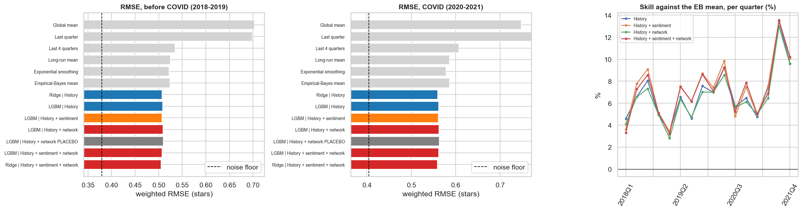
Figure 10. Panel forecast: RMSE before and during COVID against the noise floor, and skill against the EB mean per quarter.
Sentiment helps a little before COVID (-0.74 % MSE, p = 0.014), and this gain does not hold in the COVID years (p = 0.55). Network inputs do not help: they slightly increase error in both periods (+0.32 % and +0.35 %) and do not beat the scrambled placebo (p = 0.62 and p = 0.79). Inputs without signal simply add noise.

9.3 Why the network does not help
A null result could come from faulty features. Each network input was therefore checked on its own against its placebo, within quarters, on training rows. Several differ clearly (for example -0.026 against 0.000 for reviewers' mean log degree), yet all correlations are tiny (below 0.08 in absolute value). So the features work and the signal is simply weak.
A simple calculation shows why. Let β be the conformity effect in Section 6.4, π the share of reviews that follow a friend's review within 30 days, and σ_{x} the standard deviation of the friend's deviation. The typical shift of a business's quarterly mean is:
$$β · π · σ_{x} = 0.37 × 0.013 × 1.00 ≈ 0.005 stars, against noise of about 0.39 stars$$ | (31)

This is the central explanation of the project: a real individual effect can be invisible at the business level, if few reviews are exposed to it.

9.4 Which inputs matter, and the sentiment-star gap
SHAP values (Lundberg and Lee, 2017), calculated natively by LightGBM for a model fitted on data up to 2019, attribute 57.4 % of total importance to sentiment, 37.6 % to history, 3.4 % to the friendship network and 1.6 % to co-review. This looks at odds with sentiment's small gain, but the two measures answer different questions: SHAP shows what a model uses, whereas Table 24 shows what it would lose. Sentiment and history are correlated, so the model can largely substitute one for the other.
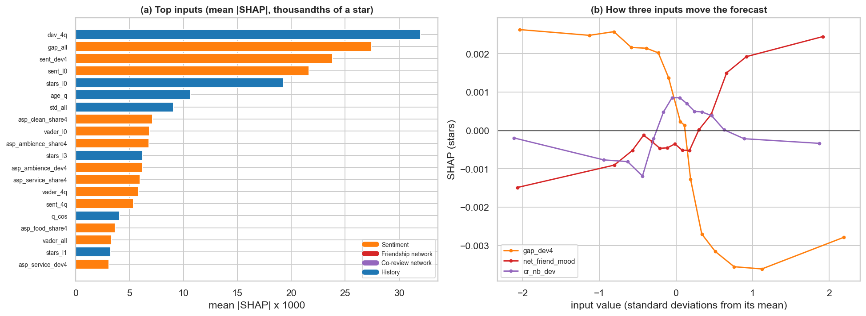
Figure 11. SHAP analysis: (a) the top 20 inputs by group; (b) how three inputs move the forecast.
Testing the gap hypothesis. The next-quarter surprise (stars minus the EB mean) was regressed on the recent gap relative to the business's normal gap, controlling for recent stars relative to the long-run mean, with quarter fixed effects and errors clustered by business:
$$y_{b,t+1} - {\hat{y}}_{b,t+1}^{EB} = β_{1}{gapdev}_{bt} + β_{2}{stardev}_{bt} + τ_{t} + ε_{bt}$$ | (32)

With both inputs standardised, β₁ = 0.028 (SE 0.008, p < 0.001) and β₂ = 0.110 (SE 0.008). The hypothesis holds in a modest form: given recent stars, text more negative than usual goes with slightly lower stars next quarter. Words carry information that stars do not, but the effect is small relative to recent stars. Importantly, the raw pattern reverses without the control, because a low gap often just follows good recent stars, which is a useful warning against reading raw charts.
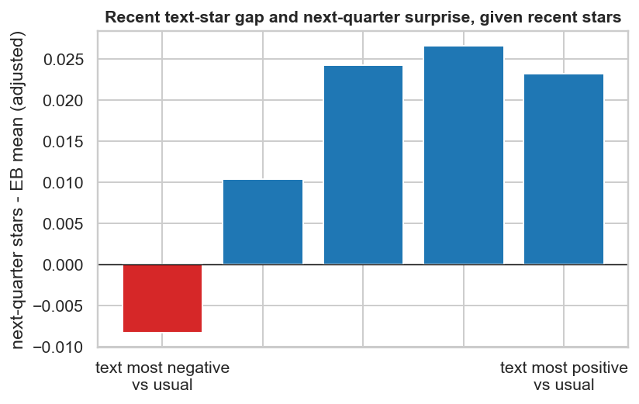
Figure 12. Next-quarter surprise by recent text-star gap, given recent stars.
Table 25. Gains by segment, before COVID. No segment shows a clear network gain; Food (other), at +0.67 %, is one of many groups tested and should not be over-read.
Split by | Group | Rows | RMSE (history) | Network gain % | Sentiment gain %
share of reviewers with a friend who reviewed earlier | low | 1444 | 0.643 | -0.45 | +0.53
share of reviewers with a friend who reviewed earlier | middle | 1444 | 0.463 | -0.33 | +0.99
share of reviewers with a friend who reviewed earlier | high | 1444 | 0.464 | -0.17 | +0.73
reviews in the last 4 quarters | low | 1445 | 0.785 | -0.23 | +1.12
reviews in the last 4 quarters | middle | 1444 | 0.606 | -0.28 | +0.36
reviews in the last 4 quarters | high | 1445 | 0.367 | -0.44 | +0.69
category | Food (other) | 248 | 0.483 | +0.67 | +2.13
category | Nightlife & Bars | 207 | 0.556 | -0.25 | -0.77
category | Restaurants | 2747 | 0.460 | -0.33 | +0.51
category | other | 1132 | 0.691 | -0.44 | +1.24

9.5 Where the network does help: individual ratings
If the channel is too thin to move a business's quarterly mean, it might still appear for one person's rating. For reviews preceded by a friend's review of the same business at least one day earlier, linear models were trained before 2018 and tested on 2018-2019 (6,992 reviews). The placebo is the matched non-friend.
Table 26. Out-of-time forecast of one person's rating.
Inputs | RMSE, all friends | RMSE, friend within 30 days
Business mean | 1.0297 | 0.9567
+ user generosity | 1.0013 | 0.9456
+ non-friend's rating (placebo) | 1.0012 | 0.9423
+ friend's rating | 0.9871 | 0.8641
+ both | 0.9872 | 0.8618

Table 27. Bootstrap by user.
Comparison | Change in MSE | 95 % CI
+ friend's rating vs + user generosity | -0.0282 | -0.0398 to -0.0164
+ non-friend's rating (placebo) vs + user generosity | -0.0001 | -0.0014 to +0.0013
+ friend's rating vs + non-friend's rating (placebo) | -0.0281 | -0.0395 to -0.0166

The network does help here. The friend's rating lowers RMSE from 1.001 to 0.987 overall and from 0.946 to 0.864 when the friend's review is under 30 days old, while the matched non-friend adds nothing (MSE change -0.0001). This is a true out-of-time result. Two caveats apply: recent cases may include joint visits, and the snapshot may contain ties formed after the reviews.

9.6 Review volume
If friends affect where people go, volume may be the place where the network matters. The same panel design was used with log(1 + reviews next quarter) as the target. The models start from the mean of the last four quarters; an earlier version started from the same quarter one year before, but that is a much weaker baseline (RMSE 0.73 against 0.58), and it penalised the models unfairly.
Table 28. Forecast of next-quarter review volume. Negative means the first model has the lower error.
Period | Comparison | Change in MSE × 1000 (95 % CI) | % of MSE | p
before COVID | History vs mean of 4 quarters | -62.94 (-75.01, -52.14) | -18.83 | <0.001
before COVID | History + network vs History | +0.29 (-0.32, +0.83) | +0.11 | 0.346
before COVID | History + friendship network only vs History | -0.13 (-0.58, +0.27) | -0.05 | 0.532
before COVID | History + co-review network only vs History | -0.17 (-0.69, +0.34) | -0.06 | 0.528
before COVID | History + network vs History + network PLACEBO | -0.30 (-0.89, +0.25) | -0.11 | 0.308
before COVID | History + network PLACEBO vs History | +0.58 (+0.16, +0.99) | +0.22 | 0.012
COVID | History vs mean of 4 quarters | -45.84 (-55.96, -35.80) | -12.49 | <0.001
COVID | History + network vs History | +0.81 (+0.11, +1.49) | +0.25 | 0.022
COVID | History + friendship network only vs History | -0.39 (-0.91, +0.12) | -0.12 | 0.118
COVID | History + co-review network only vs History | +0.15 (-0.50, +0.81) | +0.05 | 0.686
COVID | History + network vs History + network PLACEBO | +0.87 (+0.13, +1.60) | +0.27 | 0.014
COVID | History + network PLACEBO vs History | -0.06 (-0.60, +0.49) | -0.02 | 0.774

Global models beat the mean of four quarters by 19 % and 12 % in MSE, but network inputs add nothing before COVID (+0.11 %, p = 0.35) and do slightly worse during COVID (+0.25 %, p = 0.02). The chosen inputs do not capture any effect friends may have on visits at the business level.

10. Extensions

10.1 Influencer event study
Question. When a highly connected user reviews a business for the first time, do its later stars, sentiment and review volume change, compared with similar businesses? A simple before-and-after comparison is inadequate because influencers choose where to go, and may choose places already on the rise.
Design. Two types of influencer were used: the top 1 % by PageRank among users with friends, and Elite at the time of the review. An event is the first such review of a business, from 2012 through 2019Q1, so that the window ends before COVID, for businesses with at least 10 earlier reviews and with reviews in at least 3 of the 4 previous quarters. Each event is matched to up to 3 control businesses in the same category and quarter, not reviewed by this type of influencer through the following 4 quarters, with the most similar level and trend of stars and level and trend of volume over the previous 8 quarters. Outcomes are computed from other reviewers only, for treated and controls alike. For event e at relative quarter k, the difference-in-differences effect relative to the 4 pre-event quarters is:
$$θ_{k} = \frac{1}{|E|}\sum_{e∈E}{\left[\left(Y_{e,k}^{T} - {\overline{Y}}_{e,pre}^{T}\right) - \left(Y_{e,k}^{C} - {\overline{Y}}_{e,pre}^{C}\right)\right]}$$ | (33)

Confidence intervals come from a bootstrap over events. Quarters before the event should show no effect. Because a pre-event trend may remain after matching, a second estimate measures the post-event change beyond the straight line through the pre-event path.
Table 29. Event study results. Post-event effect is the mean of quarters 1 to 4.
Influencer | Outcome | Events | Post-event effect (95 % CI) | Pre-event slope per quarter | Beyond pre-trend (95 % CI)
Top-PageRank user | stars | 367 | -0.032 (-0.129, +0.047) | +0.022 | -0.136 (-0.402, +0.114)
Top-PageRank user | sentiment | 367 | -0.063 (-0.134, +0.011) | +0.008 | -0.090 (-0.297, +0.096)
Top-PageRank user | log reviews | 367 | +0.173 (+0.115, +0.227) | +0.050 | -0.079 (-0.231, +0.076)
Elite user | stars | 317 | -0.060 (-0.170, +0.049) | +0.002 | -0.066 (-0.355, +0.225)
Elite user | sentiment | 317 | -0.053 (-0.141, +0.033) | -0.007 | -0.006 (-0.268, +0.239)
Elite user | log reviews | 317 | +0.190 (+0.132, +0.249) | +0.054 | -0.081 (-0.242, +0.092)

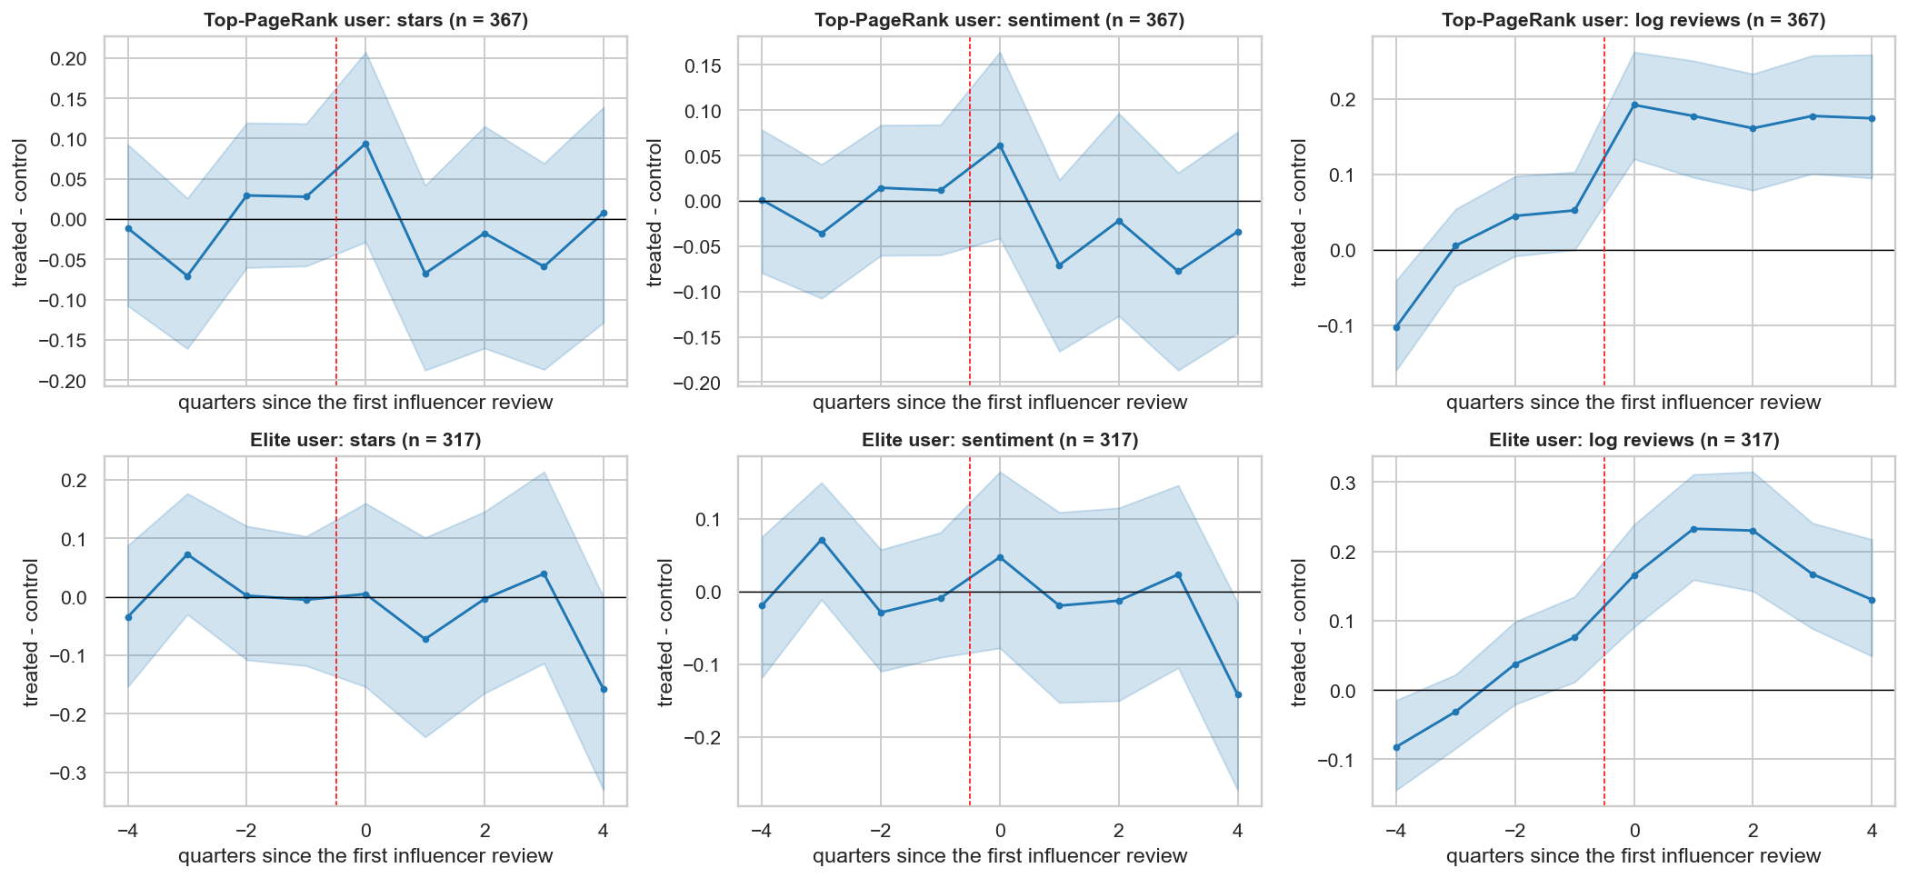
Figure 13. Event study: treated minus matched controls, by quarter relative to the first influencer review, with 95 % bootstrap bands.
- Stars and sentiment show no detectable effect for either type of influencer. Positive effects above about 0.05 stars can be ruled out.
- Volume: the simple result misleads. After the event, log volume rises by 0.17-0.19 relative to controls, with a confidence interval excluding zero. But the difference was already growing before the event (about 0.05 per quarter), even after matching on the volume trend. Beyond that trend the estimate is about -0.08, with a confidence interval including zero. The most likely reading is reverse causation: places with growing attention attract their first influencer.
- An initial version matched only on stars and volume level. It showed a similar pre-trend, and this led to adding the volume trend to the matching and the pre-trend estimate. We find no evidence that influencers raise volume.

10.2 COVID recovery and the network
Business level. Network position was measured before COVID, using 2018-2019 reviews only, so that it cannot be a result of the recovery. Outcomes were the log ratio of reviews in 2021 to 2019, and the change in mean stars. With z_{b} a standardised network measure:
$$Y_{b} = β z_{b} + γ_{1}\log{n_{b}} + γ_{2}{\overline{s}}_{b} + {Category}_{b} + {City}_{b} + ε_{b}$$ | (34)

Table 30. Pre-COVID network position and recovery, with robust standard errors.
Outcome | Network measure | Effect per 1 SD (SE) | p | Holm p | Businesses
reviews 2021 / 2019 (log) | mean log friends of reviewers | -0.131 (0.048) | 0.007 | 0.067 | 876
reviews 2021 / 2019 (log) | share of reviewers with friends | -0.108 (0.045) | 0.017 | 0.153 | 876
reviews 2021 / 2019 (log) | share of reviewers with 20+ friends | -0.114 (0.048) | 0.019 | 0.153 | 876
reviews 2021 / 2019 (log) | share of Elite reviewers | +0.032 (0.052) | 0.530 | 1.000 | 876
reviews 2021 / 2019 (log) | co-review centrality (2019) | -0.103 (0.076) | 0.171 | 0.929 | 876
stars 2021 - pre-COVID | mean log friends of reviewers | -0.036 (0.026) | 0.155 | 0.929 | 775
stars 2021 - pre-COVID | share of reviewers with friends | -0.043 (0.027) | 0.105 | 0.736 | 775
stars 2021 - pre-COVID | share of reviewers with 20+ friends | -0.021 (0.026) | 0.426 | 1.000 | 775
stars 2021 - pre-COVID | share of Elite reviewers | -0.004 (0.027) | 0.890 | 1.000 | 775
stars 2021 - pre-COVID | co-review centrality (2019) | -0.037 (0.043) | 0.386 | 1.000 | 775

Well-connected businesses did not recover faster. If anything the opposite holds: one standard deviation more connected reviewers goes with about 12 % lower volume (p = 0.007), but this does not survive the Holm correction (0.067). A plausible explanation is that connected reviewers were more often frequent users or visitors who reduced their activity, though the data cannot confirm this. Nothing appears for stars.
Communities. With only six units, the analysis is descriptive: connectivity and recovery show no clear relation (Spearman -0.26, p = 0.62).
Aspects. Within-business changes in aspect sentiment after March 2020 were estimated with business fixed effects, which exclude changes in which businesses are reviewed. Whether communities differ was tested with Cochran's Q, where β_{c} is the estimate for community c and w_{c} the inverse of its variance:
$$Q = \sum_{c}{w_{c}{\left({\hat{β}}_{c} - \overline{\hat{β}}\right)}^{2}}$$ | (35)

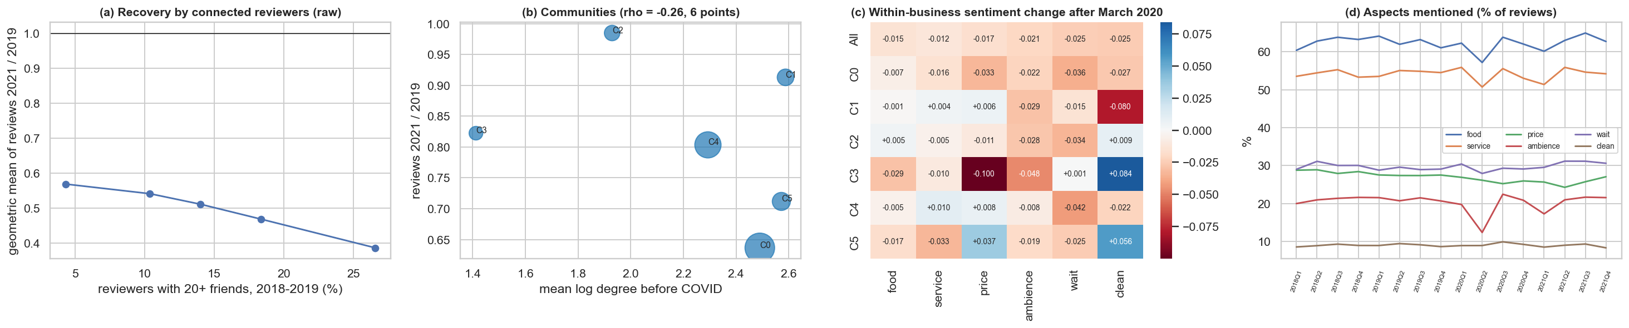
Figure 14. COVID: (a) recovery by share of connected reviewers; (b) communities; (c) within-business sentiment change; (d) aspects mentioned by quarter.
Sentiment fell slightly for all aspects (-0.01 to -0.03), and communities do not differ reliably: no test survives correction, with price the closest (Holm p = 0.066). Ambience mentions drop sharply in spring 2020 (when dining rooms closed) and return, which is a useful sign that the aspect measure reacts to real events.

10.3 Why did a rating change? Change points and aspects
For each of the 397 businesses with at least 200 reviews, the single moment when mean stars shifted most was located by maximising a CUSUM-type statistic over splits k of the sequence of n reviews, with at least 30 reviews on each side:
$$T_{k} = \left|{\overline{y}}_{1:k} - {\overline{y}}_{k+1:n}\right|\sqrt{\frac{k(n - k)}{n}}$$ | (36)

Scanning for the best split finds something even in pure noise, so significance comes from 500 permutations of the same reviews, with false discovery rate control across businesses.
Table 31. Which aspect changes go with star changes at significant breaks (121 businesses, robust standard errors, R-squared 0.84).
Change in aspect sentiment | Change in stars per 1 SD (SE) | p
food | +0.128 (0.063) | 0.043
service | +0.471 (0.052) | <0.001
price | +0.146 (0.032) | <0.001
ambience | +0.009 (0.035) | 0.787
wait | +0.032 (0.044) | 0.461
clean | +0.018 (0.041) | 0.657

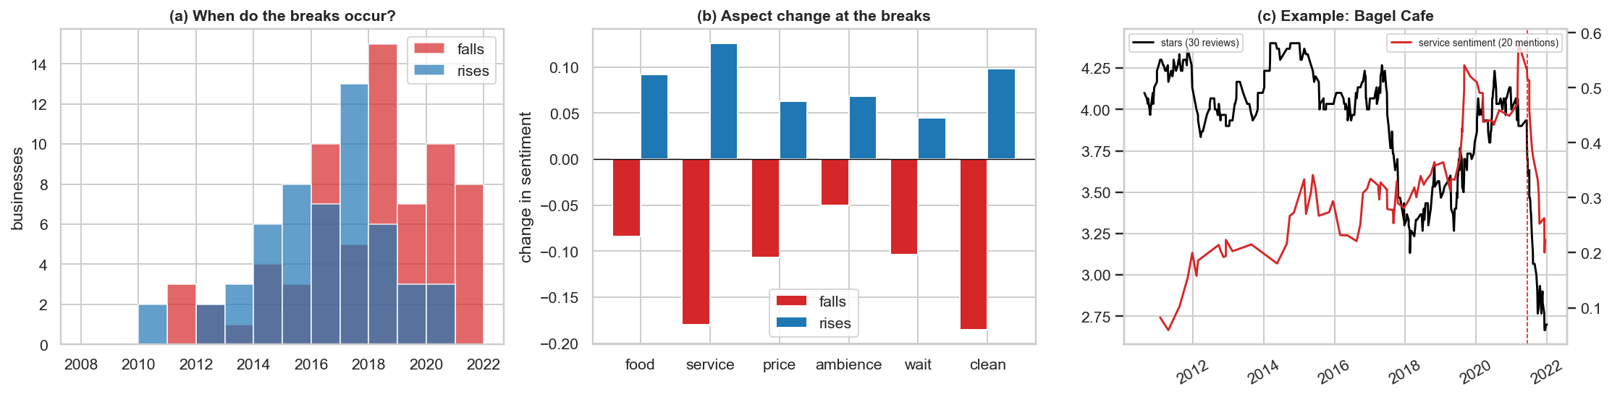
Figure 15. Change points: (a) timing; (b) mean aspect change at falls and rises; (c) an example of a business whose stars and service sentiment fall together.
About 30 % of the businesses tested show a significant shift (121 of 397; 68 falls and 53 rises), with a median size of 0.69 stars. Changes in service sentiment explain star changes best (0.47 per SD), ahead of price (0.15) and food (0.13), which agrees with Section 5. The high R-squared partly arises because text and stars are written together, so this describes the breaks and does not explain their cause. The test assumes a single break, and slow drifts can also be flagged. The businesses in the notebook show a shift in the data, which says nothing about why it happened.

10.4 Do reviews trigger reviews? A self-exciting model
In a self-exciting process (Hawkes, 1971), an event temporarily raises the rate of later events. A discrete version was used here: a Poisson regression for the weekly review count of the 499 businesses with at least 100 reviews before 2018, for 2013-2019 (163,981 business-weeks). The effect differs by who wrote the earlier reviews (H: 20+ friends; C: 1-19 friends; U: no friends). The baseline μ_{bw} is the business's mean weekly count between 5 and 52 weeks before, so that slow trends do not count as excitation, and errors are clustered by business:
$$\log{E\left[y_{bw}\right]} = \log{μ_{bw}} + τ_{month} + \sum_{g∈\{H,C,U\}}{\left(α_{g}n_{b,w-1}^{g} + δ_{g}n_{b,[w-4,w-2]}^{g}\right)}$$ | (37)

Table 32. Self-exciting count model.
Earlier review by | Rate ratio per extra review | 95 % CI | p
last week: 20+ friends | 1.035 | 1.021-1.049 | <0.001
last week: 1-19 friends | 1.021 | 1.012-1.030 | <0.001
last week: no friends | 1.017 | 1.003-1.030 | 0.014
2-4 weeks ago: 20+ friends | 1.022 | 1.012-1.033 | <0.001
2-4 weeks ago: 1-19 friends | 1.008 | 1.002-1.015 | 0.007
2-4 weeks ago: no friends | 0.996 | 0.993-1.000 | 0.056

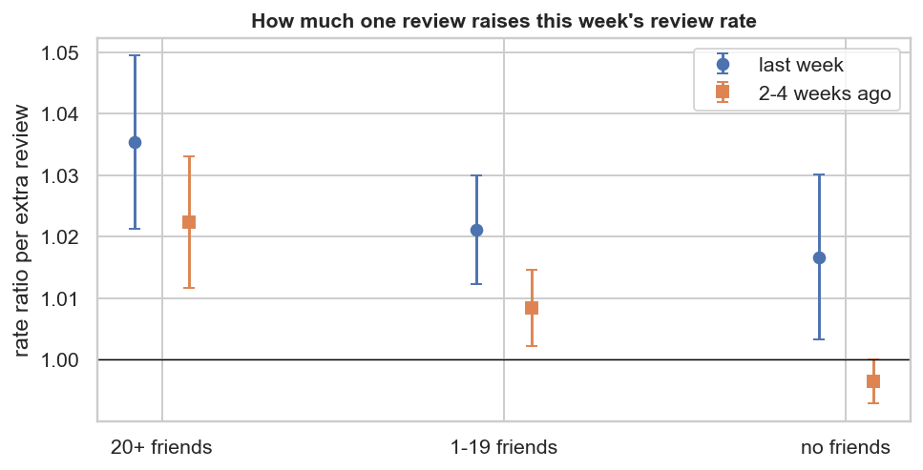
Figure 16. Rate ratios from the self-exciting count model.
Both a real trigger and a shared demand shock raise counts, so the level of excitation does not prove influence. The informative part is the contrast. One more review last week by a user with 20+ friends goes with about 3.5 % more reviews this week, against 1.7 % for an unconnected user (difference p = 0.09). At 2-4 weeks the contrast is clearer: +2.2 % against about 0 % (p < 0.001). This suggests a longer-lasting echo after reviews from well-connected users, in line with Test B, although connected users may simply be earlier in choosing places that are about to become popular. The effect per review is small, which agrees with the absence of gain in the volume forecast.

11. Discussion

11.1 Answers to the research questions
Table 33. Answers to the research questions.
Question | Answer | Strength of evidence
RQ1. Can next-quarter stars be forecast? | Yes, modestly: 6-9 % lower MSE than a strong baseline; much of the rest is sampling noise | Strong (walk-forward, 16 quarters)
RQ2. Does sentiment help? | A little: 0.7 % lower MSE before COVID; no reliable gain during COVID | Moderate
RQ3. Does the network help the forecast? | Business level: no, and no better than a placebo. Community level: no reliable gain. Individual level: yes (RMSE 0.946 to 0.864 with a recent friend review) | Strong null at business level, explained by a magnitude calculation; strong predictive result at individual level
RQ4. Are friends more similar? | Ratings yes (0.37 within 30 days against 0.04 for a matched non-friend); visits yes (odds ratio 4.5 within 30 days); general mood no | Strong association; cause not identified
RQ5. What explains ratings and changes? | Service, above all, in every category and at sharp changes | Descriptive, consistent across two analyses
RQ6. Do friends improve recommendations? | No: the hybrid is better without them, and they do not solve cold start | Moderate; likely an upper bound on their value

11.2 Interpretation
The main finding is a difference between levels. At the level of a person, a friend's recent opinion is informative. At the level of a business, the same channel is too thin to detect. Both results are consistent with a single calculation, and neither contradicts the other. Testing only one level would have given a misleading answer in either direction: one could wrongly conclude from the business forecast that friends do not matter, or from the individual result that networks should improve business forecasts.
The results on homophily point in the same direction. Friendship is sorted by activity much more than by opinion, and co-reviewing a place has little to do with being friends. On Yelp, friendship seems to be a weak carrier of general opinion and a stronger carrier of specific, recent experience, perhaps including shared visits.

11.3 Practical implications
- For a business: the content of reviews is more useful than the network of reviewers, and service sentiment is the first thing to watch. Sentiment falling behind stars is a small warning sign.
- For a platform: a friend's recent rating is a useful signal for predicting what one person will think, but friendship data does not improve the recommender here. Visit patterns and content do most of the work.
- For the analysis of social influence: check the size of the exposed population before expecting an individual effect to appear in aggregates.

11.4 Decisions revised during the analysis
Several initial choices were corrected after the evidence showed they were inadequate. They are listed because they are part of the method:
Table 34. Choices revised in response to evidence.
Initial choice | Evidence | Revision
ARIMA with d = 0 | Unit root in level, stationary after one difference | ARIMA(0,1,1) and related models
Comparing ARIMAX errors across all series | The network lag does not exist for the overall series, so means covered different series | All comparisons on the same six communities
Eight communities for time series | Two of them had fewer than 1,000 reviews | Only communities with at least 5,000 reviews
Language filter by English stop-word share | It flagged normal short English reviews | Compare common English against common foreign words
Raw event-study chart | Volume differences grew before the event | Match on volume trend; add a pre-trend estimate
Raw sentiment-gap chart | It reversed once recent stars were controlled for | Report the partial relation
Volume model based on the same quarter last year | It lost to the mean of four quarters | Start from the stronger baseline

11.5 Limitations
- The friendship list is an undated snapshot from the end of the data, so some ties may have formed after the reviews studied, possibly even because of them. This can overstate the network's value. The null at business level is therefore conservative, while the individual-level gain may be somewhat optimistic. The dated co-review graph only partly offsets this.
- Influence is not identified. Observational data cannot fully separate influence from homophily and joint visits. Placebos, matching and timing narrow the options without settling the question.
- External validity. The data are a sample of Yelp, and the subset is the Santa Barbara area, with many visitors. Friends outside the area are missing, so exposure is undercounted. Results may not transfer elsewhere.
- Ratings are self-selected and may be filtered by Yelp, so stars do not directly measure quality.
- Text methods. Transformers ran on samples, without fine-tuning, for lack of a GPU. VADER aspect scores are weak for wait and price. Star ratings are weak labels of sentiment.
- Survivorship in the panel. Businesses must have at least 50 reviews before 2018, so results do not cover new or rarely reviewed businesses.
- Multiple testing. Corrections were applied within each main family, but not over the whole project.
- Computation. The first complete run from an empty cache was never timed in one go, as the stages were run and cached separately; the final run with cached results took about 31 minutes.

12. Conclusion and future work
This project built a complete pipeline linking text, networks, recommendation and forecasting on Yelp data, under rules that guard against look-ahead and false discovery. Star ratings can be forecast modestly, text adds a little, and most of the remaining error is sampling noise. The social network adds nothing to a business-level forecast, even though friends' ratings clearly help to predict one person's rating and friends' visits predict one's own. A simple calculation explains this difference: few reviews are exposed, so the effect does not reach the aggregate.
Several extensions could deepen this work: fine-tuning a transformer on Yelp with a GPU and scoring aspects on all sentences; seeking quasi-random exposure for a more causal test, such as a friend's review appearing near the top of a page; building a recommender on the dated co-review graph to avoid look-ahead through friendships; and applying the same design to other Yelp regions to examine external validity.

References
Aral, S., Muchnik, L. and Sundararajan, A. (2009). Distinguishing influence-based contagion from homophily-driven diffusion in dynamic networks. Proceedings of the National Academy of Sciences, 106(51), 21544-21549.
Benjamini, Y. and Hochberg, Y. (1995). Controlling the false discovery rate: a practical and powerful approach to multiple testing. Journal of the Royal Statistical Society: Series B, 57(1), 289-300.
Blondel, V. D., Guillaume, J.-L., Lambiotte, R. and Lefebvre, E. (2008). Fast unfolding of communities in large networks. Journal of Statistical Mechanics: Theory and Experiment, P10008.
Cleveland, R. B., Cleveland, W. S., McRae, J. E. and Terpenning, I. (1990). STL: a seasonal-trend decomposition procedure based on loess. Journal of Official Statistics, 6(1), 3-73.
Diebold, F. X. and Mariano, R. S. (1995). Comparing predictive accuracy. Journal of Business and Economic Statistics, 13(3), 253-263.
Granger, C. W. J. (1969). Investigating causal relations by econometric models and cross-spectral methods. Econometrica, 37(3), 424-438.
Harvey, D., Leybourne, S. and Newbold, P. (1997). Testing the equality of prediction mean squared errors. International Journal of Forecasting, 13(2), 281-291.
Hawkes, A. G. (1971). Spectra of some self-exciting and mutually exciting point processes. Biometrika, 58(1), 83-90.
Holm, S. (1979). A simple sequentially rejective multiple test procedure. Scandinavian Journal of Statistics, 6(2), 65-70.
Hu, Y., Koren, Y. and Volinsky, C. (2008). Collaborative filtering for implicit feedback datasets. Proceedings of the IEEE International Conference on Data Mining, 263-272.
Hutto, C. and Gilbert, E. (2014). VADER: a parsimonious rule-based model for sentiment analysis of social media text. Proceedings of the International AAAI Conference on Web and Social Media.
Hyndman, R. J. and Koehler, A. B. (2006). Another look at measures of forecast accuracy. International Journal of Forecasting, 22(4), 679-688.
Ke, G. et al. (2017). LightGBM: a highly efficient gradient boosting decision tree. Advances in Neural Information Processing Systems, 30.
Koren, Y., Bell, R. and Volinsky, C. (2009). Matrix factorization techniques for recommender systems. Computer, 42(8), 30-37.
Krichene, W. and Rendle, S. (2020). On sampled metrics for item recommendation. Proceedings of the ACM SIGKDD International Conference on Knowledge Discovery and Data Mining, 1748-1757.
Lee, D. D. and Seung, H. S. (1999). Learning the parts of objects by non-negative matrix factorization. Nature, 401, 788-791.
Lundberg, S. M. and Lee, S.-I. (2017). A unified approach to interpreting model predictions. Advances in Neural Information Processing Systems, 30.
McPherson, M., Smith-Lovin, L. and Cook, J. M. (2001). Birds of a feather: homophily in social networks. Annual Review of Sociology, 27, 415-444.
Newman, M. E. J. (2001). Scientific collaboration networks. II. Shortest paths, weighted networks, and centrality. Physical Review E, 64, 016132.
Newman, M. E. J. (2002). Assortative mixing in networks. Physical Review Letters, 89, 208701.
Pontiki, M. et al. (2014). SemEval-2014 Task 4: aspect based sentiment analysis. Proceedings of the 8th International Workshop on Semantic Evaluation, 27-35.
Sanh, V., Debut, L., Chaumond, J. and Wolf, T. (2019). DistilBERT, a distilled version of BERT: smaller, faster, cheaper and lighter. arXiv:1910.01108.

